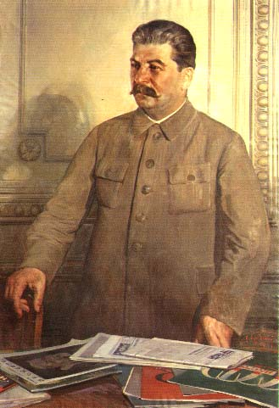
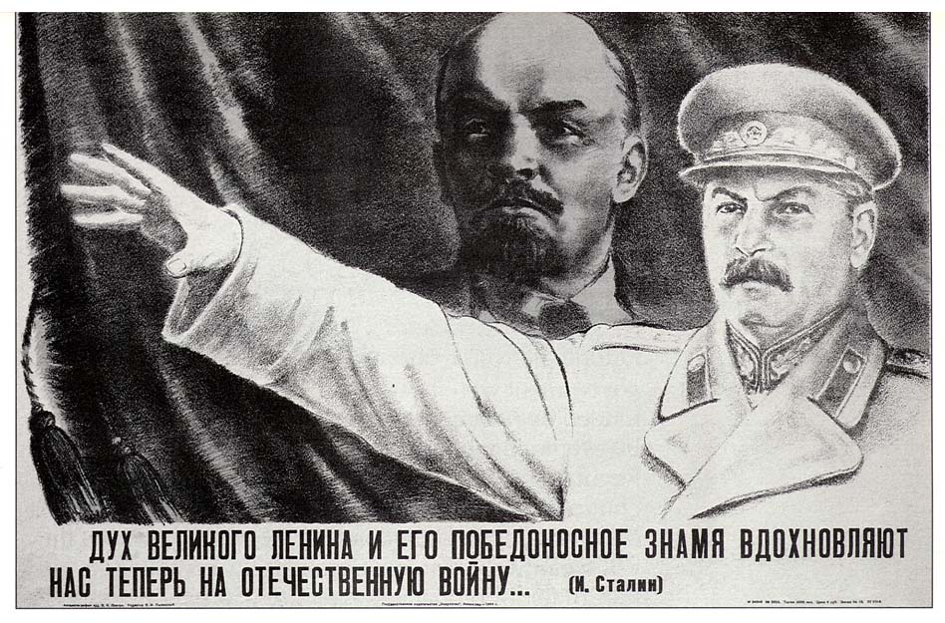
130

Watch the video entitled Life Under Stalin and answer the following questions:

- How did Stalin take control of the Communist Party after Lenin’s death?
He ran a ‘slander’ campaign against Trotsky. He rallied party members around him in the Politburo.

- What eventually happened to Leon Trotsky?
In 1940, he was assassinated with an ice-pick while in exile in Mexico. He had written many things against Stalin.

- What was Stalin obsessed with doing to the Soviet Union?
He wanted to modernize and industrialize the Soviet Union.

- Who were the Kulaks? What was the policy of de-Kulakization?
Successful peasant farmers. The Kulaks were killing their animals and burning grain in protest of collectivization, so Stalin rounded them up and detained or killed them.

- What was collectivization? Was the policy a success? Why or why not?
Policy to gather all small tracts of land and turn them into government controlled “state” or “collective” farms. It was largely a failure because peasants protested and were killed (Kulaks)

- What was the Great Famine in the Ukraine? Why did it happen?
Massive famine in agricultural center of the Soviet Union-Ukraine.
Stalin took grain that was produced and fed city workers. He also sold it to other countries to help finance industrialization.

- Describe what happened in the First Five Year Plan.
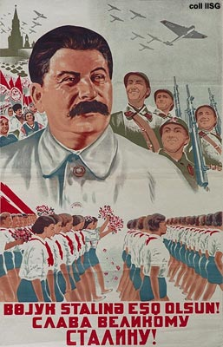
Major focus on Heavy industry - COAL & STEEL. Terrible working conditions, but industry grew at a fast rate. Millions suffered, but it was an industrial success. People suffered with lack of consumer goods.

- Describe what happened in the Second Five Year Plan.
Told people there would be more for them, but most attention and capital went to industry and the military.

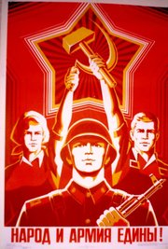
- How was propaganda used in Stalin’s Soviet Union?
Glorified workers and hard work to motivate. Their was a lot of pressure to meet quotas. They were punished if these quotas weren’t met, so managers falsified records to show that they had met them. “Be like Stakhanov!”

- Describe Stalin’s totalitarianism.
“Total” control of the Soviet Union. He ultimately made all political and economic decisions. Secret police terrified everyone! Religion was banned, complete censorship, total control of media, and history was re-written.

- What changes did Stalin make to society in terms of women and education?
Women were viewed as equals in communist society - women in all areas of the workforce. Education was viewed as very important: by 1935 USSR had an 85 % literacy rate.

- Describe what Stalin did to build a personality cult around him?

He was portrayed as a “father figure”. Books re-written and photos doctored to place Stalin in a much more prominent role in Soviet history.

- Describe the ‘Great Terror’ and the ‘purges’. Who were the targets and why?

Purges were a massive campaign to eliminate all enemies-real or invented!
Stalin was very paranoid – he wore a bullet proof vest! He used his secret police to create an atmosphere of paranoia and terror. People were encouraged to inform on each other of anti-communist feelings.
He used the secret police to terrorize the whole country.

- What were ‘show trials’ in Stalin’s Soviet Union?
Falsified evidence used at trials of people said to have challenged Stalin or communism. It was a big propaganda tool to move public opinion against popular members of the CPSU.

- What was life like in the gulags?
“Hell” – Work camps in Siberia primarily – long hours, little food, poor shelter - extremely high death rates. Stalin built new industries on the backs of his own people.

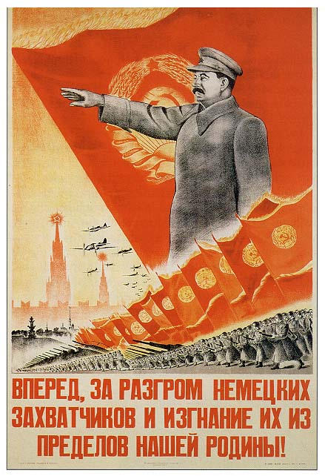
- What did Stalin do in 1939 to try and protect the Soviet Union? Did it work?
He signed a “NON-AGRESSION” PACT with Hitler and Germany. They agreed to divide Poland. It shocked the world because communists and fascists hated each other. It didn’t work because Hitler invaded the S.U. in 1941: OPERATION BARBAROSSA

- Did Stalin’s ends justify his means?

