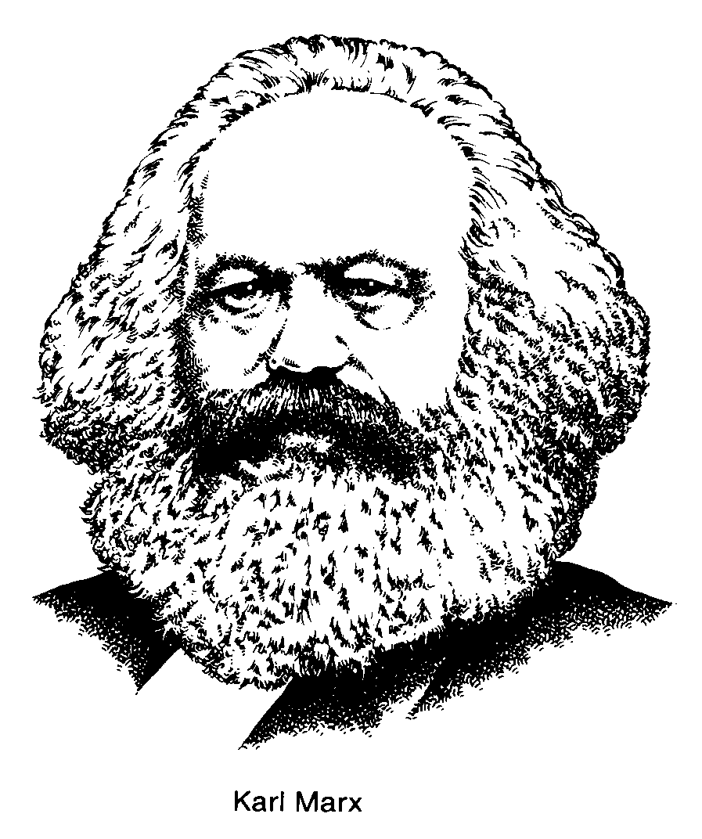
Diagram Marx’s Theory of the Decline of Capitalism.
Feudalism

decline/overthrow

Capitalism: Creation of bourgeoisie and proletariat

Bourgeoisie exploits proletariat and lesser bourgeoisie

Economic competition causes a decline in wages
Economic competition leads to fewer firms
- Capitalist crisis
- Business cycle (from boom to bust) become increasingly severe
- Imperialistic view

Proletariat becomes poorer, buys fewer goods
Some bourgeoisie accumulate great wealth

- Proletariat becomes poorer
- More unemployment
- Development of class consciousness
- Bourgeoisie makes fewer profits
- Wealth accumulates in fewer hand

Why is this stage critical in Soviet history?
Most experiments in ‘communism’ have never moved past this stage ie. Soviet Union, China, Cuba, North Korea
Breakdown of social and political order

Spontaneous revolution
proletariat overthrow the bourgeoisie

Dictatorship of the proletariat

Pure communism (classless society)

Proletariat: Marx’s term to describe the working class.
Bourgeoisie: Marx’s term to describe the owners of production.

