
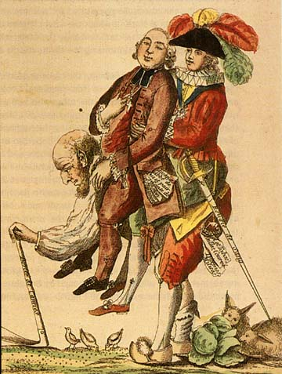


Her is a summary of the results of the French Revolution:

the monarchy is abolished

the old social, political and economic structure (‘Old Regime’) was destroyed
the recognition of human rights – ‘Declaration of the Rights of Man’ – foundation of modern constitutions – roots of democracy
nationalism in France was developed out of love for the nation and belief in control for and by the people
the idea developed that the country and the government belonged to the people, not a monarch – ‘nationalism’ is born
the ideas above were spread to many other countries in Europe


Of all the above, probably the most important is the new sense of nationalism among the French people that grew out of the revolution. No longer were the French people loyal to their king or to the church or to a local nobleman. Now they were loyal to the nation and the ideas of liberty and equality (egalitarianism). This new kind of loyalty was destined to spread throughout Europe and the world.

