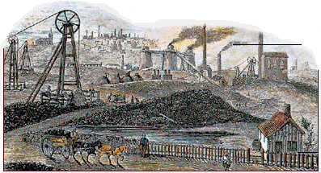

# NEGATIVE IMPACTS of the INDUSTRIAL REVOLUTION in ENGLAND



## EARLY INDUSTRIAL REVOLUTION – 1750 to 1840

* **rapid urbanization (people moving to cities to work in factories) led to:**

**- overcrowding – cities unprepared**

**- unsanitary living conditions – cities unprepared ie. sewage**

**- no services ie. police, education for children**

**- no regulations for housing and sanitation**

* **exploitation of workers**

**- a lot of competition for jobs (periods of unemployment and desperation)**

**- no labour laws – owners could fire at will – workers fearful**

**- no representation for workers (no unions)**

**- low wages (no minimum wages) – long hours (no regulation)**

**- unsafe and unhealthy conditions (no regulation)**

**- women and children exploited as cheap labour**

* **high death rates in working classes**
* **rising middle class getting richer while workers are exploited – wealth uneven**

# POSITIVE IMPACTS of the INDUSTRIAL REVOLUTION in ENGLAND

## LATE INDUSTRIAL REVOLUTION – 1840 to 1900

* **advancements in medicine lead to longer life expectancies – death rates fall**
* **improvements in food production (enclosures, crop rotation) sustain more people**
* **cities give people more access to new ideas – enlightened**
* **1840 Mines Act – women, girls and boys under 10 banned – inspectors**
* **Factory Acts 1844, 1847, 1867 – children hours restricted 6 ½ hours before noon, people under 18 and all women no more than 10 hrs.**
* **production in all area booms – especially textiles, iron and steel products**
* **trade expands with other countries – commercial revolution**
* **wages go up – more manufactured goods, and food to choose from**
* **standard of living starts to increase for most**
* **regulations (Factory, Mines Acts) give people more leisure time**
* **organized sports and activities arise**
* **more variety in consumer goods stores to compete for wages (shopping)**