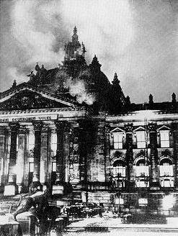
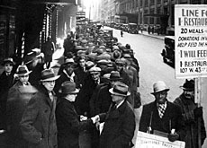

Economic Trends Between the Wars

When the Great War ended in 1918, citizens and leaders in many nations looked forward to a gradual return to normalcy. Four years of warfare had led to nearly ten million deaths and war costs combined with property damage that amounted to over 300 billion dollars. Empires had collapsed, new nations had formed (successor states), and the European balance of power had been permanently altered. The end of the war, however, promised the opportunity to reconstruct damaged economies and restore political stability. Unfortunately, although some nations were able to rebound successfully from the war, stability in other nations was more difficult to achieve. The 1920’s and 1930’s were two decades in which national economies as well as the international financial scene experienced roller-coaster-like boom and bust cycles greater than ever before. These wild fluctuations came to dominate (and in some nations, take over) political life.

Post-War Recession

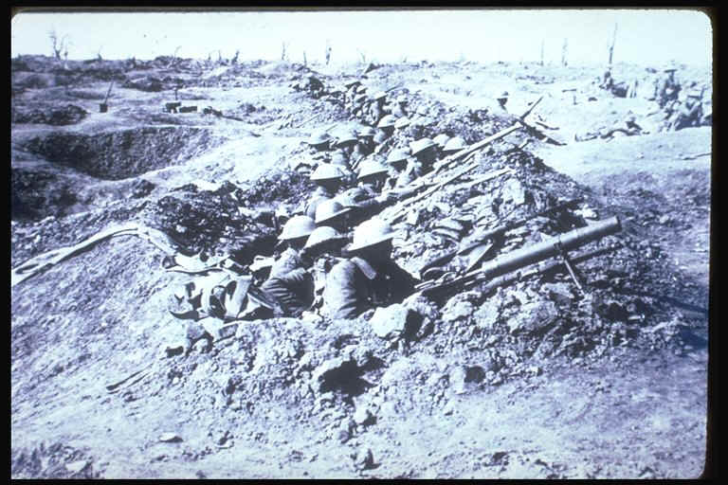
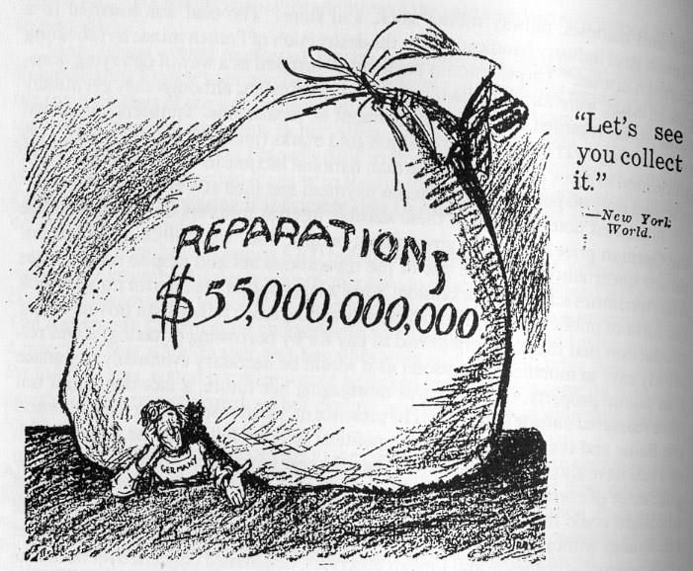
When the First World War ended in 1918, all nations involved in the war fell into a post-war recession. For several reasons recessions are common after most wars, even in the nations that “win”. During a war, a nation’s economy and production are geared toward producing materials for the war effort. In Canada, for example, companies that had produced tractors before the war converted to making shells and tanks during the war. Once the war ended, these items were no longer needed, and companies had to return to making peacetime products. This conversion took several years. The second cause of post-war recessions was the returning soldiers. Millions of young men returned from the trenches looking for jobs, but the economy was temporarily stalled. Unemployment rose drastically. In nations such as Canada, the United States and Great Britain, where the war had caused little physical damage, the recession was relatively short lived, and a return to stability was accomplished by the early 1920’s.

In other nations, however, further problems were added to the economic slowdown that followed the war. In Italy and, in particular, in France and Belgium, the war had caused a great deal of damage to homes, farms and industry. Billions of dollars had to be spent repairing the damage; this was the main reason why France insisted that Germany be forced to pay reparations. France relied on these reparations so much that when the payments stopped in 1923, France occupied Germany’s Ruhr region to force the resumption of the much-needed money. In addition, Britain and France had borrowed heavily from the United States to pay for their war efforts, and now had to repay the American loans with German money that had, in turn, been borrowed form the United States.

Trench Warfare in World War I
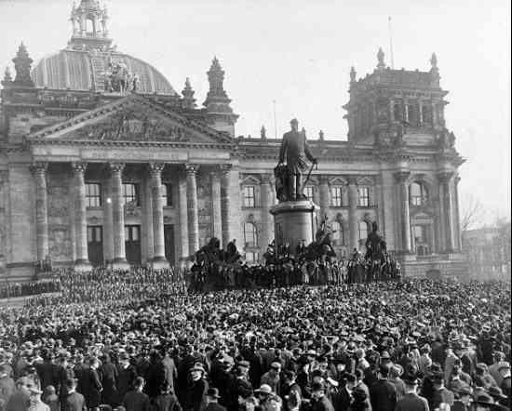
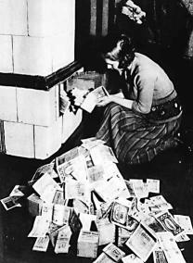
Predictably, it was in Germany where the post-war economic crisis was greatest. The German economy had all but collapsed near the end of the war and money to restart the German economy was simply not available; any money the German government did have was used to pay reparations. By 1923, when other nations were experiencing the start of a period of prosperity, the German economic crisis was reaching its climax. The Weimar government (the government which took over in Germany after the war) resorted to the desperate measure of printing more money in order to meet French demands for prompt payment of reparations. This led to hyperinflation; at one point more than one trillion German marks was needed to buy a loaf of bread. Only American intervention saved the economy.
Weimar Government declared.
In 1924, the Dawes Plan worked out a new schedule of reparation payments and the United States negotiated the French withdrawal from the Ruhr. American money was also used to establish a new German mark, guaranteed by the United States. By 1924 Germany was poised for an economic revival, but what had been the affects of the economic chaos on politics?
Inflation 1923-24: a woman feeds her tiled stove with money

Political Effects of the Post-War Recession
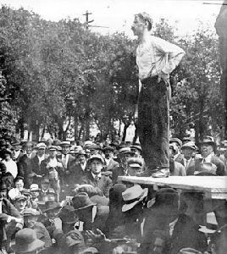
When an economy is booming, people are generally satisfied with the political system in a nation. Citizens with steady jobs in a stable economy tend to support political parties in the center of the political system. However, when the economy is unstable and people are desperate, they tend to listen to more radical political and economic solutions. This occurred, to some extent, in all countries after the First World War, with people demanding action to provide work and economic revival. Even in Canada, usually a moderate and prosperous nation, workers in Winnipeg called a General Strike, which ended in violence. Canadian officials believed that a Bolshevik conspiracy was trying to take over!
Winnipeg General
Strike,1919.

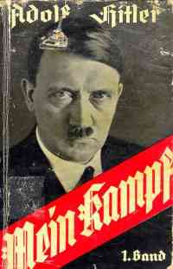
Political violence, strikes and protests occurred in every nation. In Italy, Benito Mussolini and the Fascists used the political and economic instability to convince Italians of the need for a dictatorship to guide the nation’s future. In Germany the bitterness felt by the harsh treatment at Versailles was added to the economic collapse. Riots and violence became almost the norm in Weimar Germany. Radical political parties from both the left and the right claimed to have the solution to the country’s problems. Several major coups were attempted but the government narrowly maintained control. In 1923, Adolf Hitler and his Nazi (NSDAP — National Socialist German Workers Party) followers attempted to overthrow the government of Bavaria, one of Germany’s provinces, but failed to achieve their objective. This event became known as the Munich putsch (or ‘Beer Hall putsch’). Hitler was imprisoned for 9 months as a result of his role in this event. While in prison Hitler wrote Mein Kampf (‘My Struggle’), which outlined his personal vision and beliefs about the future of Germany. Hitler also realized that he and his Nazis would have to come to power through legal means, which they would immediately start working towards. Political radicalism was closely tied to the economic crisis created by the war. Germany became a battleground for a variety of right-wing and left-wing ideologies – all offering to solve Germany’s problems. Hitler and the Nazis grew to hate the communists and used them as a scapegoat for the problems in Germany, playing on people’s fears of a communist revolution coming to Germany (as was happening in Russia – now called the Soviet Union)

The revival of the major economies in the middle and late 1920’s put to rest many of the problems of the early years of the decade. In 1924, the United States was booming and American money was finding its way all over the world in loans and investments. To a lesser extend, Britain, France and even Germany enjoyed a modest economic boom in the late 1920’s as well. Along with this economic revival came a return to relative political stability. This period, however, came to an end with the Great Depression.

Causes of the Depression

The Depression that began in 1929 and 1930 and that was firmly established in all nations by 1932 had a variety of both national and international causes. Historians and economists have advanced many theories, but two main causes are dominant: the global economy had not fully recovered from the First World War and all nations, to an unprecedented degree, were dependent on the United States.

By 1929, American investors had large sums of loans or investments in every major nation. The world’s economy depended on continuing prosperity in the United States and when this failed, the United States began to reduce investment and demand repayment of loans. The spectacular boom of the Roaring Twenties in the United States however had been a partial illusion. Only the wealthiest one-third of Americans shared in the prosperity, and businesses had tended to overproduce. Stocks soared in value, but widespread use of credit (buying on margin) cheapened the true value of businesses. In 1928 and 1929, growth began to slow. On October 24, 1929, “Black Thursday” investors converged on the New York Stock Exchange to sell their stock at any price. They were reacting to rumors that the market was falling. Of course, once people started to sell in panic, prices fell and the market did collapse. Confidence in the stock market was gone and over the new few years, the average value of stocks continued to decline. Many businesses went bankrupt, and others had to reduce wages and lay off workers to survive. Production of goods in the United States decreased, since few people had money to spend.
Wall Street crash, 1929.

Almost like dominos, stock markets in other nations also began to collapse as nervous investors sold their shares and American investors withdrew their remaining money. Coupled with the chaos in business came a decade of poor harvest, particularly in North America. In the rare years that farmers were able to produce a good crop, prices barely covered the costs of production. In order to protect their economies, the United States and other nations resorted to protectionist trade policies that placed heavy tariffs on imports. The net result of these tariffs was to destroy international trade. This in turn only served to increase further the unemployment in nations worldwide. This American policy was known as isolationism.

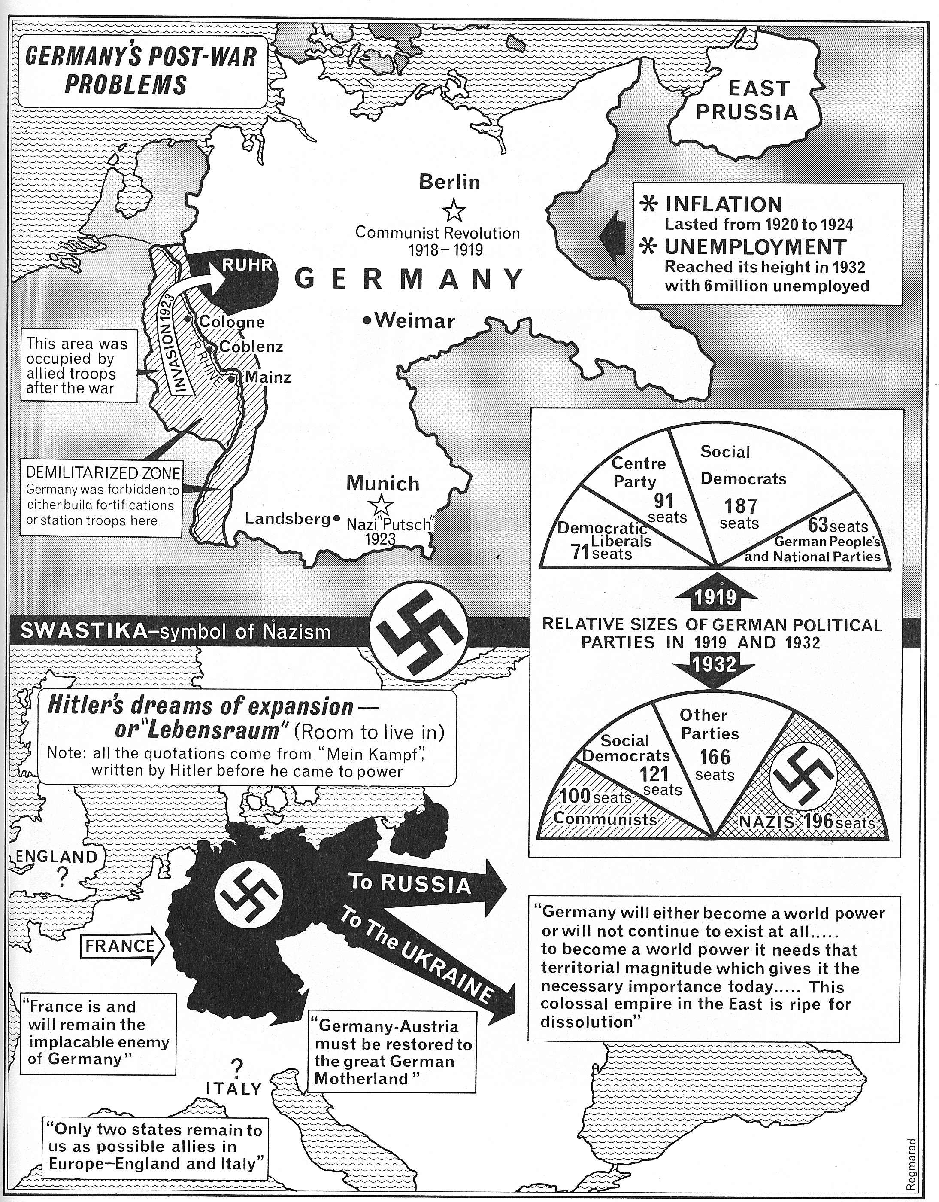
Effects of the Depression

By 1933, every industrial nation was plagued by high unemployment and economic stagnation. They also had to contend with a renewal of political radicalism. Extremists who arose from the waves of fear and discontent, offered quick solutions or scapegoats for the economic misery.

In Germany, where recovery from the previous economic crisis was weakest, the Depression had perhaps the greatest effect. Six million workers were unemployed and it was no coincidence that Adolf Hitler’s Nazis, who had only twelve seats in the German Reichstag (legislature) in 1928, had 196 seats in 1932. There was extensive support for communist ideas, but left-wing groups were disunited and spent a great deal of their energy fighting among themselves. The right-wing however was dominated by the Nazis, who became the single largest party in the Reichstag (although they did not have a majority of the seats). Hitler posed as Germany’s last hope for survival, blaming Jews, communists, democrats and the Treaty of Versailles for the nation’s poverty. To many voters, his extreme political measures promised an opportunity for growth, order and prosperity.

German Elections - NAZI Seats

Election Seats

May 1928 12
Sept. 1930 107
July 1932 230
Nov. 1932 196
Jan 1933 Hitler Chancellor March 1933 288

One day after the Reichstag Fire in February of 1933, Hitler passed the Reichstag Fire Decree which suspended civil rights under the Weimar constitution, allowing the Nazis to “…to take any appropriate measure to remedy dangers to public safety”. In this new era of terror and Nazi control Hitler calls another election in which the Nazis win and President Hindenburg appoints Hitler the Chancellor of Germany on January 30, 1933. Once Hitler controlled the German government, he introduced the Enabling Acts which give he and his cabinet dictatorial powers – they alone could pass legislation.
Every nation attempted a variety of measures to deal with the Depression. In the United States, Franklin D. Roosevelt introduced the New Deal, a series of government programs to stimulate the economy, and achieved some success in creating jobs and restoring stability. In Britain and France, small steps were taken to aid workers and farmers but, particularly in France, the government was divided on the policies it should follow. All of these nations used tariffs to protect domestic products, thereby actually losing jobs because of the reduction in exports. Germany had the most success in overcoming the Depression, but this was achieved by strong government action. Hitler created massive public works programs, such as the autobahn (highways), which employed millions. He also began the remilitarization of Germany; soon the entire economy revolved around production of war materials. Hitler was systematically violating the Treaty of Versailles as by rearming the country.
Reichstag Fire, 1933
For twenty years, from 1919 to 1939, the economies of the industrialized nations were subject to unprecedented extremes. These economic fluctuations were accompanied by political shifts as well, particularly in Germany, where it could be said that the Depression made the rise of Hitler possible. Ironically, most nations were not able to recover from the depths of depression through their own efforts; it took the Second World War to provide the spark that restarted the global economy.

The following visual is schematic describing the Weimar Republic government structure. Compare and contrast it with what you know about the Canadian and American political models.
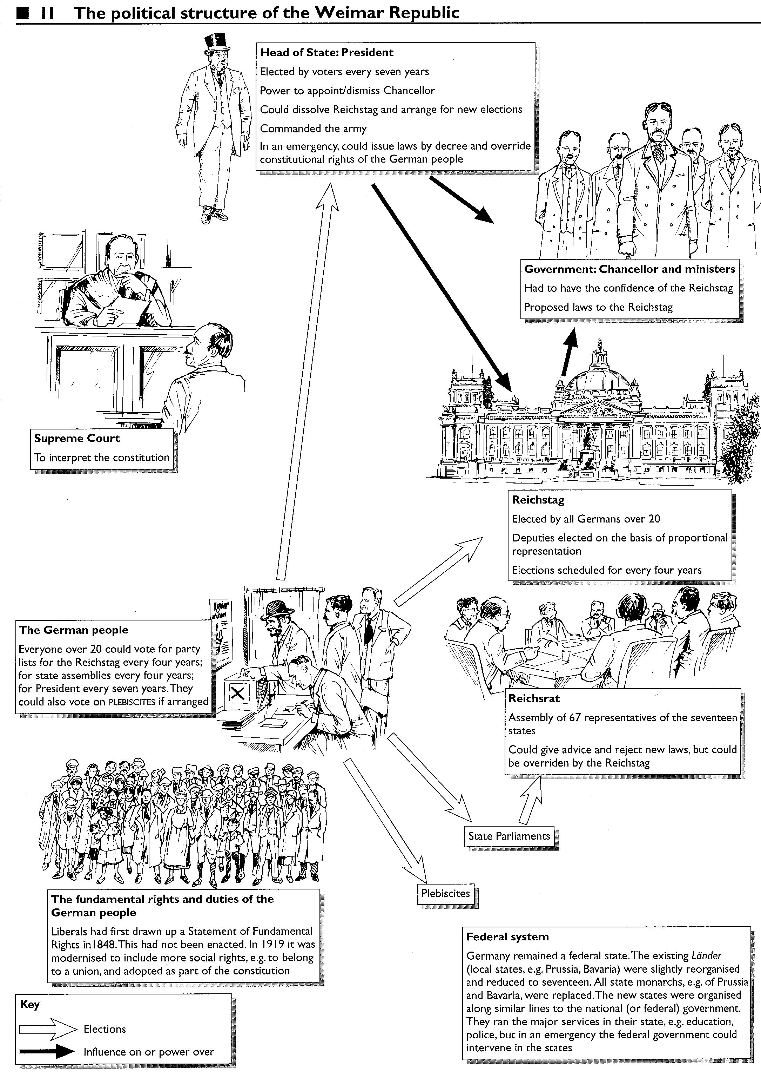
Sources: Historical Atlas of the Third Reich, A Map History of the Modern World, Weimar and Nazi Germany, Social 30 Readings

