human nature: people rational and good

human nature: people rational and good

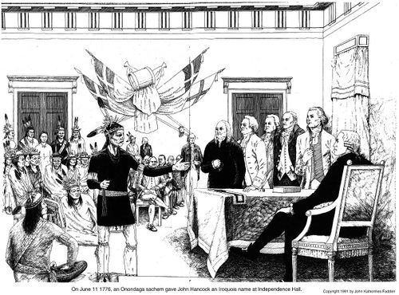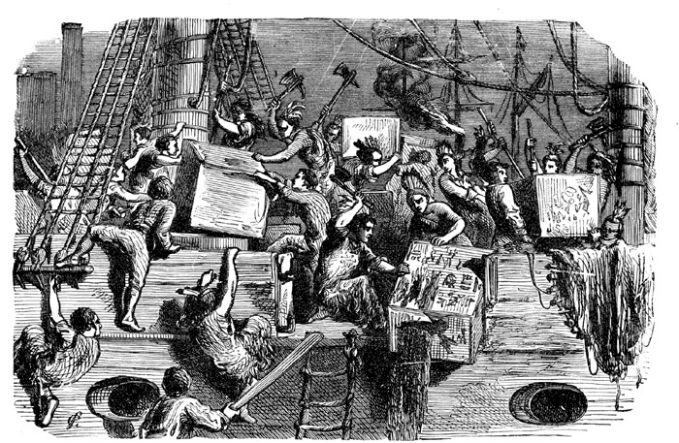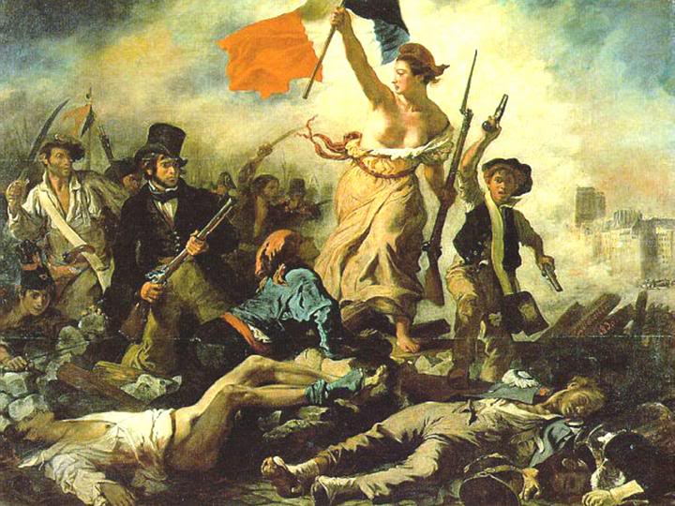

**PRINCIPLES OF LIBERALISM**

*individual rights and freedoms,*

*self-interest, competition,*

*economic freedom, rule of law,*

*private property*

Rousseau’s concept of ‘noble savage’

Iroquois Confederacy (Haudenosaunee confederacy)

‘Great Law of Peace’

constitutions

influence on fathers of American democracy

Aboriginal Contributions

(North America)

***Foundations of***

# CLASSICAL LIBERALISM

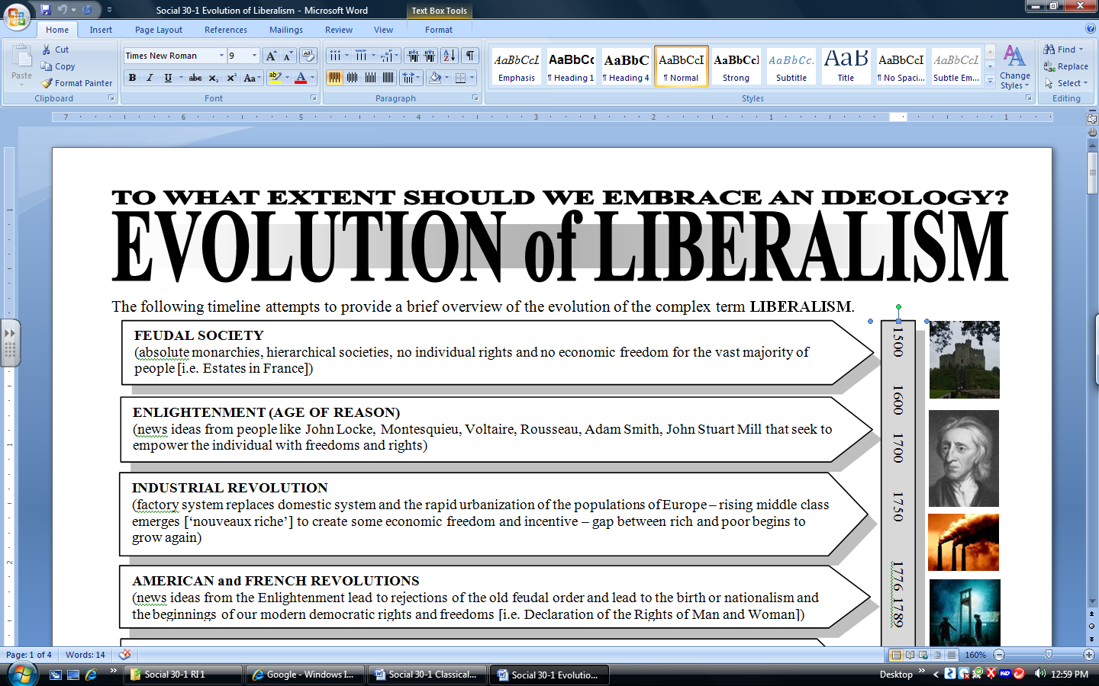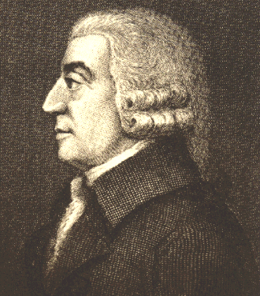

democracy experiments based on principles of liberalism

U.S. Constitution and Bill of Rights

American Revolution against the British leads to independence for the thirteen colonies – move from a colony (under Monarch) to a ‘republic’

birth of contemporary ‘nationalism

rejection of British monarchy and control – Boston Tea Party – Declaration of Independence

Declaration of the Rights of Man (Woman)

National Assembly (parliament)

overthrow of ‘Old Regime’ social structure – three Estates – absolute monarch

empowerment of the individual politically and economically

The American Revolution

(British model)

The French Revolution

checks on government power – revolution if necessary

fearful ‘tyranny of the majority’ in a democracy

checks on government power

individual liberty and the ‘social contract’

individuals free unless they hurt others

*On Liberty*

**John Stuart Mill**

mass production – new consumer products – consumerism and materialism

growing gap between rich and poor – worker exploitation pushes calls for reform – ‘socialism’ emerges

**Adam Smith**

*The Wealth of Nations*

capitalism

limited government involvement – ‘laissez faire’ – free markets

rapid urbanization – need for social services (sanitation, policing etc.)

move from domestic system to the factory system

legislative

executive

judicial

separations of powers in government

*The Spirit of the Laws*

**Montesquieu**

*Essay on Human Understanding and Second Treatise on Civil Government*.

**John Locke**

The Enlightenment

new economic opportunity – economic freedom

rising middle class – ‘nouveux riche’

The Industrial Revolution