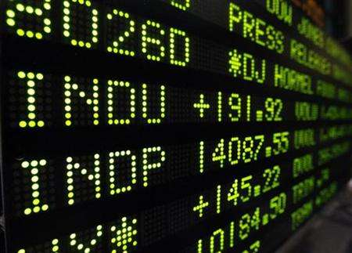

A **corporation** is a legal entity (technically, a juristic person) which has a legal personality distinct from those of its members.

The defining legal rights and obligations of a corporation consist of the capacities (i) to sue and to be sued, (ii) to have assets, (iii) to employ agents, (iv) to engage in contracts, and (v) to make by-laws governing its internal affairs. Other legal rights and obligations may be assigned to the corporation by governments or courts. These are often controversial.

Stewart Kyd, the author of the first treatise on corporate law in English, defined a corporation as "a collection of many individuals united into one body, under a special denomination, having perpetual succession under an artificial form, and vested, by policy of the law, with the capacity of acting, in several respects, as an individual, particularly of taking and granting property, of contracting obligations, and of suing and being sued, of enjoying privileges and immunities in common, and of exercising a variety of political rights, more or less extensive, according to the design of its institution, or the powers conferred upon it, either at the time of its creation, or at any subsequent period of its existence.”

Currently, the **modern business corporation** is the dominant type of corporation. In addition to its legal personality, the modern business corporation has at least three other legal characteristics: (i) transferable shares (shareholders can change without affecting its status as a legal entity), (ii) perpetual succession capacity (its possible continued existence despite shareholders' death or withdrawal), (iii) and limited liability (including, but not limited to: the shareholders' limited responsibility for corporate debt, insulation from judgments against the corporation, shareholders' amnesty from criminal actions of the corporation, and, in some jurisdictions, limited liability for corporate officers and directors from criminal acts by the corporation).

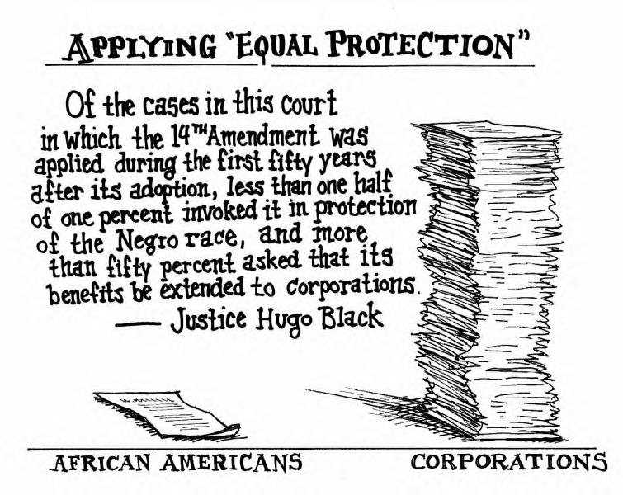

The modern business corporation's prevalence often obscures the fact that for years other corporate entities existed, before the emergence of the modern business corporation, for example, church, educational and charity corporations. Investors and entrepreneurs often form joint stock companies and then incorporated them to facilitate conducting business; as this business entity now is prevalent, the term **corporation** often is used to specifically refer to such **business corporations**. Corporations may also be formed for local government (municipal corporation), political, religious, and charitable purposes (not-for-profit corporation), or for government programs (government-owned corporation). As a generic legal term, 'corporation' means any group of persons with a legal personality. Historically, the modern business corporation emerged from the blending of the traditional corporation with the joint-stock company.

In Canada both the federal government and the provinces have corporate statutes, and thus a corporation may have a provincial or a federal charter. Many older corporations in Canada stem from Acts of Parliament passed before the introduction of general corporation law. The oldest corporation in Canada is the Hudson's Bay Company, chartered in 1670. Federally recognized corporations are regulated by the Canada Business Corporations Act.

Source: <http://www.cra-arc.gc.ca/tax/business/topics/corporations/menu-e.html>



A ***bear market*** is described as being accompanied by widespread pessimism. Investors anticipating further losses are motivated to sell, with negative sentiment feeding on itself in a vicious circle. The most famous bear market in history was after the Wall Street Crash of 1929 and lasted from 1930 to 1932, marking the start of the Great Depression. A milder, low-level long-term bear market occurred from about 1967 to 1982, encompassing the stagflation economy, energy crises in the 1970s, and high unemployment in the early 1980s.

SOURCE: <http://www.tsx.com/>

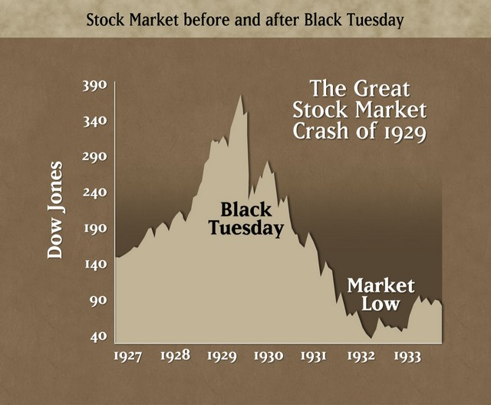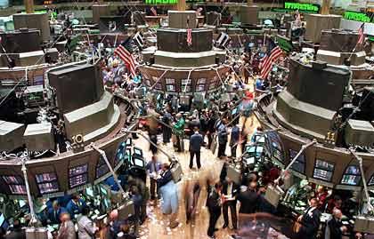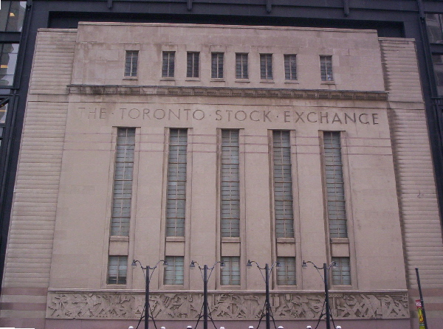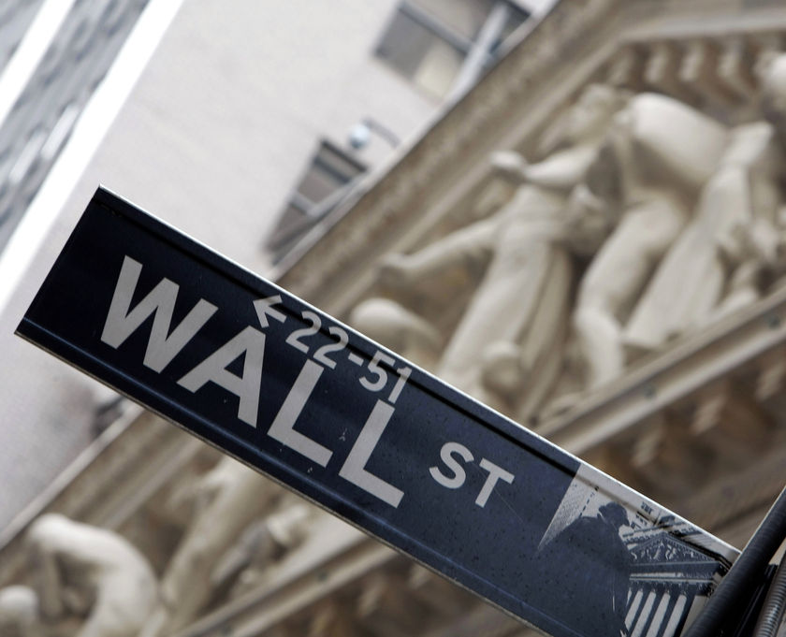

The expression ***'stock market'*** refers to the market that enables the trading of company stocks (collective shares), other securities, and derivatives. Bonds are still traditionally traded in an informal, over-the-counter market known as the bond market. Commodities are traded in commodities markets, and derivatives are traded in a variety of markets (but, like bonds, mostly 'over-the-counter'). Characteristic of commodities is that their prices are determined as a function of their market as a whole. Well-established physical commodities have actively traded spot and derivative markets. Generally, these are basic resources and agricultural products such as iron ore, crude oil, coal, ethanol, sugar, soybeans, aluminium, rice, wheat, gold and silver.

The size of the worldwide 'bond market' is estimated at $45 trillion. The size of the 'stock market' is estimated at about $51 trillion. The world derivatives market has been estimated at about $480 trillion 'face' or nominal value, 30 times the size of the U.S. economy…and 12 times the size of the entire world economy.

The stocks are listed and traded on stock exchanges which are entities (a corporation or mutual organization) specialized in the business of bringing buyers and sellers of stocks and securities together. The stock market in the United States includes the trading of all securities listed on the NYSE, the NASDAQ, the Amex, as well as on the many regional exchanges. European examples of stock exchanges include the Paris Bourse (now part of Euronext), the London Stock Exchange and the Deutsche Borse.

The largest exchange in Canada is the Toronto Stock Exchange (TSE or TSX). There are also regional exchanges like the Alberta Stock Exchange.

A ***bull market*** tends to be associated with increasing investor confidence, motivating investors to buy in anticipation of further capital gains. The longest and most famous bull market was in the 1990s when the U.S. and many other global financial markets grew at their fastest pace ever. The United States has been described as being in a long-term bull market since about 1983, with brief upsets including the Panic of 1987 and the NASDAQ crash of 2000-2002.

