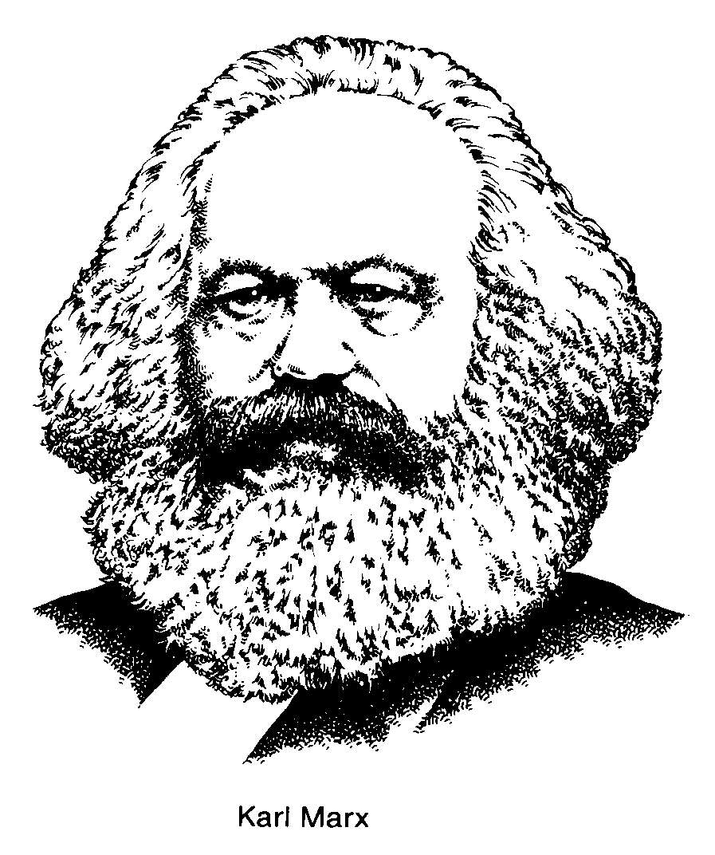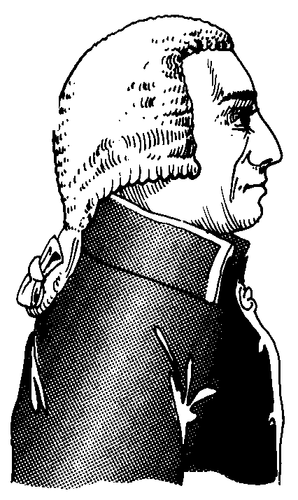

**The Power of the Invisible Hand**

Adam Smith saw himself as a philosopher but because of his interest in the operations and principles of the market he became known as an economist. Born in Scotland in 1723, Smith explained his economic theory in "The Wealth of Nations" (1776), the first work to establish economics as a separate science.

The central idea in his book is that if individuals are left to pursue their own economic interests without constraint, then everybody benefits. Except for limited functions (defence, justice, certain public works), he believed that government should keep out of the economic life of a nation.

That's not to say that Smith had a high opinion of merchants and businessmen. "People of the same trade," he wrote, "seldom meet together, even for merriment and diversion, but the conversation ends in a conspiracy against the public, or in some contrivance to raise prices."

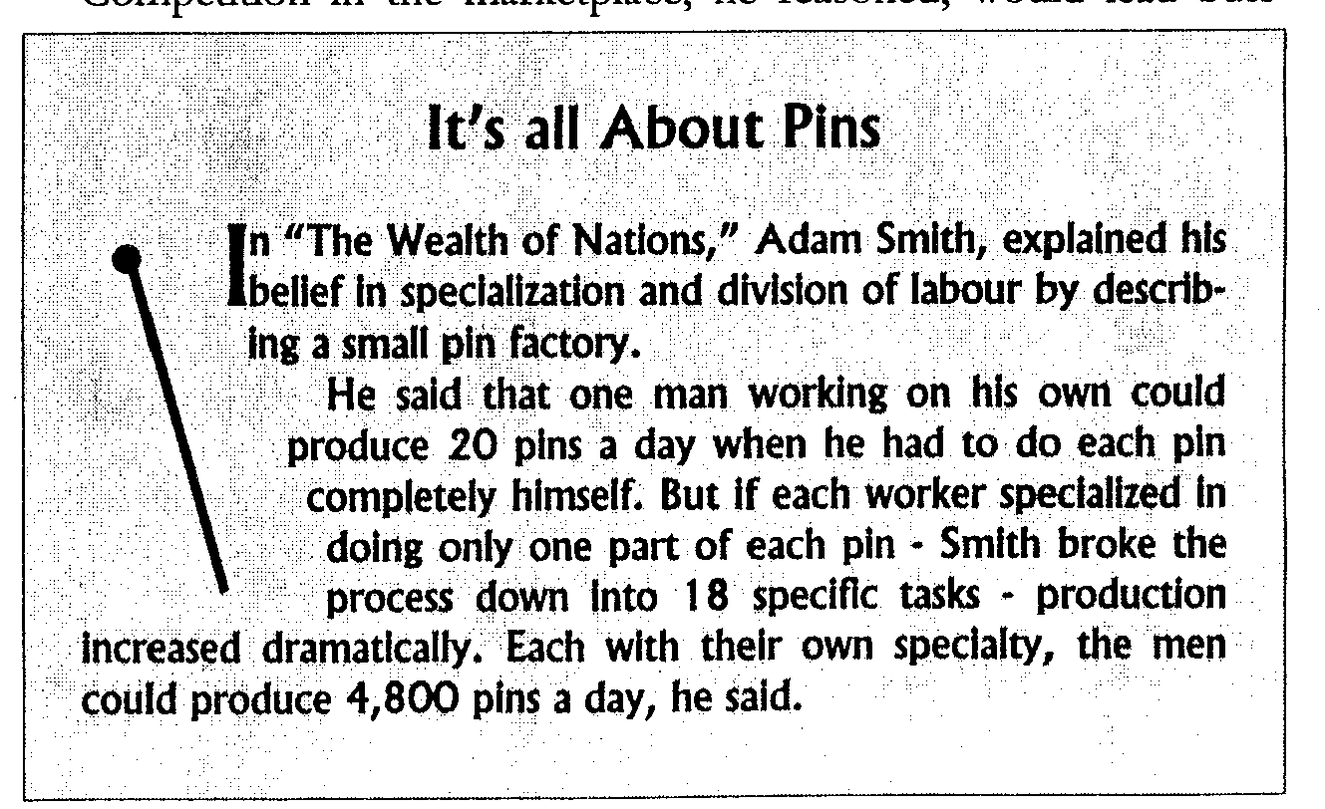

But he did think that businessmen seeking their own interest are led ''as if by an invisible hand" to promote the well-being of society. Therefore, any interference with free competition by government is almost certain to be negative. In fact, he said that all individuals, seeking the best for themselves, would provide the most for society.

Competition in the marketplace, he reasoned, would lead businessmen to supply the goods consumers want, to produce them efficiently, and to charge only what they are worth. That left monopoly, whether private or state-imposed, as an evil to be stamped out, and competition as society's benefactor. The resulting market economy based on supply and demand would respond freely to the balancing effect of price changes: a rise in price tends to increase the supply and reduce the demand, and vice versa. Trying to control prices could dampen market reactions and perpetuate a shortage of surplus, Smith said.

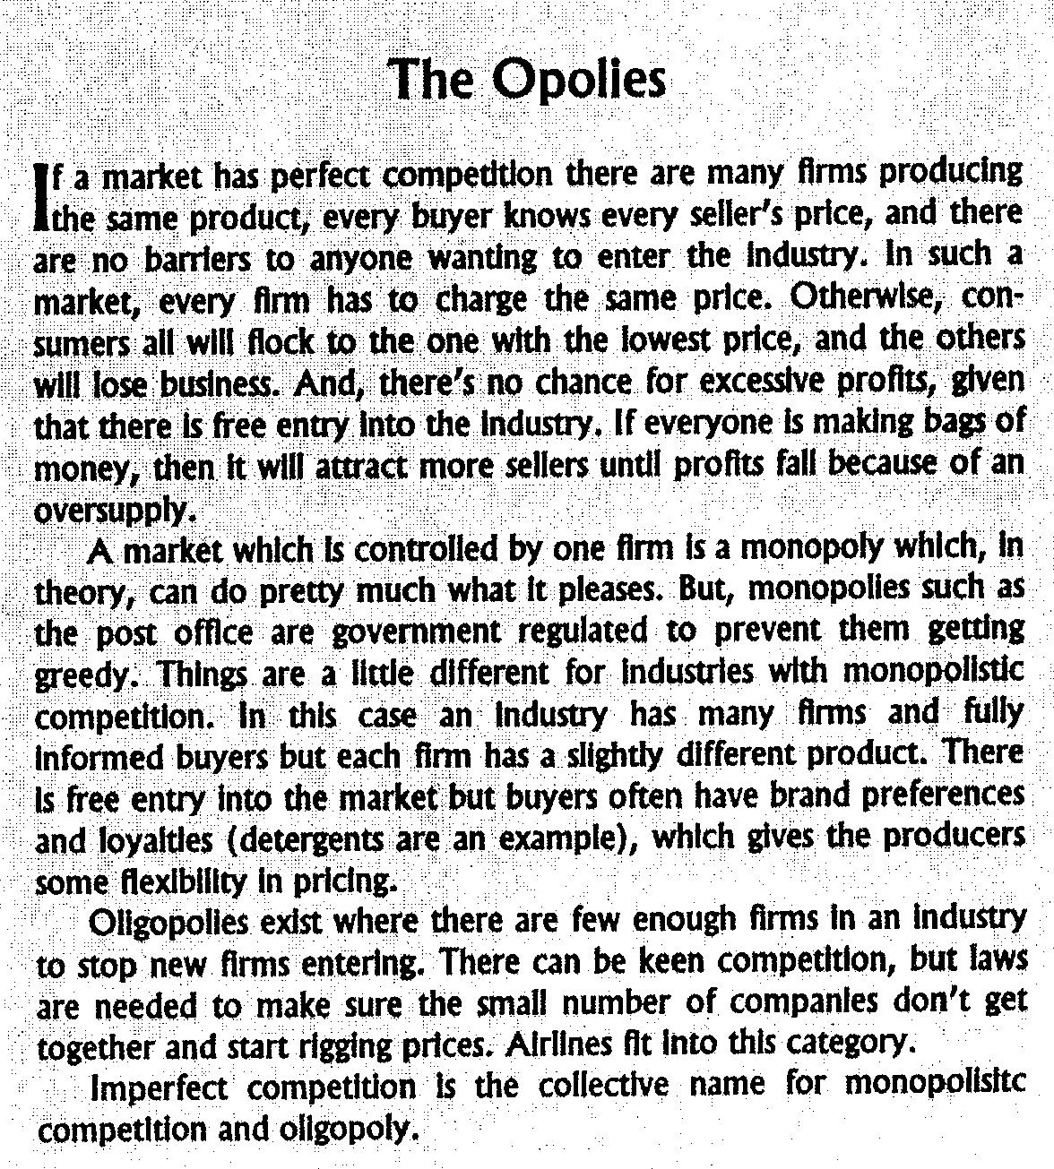

He further argued that economic growth, which depends upon capital accumulation and an increased division of labour (the efficiency of specialization in business and occupation), would be promoted best by private rather than public efforts. People would save and 'invest for the future because of a natural tendency to better their own condition.

Not surprisingly, Adam Smith was very much against mercantilism, which restricted international, trade in European countries during the 16th, 17th, and 18th centuries. Mercantilists believe that one country's gain is another's loss. So, boosting their own nation's wealth meant discouraging imports, through such measures as tariffs, and encouraging exports by having government subsidize local industries to dampen foreign competition.

Smith was all for free trade as a means of increasing the wealth of nations, believing that restrictions on trade diminished wealth.

Although Smith's ideas have been modified over time, many sections of "The Wealth of Nations," notably those relating to the sources of income (rent, wages, and profits) and the nature of capital, have continued to form the basis for theoretical study in the field of political economy. "The Wealth of Nations" has also served, perhaps more than any other single work in its field, as a guide to the formulation of governmental economic policies.

**Smith Distorted?**

Libertarians believe that individuals have the right to control virtually every aspect of their lives. They see little use for government and would be happiest if it did not exist. Many libertarians see Adam Smith as almost a patron saint for their beliefs. His writing is often used as the intellectual underpinning for complete market freedom. But David C. Korten, in his 1995 book "When Corporations Rule the World" says libertarians distort what Adam Smith really meant:

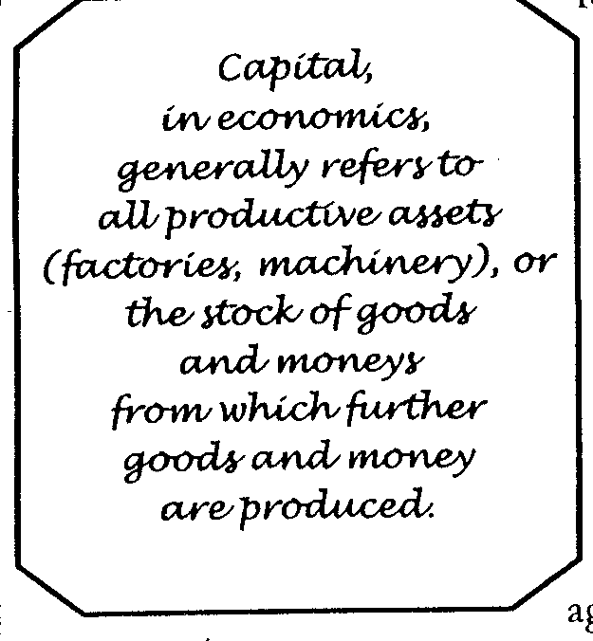

"Adam Smith's ideal was a market comprised solely of small buyers and sellers. He showed how the workings of such a market would tend toward a price that provides a fair return on land, labour, and capital, produce a satisfactory outcome for both buyers and sellers, and result in an optimal outcome for society in terms of the allocation of its resources. He made clear, however, that this outcome can result only when no buyer or seller is sufficiently large to influence the market price - a point many who invoke his name prefer not to mention. Such a market implicitly assumes a significant degree of equality in the distribution of economic power - another widely neglected point.

"Indeed, Smith was almost fanatical in his opposition to any kind of monopoly power, which he defined as the power of a seller to maintain a price for an indefinite time above its natural price. Indeed, he asserted that trade secrets confer a monopoly advantage and are contrary to the principles of a free market.

"He would surely have strongly opposed current efforts by market libertarians to strengthen corporate monopoly control of intellectual property rights through the World Trade Organization. The idea that a major corporation might have exclusive control over a life-saving drug or device and thereby be able to charge whatever the market will bear would have been anathema to him.

"Furthermore, Smith did not advocate a market system based on unrestrained greed; He was talking about small farmers and artisans trying to get the best price for their products to provide for them- selves and their families. That is self-interest - but it is not greed. Greed is a high paid corporate executive firing 10,000 employees and then rewarding himself with a multi-million dollar bonus for- having saved the company so much money. Greed is what the economic system being constructed by the corporate libertarians encourages and rewards.

"Smith had a strong dislike for both governments and corporations.. He viewed governments primarily as instruments for extracting taxes to subsidize elites and for intervening in the market to protect monopoly. In his words, 'civil government, so far as it is instituted for the security of property, is in reality instituted for the defence of the rich against the poor, or of those who have some property against those who have none at all.'

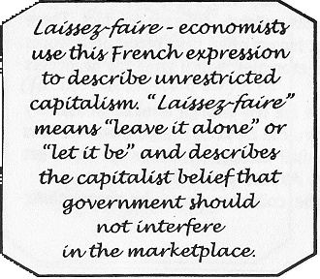

"Smith made no mention of government intervention to set and enforce minimum social, health, worker safety, and environmental standards in the common interest to protect the poor against the rich."

# Let it Be

David Ricardo (1772-1823), was a British economist, born in London. He left school at the age of 14 to join a brokerage house; by his mid-20s he had amassed a fortune on the stock market. His interest in economics arose in 1799 when he happened to read Adam Smith's "Wealth of Nations."

Eventually, as a leader of the British classical school of economists, he systemized the economic theory of his day and strongly influenced its subsequent development. Like Adam Smith before him, Ricardo believed in limiting state intervention in economic life. He supported the classical theory of international trade, emphasizing national specialization and freedom of competition. His early publication, "An Essay on the Influence of a Low Price of Corn on the Profits of Stock" (1815), argued against high tariffs on grain imports. His theory of comparative advantage showed how the free flow of commodities among nations could be of mutual benefit to all parties.

His *laissez faire* doctrines were also influenced by his friend Thomas Malthus as seen in Ricardo’s *Iron Law of Wages*, which stated that all attempts to improve the real income of workers were futile. He reasoned, along the same lines as Malthus, that a continuing increase in population would create so much competition for work and for food that subsistence was the best workers could hope for any attempt by government or trade unions to raise wages and rescue people from poverty would only increase their numbers and put them back at square one again. It was the fate of the starving masses to make the rich richer. What could one do?

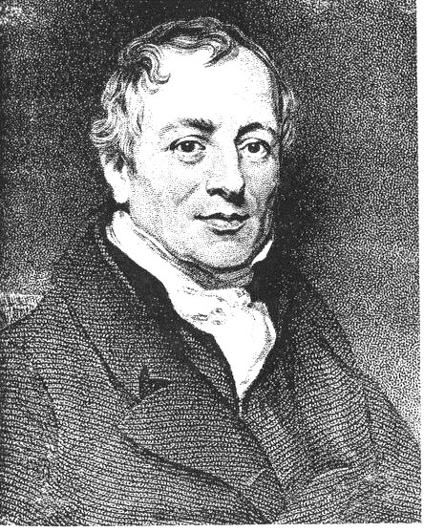

In his first work on economic theory, "The High Price of Bullion, a Proof of the Depreciation of Bank Notes" (1809), he argued for a sound currency based on metal. In his major work, "Principles of Political Economy and Taxation" (1817), Ricardo offered several theories based on his studies of the long-range distribution of wealth. Writers of various persuasions drew heavily upon his ideas, including those who favoured *laissez faire* capitalism and those, such as Karl Marx and Robert Owen, who opposed it.

### David Ricardo

# Nineteenth Century Marvel

John Stuart Mill (1806-1873) is seen as the most influential British social and political thinker of the mid-Victorian period. An English philosopher and political economist, he was a brilliant child who started to learn Greek at the age of three and Latin at eight. His father, radical reformer James Mill, also taught him economics, history, philosophy, and natural science.

In 1844, he published the "Essays on Some Unsettled Questions of Political Economy," which he had written several years earlier. The essays deal with solutions to various problems, including the distribution of the gains of international commerce, the influence of consumption on production, the definition of productive and unproductive labour, and the precise relations between profits and wages.

He wrote his "Principles of Political Economy" in 1848. At about the same time, Mill started to take more interest in Socialist writers. He was convinced that the social question was as important as the political question. He separated questions of production and distribution and wasn't comfortable with the idea that the labouring classes should be condemned to a cramped and wretched existence, in many cases to starvation. He did not come to a Socialist solution, but he is credited with raising questions about the foundations of society. Mill is often considered a founder of modern (reform) liberalism.

# Attack on Capitalism

Karl Marx (1818-1883) was a German political philosopher and revolutionary. With Friedrich Engels, he co-founded scientific socialism (modern communism) and, as such, was one of the most influential thinkers of all times.

Marx was born in the city of Trier in the Rhine province of Prussia, now in Germany, He was the oldest surviving boy of nine children. Both parents were Jewish and were descended from a long line of rabbis, but, a year or so before Karl was born, his father, Heinrich - probably because his professional career as a lawyer required it - was baptized in the Evangelical Established Church. Karl was baptized when he was six years old. As a youth, Karl was influenced less by religion than by the critical, sometimes radical social policies of the Enlightenment, His Jewish background exposed him to prejudice and discrimination that may have led him to question the role of religion in society and contributed to his desire for social change.

In "The Communist Manifesto", published in 1848, Karl Marx and Friedrich Engels wrote that in less than a century the capitalist system had created "more massive and more colossal productive forces than have all preceding generations together." They also wrote that it was "like the sorcerer, who is no longer able to control the powers of the nether world whom he has called up by his spells.”

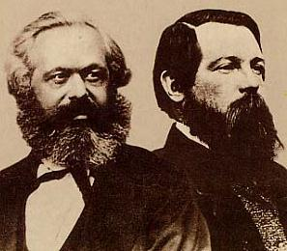

The Manifesto was the first systematic statement of modern socialist doctrine. It says it is the economic system that decides what form of social organization will dominate; and that the history of society is a history of struggles between the exploiting and exploited, that is, between ruling and op- pressed social classes. Marx concluded in the Manifesto that the capitalist class would be overthrown and that it would be eliminated by a world-wide working-class revolution and replaced by a classless society. The Manifesto influenced all subsequent communist literature and revolutionary thought generally; it has been translated into many languages and published.

### Karl Marx and Friedrich Engels

## Marx went to live in England in 1849 after being expelled from Germany and France for revolutionary actiyities. There, he devoted: himself to study and writing, and to efforts to build an international communist movement. During this period he wrote, a number of works that, are regarded as classics of communist theory. These include his greatest work, "Das Kapital”, a systematic and historical analysis of the economy of the capitalist system of society, in which he developed the theory that the capitalist class exploits the working class by appropriating the “surplus value” produced by the working class.

Marx's influence during his life was not great. After his death it increased with the growth of the labour movement. Marx’s ideas and theories came to be known as Marxism, or scientific socialism, which constitutes one of the principal currents of contemporary political thought.

When the Russian Revolution of 1919 brought communists to power, it looked as though Marx's theories were going to get a practical workout. But, the leaders of the revolution and those who followed quickly corrupted Marxism beyond recognition. The experiment in social and economic equality became another system for oppressing the masses and maintaining a privileged group in power.

# Pitfalls of Private Property

Marx's colleague Friedrich Engels (1820-95), also was a German revolutionary political economist. Like Marx, Engels was a member of the upper middle class. His family were textile manufacturers in the Ruhr and, much wealthier than the Marx family. Engels spent most of his life in England, in Manchester, where he combined revolutionary thought with the supervision of thelocal branch of the family firm.

In a Manchester, England textile firm between 1842 and 1844, Engels came into contact with *Chartism*, the movement for extension of suffrage (the vote) to workers. He wrote and studied political economy, and came to the conclusion that politics and history could be explained in the terms of the economic development of society. He believed that the social evils of the time were the inevitable result of the institution of private property and could be eliminated only through a class struggle ending in a communist society. His historical study, "Condition of the Working Class in England" (1844), established his reputation as a revolutionary political economist.

In Paris, in 1844, Engels visited Marx, who had published works sympathetic to communism. The two men found that they had arrived independently at identical views and worked together until the death of Marx in 1883. Their aims were to explain communist principles, later known as Marxism, and to organize an international communist movement.

"The Communist Manifesto," is regarded as a classic explanation of modern communist views. It was written by Marx, party on the basis of a draft prepared by Engels. Engels made what is considered his greatest single contribution to Marxism after the death of Marx by editing, from rough drafts and notes, the second and third volumes of Marx's "Das Kapital."

#### Social Darwinism

#### 

Herbert Spencer (1820-1903), British social philosopher, is often regarded as one of the first sociologists. Born in Derby, England, Spencer was mainly self-educated. After Charles Darwin published "On the Origin of Species" in 1859, Spencer took hold of Darwin's theory of natural selection and applied it to society as well as evolution. Spencer's ideas became known as ‘Social Darwinism’.

The theory of natural selection holds that only the most well-adapted individuals in a population will survive and reproduce. These successful individuals pass on their adaptive advantage to their offspring. Over many generations, the process ensures the adaptation of the entire population to its environment. This holds true in the jungle, but it was Spencer who coined the phrase "survival of the fittest" to describe the competition among human individuals and groups. He argued that human progress resulted from the triumph of more advanced individuals and cultures over their inferior competitors. Wealth and power were seen as signs of inherent "fitness," while poverty was taken as evidence of natural inferiority. In the late 19th and early 20th centuries, Social Darwinism was used to argue for unrestrained economic competition and against aid to the "unfit" poor. The theory was also used to justify racist and imperialist policies in Europe and the United States.

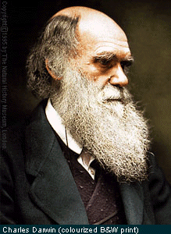

Social Darwinist ideas fell from grace in the early 20th century; Herbert Spencer's reputation as a philosopher and social theorist went with it. We can hear echoes of this philosophy today among right-wing conservatives. They stress the importance of what are called traditional family values. They call for reductions In government funded social programs that aid the poor so as to reduce the taxation burden on the middle class.

### Charles Darwin