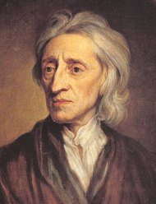

John Locke (29 August 1632 – 28 October 1704), widely known as the Father of Liberalism, was an English philosopher and physician regarded as one of the most influential of Enlightenment thinkers. Considered the first of the British empiricists, he is equally important to social contract theory. His writings influenced Voltaire and Rousseau, many Scottish Enlightenment thinkers, as well as the American revolutionaries. In fact, several passages from the Second Treatise are reproduced verbatim in the Declaration of Independence, most notably the reference to a "long train of abuses." Such was Locke's influence that Thomas Jefferson wrote: "Bacon, Locke and Newton ... I consider them as the three greatest men that have ever lived, without any exception, and as having laid the foundation of those superstructures which have been raised in the Physical and Moral sciences".

Locke exercised a profound influence on political philosophy, in particular on liberalism. Locke, believing in the relative ‘goodness’ of human nature, launched liberalism by tempering Hobbesian absolutism and clearly separating the realms of Church and State. He had a strong influence on Voltaire who called him "le sage Locke". He ardently promoted individual liberty and the social contract. Social contract describes a broad class of theories that try to explain the ways in which people form states to maintain social order. The notion of the social contract implies that the people give up sovereignty to a government or other authority in order to receive or maintain social order through the rule of law. It can also be thought of as an agreement by the governed on a set of rules by which they are governed. Today, most contemporary libertarians claim Locke as an influence. Locke's Essay Concerning Human Understanding (1690) marks the beginning of the modern Western conception of the self.

Political Theory
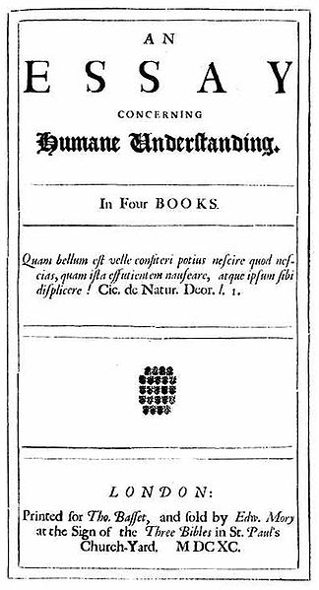
Locke's political theory was founded on social contract theory. Unlike Thomas Hobbes, Locke believed that human nature is characterized by reason and tolerance. Like Hobbes, Locke believed that human nature allowed men to be selfish. This is apparent with the introduction of currency. In a natural state all people were equal and independent, and everyone had a natural right to defend his “Life, health, Liberty, or Possessions", basis for the phrase in America; "Life, liberty, and the pursuit of happiness".

Like Hobbes, Locke assumed that the sole right to defend in the state of nature was not enough, so people established a civil society to resolve conflicts in a civil way with help from government in a state of society. However, Locke never refers to Hobbes by name and may instead have been responding to other writers of the day. Locke also advocated governmental separation of powers and believed that revolution is not only a right but an obligation in some circumstances. These ideas would come to have profound influence on the Constitution of the United States and its Declaration of Independence.

An Essay Concerning Human Understanding is one of John Locke's two most famous works, the other being his Second Treatise on Civil Government. First appearing in 1690, the essay concerns the foundation of human knowledge and understanding. He describes the mind at birth as a blank slate (tabula rasa, although he did not use those actual words) filled later through experience. The essay was one of the principal sources of empiricism in modern philosophy, and influenced many enlightenment philosophers.

Source: www.wikipedia.org

