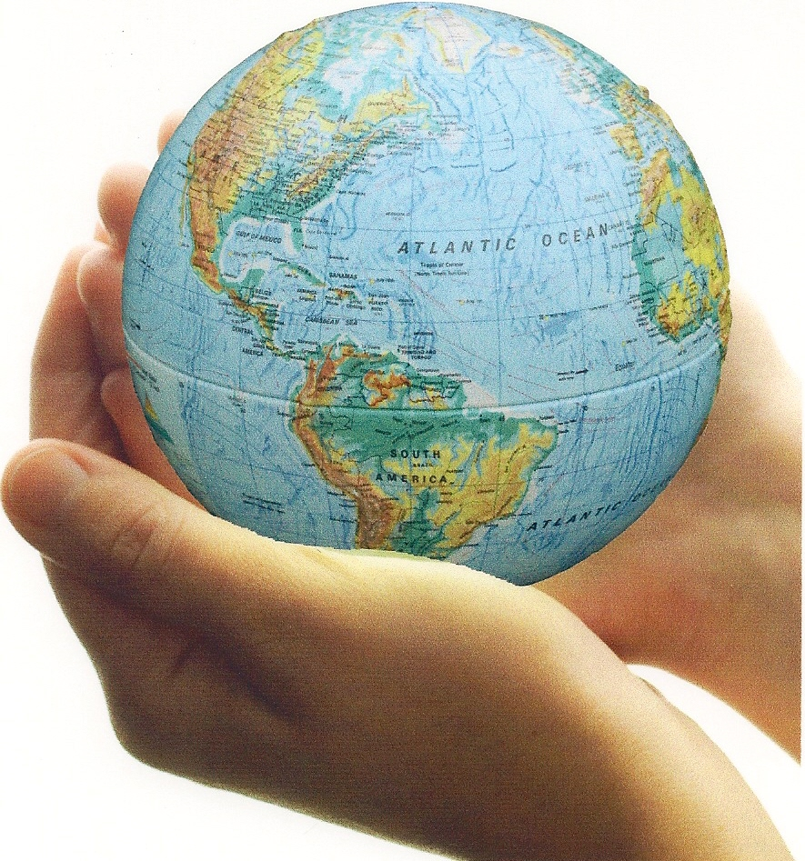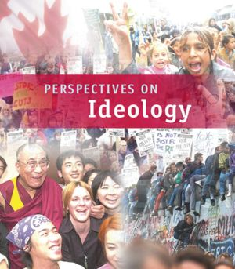

**RELATED ISSUE 2: CHAPTER 4**

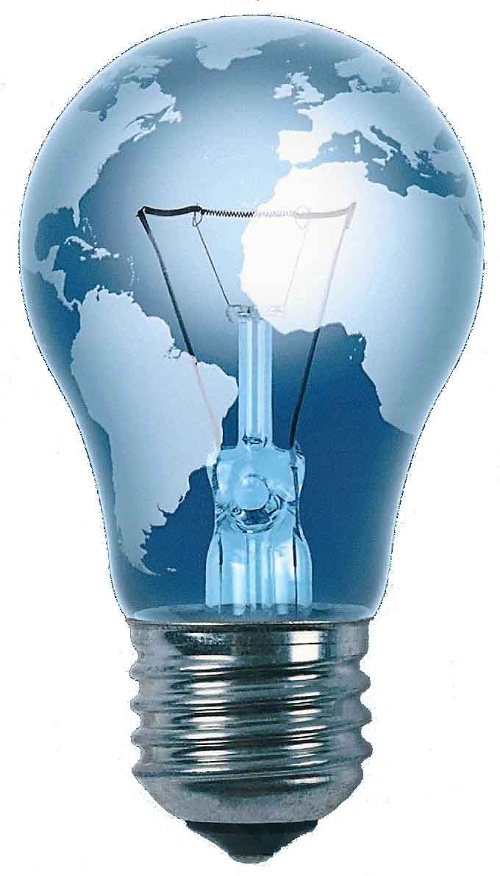

***WHERE* ARE WE GOING**

By the end of this chapter you will have to respond to the questions for inquiry listed below and demonstrate a contextual understanding of the vocabulary, concepts, people and events listed.

**Chapter Issue**:

To what extent did classical liberalism

meet the needs of society?

Utopians

Chartists

socialism

CCF

Luddites

universal suffrage

Edmund Burke

communism

feminism

Great Depression

John Maynard Keynes

human rights

labour standards

Marxism

command economy

labour unions

welfare capitalism

progressivism

Mary Wollstonecraft

classical conservatism



Use the visuals on the following page to explain some of the critiques of

***classical liberalism*** in the 18th and 19th century.

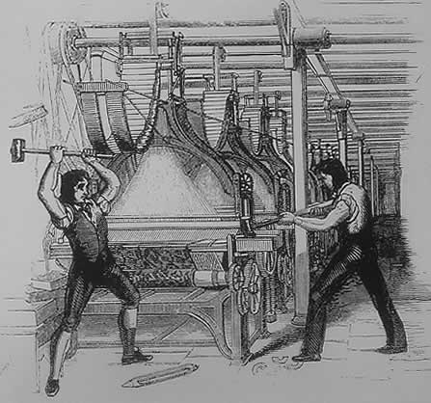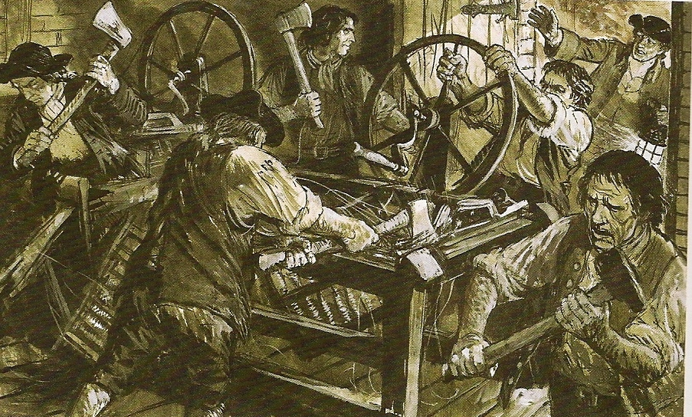

If you attended the meeting below (look at both visuals at the bottom of the page)

what were you likely to hear?

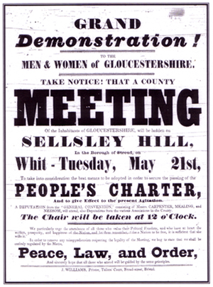

*Chartist meeting*

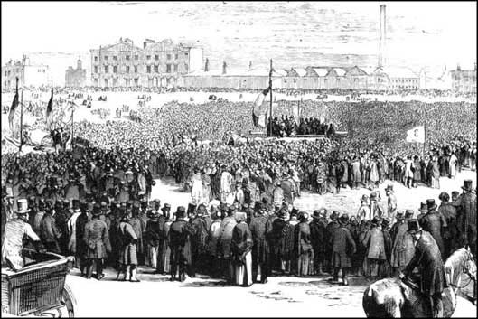

*Source:* [www.bbc.co.uk/.../04/beat_selsley_feature.shtml](http://www.bbc.co.uk/gloucestershire/content/articles/2006/09/04/beat_selsley_feature.shtml)

The term socialism has been used a lot in the media lately. What does the



term ***socialism*** mean?

Barack Obama has been accused of being a ***socialist*** by his political opponents.

Would consider this accusation accurate? Use examples to support your answer.

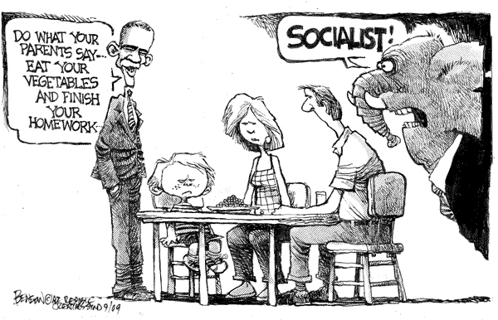

Read the quote from Robert Owen on page 135. Explain the personal and

historical context of the quote.

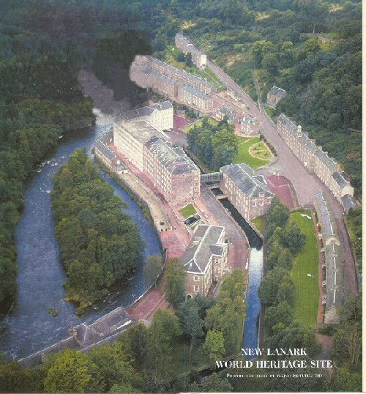

*The Socialist Brain of a Liberal Democrat* diagram below represents a modern conservative (classical liberal) perspective of modern socialist liberal democrats – it is meant to be a fun critique.

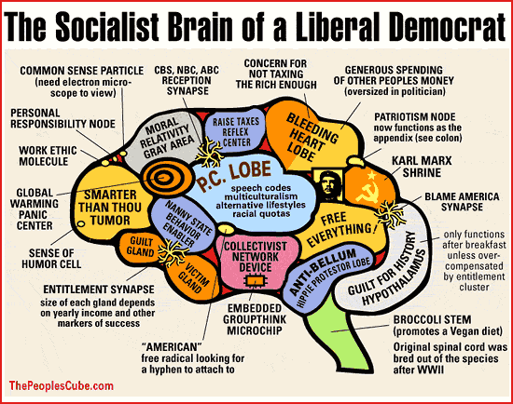

Your task is to flip this and create a similar diagram but from a modern socialist liberal democratic perspective making fun of a modern conservative (classical liberal) perspective.

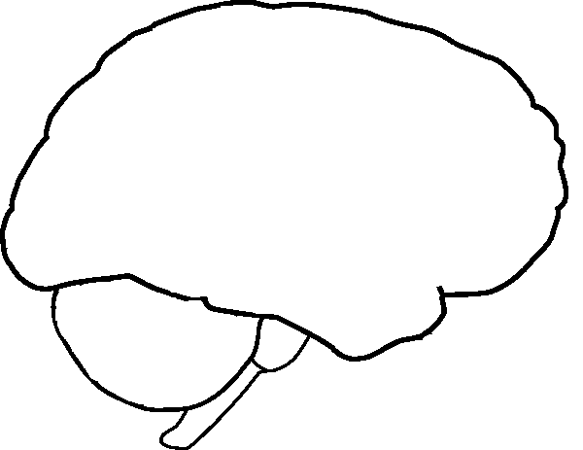

Use the following diagram and the information on pages 136-139 to explain ***Marxism.***

Diagram ***Marx’s Theory of the Decline of Capitalism****.*

**proletariat overthrow the** **bourgeoisie**

**Pure communism (classless society)**

# Dictatorship of the proletariat

**Spontaneous revolution**

**Breakdown of social and political order**

* **Bourgeoisie makes fewer profits**
* **Wealth accumulates in fewer hand**
* **Proletariat becomes poorer**
* **More unemployment**
* **Development of class consciousness**

**Some bourgeoisie accumulate great wealth**

**Economic competition leads to fewer firms**

* **Capitalist crisis**
* **Business cycle (from boom to bust) become increasingly severe**
* **Imperialistic view**

**Proletariat becomes poorer, buys fewer goods**

**Economic competition causes a decline in wages**

**Bourgeoisie exploits proletariat and lesser bourgeoisie**

**Capitalism: Creation of bourgeoisie and proletariat**

**decline/overthrow**

**Feudalism**

Why is this stage critical in Soviet history?

Most experiments in ‘communism’ have never moved past this stage ie. Soviet Union, China, Cuba, North Korea

**Bourgeoisie: *Marx’s term to describe the owners of production.***

**Proletariat: *Marx’s term to describe the working class.***

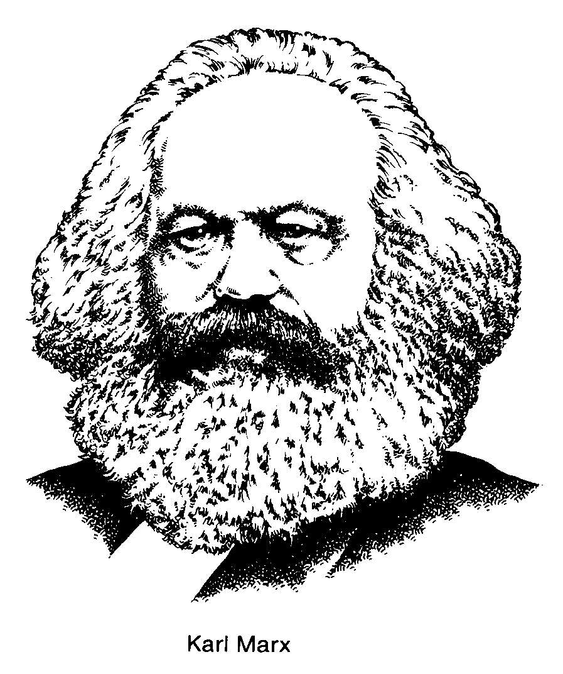

***Marxism*** is… (use the five ‘W’ approach)



Based on your understanding of ***Marxism***, critique the following cartoon:

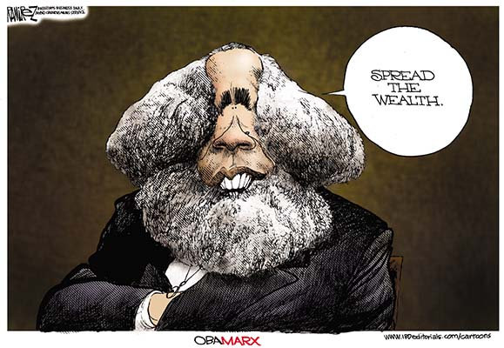

Explain the following source in the

*A call goes out to Canada*

*It comes from out the soil—*

*Come and join the ranks through all the land*

*To fight for those who toil*

*Come on farmer, soldier, labourer,*

*From the mine and factory,*

*And side by side we'll swell the tide—*

*C.C.F. to Victory!!*

context of Canadian history.



“Classical liberals slowly start to recognize the merit of many of their opponents’ views and modified the practical applications of some of their values and beliefs.”



If you were as a classical conservative in the 18th and 19th century

what would your core beliefs be?

One of the most famous classical conservatives, Edmund Burke (1729-1797), *“…believed that uninformed people should not have a say in government; government should be left to those who naturally understood their duties to the country and the people, those with experience and wisdom.”* p.141

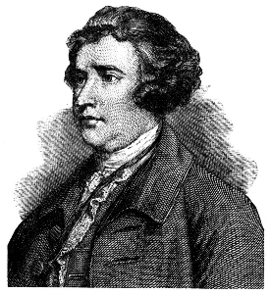

To what extent do you agree with Burke? Should there be a voter competency test people in Canada should have to pass before they can vote? Explain your answer.

Edmund Burke (1729-1797)

“Classical liberals slowly start to recognize the merit of many of their opponents’ views and modified the practical applications of some of their values and beliefs.”



Explain the quote in the context of the following terms:

***Welfare capitalism:***

***Progressivism:***

***Great depression and the welfare state:***

Create a graph or a visual to explain ***Keynesian economic theory*** as a response to the great depression and the extremes of the business cycle (see pages 147 and 149).

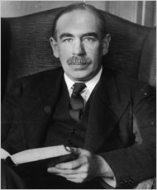

Briefly explain the purpose of a ***union*** (***labour union***).

In general, what do you think the perspective of the following people would be about ***unions***?

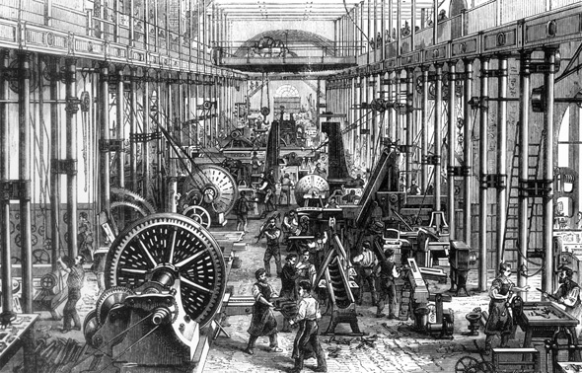

*18th century factory worker in England:*

*18th century factory owner:*



*21st century Wal-Mart CEO:*

*21st century Wal-Mart employee:*

When you look at the timeline of Canada’s path towards ***universal suffrage***, what elements of the timeline surprise you the most? Please provide a clear rationale for your choices.



Complete the following mind map by adding details form the textbook.

Add notes to the branches on the map.

**Feminist Ideology**

Mary Wollstonecraft

Roots of Feminism

“separate spheres”

Suffragists

Arrange the following terms on the spectrum below:

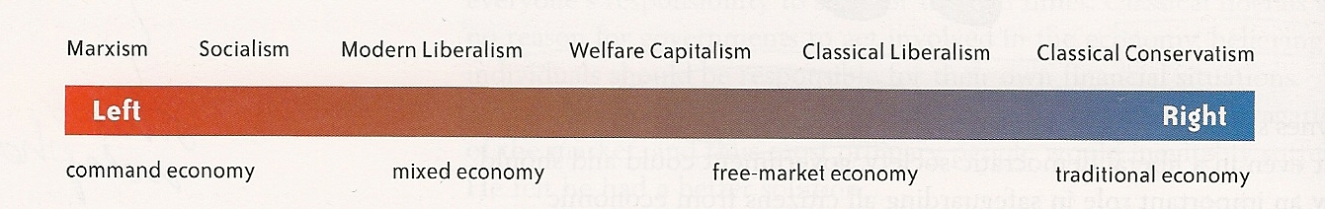

**classical liberalism, socialism, Marxism, classical conservatism, modern liberalism, welfare capitalism**

**mixed economy, traditional economy, free-market economy, command economy**