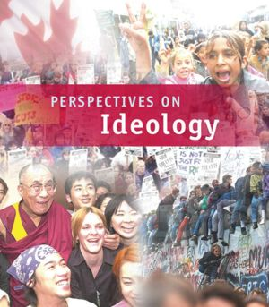

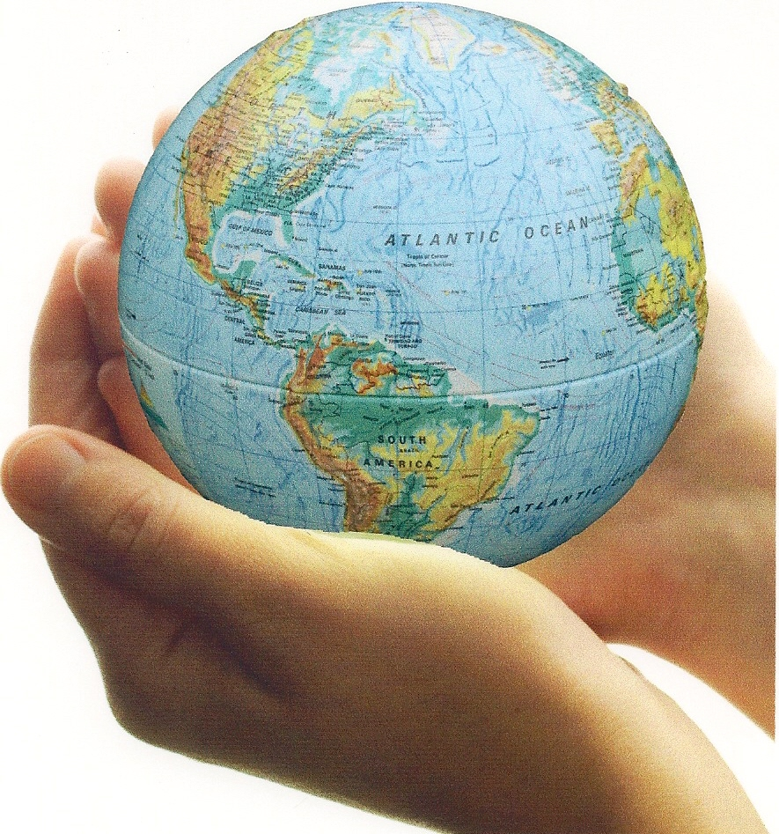

**RELATED ISSUE 2: CHAPTER 5**



***WHERE* ARE WE GOING**

By the end of this chapter you will have to respond to the questions for inquiry listed below and demonstrate a contextual understanding of the vocabulary, concepts, people and events listed.

**Chapter Issue**:

To what extent is the rejection of liberalism justified?

Hitler

Youth

propaganda

censorship

fascism

Treaty of Versailles

communism

scapegoat

Stalin

Lenin

radical

dissent

reactionary

Adolf Hitler

Czar (Tsar)

Nazism

proletariat

collectivization

totalitarianism

authoritarianism

hyperinflation

Great Purge



Throughout the twentieth century there have been many regimes clearly

rejecting the principles of liberalsim you have learned about up to this point

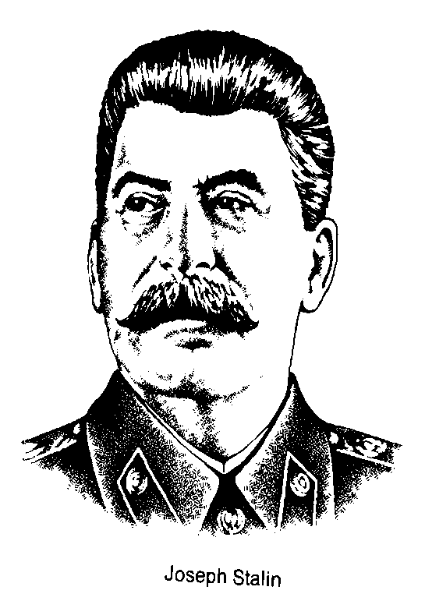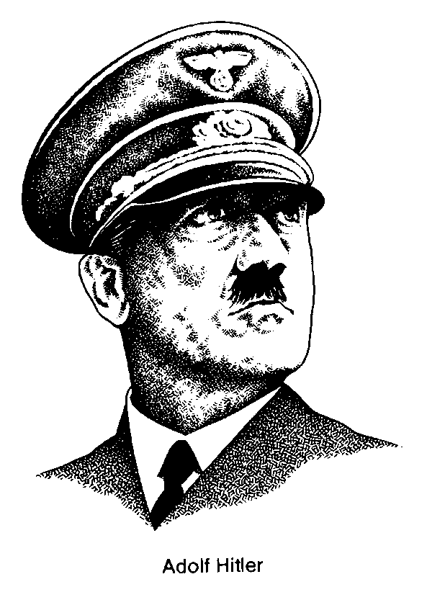in the course. Your main task is to evaluate two of these regimes:

Stalin’s communist Soviet Union

Adolf Hitler’s fascist Nazi Germany

You will need to know the following about each regime:

* the pre-conditions that allowed the regimes to come to power
* a brief biography of the dictator
* the rise to power, including how power was taken
* the placement of each system on the political and economic spectrum
* the illiberal practices of the regime while in power (techniques of dictatorship)

You will have a variety of sources of information to help with your work:

* textbook
* resources posted in Moodle
* video segments from class
* LCI library (we have a number of excellent books on the topics)
* internet

After building an understanding of these regimes you will answer the following question:

***Which regime, Adolf Hitler’s fascist Nazi Germany or***

***Stalin’s communist Soviet Union, was the most illiberal?***

Your response…(you must use specific support for your response)

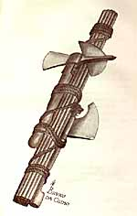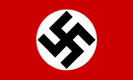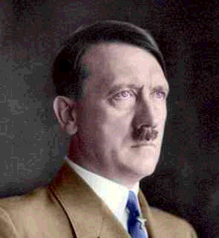

posters, bill boards of Hitler everywhere

- re-write history

*Gleischaltung* – Nazi organiztions throughout society

‘Hitler Youth’

control of all media

rallies at Nuremburg

## Joseph Geobbels

Minister of Propaganda and Public Enlightenment

Mussolini in Italy

(fascis)

charismatic leader -

anti-communist

-Social Darwinism

expansion – reclamation of lost territory

*Rhineland*

*Sudetanland*

*Polish Corridor*

‘Lebensraum’ – living space

Militarism –

re-armament

*Wehrmacht*

*Kriegsmarine*

*Luftwaffe*

Ghettos, Concentration, Work, and Death camps

*Dachau*

*Auschwitz*

*Buchenwald*

Kristallnacht – ‘night of the broken glass’

Nuremburg Race Laws

‘Final Solution’ - holocaust

Pure German – eliminate all ‘undesirables’

Anti-semitic – hatred of Jews

Anti-communist

- blame communists for the Reichstag fire

Racism – pure German Aryan race

#### Ultranationalism

Hitler’s vision of a

‘Third Reich’

‘Night of the Long Knives’

extensive network of ***Secret Police*** in all parts of society

*Gestapo, SS, SA,*

eliminates all political opponents – political parties, unions

Hindenburg dies –

the ‘Fuhrer’

Weimar Republic

economic depression – hyperinflation , 1923

Enabling Act

Emergency Decrees

Reichstag Fire

National Socialist German Workers Party - NAZI

1933 elections, Nazi success, Chancellor

*Mein Kampf*

resentment of

*Treaty of Versailles*

- *lost territory*

*- lost Germans*

*- reparations*

*- hurt German pride*

failed Munich

(‘Beer Hall’) *putsch*

WWI Soldier – medals of honor

### INDOCTRINATION

### SCAPEGOATING

### PROPAGANDA

### FEAR and TERROR

**TECHNIQUES of DICTATORSHIP**

**RISE to POWER**

# FASCISM

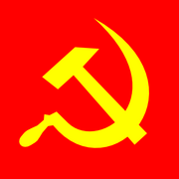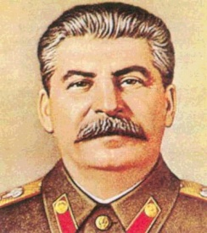

*Gulags* – slave labor of his own people

glorification of workers (industrial and agrarian – ‘hammer’ and ‘sickle’ – statues, posters, bill boards - *Stakhanovites*

Banned religion

statues, posters, bill boards of Stalin everywhere

education became a priority to train workers and citizens

- re-write history

‘Cult of Personality’ built around Stalin as a father figure

Extensive network of ***Secret Police*** in all parts of society

*Cheka* under Lenin

*NKVD* under Stalin

*KGB* in modern times

Regular elections – only hand-picked Communist Party members on the ballot – elected parliament called the Duma with no real power – not showing up raised suspicions with secret police

1936 Constitution,

Democratic on paper – not followed in practice

## Show Trials

Illusion of a fair judicial process

*Purges*

*‘Great Terror’*

Work camps or *Gulags* for political prisoners - *dissidents*

Industrialization main priority

De-Kulakization and the *great famine* in the Ukraine result from shortage of grain. - grain given to workers and/or sold

Collectivization of agriculture – land seized for large state and collective farms

*Five Year Plans* – Central Planning Committee (GOSPLAN)

eliminates all political enemies

based in theory on the ideas of egalitarianism or equality

based on theories of Marx and Engels – *Communist Manifesto*

Centralization of power – central planning of production. *Totalitarianism* – total economic and political control

Lenin leads the Russian Revolution in 1917. Stalin replaces him as leader in 1928. Beats out Leon Trotsky as main leadership rival.

Stalin is editor of *Pravda,* communist paper – not important player in revolution

Bolshevik Revolution, 1917,

end of Tsarism - Civil War – ‘War Communism’ – New Economic Policy (NEP)

### INDOCTRINATION

CONTROLLED PARTICIPATION

### PROPAGANDA

### FEAR and TERROR

**TECHNIQUES of DICTATORSHIP**

**RISE to POWER**

# COMMUNISM

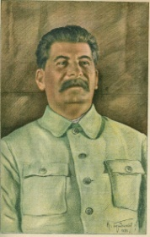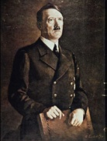

*In the sixteenth century,* ***Niccolo Machiavelli*** *wrote a book based on the activities of the rulers of the small city-states of Italy. The Prince detailed the methods and strategies which an ambitious ruler might use to maintain and increase his power.*

*Machiavelli wrote that, in his day, for a ruler, to display a tendency toward goodness of character was a handicap. The problem was that other people were not good. Therefore a Prince should not seek to be good. In fact, a ruler was well advised to concentrate on war and a state of readiness in his military forces. Machiavelli suggested that military power allowed princes to maintain their station, and it also allowed for lower class persons to become rulers.*

*Machiavelli had views on the question of whether it is better to be loved or to be feared. His idea was that if a choice had to be made, it was more valuable to be feared because it is safer to be feared than to be loved.*

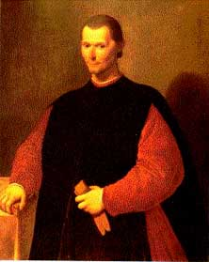*He noted that a Prince's reputation is increased when he acts in good faith, acts with integrity and avoids deceit. Yet, he did not advise this. His experience was that princes who achieved great things were not particularly concerned about good faith and were prone to the use of cunning to gain their ends. Such leaders generally won out over those who were guided by good faith and loyalty.*

*Therefore, he said that a wise ruler should not be bound by promises when it is against his interest to honor them, and when the reasons behind his promises no longer exist. This is because other men are generally bad and will not keep their word when their interests are threatened.*

*He thought that a ruler should seek to be good if at all possible, but the ruler should have the flexibility of mind to embrace evil when necessary.*

The following are the ***major characteristics (techniques) of dictatorships:***

# Propaganda

All forms of media communication are controlled by the government. News of the outside world and news of national concern is censored, altered, and presented to the people so that it best serves the interests of the government. In endless variation, the government bombards the people with its view of the world. Its view is the only view. Its view becomes the truth. Propaganda is one-sided information.

There are countless examples of propaganda used by dictators, past and present. Control of information and the media is critical to conveying one-sided information to the population under a dictator’s control. Hitler had a minister of *Public Enlightenment and Propaganda* (Joseph Goebbels) who controlled all information people in Nazi Germany heard and viewed, as well as organize massive Nazi rallies to play on people’s sense of nationalism. Stalin went so far as to re-write history books and alter historical photographs in order to make it appear that he had a more prominent role in Soviet communism.

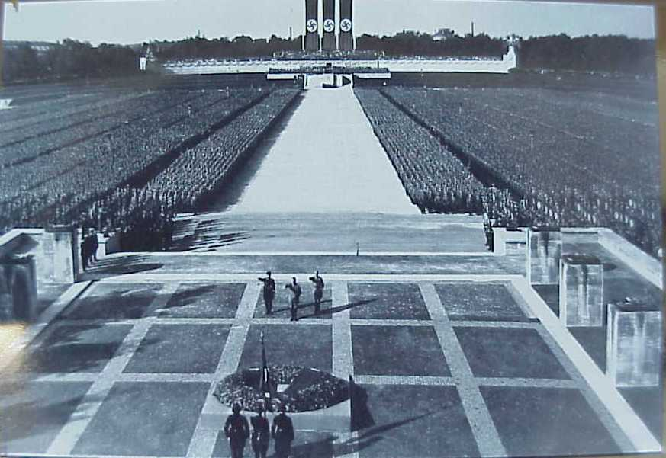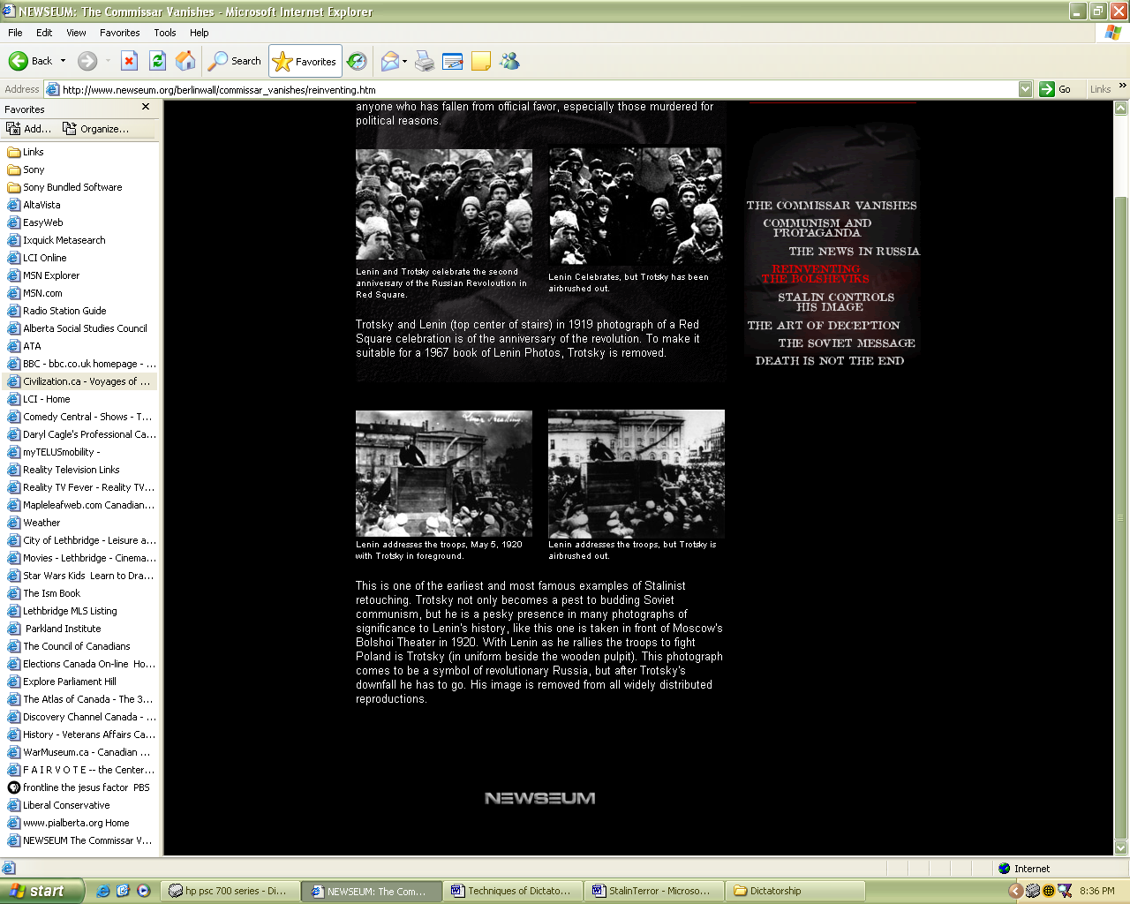

# Indoctrination (‘brainwashing’)

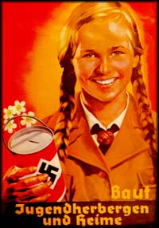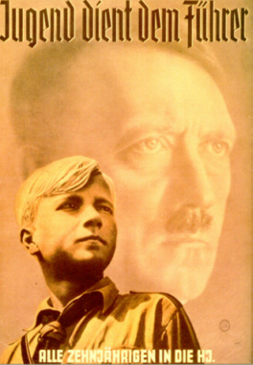

Indoctrination takes the place of education. Citizens, and particularly the youth, are not given alternatives or choices as to what to believe in. They are subject to a systematic presentation of information designed to strengthen their support of the government. Schools and universities serve the interests of the government. Success is not measured in terms of original, or creative thinking, but rather in conformity.

Stalin and Hitler both targeted the youth in their societies as far as ‘brainwashing’ them to conform to the leader’s ideology. Adults who would not conform were eliminated or imprisoned.

# Direction of Popular Discontent (‘scapegoating’)

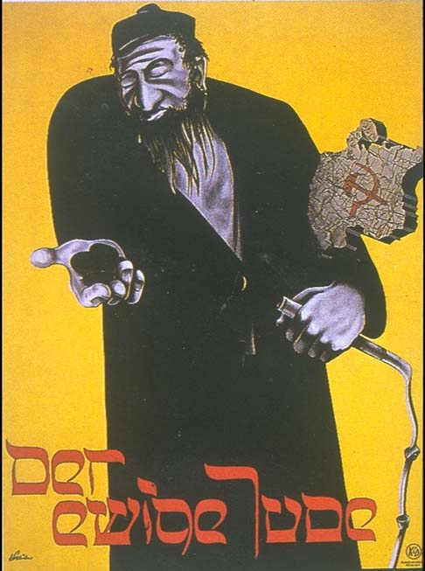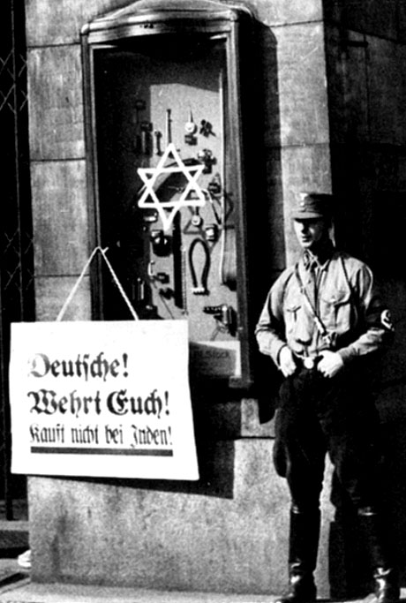

It is highly unlikely that a dictatorship would al ways be able to keep its people in line and content. They are likely to harbour some frustration or grievance. If, however, their grievances can be directed against groups other than the government; if the government can find someone else to blame, then the policies of the government will not be questioned. In fact, the government gains further support for the people.

The classic example of scapegoating is Hilter’s direction of popular discontent towards Jews and communists. Saddam Hussein often used Israel and the U.S. as the enemy of the Iraqi people.

# The Use of Force (‘terror and secret police’)

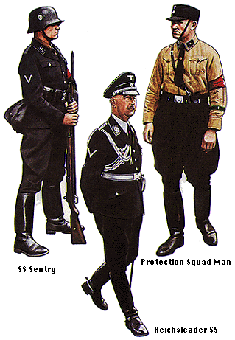

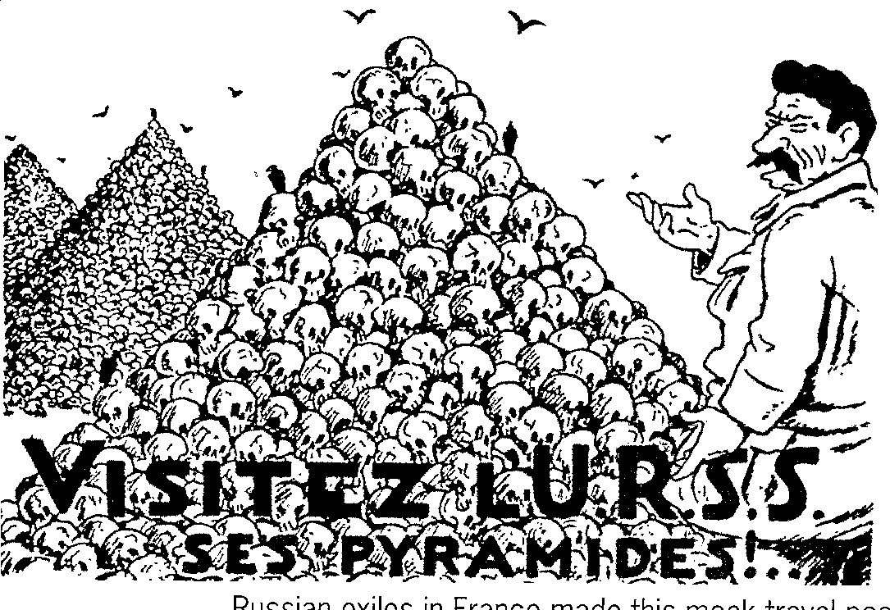Terror and violence are effective measures for subduing a population and maintaining total control over them. Particularly effective is the use of a *Secret Police* whose powers enable them to enforce the will of thee government. They are empowered to deliver swift and arbitrary punishment to anyone suspected of possible disloyalty to the government. Citizens who 'might' one day oppose the government are prime candidates for imprisonment, torture, or liquidation. Their disappearance serves to terrorize any potential opposition.

All dictators have instruments of terror, usually some form of secret police used to terrorize the population so they won’t think of dissenting. Hitler had a myriad of terror weapons – Gestapo, SS, SA, SD; Stalin had the NKVD which later become the KGB; Mussolini had his Blackshirts (squadristi) etc.

# Controlled Participation

People who are allowed to participate in and contribute to something are more likely to support it. Totalitarian dictatorships rally the people in displays of support for the government. Elections are held to allow the people to vote for the candidate chosen by the government. There is no opposition. The election process is simply an opportunity to allow people a sense of participating in government. Government sponsored youth groups provide opportunities for young children to take an active role in their country. Such groups are also the primary source for future supporters and members of the government.

There are some classic examples of controlled participation in the modern day and in historical examples. Stalin passed a very democratic constitution in 1936, guaranteeing basic human rights to his people, even though he was in the midst of a purge of millions of soviet citizens. Prior to the latest war in Iraq Saddam Hussein held a national vote to confirm his presidency – one hundred percent of eligible voters turned up to vote and an amazing one hundred percent terrified Iraqis voted to confirm Hussein as President.

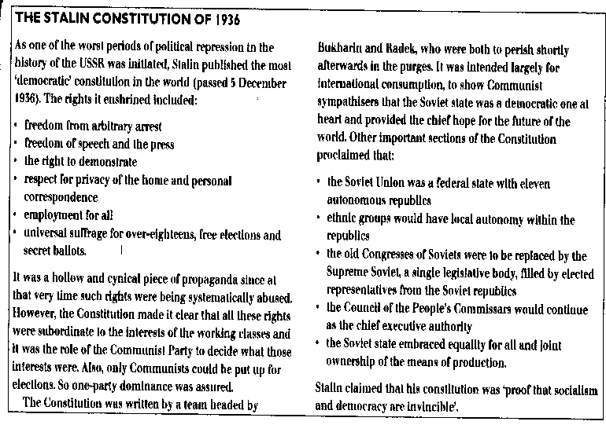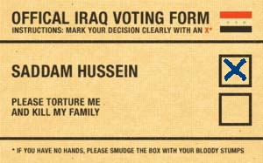

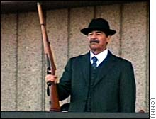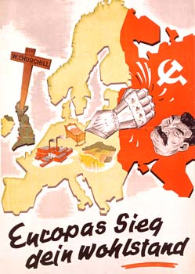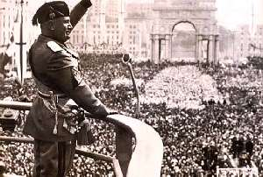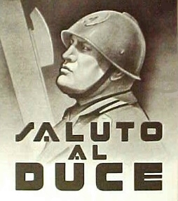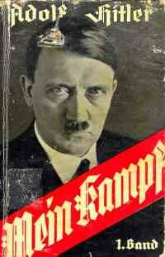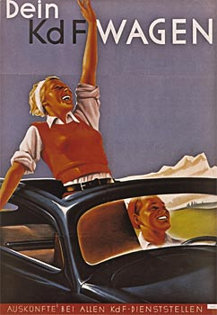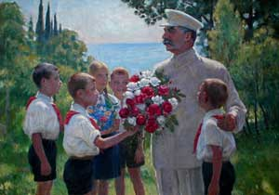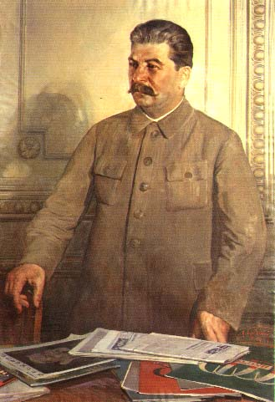

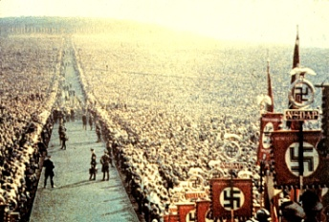

It’s 1938 and the world finds itself in the shadow of the totalitarian dictatorships of Europe and the Far East. The competing ideologies of fascism and communism stand defiantly against the liberal democracies of the West. Government bureaucracies, on all sides, work diligently to promote their ideological perspectives, using mass media to convince their people of the ‘evils’ of opposing ideologies. The struggle for the hearts and the minds of citizens is well underway - the propaganda wars have begun!

You will take on the role of a government bureaucrat who has been asked to create a persuasive piece of propaganda that attacks an opposing ideology. You will use your understanding of communism in the Soviet Union, fascism in Nazi Germany, and liberalism in Western Europe and/or North America, to construct three pieces of propaganda from each of these three perspectives. The perspectives, embedded within the propaganda, will provide a condemnation of opposing ideological views.

As a bureaucrat, you will be competing to have your work selected by the government ministry to be used in an upcoming propaganda campaign. There is great prestige, and potential political advancement, for those who can impress their political masters. Ultimately, students will share their propaganda with classmates and fellow bureaucrats.

Your task is to create propaganda from each of the following perspectives:

* a fascist attacking the principles of liberalism
* a communist attacking principles of liberalism
* a liberal attacking fascism and/or communism

In the propaganda you create, be sure that you

* make clear each ideological perspective
* demonstrate differences among competing ideologies

You will present your propaganda in one of the following ways

(you may use all three mediums or only one):

* propaganda film (maximum 3 minutes using MovieMaker, iMovie, etc.
* propaganda poster (electronic, paint, drawing, etc.)
* radio address or propaganda speech (live performance or video/audio recording
* full page newsprint advertisement

Good luck as you share your propaganda with fellow bureaucrats.