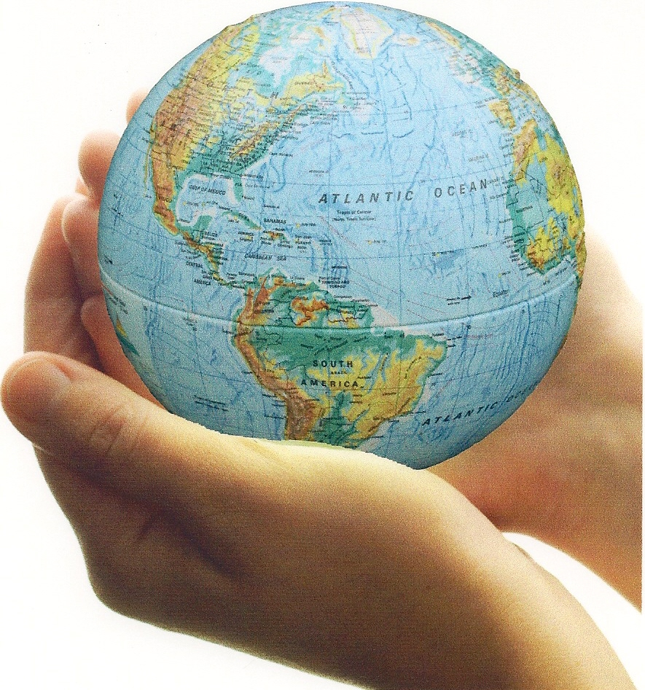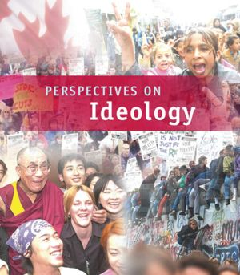

RELATED ISSUE 2: CHAPTER 6
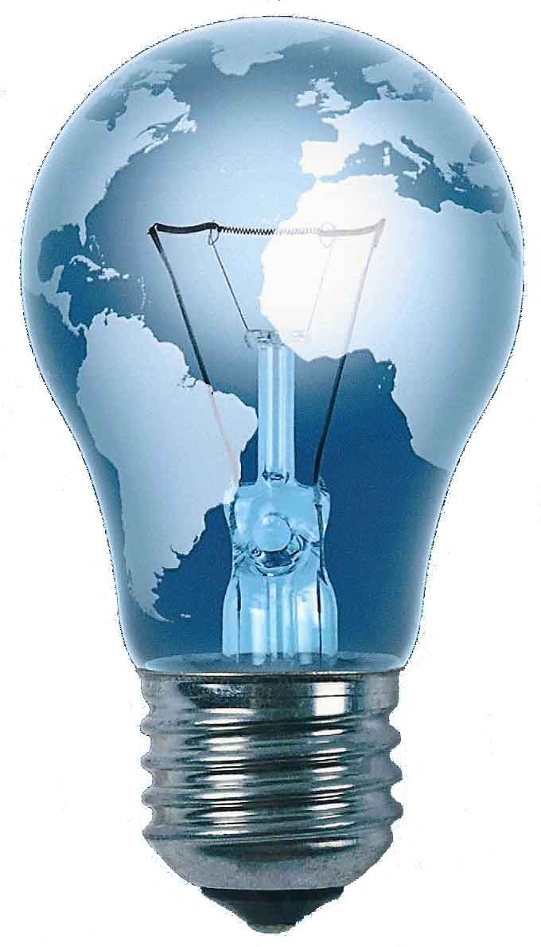
WHERE ARE WE GOING

By the end of this chapter you will have to respond to the questions for inquiry listed below and demonstrate a contextual understanding of the vocabulary, concepts, people and events listed.

Chapter Issue:

To what extent do contemporary economic policies and practices reflect the principles of liberalism?
Reaganomics and Thatcherism
Keynesian economics

income disparity
consumerism

Friedman and Hayek
Question for Inquiry #2:

In what ways have economies reflected the principles of liberalism since the Second World War?
Question for Inquiry #1:

In what ways did economies in the first half of the twentieth century reflect the principles of liberalism?

inflation
monetary and fiscal policy
Great depression
Roaring twenties
monopoly

stock market crash
social programs
monetarism
Welfare state

New Deal

demand-side economics
trickle down economics
progressivism

FDR
‘Red Scare’
supply-side economics

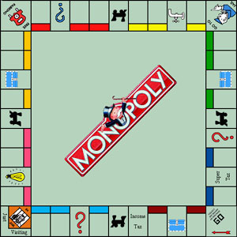You have probably played some version of the board game Monopoly. Using your understanding of the term monopoly, do you think the title of the game is an accurate reflection of the game?

What is the difference between a commercial bank and a credit union? What is the connection between early credit unions and Canada?

Write a 30 second script for a radio promotion of a
program on the ‘red scare’ during the 1920’s
in the U.S. and Canada.
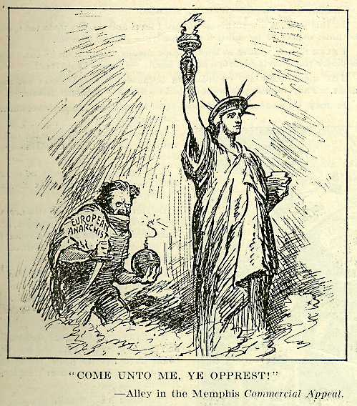

Pretend you were working for the Harding-Coolidge ticket in 1920 and it was your job to create campaign slogans for their posters targeting their economic policies. Create slogans for the campaign posters below.
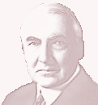

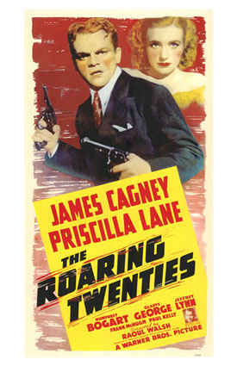Why do you think that many historians consider the 1920’s as the most capitalist time in American history. Provide evidence to support your answer.

You need to understand the following events in order to understand the significant challenges to classical liberal (capitalism) in the United States and Canada.

Create a mind map or point form notes to summarize each event listed below. You must also create or find one visual to help you understand and remember each event.

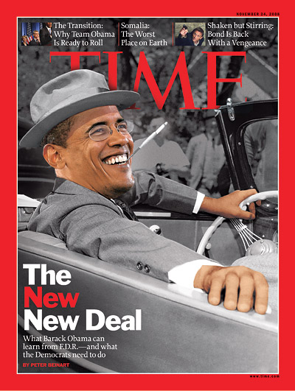Look at the pictures. Do you think Time Magazine is making a fair comparison?
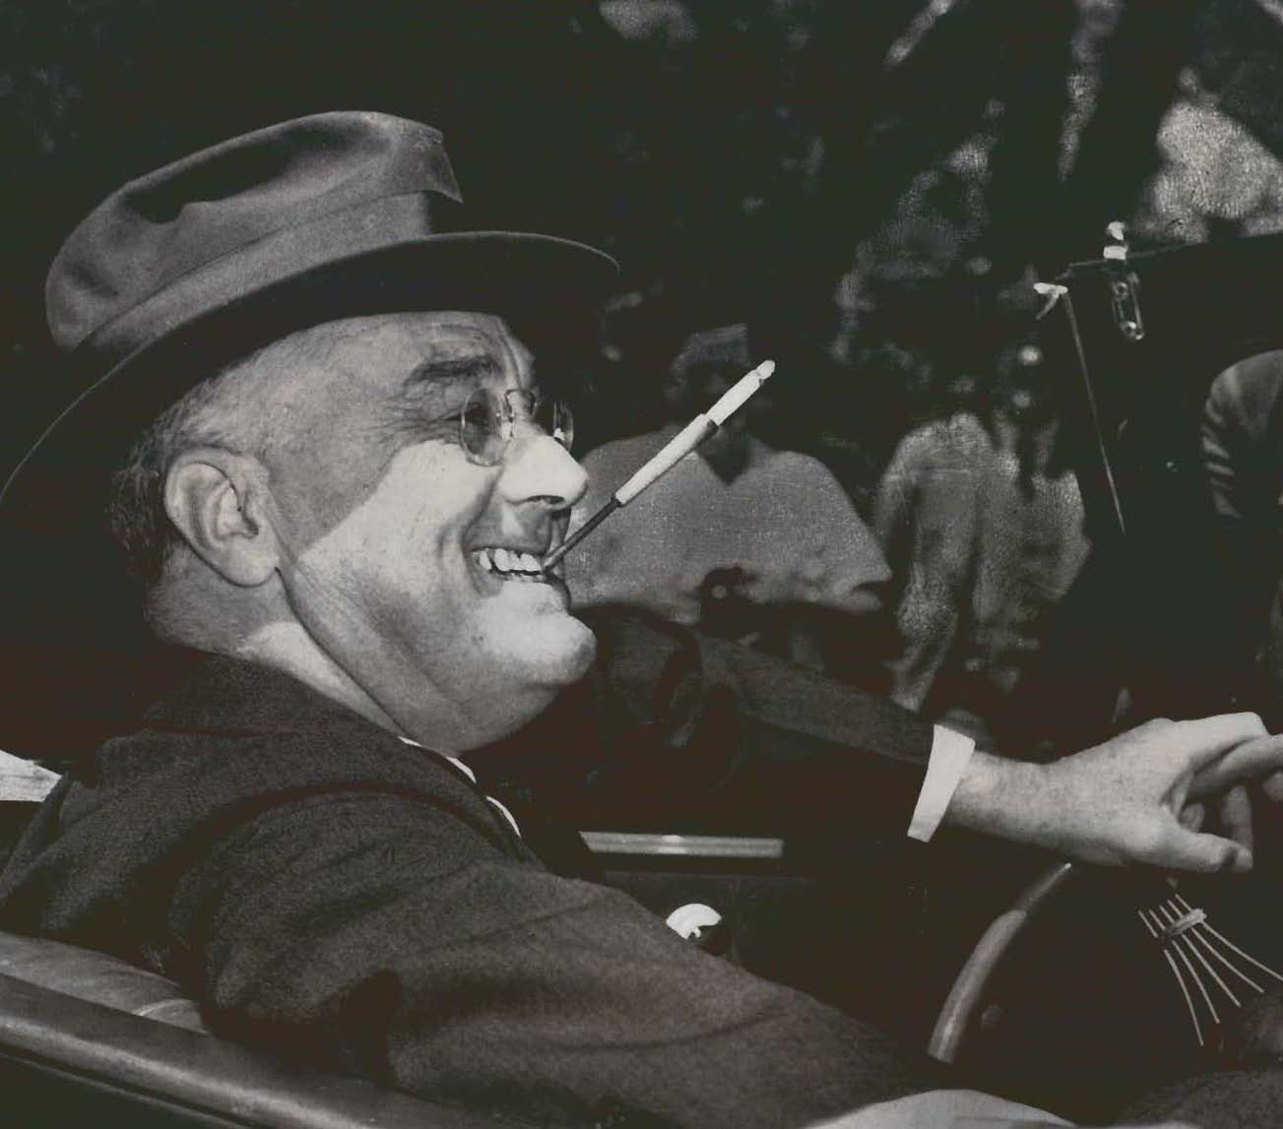

Source: http://www.time.com/

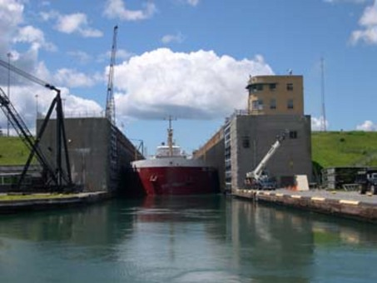What impact did World War II have on social programs in
Canada and Britain? Provide examples to support your answer.

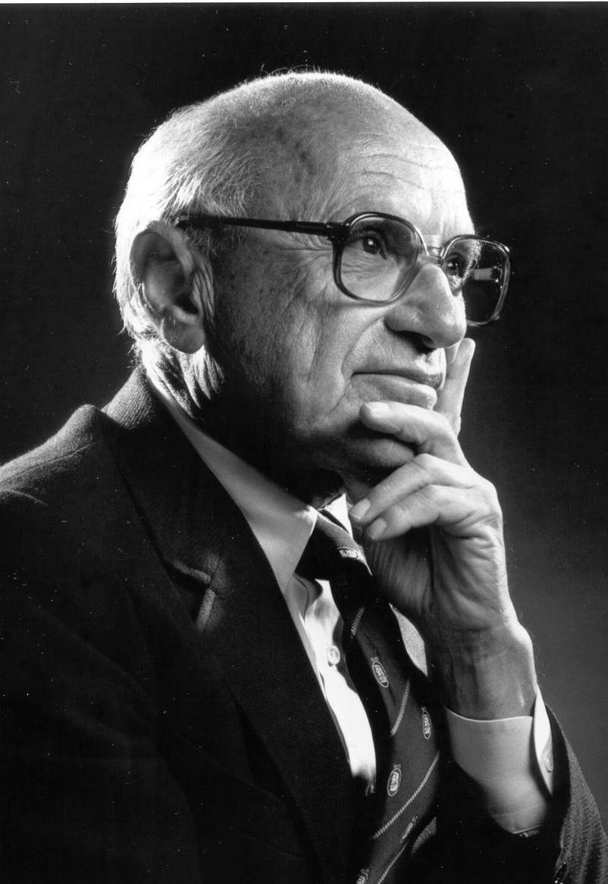Briefly describe monetarist theory (monetarism). What perspective did Milton Friedman, Friedrich Hayek and Adam Smith share?

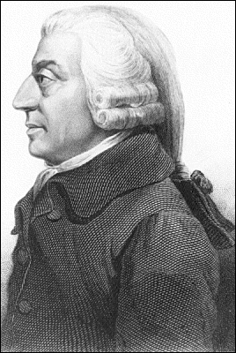

Compare and contrast monetarism and Keynesian economics

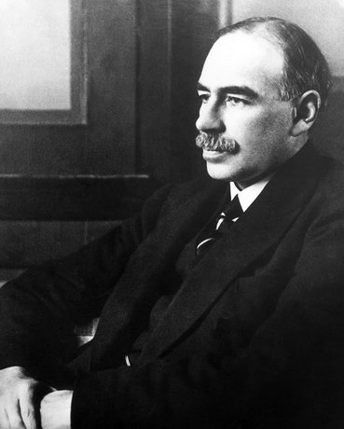

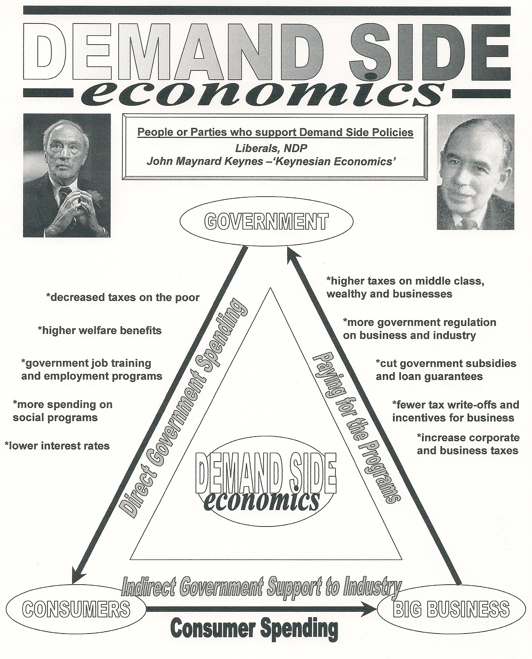Use the diagrams below to explain the difference between demand side and supply side economics. Make specific reference to the diagrams.
COMPLETE
SUPPORT FOR
DEMAND SIDE
ECONOMICS

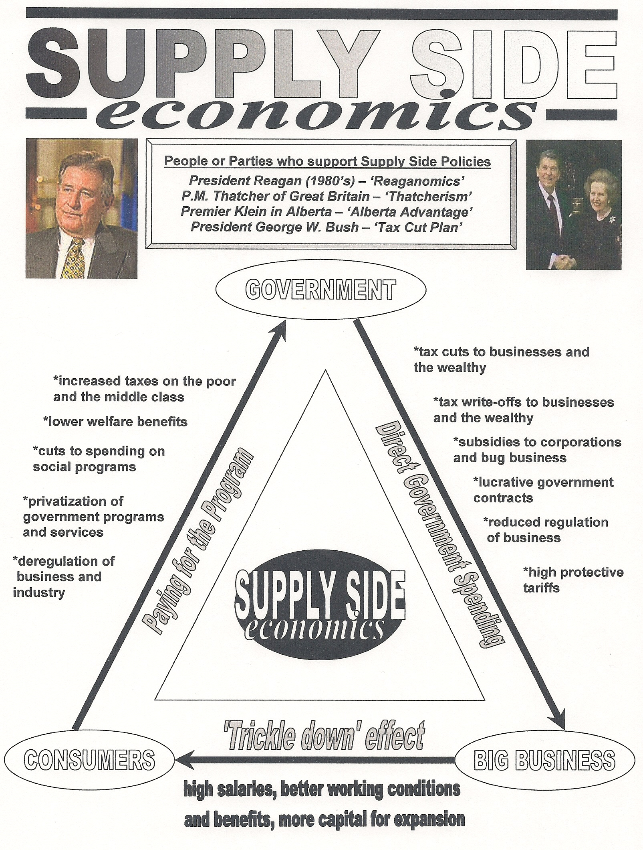

Place yourself on the spectrum that runs beside the diagram. The closer to the top of the page the more you support demand side economic theory, the closer to the bottom the more you support supply side economic theory.

Provide a rationale for your placement.

COMPLETE
SUPPORT FOR
SUPPLY SIDE
ECONOMICS

Watch the clip on life in Denmark from the October 21st Oprah Whinfrey show. Briefly explain the ideological perspective of the women interviewed within the clip. What do you think of the perspective?

Read the article called ‘Canada’s Economy’. If you had to cut five areas the government in Canada is involved in the economy, what would they be? Provide a clear rationale for your choices.
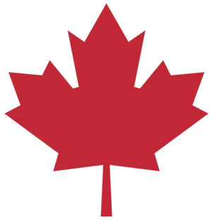
RATIONALE:

RATIONALE:

RATIONALE:

RATIONALE:

RATIONALE:

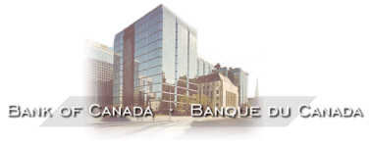

Probably the closest Canada has come to a pure laissez faire capitalist economy was during the 1920’s. During that decade governments followed Adam Smith’s advice, and left the privately-owned economy alone. Since government did little, taxes were low and there was no income tax.
Then came the crash of 1929 followed by the Great Depression. Most Canadians experienced major economic hardships throughout the 1930’s. Business owners and workers began to feel that government should do something to prevent such a massive economic collapse from ever happening again, and to provide help to the helpless individuals in society. Since this era, the governments in Canada have steadily broadened their role in the economy. We are now a true mixed economy or democratic socialist state.

Here is a list of some of the ways that governments are involved in the Canadian economy:

Stabilization policy – preventing boom and busts in the economy
-monetary policy – increasing and decreasing interest rates through the Bank of Canada
-fiscal policy – increasing and decreasing taxes
-increasing and decreasing government spending on programs

Regulation of the marketplace
-quality and safety controls on consumer products
-some price controls
-prevention of monopolies to preserve competition and to protect consumers

Regulation of the environment
-pollution controls and regulations
-conservation policy

Redistribution of wealth and to provide security to citizens
-social assistance (welfare)
-old age pension (CPP)
-employment insurance (EI)
-family allowance

Provision of public service – transfer payments to provincial and municipal governments
-universal health care
-education – K-12 and post-secondary
-police services
-fire protection services
-parks

Business subsidies – financial assistance to business
-farm subsidies for low crop prices
-emergency relief
-tax relief and/or interest free loans

Ownership of companies by government (nationalization) – ‘crown corporations’
-CBC Radio and TV
-Canada Post
-Ontario Power, Hydro Quebec
-Canada Mortgage and Housing
-Via Rail Canada

KEY TERMS

Privatization: when a company or business is released from government control to private ownership and control

Nationalization: when a company of business is owned and controlled by government

Public sector: areas of the economy owned and controlled by the government

Private sector: areas of the economy owned and controlled by individuals or private investors

Regulation: direct government control over certain aspects of an industry

De-regulation: removing government control over aspects of an industry

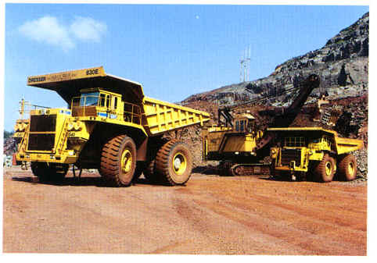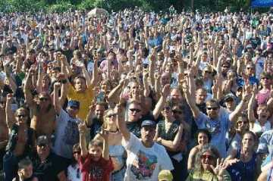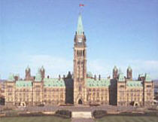

MUNICPAL POWERS

Police Services
Fire Services
Public Transit
Water Treatment
GOVERNMENT
SERVICES
TRANSFER
PAYMENTS

FEDERAL POWERS

Canada Health Act
Military
Currency
Aboriginal Affairs

PROVINCIAL POWERS

Health Care
Education
Resources

Licensing
GOVERNMENT
SERVICES
SUBSIDIES
CAPITAL
ASSISTANCE

What Taxes Apply in Canada Today?

Taxation in Canada can be viewed as ‘redistribution policy’. The government collects various taxes so it can provide programs and services it decides are important to Canadians. Canadian taxes consist of direct taxes and indirect taxes. "Direct taxes" are taxes are imposed on the income of Canadian resident individuals, Canadian corporations and various other entities that either reside or carry on business in Canada. Non-resident individuals and businesses may be subject to taxation in Canada if they have a connection with Canada. Whether non-residents are required to pay Canadian income taxes or are otherwise required to file income tax returns depends not only on Canadian income tax laws but also on international tax treaties.

Income taxes are also levied at the provincial level. For the most part, these taxes are collected by the federal government on behalf of the provinces. Only Quebec has a separate income tax regime at the individual level, while Quebec, Ontario and Alberta have their own corporate income tax laws and administration.

"Indirect taxes" are generally consumption taxes levied on property and services, which distinguishes them from direct taxes, such as income taxes. In Canada, the term "commodity taxes" is often used in place of indirect taxes.
In a Canadian context, indirect taxes encompass the sales taxes of general application as well as the other indirect taxes that are levied on commodities such as fuels, tobacco products and alcoholic beverages. They also include excise taxes and customs duties, since both excise taxes and customs duties are selective taxes on goods.

Canada's system of indirect taxation is unique among industrialized countries in that there are two levels of government, federal and provincial, that impose a general sales tax on the same transactions. The federal government levies the Goods and Services Tax, or GST, which is a 7% value-added tax on virtually all goods and services sold in Canada. Most provinces levy their own separate retail sales taxes on sales of goods, and a limited number of services, to users or consumers. On the other hand, Quebec has repealed its retail sales tax in favor of a multi-stage tax modeled after the GST. New Brunswick, Nova Scotia and Newfoundland have replaced their respective retail sales taxes with a federal tax that is collected as an additional component of the GST. This 15% combined tax is known as the Harmonized Sales Tax, or HST. Alberta and Canada's two territories do not have a separate sales tax system. Source: http://www.benderoff.ca/comtaxes.htm

The Birth of Income Tax
By 1917, Canada had had its share of unique finance ministers. There had been Alexander Galt, Canada's first minister of finance, who had resigned before the first Parliament had even met. His successor, Sir Francis Hincks caused the resignation from the Conservative ranks of one of its brightest young backbenchers. That same backbencher, Richard Cartwright became Minister of Finance during the short four-year reign of the Right Hon. Alexander Mackenzie. Sir Wilfrid Laurier quelled a separatist provincial government in Nova Scotia by bringing its premier into the federal cabinet, as finance minister. William Fielding remained at the position for 15 consecutive years, and later returned under Mackenzie King in 1921 for another four.

On April 24, 1917, White tabled his annual budget in the House of Commons. Despite the recent entry of the United States into the conflict, the military requirements of the allies was draining the resources of Canada. From Baghdad to the North Sea, men, equipment and supplies were in constant need. The cost of the war to Canada had reached $600-million, White told the House. Already, Great Britain and the United States had implemented income tax schemes but, added White, "it would appear to me that income tax should not be resorted to (in Canada)."

At least not until the House went into Committee of the Whole, on July 25, 1917. On that day, the 50-year old finance minister tabled a resolution which called for income tax: 4% on all income of single men over $2,000. For others, the personal exemption was $3,000. For those Canadians with annual incomes of more than $6,000, the tax rate ranged from 2 to 25 per cent.

The Canadian Constitution gives the Federal Government the right to raise money through taxation. Originally designed as "temporary", to assist in paying for our military efforts in World War I, taxation of income has been with us ever since. Provincial governments now, also, resort to taxation to raise money to pay for provincial programs and services. Prior to the Second World War, the government managed to pay for all its endeavours mainly by taxing imported goods. By 1948, the Income War Tax Act had become the Income Tax Act.

The most universal tax is personal income tax, which most Canadians pay directly off their pay-cheques. Except for Quebec, the Federal Government collects personal income tax, sharing the money with the provinces. Quebec collects its personal income tax directly through separate forms which its citizens have to fill out in addition to the federal form. Quebec, Alberta and Ontario also have separate corporate income tax collection systems. Other taxes are collected by the federal government for itself and on behalf of the provinces.

"An income tax shall be paid as hereinafter required upon the taxable income for each taxation year of every person resident in Canada at any time in the year". So starts the Income Tax Act, the longest and most complicated law on the books. To make matters worse, the Act is changed frequently, most notably after every federal budget (usually in February), when the financial changes proposed by the government of the day translate into changes to the Income Tax Act.

Corporations pay income tax as do people but with regard to the latter group, only if they have resided in Canada for 183 days or more of a calendar year. But even then, non-residents pay tax on money earned in Canada. The list of organizations which do not pay income tax includes Federal, Provincial and Municipal governments and Crown corporations, chambers of commerce, labour organizations and pension trust corporations. Municipal governments also collect taxes – in Alberta these are primarily property taxes. These taxes are levied to owners of property depending on the size and net worth of the property.

Use this fictitious chart to assess which system you think is the fairest:

When you combine all of the various direct and indirect taxes, from all three levels of government, Canadians pay some of the highest rates of tax in the world. How do you feel about paying taxes? What kind of taxation system do you think is best? What do our taxes pay for? What is ‘redistribution policy’? Discuss these questions with your class.

Place the following people on the spectrum below. Simply draw a line from the name to the location on the spectrum you feel is most appropriate. Provide a brief rational for your placement.
John Maynard Keynes
Rationale:

Milton
Friedman
Rationale:
Friedrich
Hayek
Rationale:

Ronald
Reagan
Rationale:
Tommy
Douglas
Rationale:

Margaret
Thatcher
Rationale:

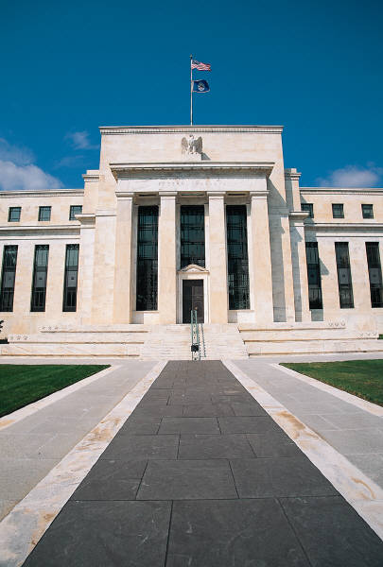

MONETARY POLICY – INTEREST RATES
What goes down must – when it comes to interest rates – eventually go up. And on June 30, 2004, another cycle of rising interest rates began in North America. For the first time in four years, the U.S. Federal Reserve Board raised rates.
The last time there had been any movement at all in American interest rates was a year earlier, when the Fed cut its benchmark rate by one-quarter of a percentage point to one per cent. Rates hadn't been that low since Father Knows Best ruled TV screens across the continent. The movement of American rates is critical to what happens on this side of the border. According to the Bank of Canada, interest rates in Canada are broadly determined by the level of interest rates in the United States, the relative inflation rates in both countries, and the relative stances of their monetary policies. A risk factor is also factored in. The result is that Canadian interest rates can be either higher or lower than U.S. rates but are never fully independent.
The Bank of Canada joined the upward cycle on September 7, 2004, increasing its overnight loan rate by 0.25 percentage points. It was the first increase in 17 months. The bank made it clear that as the economy continued to improve, there was only one way for rates to gradually go: up.
What is interest?
It is the cost of borrowing money – or the return on money you deposit in things like savings accounts, Guaranteed Investment Certificates and government bonds. There are two types of interest: simple and compound. With simple interest, if your bank pays you four per cent on a five-year GIC, you will receive $4 per year for every $100 you invest. With compound interest you receive interest on your interest. You will receive $4 the first year and approximately $4.16 in year two, $4.33 the third year, $4.50 in year four and $4.68 in year five. Your effective rate of interest becomes approximately 4.3 per cent.
Over that period of time, you hope inflation remains low. If it stays at two per cent, your real rate of return will be around two per cent on that GIC that pays four per cent. The real rate of return is what your money is really worth after you factor in how inflation erodes its buying power.
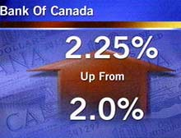What happens when rates go up?
It costs more to borrow money. This doesn't have much of an impact on day-to-day buying decisions. But if you're in the market for a house, you might think twice about buying as rates rise. For instance, if you need a $200,000 mortgage – which is not uncommon now that you can buy a home with essentially no down payment – you would be paying $1,163.21 every month in principal and interest for 25 years, if your mortgage interest rate was five per cent.
But if that rate is just one percentage point higher, your payments would be $1,279.62 per month. And that doesn't include property taxes. Bump the rate to seven per cent and your payments are just over $1,400 a month. Might be enough to make you think twice about buying. And if you don't buy, then those big box hardware stores might not see as much of you because you won't be doing all those renovations to that house. The same goes for the furniture stores that wanted to sell you that entertainment unit for the new home theatre you were thinking of installing.

Another problem with higher rates: if you have a line of credit that's secured by the equity in your home, it's going to cost more to carry that debt. On the other hand, if you've paid off your mortgage and have a whack of cash lying around, higher rates mean the bank will pay you more to let your money sit with them in savings accounts or GICs.
The central bank moves to higher rates when it believes the economy is in danger of growing too rapidly. Rapid economic growth could cause a cycle of rising prices and wages. The central bank wants that growth to be moderate, so inflationary pressures are kept in check.
What happens when rates go down?
The cost of borrowing goes down, except, usually, for credit cards. Lower rates are a signal from the central bank that it's worried that the economy is weakening and people aren't buying enough big-ticket items. When people stop buying cars and homes, a lot of people are in danger of losing their jobs.
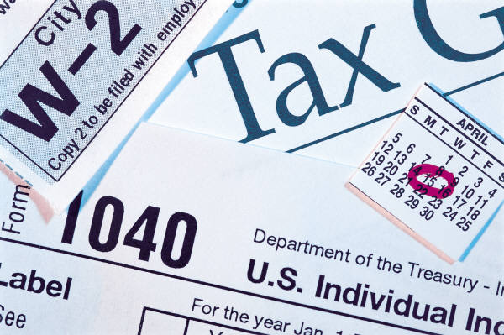

Fiscal policy is a term used to describe the spending habits of government. Governments account for both their revenues (money collected) and their spending in annual budgets. Governments traditionally create revenue by collecting taxes. A government can therefore impact the economy by raising taxes in order to gathering more revenue, perhaps to spend on government programs. John Maynard Keynes' theory suggested that the economy need not automatically tend towards full employment, it also suggested that active government policy could be effective in managing the economy. Keynes advocated counter-cyclical fiscal policies: deficit spending when a nation's economy was sluggish and the supression of inflation (raising interest rates and cutting government spending) in boom times.

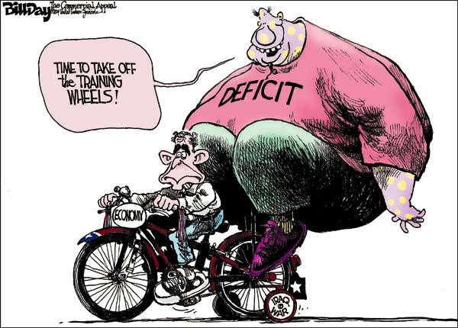Conversely, a government can reduce taxes in an attempt to return money back into the hands of citizens – who will hopefully spend that money and in turn bolster the economy. The later is a plan (tax cuts) supported by economic conservatives who believe that government should play as little a role as possible in the economy, and that individuals should support themselves and make their own decisions about how to spend their money. In his first term in office George W. Bush pushed through a plan that provided a massive tax cut, particularly for the wealthy classes in America.

Governments must balance their budgets or they will run deficits (spending more than your revenues). Running deficits will cause an accumulation of debt (total money owed to lenders). Canada currently (2004) owes $507 billion to lenders. In the final year of George W. Bush’s first term the United States is running a $374 billion deficit and is carrying a $7.3 trillion debt load.

Source: http://www.cbc.ca/news/background/economy/

