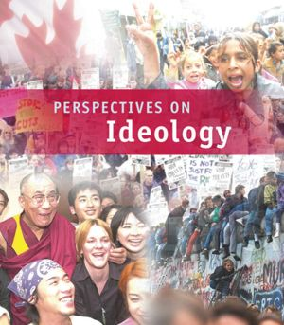

RELATED ISSUE 2: CHAPTER 8
WHERE ARE WE GOING

By the end of this chapter you will have to respond to the questions for inquiry listed below and demonstrate a contextual understanding of the vocabulary, concepts, people and events listed.

Chapter Issue:

To what extent is
modern liberalism
continuing to evolve?

Question for Inquiry #1:

How far has liberalism strayed from its roots?
Question for Inquiry #2:

How is liberalism challenged by alternative thought?

Aboriginal justice
negative
freedom

consensus
civil rights
positive freedom
fundamentalism

Christian right
civil rights movement
enfranchisement
foreign policy

Neo-conservatism
environmentalism

Explain the difference between a positive freedom and a negative freedom.
Use specific examples to support your explanation.

Liberalism has evolved significantly over the last three hundred years. What do you think are the two most significant changes between classical liberalism and modern liberalism? Provide a clear rationale for the choices you make.

Provide a response to the chapter inquiry question #2 by using an example from each of the headings below:
Question for Inquiry #2:

How is liberalism challenged by alternative thought?

ENVIRONMENTALISM:

NEO-CONSERVATISM:

RELIGIOUS PERSPECTIVES:

ABORIGINAL COLLECTIVE THOUGHT:

To what extent should the principles of liberalism be imposed on people?

Think about the following case studies and examples:

  - democracy, freedom and capitalism in Iraq
  - democracy, freedom and capitalism in Afghanistan
  - residential schools in Canada
  - self-government in Nunavut
  - democracy, freedom and post-World War II Japan
  - capitalism in China
  - democracy, freedom and capitalism in the Former U.S.S.R. and Eastern Bloc countries

