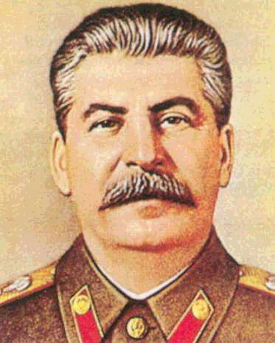
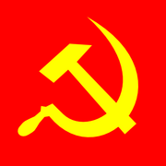

COMMUNISM
RISE to POWER
TECHNIQUES of DICTATORSHIP

FEAR and TERROR

PROPAGANDA
CONTROLLED PARTICIPATION

INDOCTRINATION
Bolshevik Revolution, 1917,
end of Tsarism - Civil War – ‘War Communism’ – New Economic Policy (NEP)
Stalin is editor of Pravda, communist paper – not important player in revolution
Lenin leads the Russian Revolution in 1917. Stalin replaces him as leader in 1928. Beats out Leon Trotsky as main leadership rival.
Centralization of power – central planning of production. Totalitarianism – total economic and political control
based on theories of Marx and Engels – Communist Manifesto
based in theory on the ideas of egalitarianism or equality
eliminates all political enemies
Five Year Plans – Central Planning Committee (GOSPLAN)
Collectivization of agriculture – land seized for large state and collective farms
De-Kulakization and the great famine in the Ukraine result from shortage of grain. - grain given to workers and/or sold
Industrialization main priority
Work camps or Gulags for political prisoners - dissidents
Purges
‘Great Terror’

Show Trials
Illusion of a fair judicial process
1936 Constitution,
Democratic on paper – not followed in practice
Regular elections – only hand-picked Communist Party members on the ballot – elected parliament called the Duma with no real power – not showing up raised suspicions with secret police
Extensive network of Secret Police in all parts of society
Cheka under Lenin
NKVD under Stalin
KGB in modern times
‘Cult of Personality’ built around Stalin as a father figure
education became a priority to train workers and citizens
- re-write history
statues, posters, bill boards of Stalin everywhere
Banned religion
glorification of workers (industrial and agrarian – ‘hammer’ and ‘sickle’ – statues, posters, bill boards - Stakhanovites
Gulags – slave labor of his own people

