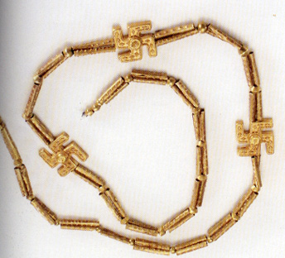
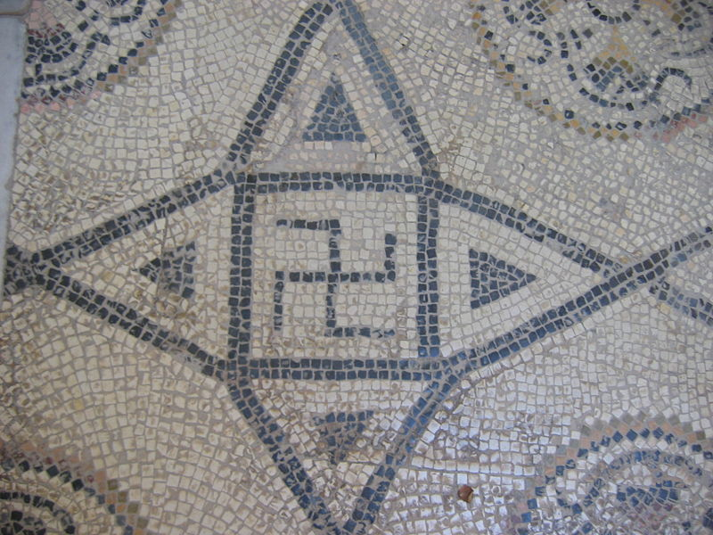

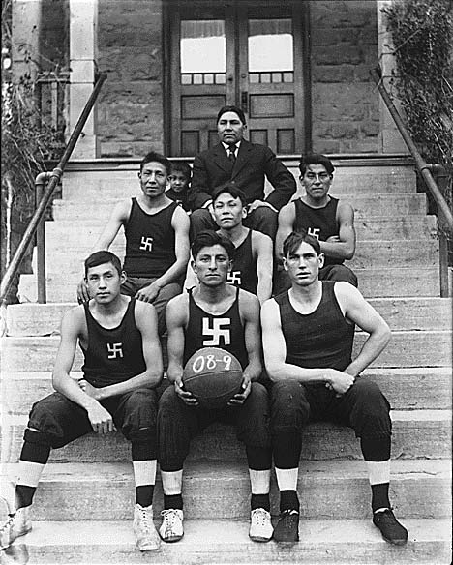
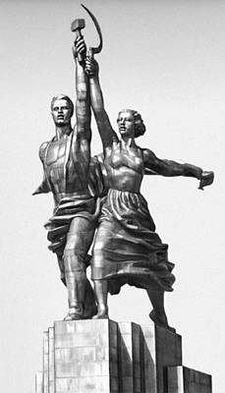


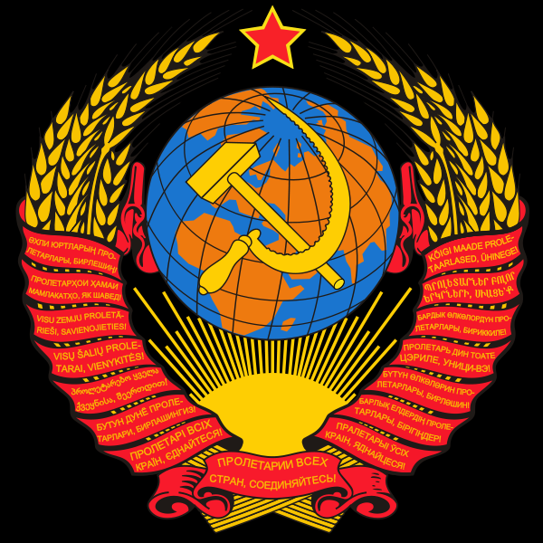
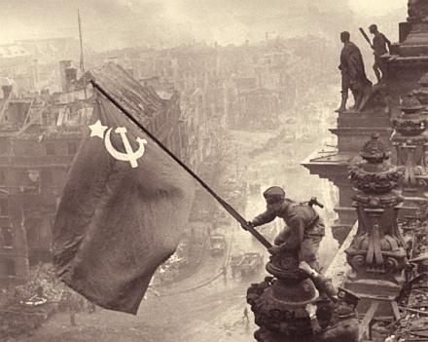
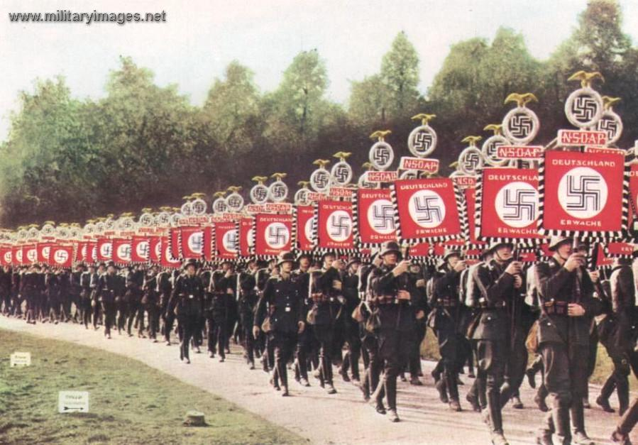
Archaeological evidence of swastika-shaped ornaments dates from the Neolithic period. An ancient symbol, it occurs mainly in the cultures that are in modern day India and the surrounding area, sometimes as a geometrical motif and sometimes as a religious symbol. It has long been widely used in major world religions such as Hinduism, Roman Catholicism, Buddhism and Jainism.
The swastika was appropriated as a Nazi symbol and gained further association with the Third Reich as the Reich gained influence. Though once commonly used over much of the world without stigma, over time the symbol has become a controversial motif, especially in the Western world.

Iranian necklace – excavated from 1st millennium
Swastika found on a
Roman mosaic
Swastika found on a Buddhists temple
Navajo basketball team, 1909
The hammer and sickle is a part of communist symbolism and its usage indicates an association with Communism, Communist Party, or Communist state. It features a hammer superimposed on a sickle, or vice versa. The two tools are symbols of the industrial proletariat and the peasantry; placing them together symbolizes the unity between industrial and agricultural workers. The ‘soviet’ was a council of workers and these soviets became the foundation for the revolution prior to 1917.
It is best known from having been incorporated into the red flag of the Soviet Union, along with the Red Star. It has also been used in other flags and emblems.

