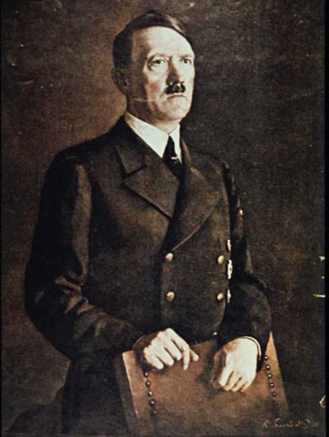
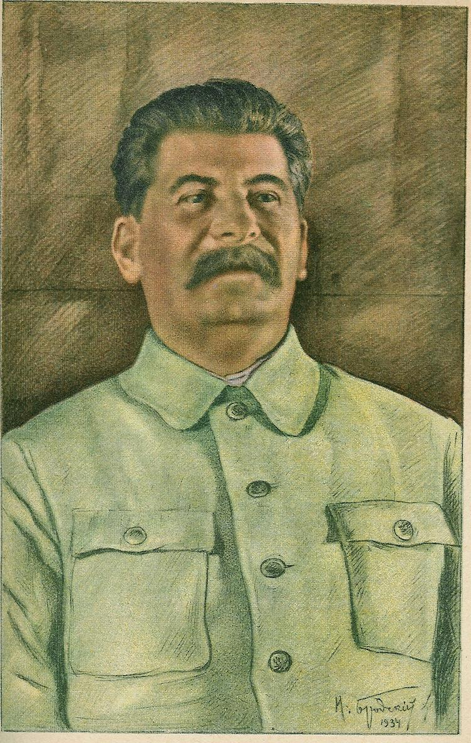

In the sixteenth century, Niccolo Machiavelli wrote a book based on the activities of the rulers of the small city-states of Italy. The Prince detailed the methods and strategies which an ambitious ruler might use to maintain and increase his power.

Machiavelli wrote that, in his day, for a ruler, to display a tendency toward goodness of character was a handicap. The problem was that other people were not good. Therefore a Prince should not seek to be good. In fact, a ruler was well advised to concentrate on war and a state of readiness in his military forces. Machiavelli suggested that military power allowed princes to maintain their station, and it also allowed for lower class persons to become rulers.

Machiavelli had views on the question of whether it is better to be loved or to be feared. His idea was that if a choice had to be made, it was more valuable to be feared because it is safer to be feared than to be loved.

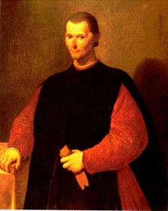
He noted that a Prince's reputation is increased when he acts in good faith, acts with integrity and avoids deceit. Yet, he did not advise this. His experience was that princes who achieved great things were not particularly concerned about good faith and were prone to the use of cunning to gain their ends. Such leaders generally won out over those who were guided by good faith and loyalty.

Therefore, he said that a wise ruler should not be bound by promises when it is against his interest to honor them, and when the reasons behind his promises no longer exist. This is because other men are generally bad and will not keep their word when their interests are threatened.

He thought that a ruler should seek to be good if at all possible, but the ruler should have the flexibility of mind to embrace evil when necessary.

The following are the major characteristics (techniques) of dictatorships:

Propaganda

All forms of media communication are controlled by the government. News of the outside world and news of national concern is censored, altered, and presented to the people so that it best serves the interests of the government. In endless variation, the government bombards the people with its view of the world. Its view is the only view. Its view becomes the truth. Propaganda is one-sided information.

There are countless examples of propaganda used by dictators, past and present. Control of information and the media is critical to conveying one-sided information to the population under a dictator’s control. Hitler had a minister of Public Enlightenment and Propaganda (Joseph Goebbels) who controlled all information people in Nazi Germany heard and viewed, as well as organize massive Nazi rallies to play on people’s sense of nationalism. Stalin went so far as to re-write history books and alter historical photographs in order to make it appear that he had a more prominent role in Soviet communism.
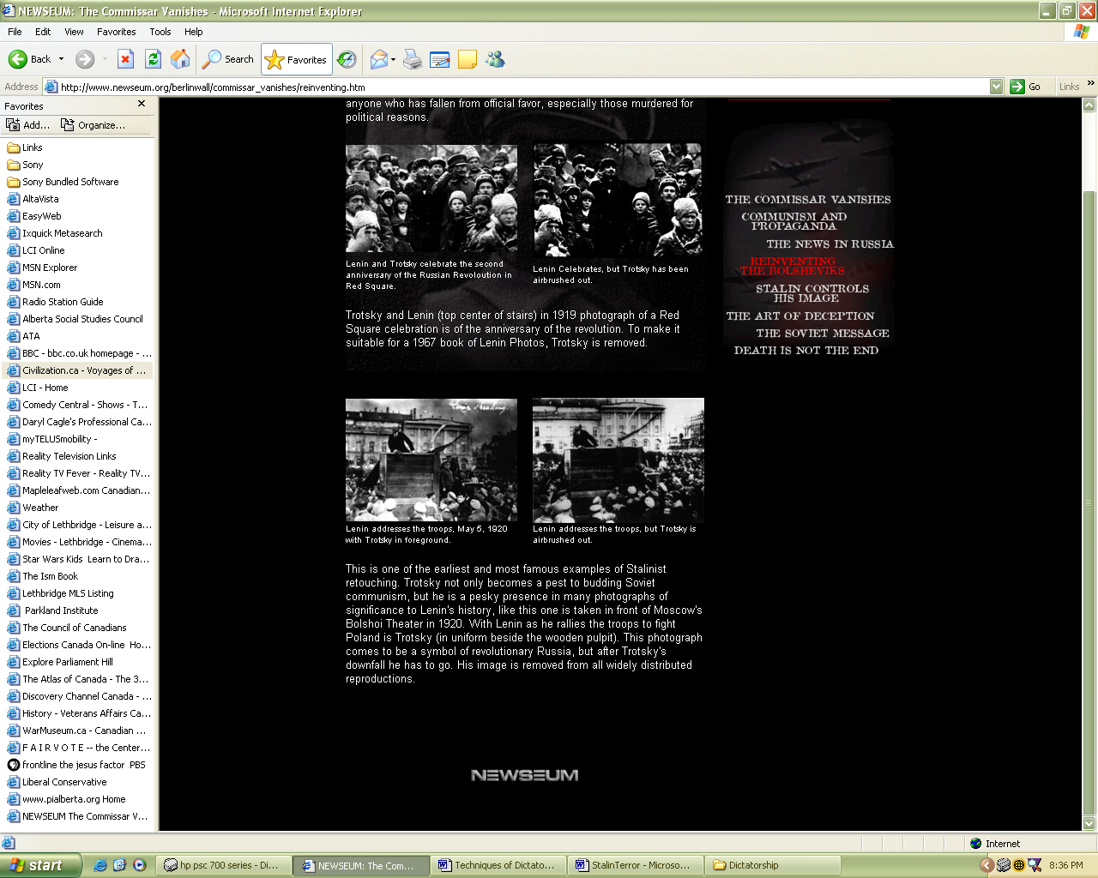
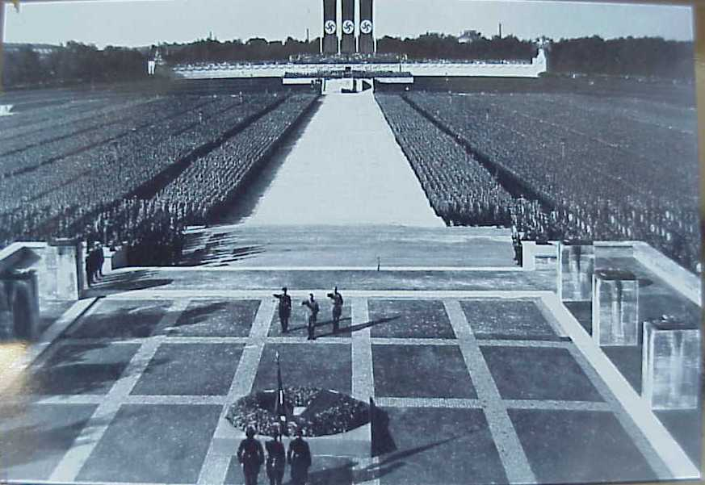

Indoctrination (‘brainwashing’)
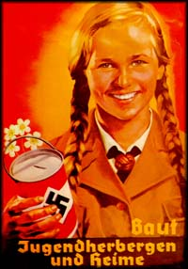
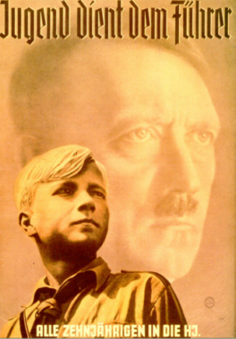
Indoctrination takes the place of education. Citizens, and particularly the youth, are not given alternatives or choices as to what to believe in. They are subject to a systematic presentation of information designed to strengthen their support of the government. Schools and universities serve the interests of the government. Success is not measured in terms of original, or creative thinking, but rather in conformity.

Stalin and Hitler both targeted the youth in their societies as far as ‘brainwashing’ them to conform to the leader’s ideology. Adults who would not conform were eliminated or imprisoned.

Direction of Popular Discontent (‘scapegoating’)
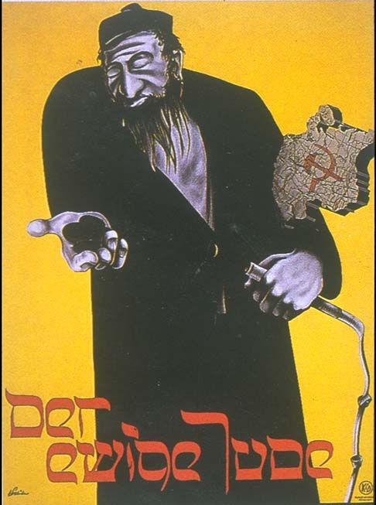
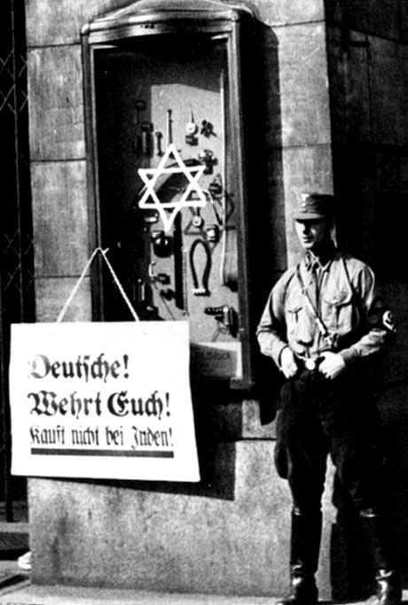
It is highly unlikely that a dictatorship would al ways be able to keep its people in line and content. They are likely to harbour some frustration or grievance. If, however, their grievances can be directed against groups other than the government; if the government can find someone else to blame, then the policies of the government will not be questioned. In fact, the government gains further support for the people.

The classic example of scapegoating is Hilter’s direction of popular discontent towards Jews and communists. Saddam Hussein often used Israel and the U.S. as the enemy of the Iraqi people.

The Use of Force (‘terror and secret police’)
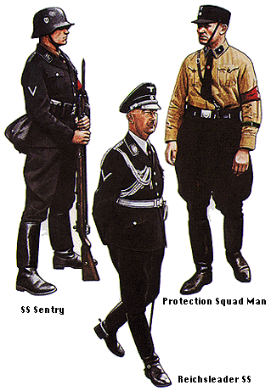
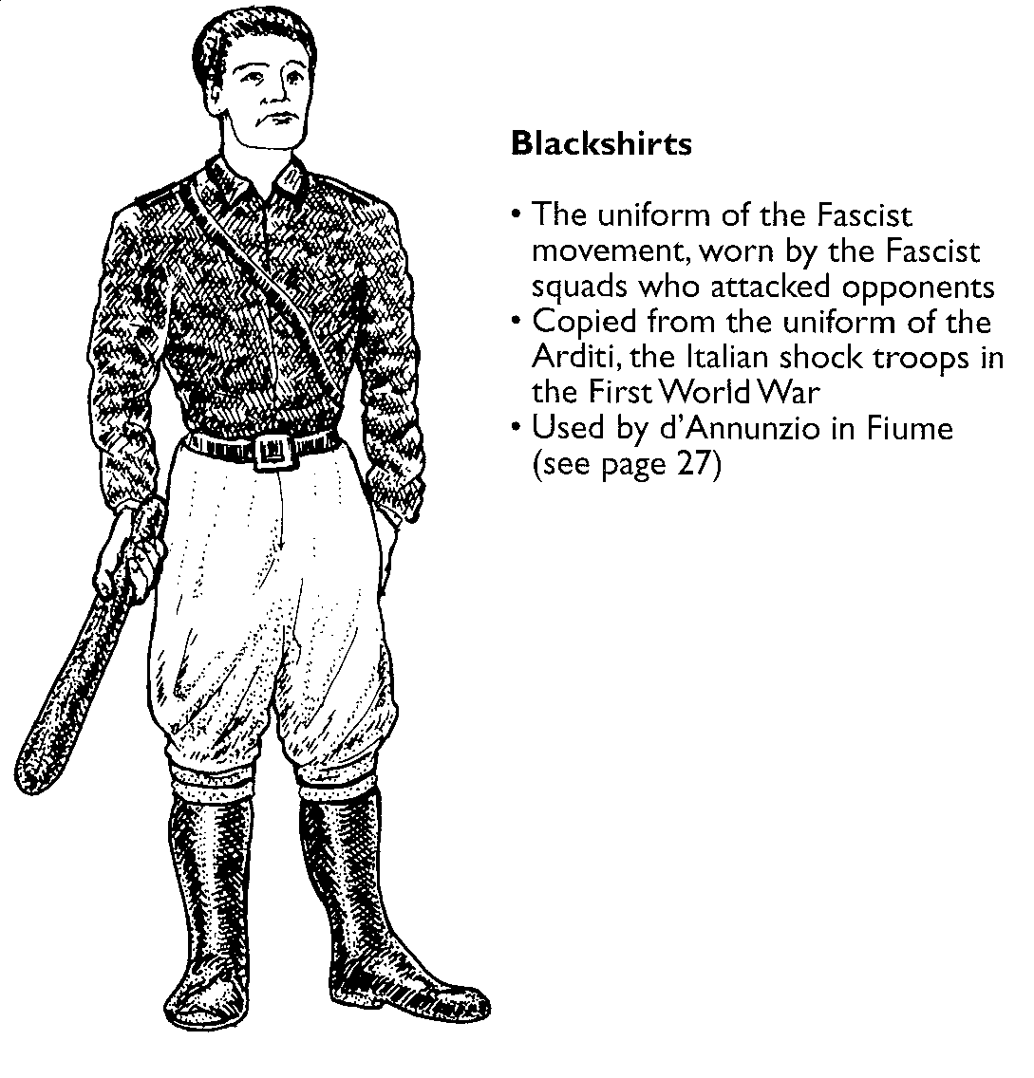
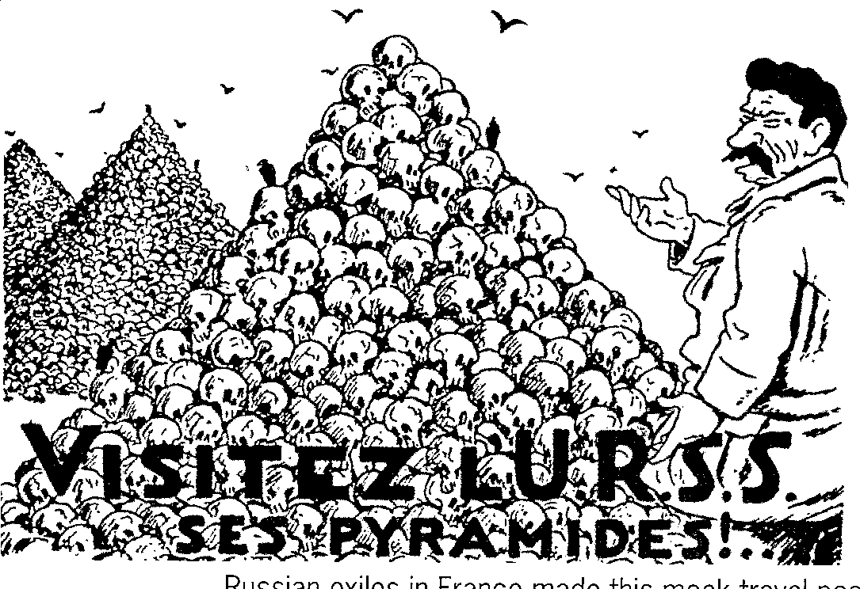
Terror and violence are effective measures for subduing a population and maintaining total control over them. Particularly effective is the use of a Secret Police whose powers enable them to enforce the will of thee government. They are empowered to deliver swift and arbitrary punishment to anyone suspected of possible disloyalty to the government. Citizens who 'might' one day oppose the government are prime candidates for imprisonment, torture, or liquidation. Their disappearance serves to terrorize any potential opposition.

All dictators have instruments of terror, usually some form of secret police used to terrorize the population so they won’t think of dissenting. Hitler had a myriad of terror weapons – Gestapo, SS, SA, SD; Stalin had the NKVD which later become the KGB; Mussolini had his Blackshirts (squadristi) etc.

Controlled Participation

People who are allowed to participate in and contribute to something are more likely to support it. Totalitarian dictatorships rally the people in displays of support for the government. Elections are held to allow the people to vote for the candidate chosen by the government. There is no opposition. The election process is simply an opportunity to allow people a sense of participating in government. Government sponsored youth groups provide opportunities for young children to take an active role in their country. Such groups are also the primary source for future supporters and members of the government.

There are some classic examples of controlled participation in the modern day and in historical examples. Stalin passed a very democratic constitution in 1936, guaranteeing basic human rights to his people, even though he was in the midst of a purge of millions of soviet citizens. Prior to the latest war in Iraq Saddam Hussein held a national vote to confirm his presidency – one hundred percent of eligible voters turned up to vote and an amazing one hundred percent terrified Iraqis voted to confirm Hussein as President.
