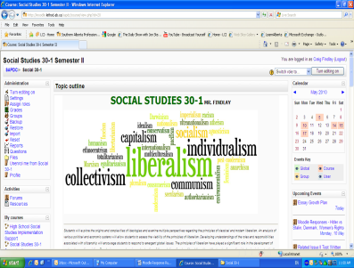

A good Moodle response meets the following criteria:

  - clearly addresses the central question or issue
  - demonstrates understanding of the chosen topic
  - communicates ideas and information effectively

Student Name ___________________ Cartoon: _____________ Date ______________

Level  Criteria | 4  Excellent | 3  Proficient | 2  Adequate | 1  Limited * | Insufficient / Blank *
Responds to the central question or issue | Response to the central question is specific and insightful | Response to the central question is meaningful and relevant | Response to the central question is general | Response to the central question is vague | No score is awarded because there is insufficient evidence of student performance based on the requirements of the assessment task.
Demonstrates understanding | Demonstrates a thorough and insightful understanding of the chosen topic | Demonstrates a clear understanding of the chosen topic | Demonstrates some understanding of the chosen topic | Demonstrates little, or no understanding of the chosen topic
Communicates key ideas and information | Communicates key ideas and information convincingly | Communicates ideas and information effectively | Communicates some ideas and information | Communicates few ideas

COMMENTS:

