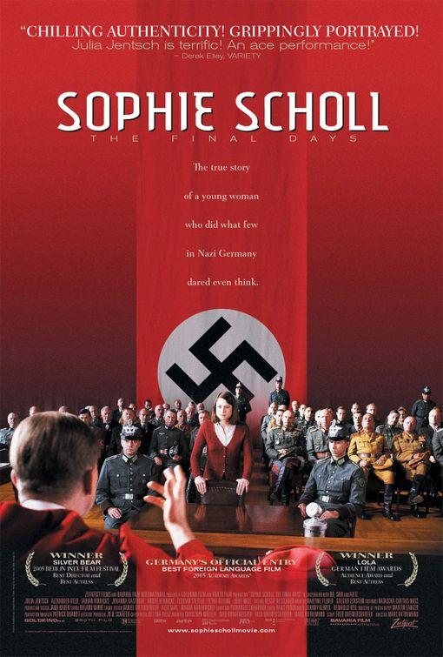
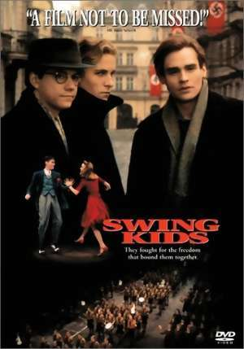

Your task is to choose a movie to watch and analyze. Your movie selection needs to have either a non-fiction political or historical component to it. Your movie should focus on the historical and political content we have been exploring in class up to this point. You will need to write a movie analysis by answering the following questions after watching the movie.

MOVIE QUESTIONS

Movie Title: ____________________________________________________________
Producer: _________________________________________________

Director: __________________________________________________

Actors: _________________________________________________________________

Brief Overview of the Movie: _______________________________________________

________________________________________________________________________

________________________________________________________________________

________________________________________________________________________

________________________________________________________________________

________________________________________________________________________

________________________________________________________________________

What is the historical and/or political message in the movie? ______________________

________________________________________________________________________

________________________________________________________________________

________________________________________________________________________

________________________________________________________________________

________________________________________________________________________

________________________________________________________________________

________________________________________________________________________

________________________________________________________________________

________________________________________________________________________

________________________________________________________________________

________________________________________________________________________

________________________________________________________________________

________________________________________________________________________

________________________________________________________________________

________________________________________________________________________

________________________________________________________________________

________________________________________________________________________

What is the link between the movie and the social studies content you have studied?

________________________________________________________________________

________________________________________________________________________

________________________________________________________________________

________________________________________________________________________

________________________________________________________________________

________________________________________________________________________

________________________________________________________________________

What rating would you give this movie (circle the number of reels – the more the better the movie)?

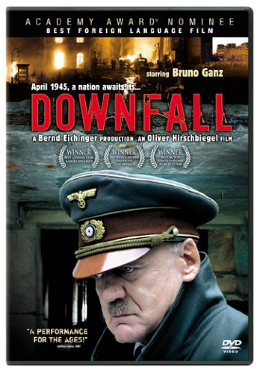
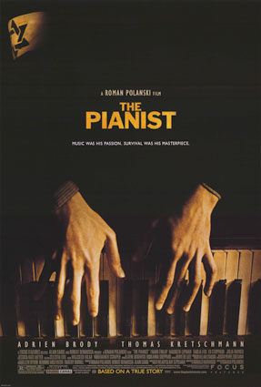

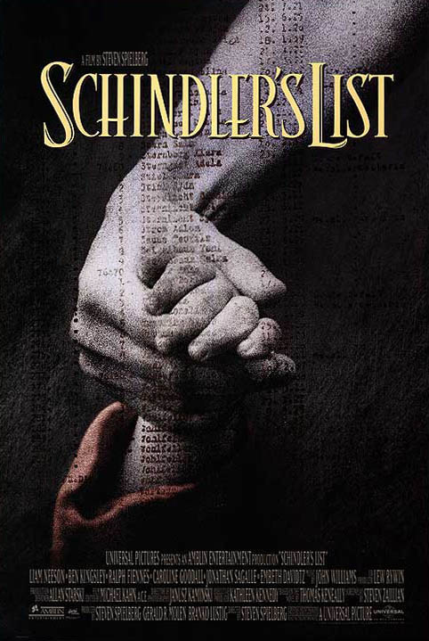
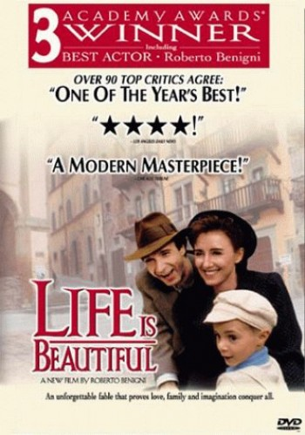
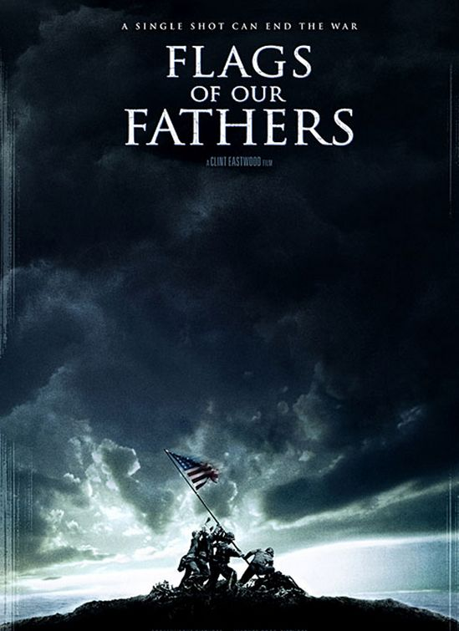


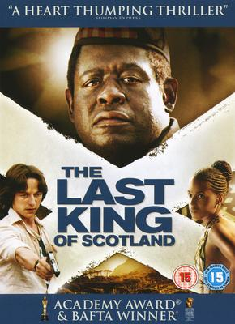
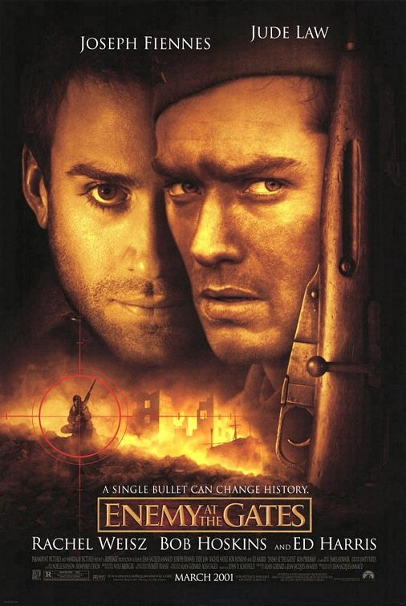

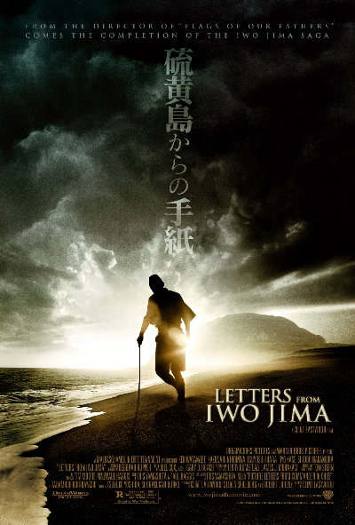
WARNING: many of the movie sited are rated 14A or higher. If you are under the age of 18, please insure that you have parental permission to view the movie.

