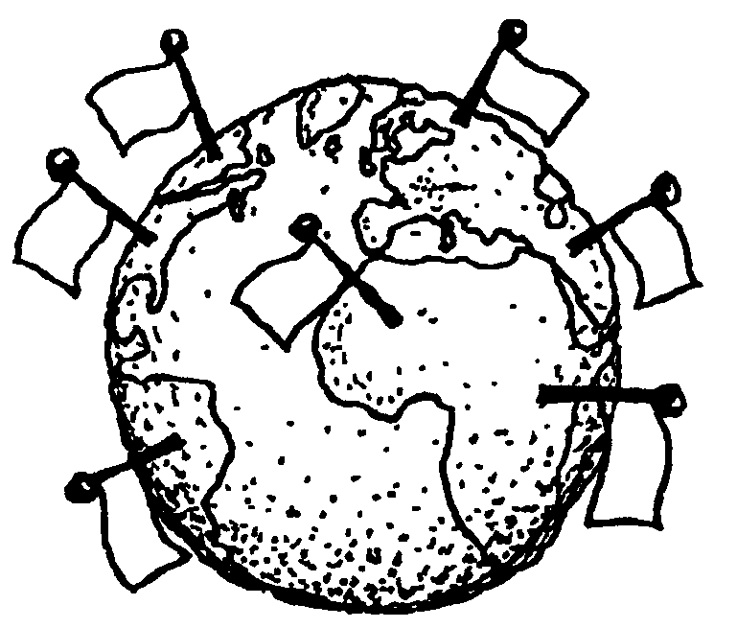

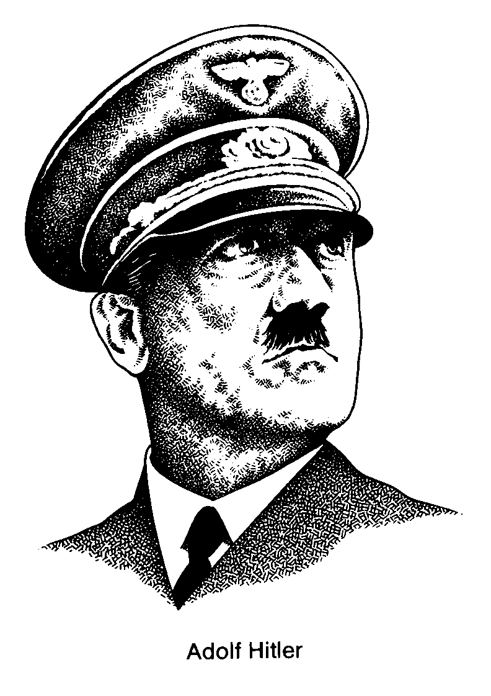
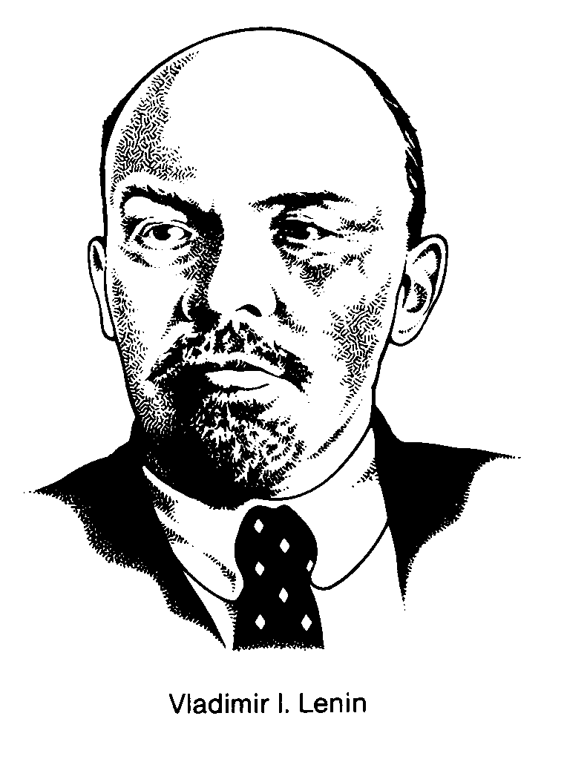
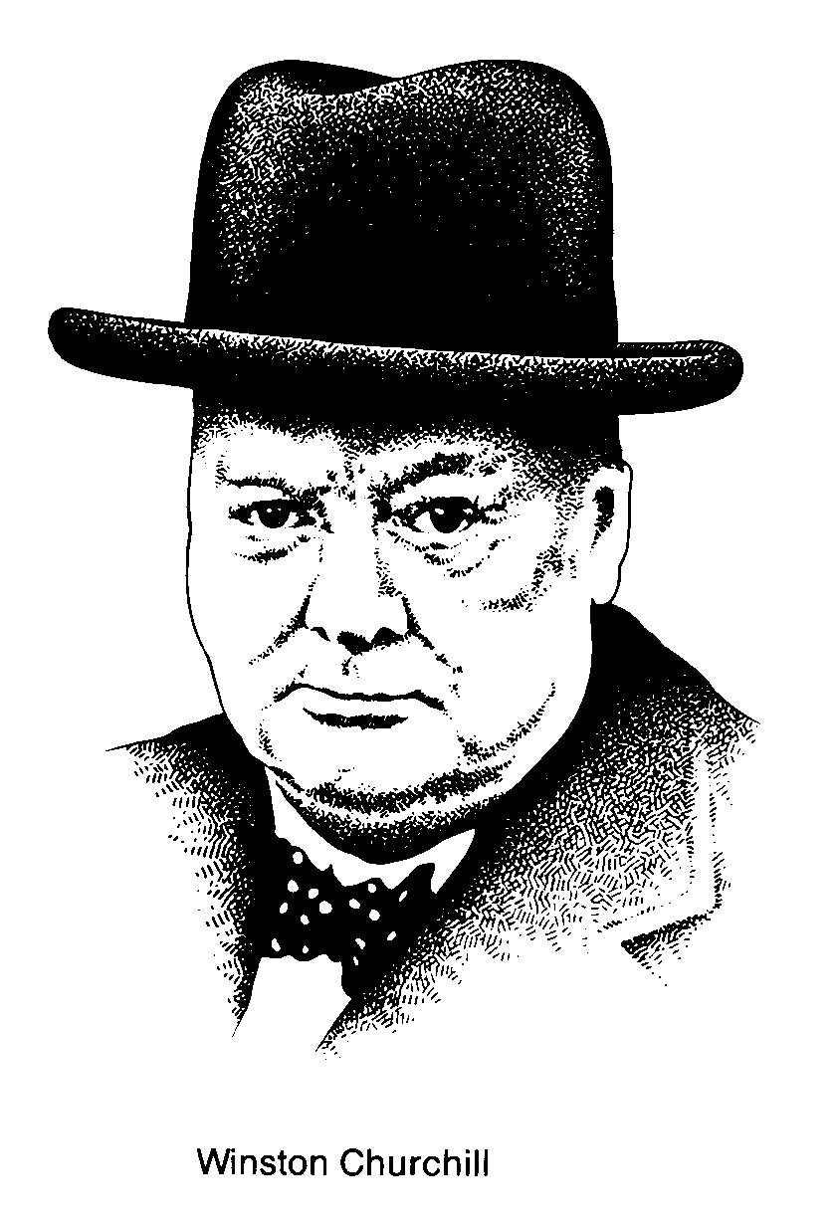
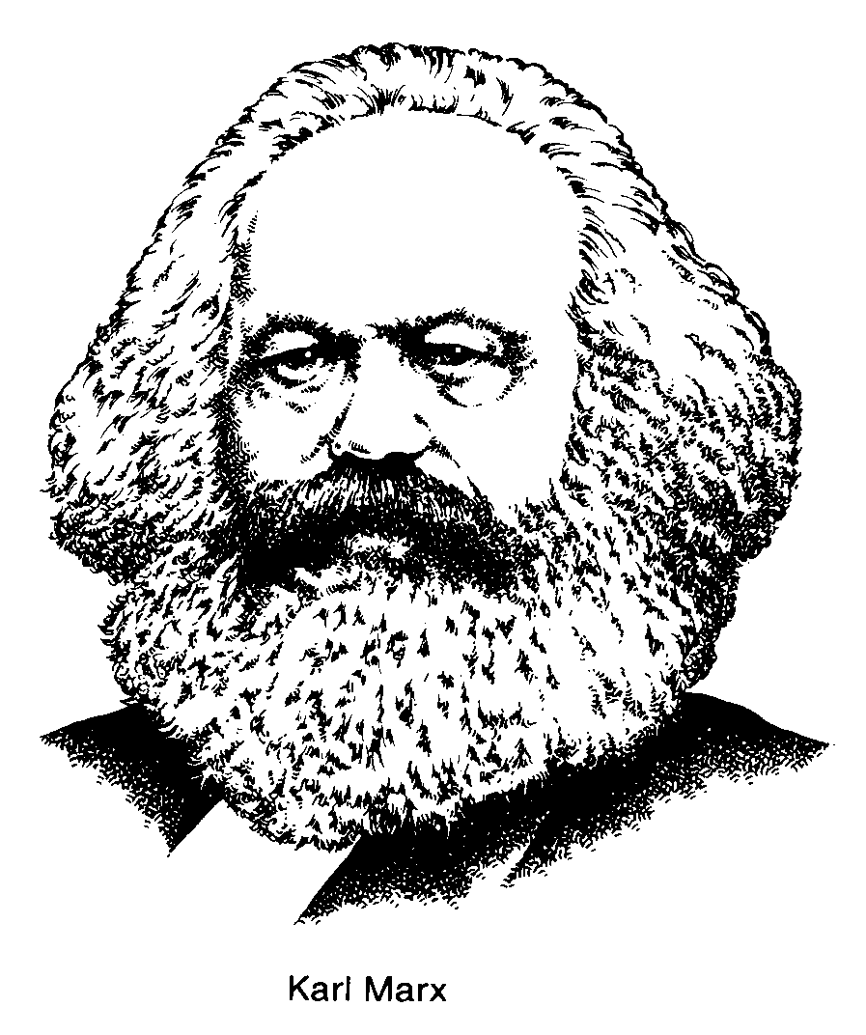
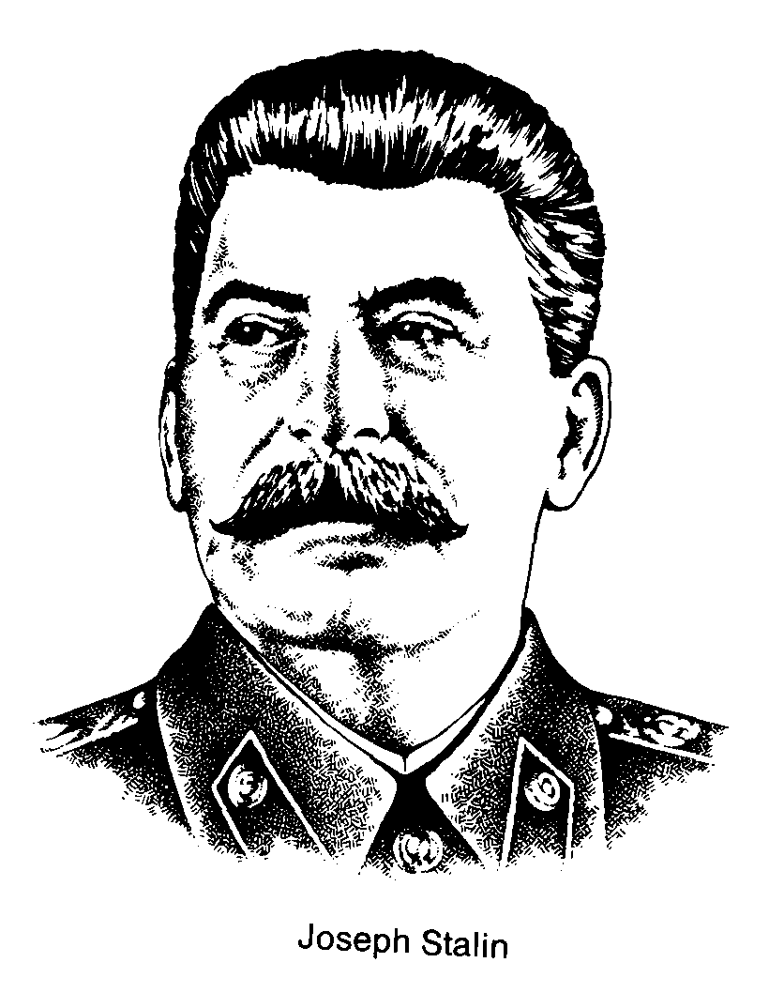
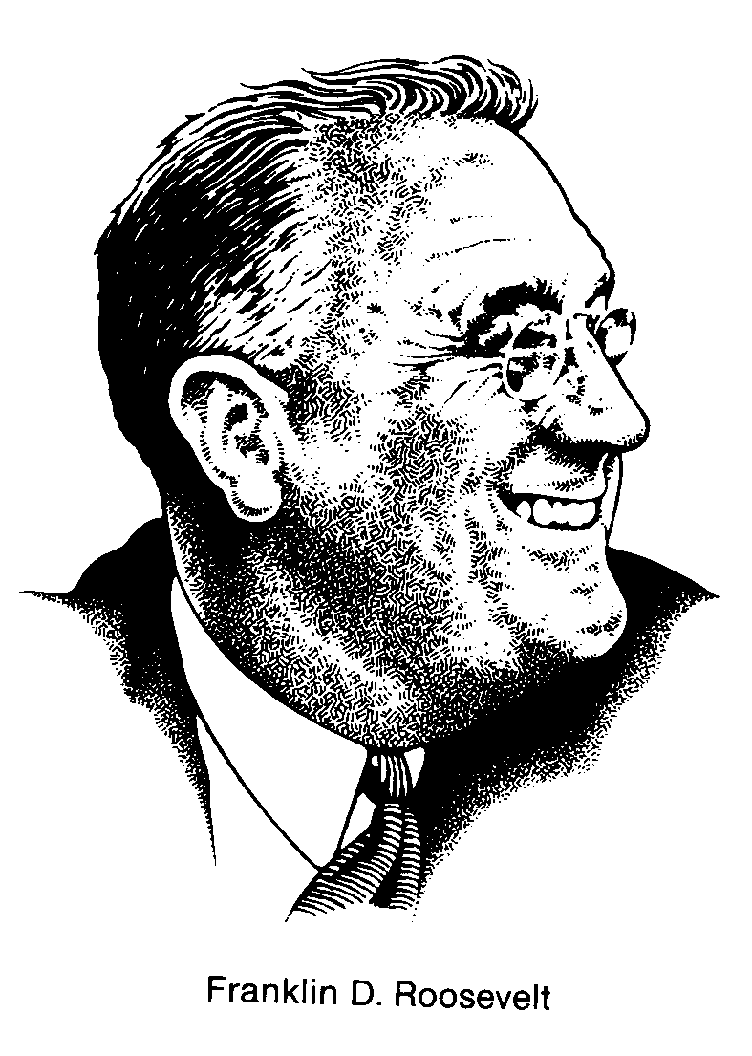
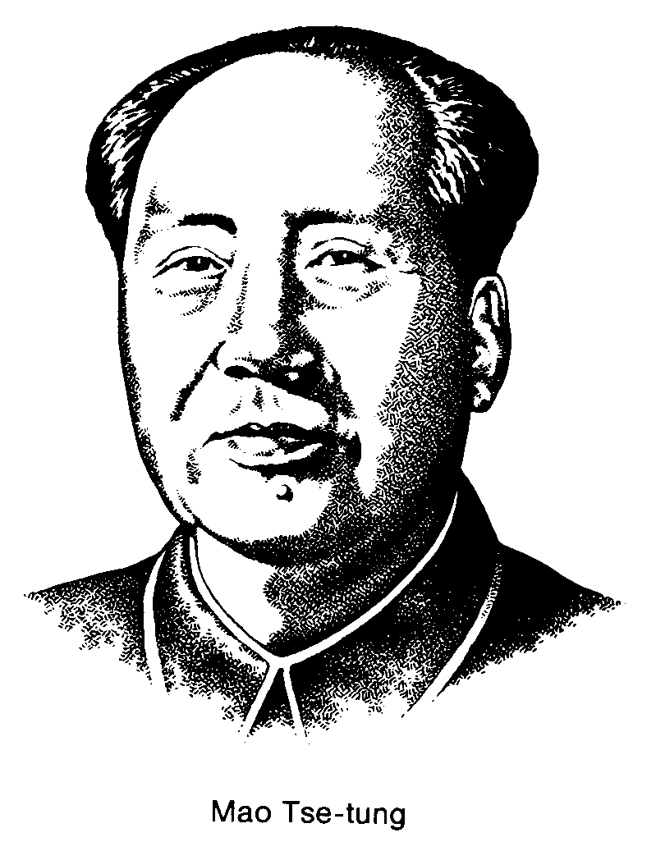
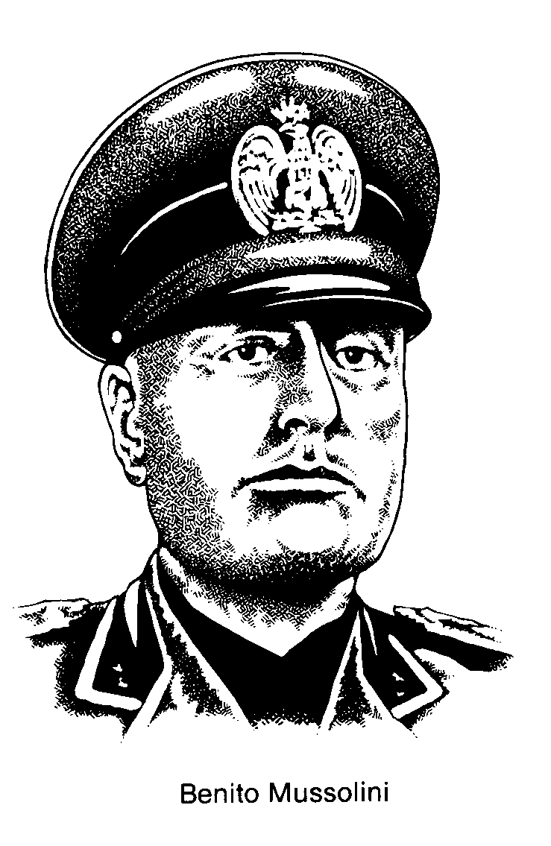

Canadian and U.S. Political System – Levels and Branches of Government

FEDERAL

PROVINCIAL
MUNICIPAL

HOUSE of COMMONS
(308 seats [constituencies] across Canada)
(election at least every 5 years)

SENATE
(105 seats – regional distribution)
(appointed by the P.M and G.G. to vacant seats)
*two houses = bicameral legislature

LEGISLATIVE ASSEMBLY
(NATIONAL ASSEMBLY in Quebec)

(83 seats [constituencies] in Alberta)
(election at least every 5 years)

(PMO – Ministries – Deputy Ministers)

TOWN or CITY COUNCIL

(Alderman - election every 3 years)
(8 Alderman in Lethbridge)

GOVERNOR GENERAL

LIEUTENANT GOVERNOR

MAYOR or REEVE

(election every 3 years)

COUNCIL COMMITTEES

PUBLIC SERVICE

PRIME MINISTER
(leader of party with most seats)

CABINET
(Ministers - chosen by P.M.)

CIVIL SERVANTS
(PMO – Deputy Ministers - Ministries)

PREMIER
(leader of party with most seats)

CABINET
(Ministers - chosen by Premier.)

CIVIL SERVANTS
(PO – Deputy Ministers - Ministries)

SUPREME COURT
(appointed by G.G. w/ advice from P.M.)
(appeal court)

FEDERAL COURT
(trial court)

PROV. SUPREME COURT
(appeal court)

SUPERIOR TRIAL COURT
(appointed by federal government)

PROVINCIAL COURTS
(small claims, criminal, youth, family)
(appointed by Premier)

MUNICIPAL BYLAWS

(enforced by provincial courts)

CONGRESS

HOUSE of REPRESENTATIVES
(directly elected – two year terms)

SENATE
(directly elected – six year terms)

THE PRESIDENT
(indirectly elected – four year term)
(pre-determined exact date of election)

CABINET
(appointed by President, confirmed by Senate)

SUPREME COURT
(members appointed for life)

