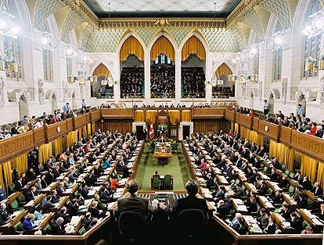
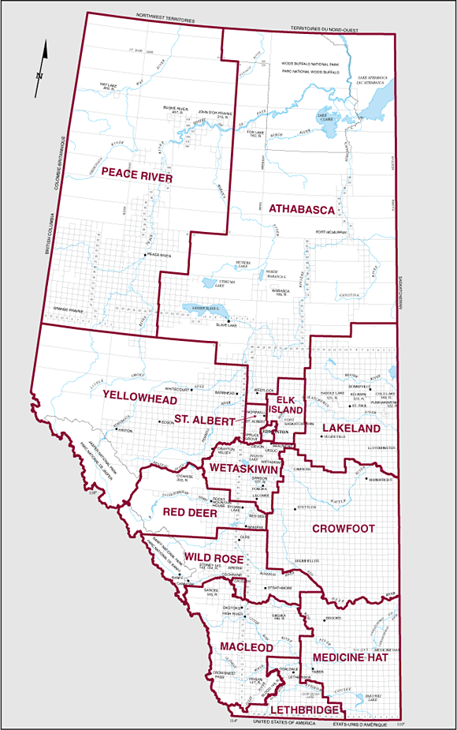



- Single Member Plurality (First Past the Post) Electoral System
In this system, each district elects one member. The candidate for that seat who earns the most votes wins the seat. In other words, as long as the candidate just one more vote than their closest opponent, they win the election (seat) – ‘winner takes all’! This is the system used in Canada, the United States, the United Kingdom, and India, to name a few examples.

Advantages: usually elects stable majority governments, major parties like this system
Disadvantages: people feel misrepresented or that their votes do not count

- Proportional Representation (PR) Systems
This is the most commonly used type of electoral system. In PR systems, each district usually elects multiple representatives and the seats are handed out in proportion to each party based on their share of the vote. There are many types of proportional representation systems and countless variations on the basic types. Broadly speaking, though, we can distinguish between three types of proportional representation systems. In a party list system, each party present lists of candidates for each district prior to the election. On the ballot, votes place an “X” above the party list they prefer. When a party wins seats in a district, then, the seats are awarded to the party, starting with candidate at the top of the list. For example, if a party deserves wins 30% of the vote in a district with twenty seats, they deserve six seats. The seats will be given to the top six candidates on the list. This is the most common type of proportional representation in the world. The Netherlands is an example of a country that uses a list form of PR.

Advantages: allows small third parties to gain representation, voters feel connected
Disadvantages: usually results in minority governments – less stable

What is Wrong With Our Electoral System?

Canadian democracy is deeply rooted in our culture and history. But today many Canadians feel their votes makes little difference, and a disturbing number no longer bother to even cast a ballot. Many citizens are reduced to voting ‘strategically’, not for their favoured candidate. They are afraid of ‘wasting’ their vote on a candidate with little chance of winning. For many this is a disheartening dilemma.
However, in most democratic countries voters are not forced into such strategic choices, and can go to the polls with confidence that their ballots will make a difference.
The Canadian electoral system is called Winner-Takes-All. There is only one winner in each constituency, and the winner is the candidate with the most votes. The system disregards all other ballots, even when they outnumber those cast for the winner. So there is a tremendous gap between what people vote for and what they end up getting.
Most other democratic countries use a system of proportional representation, which counts every ballot to elect a group of winning candidates. The result in these PR systems better reflect how the entire electorate cast their ballots.

Let’s look at the results of the 2000 federal election in Canada and note the difference between the number of seats and the number of votes each party received.

PARTY SEATS %ofVOTE %ofSEATS PR SEATS

Liberal 172 41 57 123
Alliance 66 25 22 75
PC 12 12 4 36
BQ 38 11 13 33
NDP 13 9 4 27

Look at these numbers and decide who is over-represented and who is underrepresented based on popular vote.

Here are some things to think about:

· The Liberal Party formed a majority government with just 41 per cent of the popular vote.

· The Bloc Québécois received slightly fewer votes than the PCs, but the BQ won more than three times the seats. Most parties benefit in some ways under the current system but are penalized in others. To take one example the Liberal Party is generally over-represented, but is drastically under-represented in British Columbia, Alberta and Saskatchewan.

· The Liberals received one out of every five votes in Alberta but won only two of the province's 26 seats.

· The Canadian Alliance received one out of every five votes in Ontario, but won only two of the province's 103 seats. Another way of making the point about the gap between votes and seats is to compare the votes each party needed to elect a member.

· The Bloc Québécois received one seat for every 36,258 votes;

· The Conservatives received one seat for every 130,583 votes.

These disparities raise disturbing questions for Canadian citizens. If we believe in democracy, why do we tolerate an electoral system that frustrates the voters' intentions. If we believe in the principle of ‘one person, one vote,’ why tolerate a system which treats voters unequally? Every vote is counted, but not every vote counts.
Sources: mapleleafweb.com, fairvotecanada.org

THINKING CRITICALLY

Look at the results from the Wood Buffalo Riding. Answer the following questions:

Which candidate would win the seat for Wood Buffalo? ______________________

What percentage of the vote did the winning candidate receive? ______ %

Imagine that every one of Canada’s
ELECTION RESULTS for WOOD BUFFALO RIDING

VOTES PARTY

Candidate 1 10 001 Liberals
Candidate 2 10 000 Conservatives
Candidate 3 10 000 New Democratic
Candidate 4 9 999 Green
Candidate 5 9 998 Action

constituencies (ridings) had similar results.
How well do think the results would
reflect the wishes of Canadian voters?

