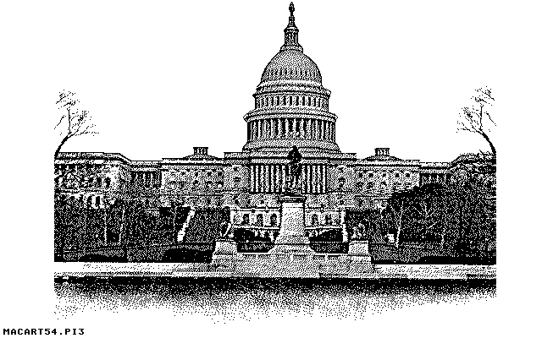
Congressional System
(Congress)

Executive Branch
Legislative Branch
Foundations of

AMERICAN DEMOCRACY
Republic
American Revolution
President
as Head of State
Federal System
(multi-level)
Municipal (local)
government
State
government
Federal (national)
government
Separation of Powers
Judicial Branch
Representative Democracy
(British model)
‘First Past the Post”
‘Rep by Pop’
in House of Represent.
Districts
Bicameral Legislature
House of Representatives
(lower house)
Senate
(upper house)
Checks and Balances
Constitutional

Declaration of Independence
Constitution and Amendments
Principles

Majority Rule
Secret Ballot
Political Parties

Bi-Partisan system
Democrats

Elections
Presidential
(every fours years)
House of Representatives
(every 2 years)
Senate
(every 6 years)
Republicans

Equal Represent.
in the Senate

