
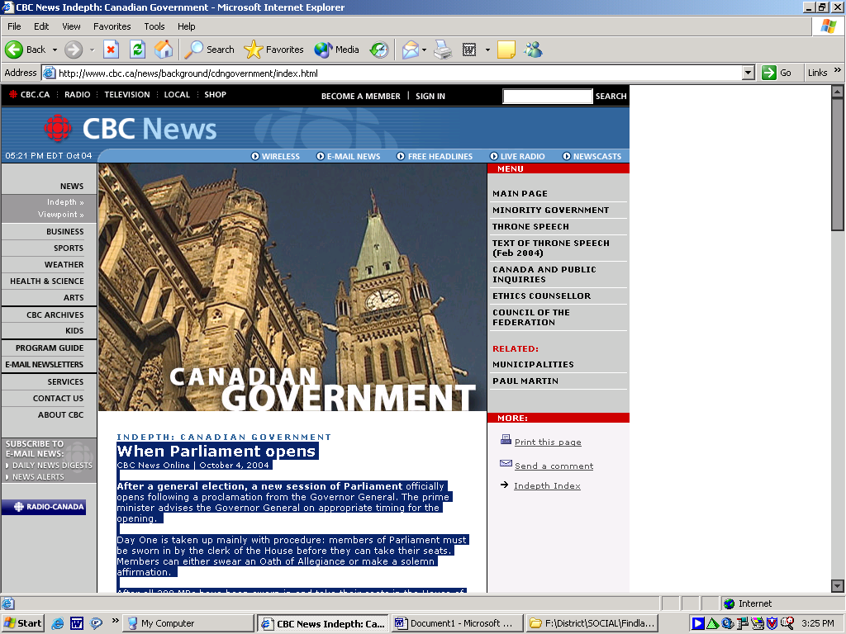

Mandatory voting could improve Canadian turnout
Updated Wed. Jan. 18 2006 1:21 PM ET
CTV.ca News Staff
Voter turnout in the 2004 federal election hit a record low, prompting some Canadian officials to consider introducing mandatory voting, a practice already law in Australia. Officials Down Under have seen higher than 90 per cent voter turnout since installing a mandatory voting law in 1924. That compares to 60.3 per cent in Canada in the 2004 election, the lowest since 1898.
The Australian high commissioner to Canada says his country's high turnout can be attributed to the simple law-abiding and fine-avoiding nature among most of his country's population. "Fifty dollars is not going to send you to the bank, but it's enough to encourage people to do the right thing," William Fisher told CTV's Canada AM Wednesday.
He explained that because Australia's elections are always held on a Saturday, if citizens weren't forced to vote many people would find other things to do with their time. "If we had voluntary voting now, we would still have very low voting turn-out because, as you can guess, in Australia, a weekend is something to value."
The country invoked the measure after voting levels dropped to 40 per cent in the early 1920s. Offenders aren't asked to qualify why they didn't participate in the election, but receive a ticket much like a parking fine in the mail. Fisher said a small percentage of voters who haven't chosen a party turn in a blank ballot to avoiding being fined, but the majority devote at least some time to figuring out which party best represents their views.
"It does make people think about what they're going to vote for, so even if people were not naturally inclined to be interested in politics, the fact that they are going to vote means that they do give it some thought," he said. "I think it has a general educational effect on the population."
Experts in Canada, including Chief Electoral Officer Jean-Pierre Kingsley and a Winnipeg think tank called the Frontier Centre for Public Policy, think mandatory voting could have equally positive results in Canada.
After announcing a 61.2 per cent turnout for the 2000 election -- a record low at that time -- Kingsley suggested politicians take another look at the idea. It was later proposed in a Senate bill in 2004. "Sometimes, in order to save democracy, you have to do things that might seem to run a little bit against it," said Kingsley.
The Frontier Centre's Dennis Owens, who has studied the issue extensively, believes higher turnout would prevent special interests from having a disproportionate effect on election results. He recommends a law that would allow for exemptions for those who could show they have good reason to abstain from casting a ballot.
Australia isn't the only democracy to implement mandatory voting. Citizens are required to vote in more than 30 countries worldwide, including Belgium and Greece. The turnout rates for elections in those countries are 92 and 80 per cent respectively.

