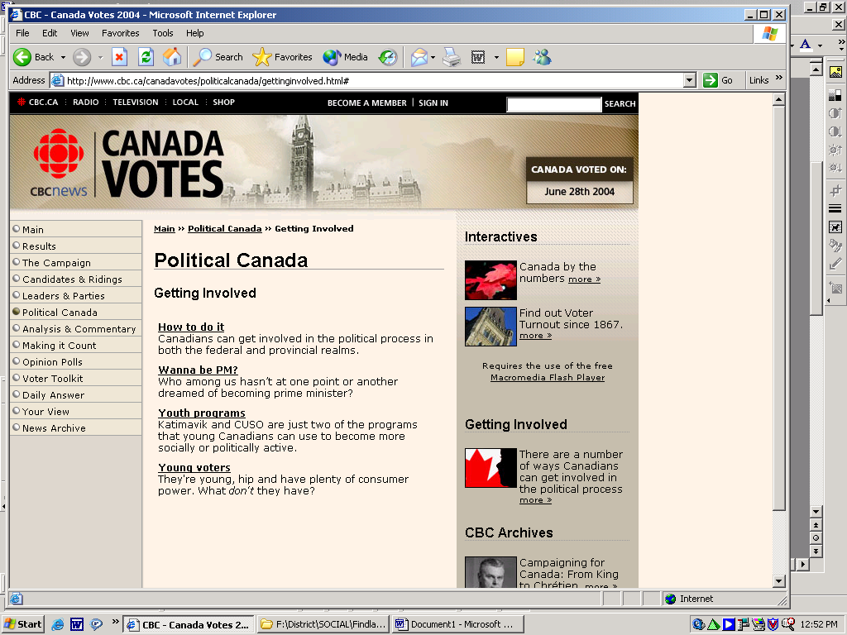

Our ‘first-past-the-post’ system of electing parliamentarians usually results in stable majority governments (party winning the election with more than half of the seats in the House of Commons). Minority governments (party winning the election with less than half of the seats in the House of Commons) in Canada are more rare, and with our ‘responsible government’ system are much less stable. A ‘vote of non-confidence’ in parliament can bring down a government.
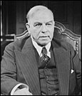
William Lyon Mackenzie King (Liberal)1921 election: Liberal (116); Progressive (50); Conservative (63); Labour (3); and Other (3)
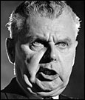
John Diefenbaker (Progressive Conservative)1957 election: PC (113); Liberal (103); CCF (25); Social Credit (19); Independent (2) and Other (3)
Lester Pearson (Liberal)

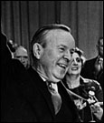
Lester Pearson (Liberal) 1963 election: Liberal (128); PC (95); Social Credit (24); NDP (17) and Other (1)

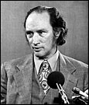
Pierre Trudeau (Liberal) 1972 election: Liberal (109); PC (107); NDP (31); Social Credit (15) and Other (2)

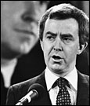
Joe Clark (Progressive Conservative) 1979 election: PC (136); Liberal (114); NDP (26) and Social Credit (6)

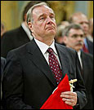
Paul Martin (Liberal) 2004 election: Liberal (135); Conservative (99); Bloc (54) ; NDP (19)


Stepen Harper (Conservative) 2006 election: Conservative (124); Liberals 103; BQ 51, NDP 29

Here is an interesting scenario that could play out in our political system in Canada:

If the ruling party comes in second in an election in which no party has a majority, can that party continue as the government?

A minority government is a situation in which no one party has more than 50 per cent of the seats in the House of Commons. With 308 ridings electing MPs this time, a party would need 155 to form what's called a majority government.
If no party wins 155 seats, the leader of the ruling party (the Liberals in this case) gets first crack at convincing the Governor General that he can form a government, even if another party has won more ridings. That's because the prime minister remains the prime minister until his government is defeated by another party that wins a majority of seats in a general election, he resigns, or his government loses a ‘vote of confidence’ on a major motion in the House of Commons (for example, on the vote to accept a budget). With all the other parties combined holding more seats and thus votes than the ruling party, this is the usual way a minority government comes to an end.
The day of defeat can be staved off for months or even years if the governing party strikes a pact with one or more small parties to support it on parliamentary votes (look to the King-Byng Affair as an interesting case study). The usual payoff is a promise that the ruling party will introduce legislation that accomplishes some of the planks in the minor party's platform. At some point, however, the relationship falls apart over some deep disagreement on policy or an itch to get back to the polls to ask voters for a more stable majority government.
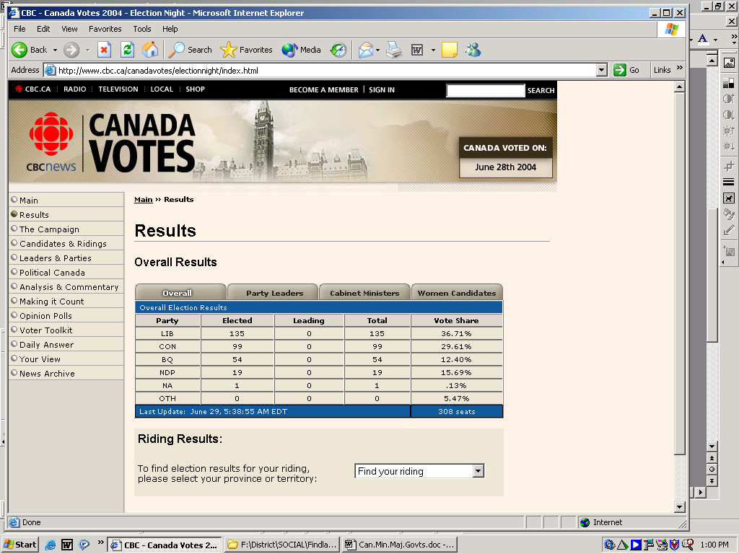
Governor General Adrienne Clarkson would come into the picture if our next government falls on a confidence vote. She would go to the party with the best chance of forming a different minority government with the same group of 308 MPs sitting in the House of Commons. Say the Liberals had won 110 seats and the Conservatives 140, with the other parties racking up 58 between them. If Liberal Leader Paul Martin's attempt at a minority government fell, Clarkson would ask Conservative Leader Stephen Harper if he was prepared to form a government. If he could form an alliance with another party, the Bloc Québécois for example, he could then rule for as long as that friendship stayed intact (or until the natural end of the government's five-year mandate). But that coalition too would likely fall apart before long and the Conservatives would lose a vote of confidence.
If no party is prepared to form a government, the Governor General will dissolve Parliament and call a general election, in which all the parties get a chance to win more than half the seats and form a majority government.
That's not a guaranteed result after a minority government falls in Canada, it should be noted. Liberal Lester B. Pearson led two back-to-back minority governments following elections in 1963 and 1965. The Nobel Peace Prize winner was the first prime minister in Canadian history to never win a majority government.
GOVERNOR GENERAL
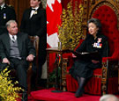
The Governor General would play an important role in our political system if there was not a clear victor in an election, but is that enough to justify their position within our political structure?

Officially, Canada’s Head of State is Queen Elizabeth II. We technically do not have our own ‘Head of State’. Although once a force in Canadian government, the Queen's powers today are ceremonial. She is represented federally by the governor general and provincially by the lieutenant-governors.

The Governor General represents the Crown in Canada. The governor general is appointed by the Queen on the advice of the prime minister. She opens and ends sessions of Parliament, gives royal assent to bills and reads the speech from the throne. History and convention show that, although the governor general is the formal executive - approving cabinet decisions or bills passed in Parliament - he or she does so only on the advice of the prime minister and cabinet. The governor general also presides over the swearing in of prime ministers, cabinet ministers and the chief justice of the Supreme Court. She also ensures there is always a prime minister in office.

Many people have begun to question the role and the need of the Governor General in Canada. The budget of the Governeor General’ office is $19 million (up from $11 million in 1999). A recent trip to Russia and other neighboring Arctic countries, costing five times as much as first proposed ($5 million) are forcing Canadians to examine the traditional role of the Governor General. Many Canadians think that Canada should take its final step towards true sovereignty and eliminate the role of Governor General. What do you think? www.cbc.ca/canadavotes

