

What is Party Discipline?
Party discipline is a major component of the Canadian system of government. This section examines the idea of party discipline, its relationship to Canada’s parliamentary system, and its strengths and weaknesses.

Parliamentary System
When a Canadian election is held, people vote for a local representative who usually belongs to a political party (i.e. the Liberal Party of Canada, the New Democratic Party of Canada, etc.). When the election is finished, the party that holds the most seats in the House of Commons forms the Government. The leader of that party becomes Prime Minister. Further, members of that party form the Cabinet and take control of various Government Departments.

Party Discipline
Party discipline means that each member of a political party (who is elected to Parliament) must do what the leaders of the party tell them to do. For example, when the House of Commons votes to pass a bill, members of parliament don’t vote according to their own feelings, but according to the policy of their political party. If they fail to do so, their political party punishes them. They may be demoted to a lesser position within the party or within government.
This is not to suggest that members of a party may never disagree with their leadership. However, dissent must never be public and must never interfere with official party or government business. Generally, dissent can be voiced in caucus meetings, which are usually held behind closed doors, away from the public and media.

Party Discipline and Parliamentary System
Party discipline is very important to the workings of Canada’s parliamentary system. The Prime Minister is the head of government in Canada. However, the Prime Minister’s vote is worth no more than any other member's vote in the House of Commons. For the Prime Minister to act effectively he or she must depend upon the votes of other party members in the House of Commons. When introducing new laws or programs, the Prime Minister must know that other party members will vote in support of the legislation. The Prime Minister uses party discipline to ensure this support is always present and that government legislation is never defeated.

Strengths and Weaknesses of Party Discipline

Strengths of party discipline:
- Effective Government – If the Prime Minister cannot depend upon his or her party members to vote in a certain way, then government would never get anything done. Advocates of party discipline often point to the United States. In the US, there is no party discipline and representatives often vote according to their own conscious. As such, the passing of legislation in the US is a very slow and difficult process.
- Distinction between Political Parties – With party discipline, voters can easily draw distinctions between the different political parties. Different political party policies will be maintained, regardless of individual party member's feelings. If I vote for a Liberal candidate, I know what policies that individual will support.

Weaknesses of party discipline:
- Trivializes the role of a Member of Parliament – If a Member of Parliament must vote according to party line and not their own views, then their ability to represent their own views and the views of their constituency is greatly reduced.
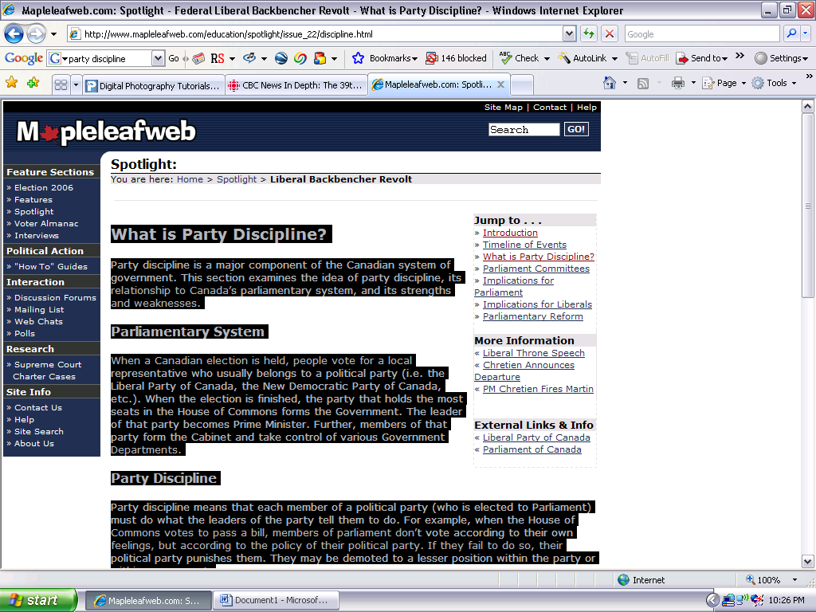
- Too much power for the Prime Minister – The Prime Minister is generally the most powerful individual in both his party and the government. With party discipline, the Prime Minister is able to ensure that his/her views and policies become the government’s policies. It is thus difficult for other members to challenge the Prime Minister's views.
Source: http://www.mapleleafweb.com/education/spotlight/issue_22/discipline.html


Party Discipline Diminishes Canadian Democracy

By David Kilgour (Member of Parliament Edmonton-Beaumont) and John Kirsner
Representative democracy in Canada is so dominated by political parties that some experts believe the party discipline exerted on most votes in our House of Commons and provincial legislatures is the tightest in the democratic world. Defenders of our model argue many Canadians prefer it this way because every candidate for each party can be assumed at election time to have identical views on every issue. Others contend our executive democracy, patterned on a system prevailing in Great Britain about three centuries ago, requires iron party discipline if our fused legislative and executive branches of government are to function effectively. Another reason, probably the most important, is that our practice makes life easier for leaders of both government and opposition parties.
Unlike parliamentary systems in places such as Australia, virtually every vote in Canadian legislatures is considered potentially one of non-confidence in a government. Even a frivolous opposition motion to adjourn for the day can be deemed by a cabinet, if lost, to have been one of non-confidence. The whips of government parties have for decades used the possibility of an early election to push their members into voting the respective party line. The opposition attitude is so similar that we have the recent spectacle of both opposition parties in our House of Commons arguing that a free vote on an abortion resolution would "rip out the heart" of our parliamentary system of government. The constituents of both provincial and federal legislators would be the real winners if party discipline is loosened. Private members from both government and opposition benches could then take positions on government bills and other matters based on pleasing constituents instead of their respective party hierarchies.
A key recommendation of the all-party McGrath report on House of Commons reform favoured more free votes by calling for the inclusion in any opposition motion intended to bring down a government an explicit provision that its passage would constitute a vote of non-confidence. Another solution to excessive party discipline is the "positive non-confidence rule" used in the West German Bundestag. It prescribes that an administration is only defeated if a successful opposition non-confidence motion also names a new chancellor. In the case of the defeat of the minority Clark government in 1979 on its budget, for example, the West German rule would have left Clark in office unless the Liberals, New Democrats and Social Credit MP's had agreed simultaneously on a new prime minister who could hold the confidence of a majority of MP's.
A study of the Thirty-Second Assembly of Ontario (1981-1985) indicated legislators voted in uniform party blocs about 95 percent of the time. The same basic pattern applies in the present and at least the previous two House of Commons elected in Ottawa. This record suggests the various party leaders could cast a proxy on behalf of all their followers without bothering to have them physically present for votes. It also overlooks that a majority or even minority government can function effectively without stratospheric levels of party solidarity.
In the American Congress, where admittedly there is a strict separation of powers between the executive and legislative branches of government, legislation does get passed with far less party loyalty. So different are the practices in our two countries that The Congressional Quarterly defines party unity votes as ones in which at least 51 percent of members of one party vote against 51 percent of the other party. Under this definition, itself astonishing to Canadian legislators, the Quarterly notes that for the years 1975-1982 party unity votes occurred in only 44.2 percent of 4,417 recorded Senate votes and in only 39.8 percent of ones in the House of Representatives. This sample, moreover, includes the years 1976-1980 when the Democrats controlled The White House and both branches of Congress.
A consequence of the American practice of voting one's constituents' presumed interests first is the longtime legislative coalition of Southern Democrats and Republicans.
During 1981-82, the height of the "boll-weevil" era, the group was successful more than 85% of the time because a majority of American legislators from both parties shared a number of areas of agreement. Whether one agreed with them or not is irrelevant; the point is that Canadian bloc voting makes bi or tri-partisan agreement on anything in our legislatures exceedingly rare.
If party discipline in Canada is relaxed, it would be easier for, say, Atlantic MP's to defy their three party establishments, if need be, in support of maritime issues. Coalitions composed of members from all parties could exist for the purpose of working together on matters of common regional or other concern. The adversarial attitudes and structures now entrenched in Parliament and our legislatures by which opposition parties oppose virtually anything a government proposes might well change in the direction of all parties working together in the national interest.
Source: http://www.david-kilgour.com/mp/partydiscipline.htm

