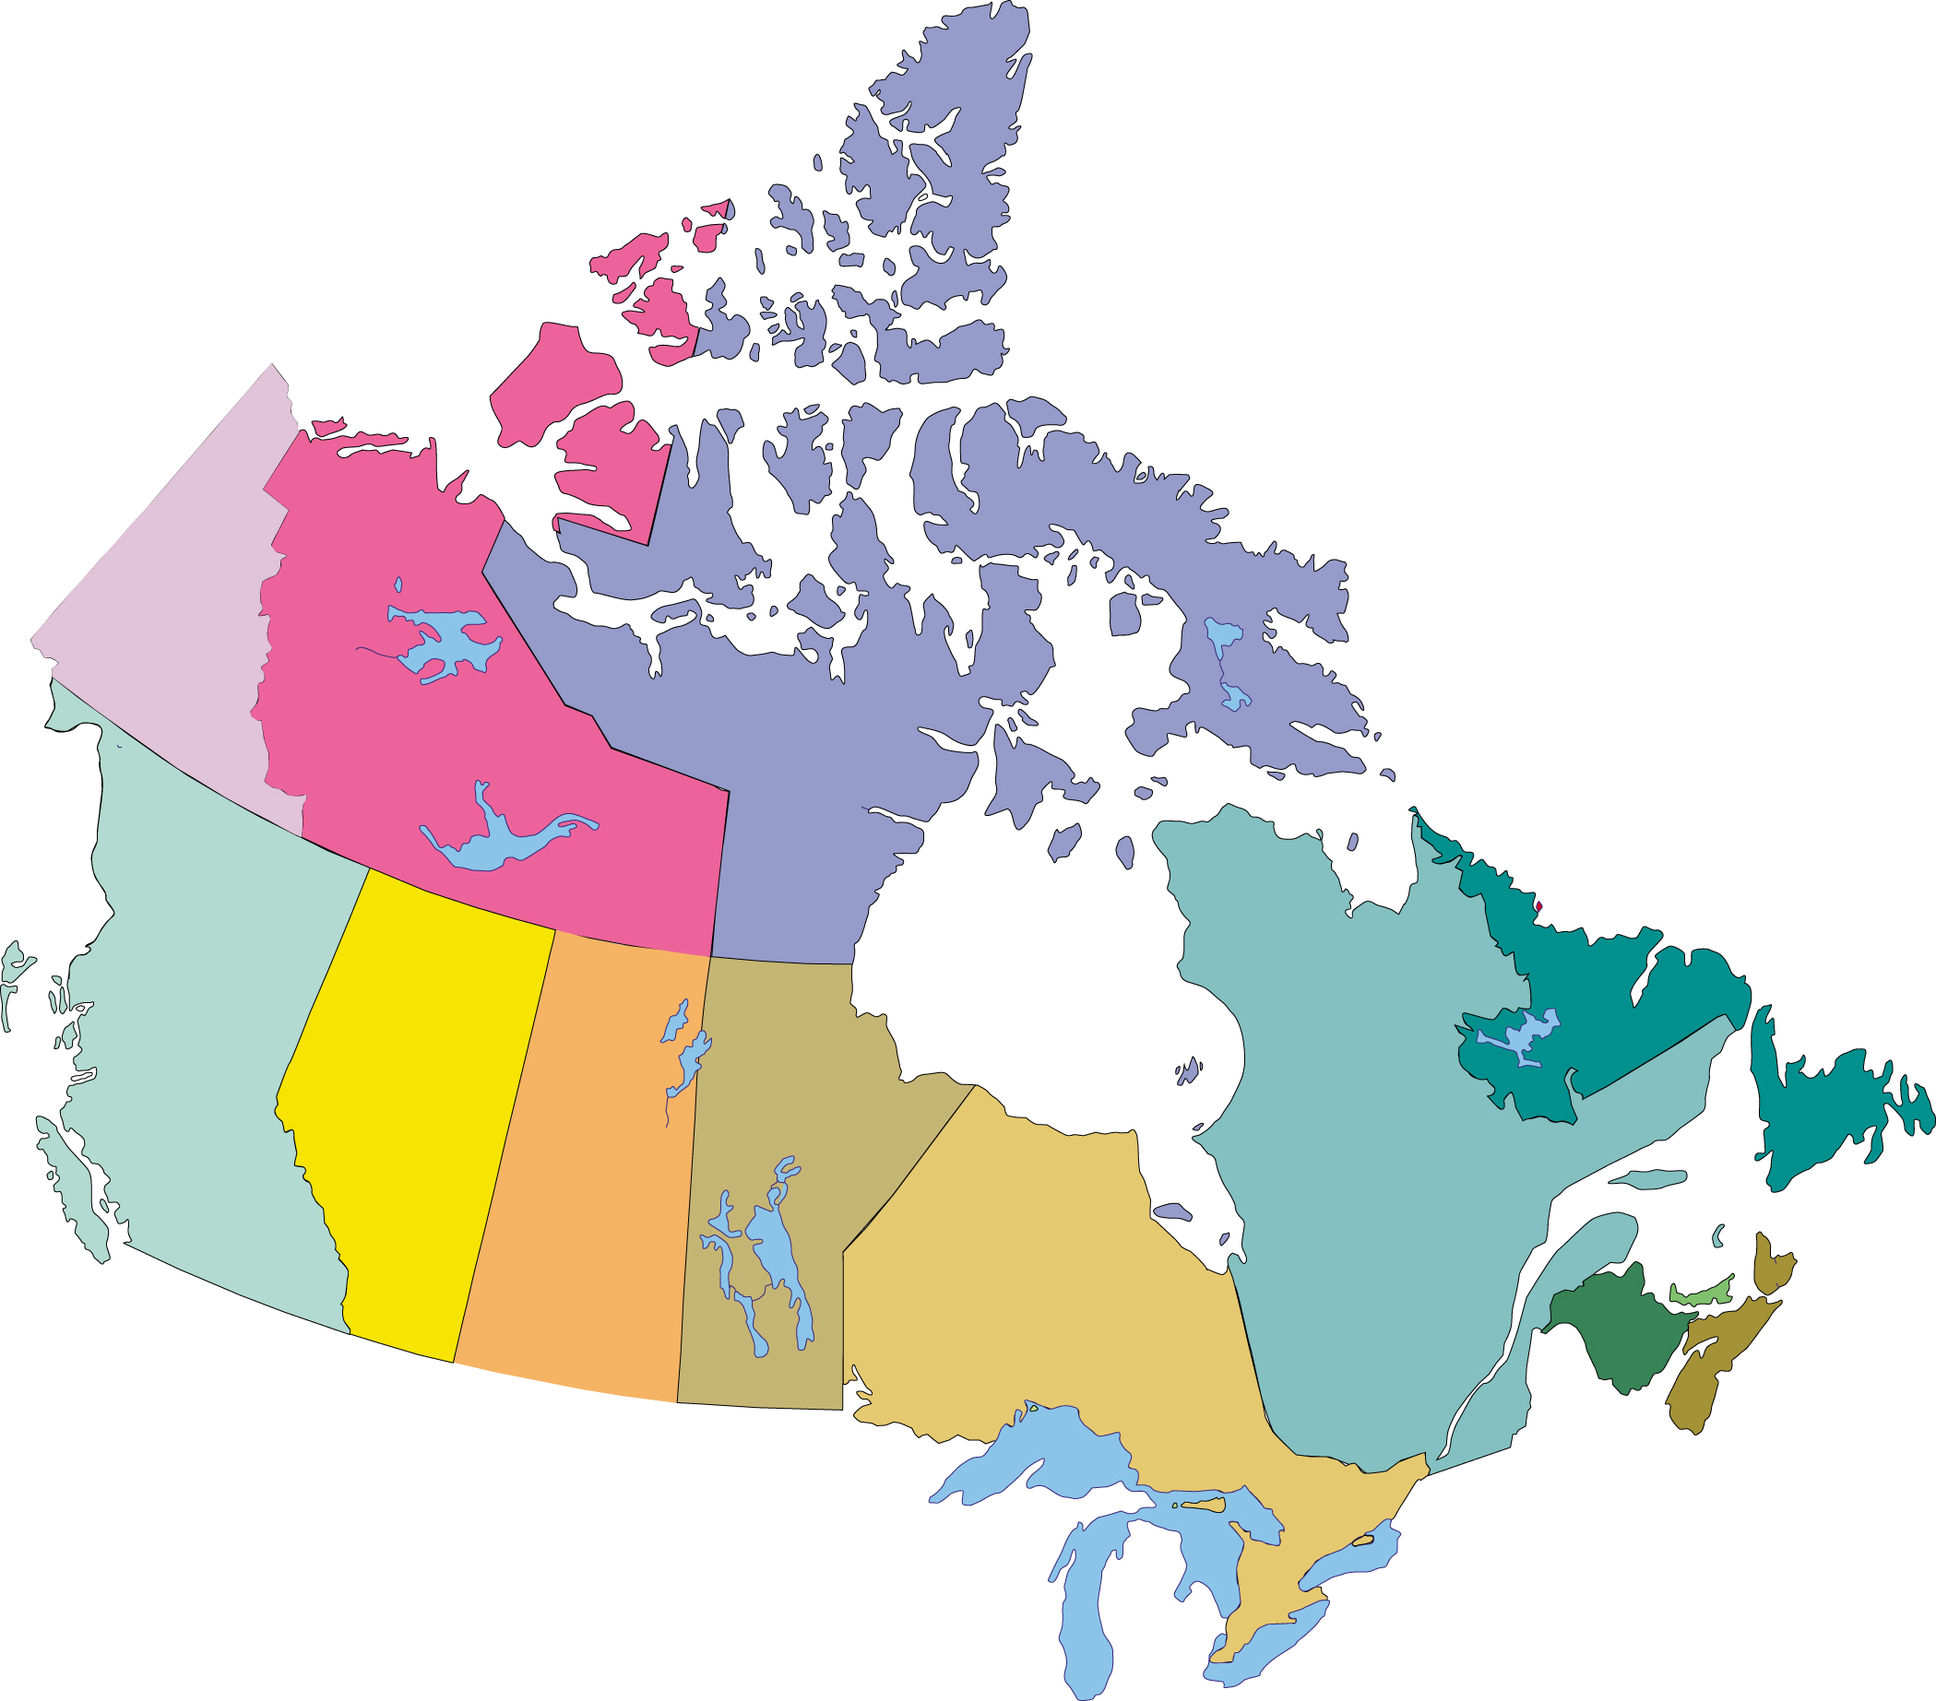
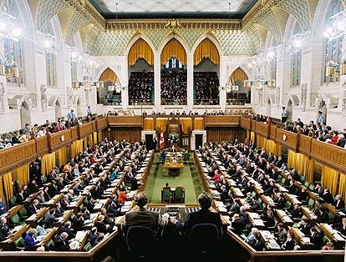
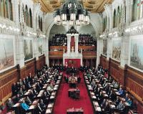
 | HofC | Senate |  | Constituents
 | Seats | Seats | Population | per Seat
BC | 36 | 6 | 4,220,000 | 117,222
 | HofC | Senate |  | Constituents
 | Seats | Seats | Population | per Seat
NFL | 7 | 6 | 517,000 | 73,857
 | HofC | Senate |  | Constituents
 | Seats | Seats | Population | per Seat
PEI | 4 | 4 | 137,700 | 34,425
 | HofC | Senate |  | Constituents
 | Seats | Seats | Population | per Seat
NB | 10 | 10 | 751,300 | 75,130
 | HofC | Senate |  | Constituents
 | Seats | Seats | Population | per Seat
NS | 11 | 10 | 937,500 | 85,227
 | HofC | Senate |  | Constituents
 | Seats | Seats | Population | per Seat
AB | 28 | 6 | 3,223,400 | 115,121
 | HofC | Senate |  | Constituents
 | Seats | Seats | Population | per Seat
SK | 14 | 6 | 995,300 | 71,093
 | HofC | Senate |  | Constituents
 | Seats | Seats | Population | per Seat
MAN | 14 | 6 | 1,174,600 | 83,900
 | HofC | Senate |  | Constituents
 | Seats | Seats | Population | per Seat
ONT | 106 | 24 | 12,449,500 | 117,448
 | HofC | Senate |  | Constituents
 | Seats | Seats | Population | per Seat
QU | 75 | 24 | 7,568,600 | 100,915
 | HofC | Senate |  | Constituents
 | Seats | Seats | Population | per Seat
NWT | 1 | 1 | 42,900 | 42,900
 | HofC | Senate |  | Constituents
 | Seats | Seats | Population | per Seat
NUN | 1 | 1 | 29,700 | 29,700
 | HofC | Senate |  | Constituents
 | Seats | Seats | Population | per Seat
YK | 1 | 1 | 31,200 | 31,200
 | HofC | Senate |  | Constituents
 | Seats | Seats | Population | per Seat
CANADA | 308 | 105 | 32,078,700 | 104,152

Canada’s lower house of the federal legislative branch of government, the House of Commons, is designed based on the principle of representation by population (‘rep by pop’). Canada’s upper house of the federal legislative branch of government, the Senate, was established based on the principle of equitable representation by region. What do you think of the numbers you see on this page?
House of Commons
Senate of Canada

