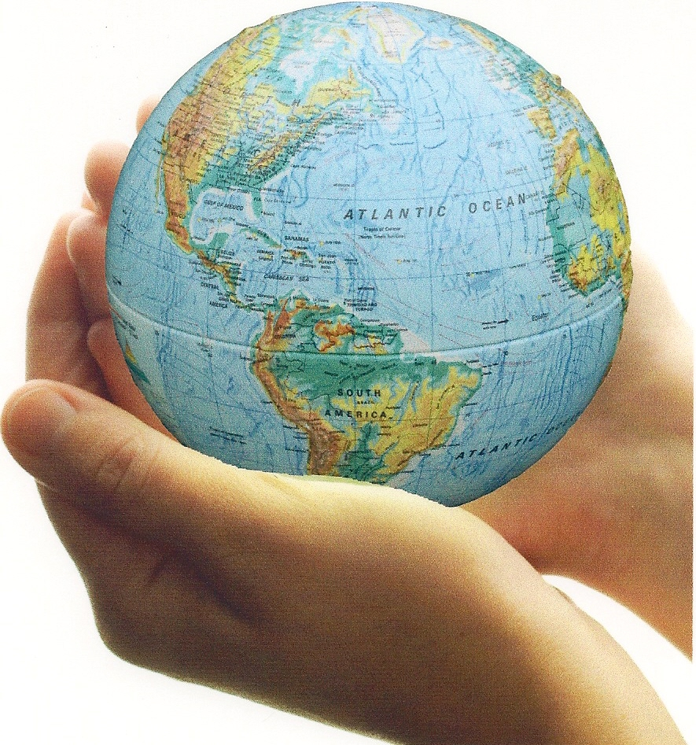

Read the following article and complete the tasks below (you likely read this piece in social 10-1):

Canadian Underground Informer

September 21, 2078.

Our situation continues to deteriorate and there are only a few thousand of us left. We salute those patriots strong enough to resist the oppressor and protect and defend the last vestiges of the Canadian identity. Our message is clear: do not let go of our story, our values, our cultures, our languages.

It has been ten years since the day Canada ceased to exist. It was a cold morning day on the 21st day of September, 2068, when the first reports started flowing through our electronic media receivers.

“Canada has been attacked and invaded, in a five pronged assault. The swift barrage was an overwhelming military operation that quickly disposed of our weak national defense system. By noon it is estimated that there are close to 600 000 Chinese Red Army troops occupying Canadian cities. Vancouver, Victoria, Halifax, Calgary, Toronto, Ottawa and Montreal have fallen to divisions of the Chinese Expeditionary Force. Canada as we know it has ceased to exist. Our pleas for help have fallen on deaf ears as our traditional allies fail to act in the face of the Chinese dragon.”

The CBC report marks the beginning of the darkest era of Canadian history. It is hard to imagine that our circle of international friends abandoned us in our most dire moment of need. Was it not Canada that sent countless young soldiers to the defense of our so-called friends during the great wars of the twentieth century? Where were they when our liberty was being ceased?

We are clearly the victims of the new global order. After the collapse of the American currency and the implosion of the World Trade Organization during the early 2040’s, the shift of global power fell to the Asian giants. The dual alliance of China and India began its reign and a new empire had begun. The economic clout of the alliance was undeniable, leaving the traditional powers of the North American and European markets outside of the new economic global reality.

The irony of globalization was clear; the greed of the global power players in the early part of the century created the markets that would slowly be enveloped by the exploited. The exploited would learn the game and take control of it. Once those that allegedly held power were completely dependent upon the goods and services offered by the so-called powerless, the balance quickly shifted. Slowly their power had grown within the global marketplace and now the global marketplace was theirs to control. Unfortunately, roles had been reversed and we were now the economic slaves within the new world order.

Canada, with her modest 45 million people, was now an insignificant player in the global economic game. Our traditional allies turned inwards and began an aggressive policy of ultraisolationism. Their goal was to withdraw from the global game they no longer controlled, set up rigorous national defenses and become completely self-sufficient. When the United Sates passed the ‘Isolation Acts’, Canada’s fate was sealed. We were on our own. The economic giants of Asia quickly understood our situation and moved to exploit it. Our land and our resources were not just appealing, they were necessary to fuel the incredible economic growth China and India were seeking to sustain. Canada was now a strategic target.

The invasion has brought with it the eradication of the Canadian ethos. The Chinese invaders quickly implemented a campaign of cultural genocide. The school system and our youth were targeted first. Young people were taken away from their families and communities and were sent to different provinces, of which there are now 36 after the political reconfiguration of 2022. Young Canadians, from the ages of 4-17 were completely isolated from their families and were forbidden to speak English and display any remnants of their Canadian identity. The new Chinese government policies aimed to assimilate the Canadian population, training children in the cultural norms of Chinese tradition, in an attempt to subsume them within the new Chinese reality.

Canadian families were relocated to newly created re-designation areas scattered throughout the north. Many of the re-designation communities were in areas with little or no economic value and conditions of extreme poverty quickly evolved. In the first 10 years of occupation, suicide rates in the re-designation areas averaged an astounding 43% of the general population. Many Canadian families have suffered further losses as a result of sub-standard health care and death rates in re-designation areas are five times the average in the Chinese majority.

There are now only 9.9 million indigenous Canadians left in our midst. The devastating pandemic of 2065, brought by the mass migration of Chinese workers from the Jiangxi province, wiped out close to two thirds of our people. The Chinese government was slow to react with the dispersion of vaccines and many to this day believe it was purposefully done to eliminate vast numbers of unwanted Canadians. The population of the Chinese Magistrate of Canada is officially 389 million and is forecasted to grow by another 7 million Chinese migrants this year. Our nation of Canada is almost gone and it is the mandate of our small organization to tell our story and to preserve our identity. Our cause is dedicated to all of those Canadians who have perished, disappeared, or have been lost to the dominant society.

We will continue to fight for our nation, our culture, our values, our identity.

TASK ONE:

What is you initial response to the fictitious article above? Discuss with at least one other person.

TASK TWO:

What groups of people within the Canadian context could identify most with this story?

What groups of people within others countries could identify most with this story?

TASK THREE:

How plausible is the scenario described in the article? Place an ‘X’ demarcating your answer on the spectrum below:

Definitely!
This is a real possibility!
Now Way!
Completely
unrealistic scenario.

Explain why you placed your answer where you did? What evidence could you use to justify your answer?

TASK FOUR:

How do you think Karl Marx would have responded to the scenario and the statement below?

“It is ironic that the very principles of liberalism that those in the West so fervently defend have in fact led to their demise. The unwillingness to interfere in their precious marketplace left it unguarded for our assault and eventual domination. It is irrational to believe in an ‘invisible hand’. The only hand to guide the well-being of society is an iron fist.”

- Xiang Zao Ming, Supreme Chancellor of the Chinese Empire

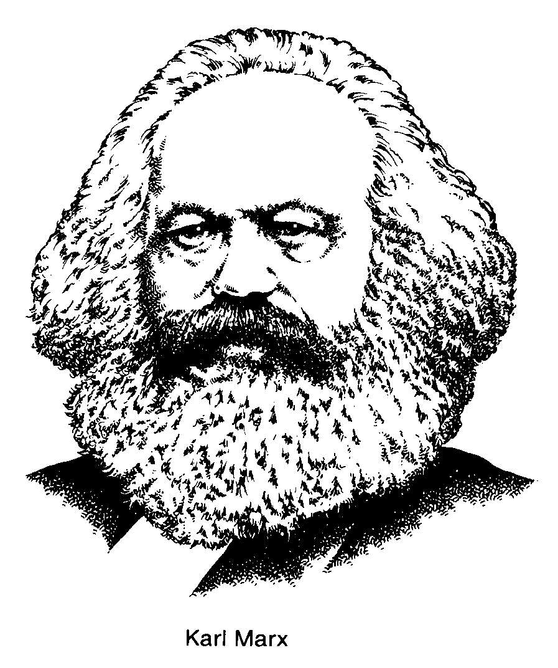
Diagram Marx’s Theory of the Decline of Capitalism.

proletariat overthrow the bourgeoisie
Pure communism (classless society)

Dictatorship of the proletariat
Spontaneous revolution
Breakdown of social and political order
- Bourgeoisie makes fewer profits
- Wealth accumulates in fewer hand

- Proletariat becomes poorer
- More unemployment
- Development of class consciousness
Some bourgeoisie accumulate great wealth
Economic competition leads to fewer firms
- Capitalist crisis
- Business cycle (from boom to bust) become increasingly severe
- Imperialistic view
Proletariat becomes poorer, buys fewer goods
Economic competition causes a decline in wages
Bourgeoisie exploits proletariat and lesser bourgeoisie
Capitalism: Creation of bourgeoisie and proletariat
decline/overthrow
Feudalism
Why is this stage critical in Soviet history?
Most experiments in ‘communism’ have never moved past this stage ie. Soviet Union, China, Cuba, North Korea
Bourgeoisie: Marx’s term to describe the owners of production.
Proletariat: Marx’s term to describe the working class.

