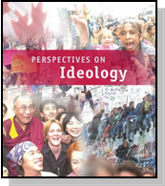

RELATED ISSUE 3: CHAPTER 11 & 12
WHERE ARE WE GOING

By the end of this chapter you will have to respond to the questions for inquiry listed below and demonstrate a contextual understanding of the vocabulary, concepts, people and events listed.
Chapter Issues:

To what extent should governments promote and protect individual and collective rights? To what extent do contemporary issues challenge the principles of liberalism?

American Bill of Rights

Anti-terrorism Act
illiberal
Question for Inquiry:

Why might liberal democratic governments choose to reject the principles of liberalism in some cases?
Question for Inquiry:

Why and to what extent do some liberal democratic governments promote individual and/or collective rights?

Canadian Charter of Rights and Freedoms
pandemic
Question for Inquiry:

How do liberal democracies balance the perceived common good with the need to respect rights?

Kyoto Protocol

emergency
and security legislation

environmental activism

language legislation
Question for Inquiry:

How do some contemporary issues raise questions about the viability of liberalism?
Question for Inquiry:

What solutions to contemporary issues are supported by the principles of liberalism?
postmodernism

Quebec Charter of Rights and Freedoms
War Measures Act
individual rights
extremism

October Crisis
collective rights
U.S.
PATRIOT Act
liberal democracy

Provide a brief overview of the following:

Canadian Charter of Rights and Freedoms:

Quebec Charter of Rights and Freedoms:

If you live in Quebec, which of the preceding documents is more powerful? Explain.

What is the fundamental difference between individual and collective rights? Provide a real or ficticious case to help you explain.

EXAMPLE: EXAMPLE:

Use the chart on page 382 to help you explain the following poltical cartoon about collective rights.

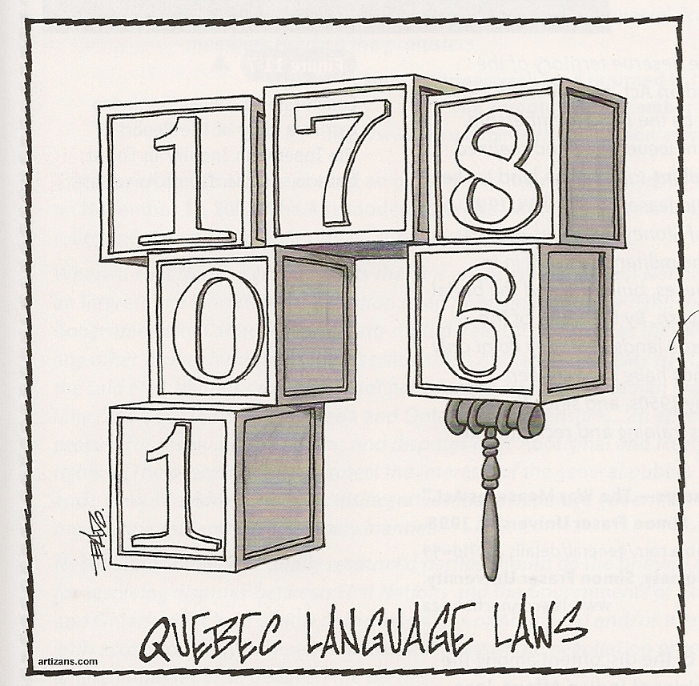

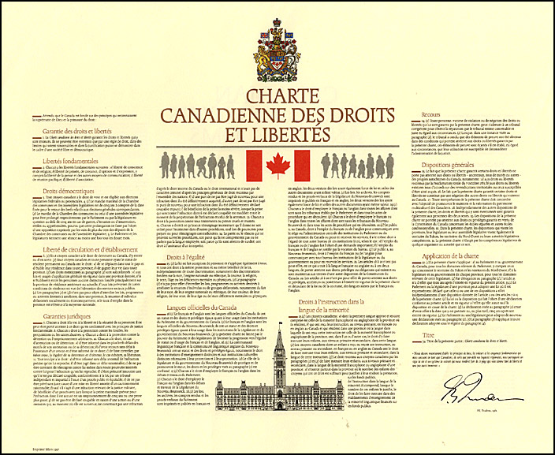Why are Sections 25 and 35 of the Canadian Charter of Rights and Freedoms so important for aboriginal peoples in Canada? Explain.

Briefly explain the context for three different times the War Measures Act has been invoked.

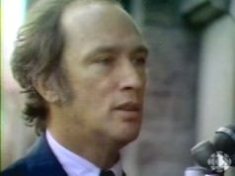
Explain the context for Prime Minister Pierre Elliot Trudeau’s famous “Just watch me.” comment. Why is this comment central to the question of individual rights in a liberal democracy?

Do you agree with Prime Minister Trudeaus invocation of the War measures Act during the FLQ crisis of 1970? Why or why not? Watch the famous clip:
http://www.youtube.com/watch?v=XfUq9b1XTa0

Read the information on pages 402-403 and explain the following cartoons:

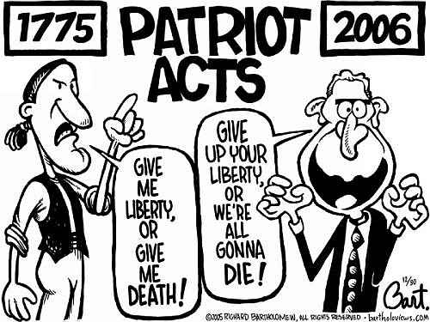

http://edkrebs.com/herb/petoons12/patriot_acts.jpg

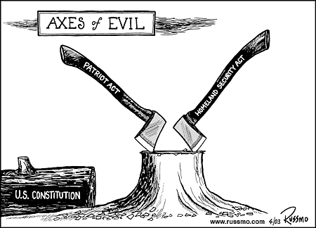

http://www.russmo.com

Read the information about modernism and postmodernism found on pages 410-411. Would you describe yourself as a postmodernist? Why or why not?

Some would argue that the dominance of classical liberal ideas (capitalist in nature) have emerged as neo-liberalism on a global scale. This is especially true following the collapse of the Soviet Union in the early 1990’s. Some would argue that the economic globalization of our planet has led to an inequitable distribution of wealth in the world. Look at the following source (2006):
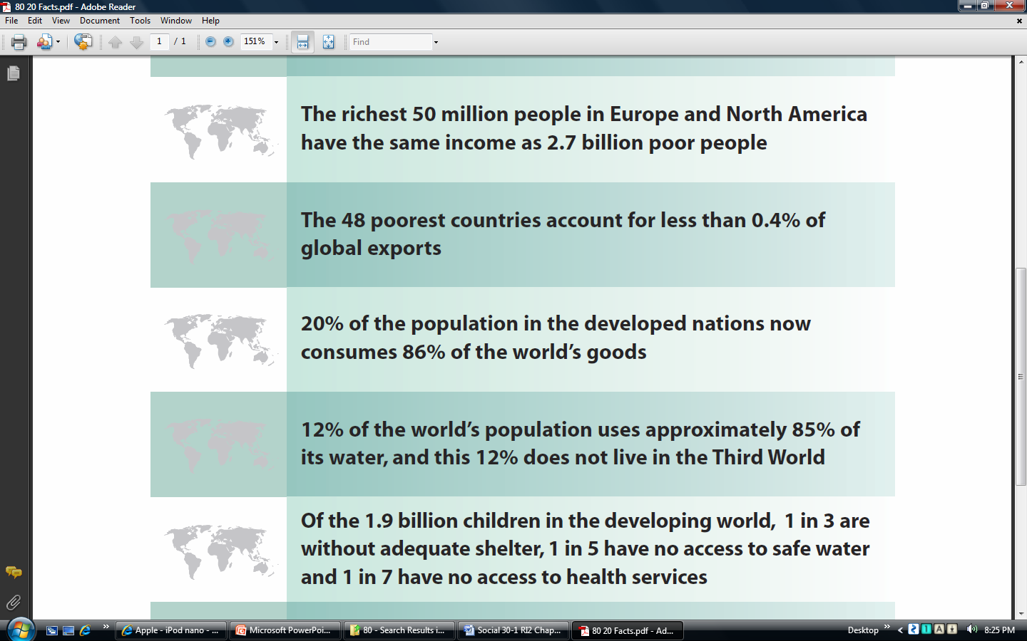

What do you think of information in the source?

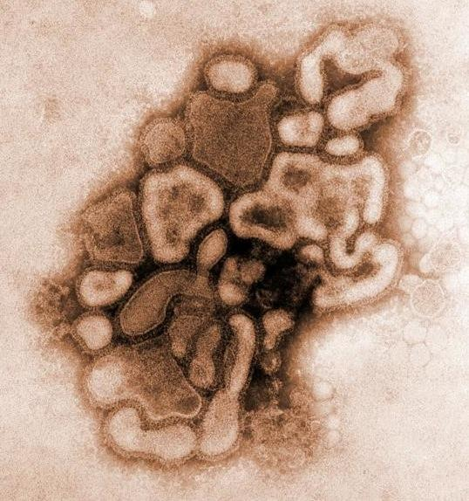How are pandemics and water shortages a potential threat to our liberal democratic values?
http://ksax.com/

