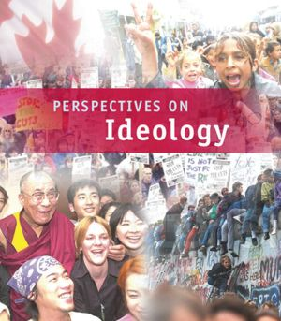

RELATED ISSUE 3: CHAPTER 9
WHERE ARE WE GOING

By the end of this chapter you will have to respond to the questions for inquiry listed below and demonstrate a contextual understanding of the vocabulary, concepts, people and events listed.

Chapter Issue:

To what extent, and for whom, has the imposition of
liberalism been
successful?

Question for Inquiry #1:

To what extent has the imposition of liberalism affected Aboriginal groups in Canada?
Question for Inquiry #2:

To what extent has the imposition of liberalism affected people globally?

NATO
Indian Act
White Paper
Red Paper

Canada in Afghanistan
assimilation

land holding
Haudenosaunee Confederacy
Royal Commission
war on
terror
enfranchisement
Nisga’a
Agreement
Residential Schools

What was the two-row wampum belt meant to symbolize? Do you think the symbolic nature of the wampum belt has been respected?

What are the general laws that govern First Nations, Metis and Inuit (FNMI) peoples (considered common to most aboriginal cultures)?

Which aboriginal ‘general laws’ do you identify with most? Provide a clear rationale.

How is the principle of liberalism pertaining to private property at odds with the ideological beliefs of many FNMI people?

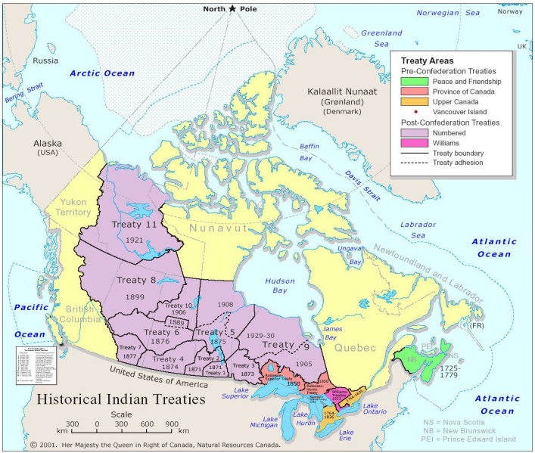
Why did problems emerge between aboriginal peoples and
Europeans with respect to historical agreements?

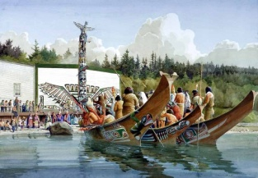
Briefly explain how the following strategies were used by Canadian governments as a means to assimilate aboriginal peoples into a liberal ideology and a more European way of life?

Enfranchisement:

Residential Schools:

White Paper

Potlatch

Watch the following video clip from the National Chief of the
Congress of Aboriginal Peoples and answer the questions that follow:

http://www.youtube.com/watch?v=uaubXDSgAxg

What is the Chief’s perspective on the Indian Act?

What would the Chief like to see done with respect to aboriginal people in Canada?

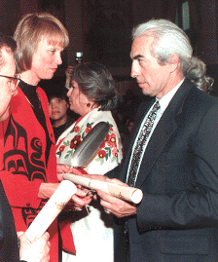
Read the closing remarks from The Royal Commission on Aboriginal Peoples and review the information on pages 313-314.

The relationship between Aboriginal and non-Aboriginal people in Canada has long been troubled and recently has shown signs of slipping into more serious trouble. The relationship can most certainly be mended - indeed, turned from a problem into an asset and one of the country's greatest strengths.

The direction change must take is toward freeing Aboriginal people from domination by and dependence on the institutions and resources of governments. The end of dependence is something Aboriginal and non-Aboriginal people alike profoundly desire. It would be quite unacceptable for First Nations, Inuit and Métis peoples to continue to find their autonomy restricted and constrained in the twenty-first century.

Yet renewal of the relationship must be done with justice and generosity. History and human decency demand restoration of fair measures of land, resources and power to Aboriginal peoples. On those foundations, self-respect and self-reliance will grow steadily firmer in Aboriginal communities. In their absence, anger and despair will grow steadily deeper - with conflict the likely result.

What we propose is fundamental, sweeping and perhaps disturbing - but also exciting, liberating, ripe with possibilities. Aboriginal people must be enabled to function once again as nations. This is a new way of thinking about old and persistent problems. For many years, the watch-word for the progress of Aboriginal people was 'self-government'. But this is only one piece of a larger undertaking - the restoration of nations, not as they were, but as they can be today. Land and economic vitality are essential for successful, hard-working governments. Whole, healthy, hopeful people are more vital still.

The Commission proposes a 20-year agenda for change, encompassing these things and more. In just 20 years, the revitalization of many self-reliant Aboriginal nations can be accomplished, and the staggering human and financial cost of supporting communities unable to manage for themselves will end. From that time forward, the return to the country will continue to grow.

That so much is possible in so short a time is good news for Canadians. The changes we propose are not modest. We do not suggest tinkering with the Indian Act or launching shiny new programs. What we propose is fundamental, sweeping and perhaps disturbing - but also exciting, liberating, ripe with possibilities.

Nor do we propose a set of lock-step directives. We offer a vision of what is possible and lots of ideas about how to get started. The agenda for change can begin today, and there are many starting places for it. Indeed, it is already getting started, as good ideas take shape and gather momentum in Aboriginal communities from coast to coast to coast.

Yet change must take place at a pace that allows Aboriginal people and nations to work through the pains of rebirth and in a way that encourages non-Aboriginal people to participate in it. Transition is something we must do together.

All of us have a part in securing the new relationship - people and governments, Aboriginal and non-Aboriginal, organizations big and small. We have 20 years of building and experimentation to look forward to - using, for the first time in many decades, all the energies of Aboriginal people as they create and live the dream of a Canada that they can share with others and yet be fully at home.
During that time - and beyond it - we can look forward to a Canada that celebrates Aboriginal heritage and draws strength from Aboriginal peoples as full partners in a renewed federation.

What do you think of the The Royal Commission on Aboriginal Peoples’
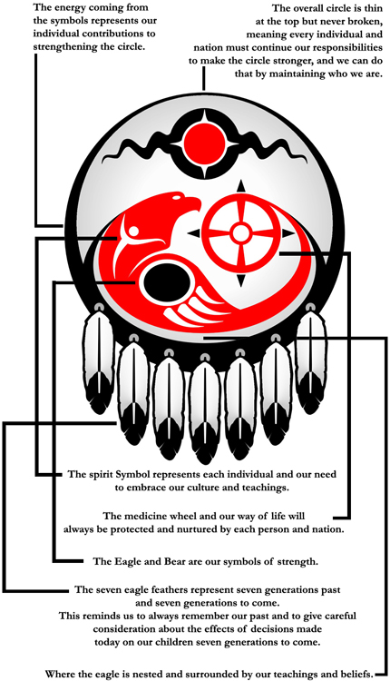
findings? How do you think it will impact FNMI people in Canada?

Use the remainder of the chapter to help you write a response to the following question:

To what extent should liberal democratic principles be imposed on people?

Your response will be similar to an argumentative paragraph you might write for a defense of position essay. You response should include the following:

  - a clear position
  - two detailed case studies or examples to support your position
  - *optional: counterargument and rebuttal
  - a summary statement

Possible case studies/examples:

  - democracy, freedom and capitalism in Iraq
  - democracy, freedom and capitalism in Afghanistan
  - residential schools in Canada
  - self-government in Nunavut
  - democracy, freedom and post-World War II Japan
  - capitalism in China
  - democracy, freedom and capitalism in the Former U.S.S.R. and Eastern Bloc countries

You may need to use other resources (i.e. internet) to help you gather the information you need.

