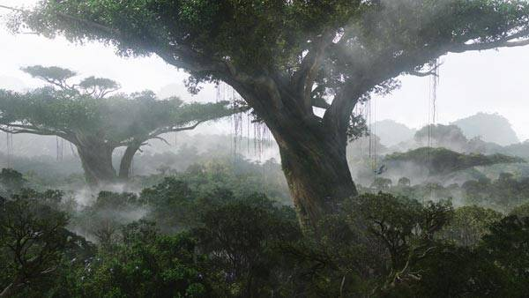

In 2154, the RDA corporation is mining Pandora, a lush, Earth-like moon of the planet Polyphemus Parker Selfridge is the head of the mining operation, and it employs a small army of former marines for security. The corporation aims to exploit Pandora’s reserves of a valuable mineral called unobtanium, which is worth $20 million per kilogram back on Earth.

There are hundreds of disparate Na'vi clans on Pandora. Some of the clans, including the Omaticaya, live in ancient trees that are two to three times the height of the Terran redwoods that once covered the Pacific Northwest. The name Hometree is misleading (see picture), as the structure is actually comprised of a grove of intertwined trees of the same species that have grown together, providing for mutual strength and structural reinforcement. This, coupled with Pandora's low gravity, is what accounts for the immense height of Hometree. The Omaticaya revere this quality of Hometree as a constant reminder that a community is stronger and more resilient than the sum of the individuals who comprise it. Like many sacred sites on Pandora, Hometree sits above a large deposit of unobtanium.

Avatar is primarily an action-adventure journey of self-discovery, in the context of imperialism and biodiversity. Cameron has said that Avatar shares themes with the films At Play in the Fields of the Lord and The Emerald Forest, which feature clashes between cultures and civilizations, and acknowledged the film's connection with Dances With Wolves, where a battered soldier finds himself drawn to the culture he was initially fighting against.

In a 2007 interview with Time magazine, Cameron addressed the meaning of the film's title, answering the question "What is an avatar, anyway?" Cameron stated, "It's an incarnation of one of the Hindu gods taking a flesh form." He said that "[i]n this film what that means is that the human technology in the future is capable of injecting a human's intelligence into a remotely located body, a biological body". Cameron stated, "It's not an avatar in the sense of just existing as ones and zeroes in cyberspace. It's actually a physical body."

The look of the Na'vi, the characters native to the world depicted in the film, was inspired by a dream that Cameron's mother had long before he wrote Avatar. She dreamt about a 12-foot-tall blue woman and he thought "that's kind of a cool image". So in 1976 or 1977, he put into his first screenplay a planet with a native population that was 12 feet tall and blue, and "gorgeous", which later became the basis for the Na'vi in Avatar. Cameron added that "the Na'vi represent something that is our higher selves, or our aspirational selves, what we would like to think we are" and that even though there are good humans within the film, the humans "represent what we know to be the parts of ourselves that are trashing our world and maybe condemning ourselves to a grim future”.

Cameron acknowledged that the film implicitly criticizes America's War in Iraq and the impersonal nature of mechanized warfare in general. In reference to the use of the term "shock and awe" in the film, Cameron stated, "We know what it feels like to launch the missiles. We don't know what it feels like for them to land on our home soil, not in America." A scene in the film portrays the violent destruction of the Na'vi Hometree, which collapses in flames after a missile attack, coating the landscape with ash and floating embers. When asked about the scene's visual resemblance to the events of the September 11 attacks on the World Trade Center, Cameron said he had been "surprised at how much it did look like September 11".

Watch the ‘Avatar’ (2009) movie trailer and discuss the questions on the next page.
What principles of individualism and principles of collectivism did you see represented in the film?

What historical parallels can be drawn from the Avatar story?
Canadian historical parallels:

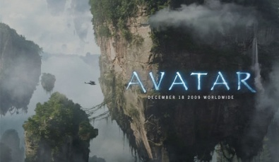
World historical parallels:

