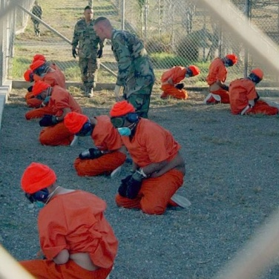
Guantanamo Bay is an American detainment facility located in Cuba. The facility is operated by Joint Task Force Guantánamo of the United States government since 2002 in Guantánamo Bay Naval Base, which is on the shore of Guantánamo Bay, Cuba.
The detainment areas consist of three camps: Camp Delta (which includes Camp Echo), Camp Iguana, and Camp X-Ray, the last of which has been closed. The facility is often referred to as Guantánamo, or Gitmo. After the Justice Department advised that the Guantanamo Bay Detention Camp could be considered outside US legal jurisdiction, prisoners captured in Afghanistan were moved there beginning in early 2002. After the Bush administration asserted that detainees were not entitled to any of the protections of the Geneva Conventions, the U.S. Supreme Court ruled in Hamdan v. Rumsfeld on June 29, 2006 that they were entitled to the minimal protections listed under Common Article 3 of the Geneva Conventions. Following this, on July 7, 2006, the Department of Defense issued an internal memo stating that prisoners would in the future be entitled to protection under Common Article 3. The detainees currently held as of June 2008 have been classified by the United States as "enemy combatants".

On January 22, 2009 the White House announced that President Barack Obama had signed an order to suspend the proceedings of the Guantanamo military commission for 120 days and that the detention facility would be shut down within the year. On January 29, 2009 a military judge at Guantanamo rejected the White House request in the case of Abd al-Rahim al-Nashiri, creating an unexpected challenge for the administration as it reviews how America puts Guantanamo detainees on trial.

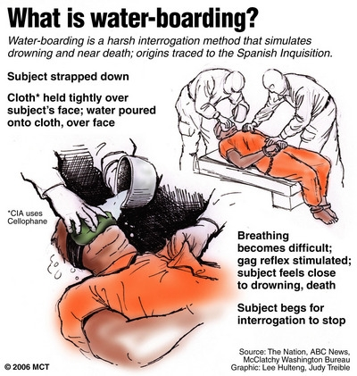
European Union members and the Organization of American States, as well as non-governmental organizations such as Amnesty International and Human Rights Watch, have protested the legal status and physical condition of detainees at Guantánamo. The human rights organization Human Rights Watch has criticized the Bush administration over this designation in its 2003 world report, stating: "Washington has ignored human rights standards in its own treatment of terrorism suspects. It has refused to apply the Geneva Conventions to prisoners of war from Afghanistan, and has misused the designation of 'illegal combatant' to apply to criminal suspects on U.S. soil." On May 25, 2005, Amnesty International released its annual report calling the facility the "gulag of our times". Lord Steyn called it "a monstrous failure of justice," because "... The military will act as interrogators, prosecutors and defense counsel, judges, and when death sentences are imposed, as executioners. The trials will be held in private. None of the guarantees of a fair trial need be observed."

Waterboarding is a form of torture that consists of immobilizing the victim on his or her back with the head inclined downwards, and then pouring water over the face and into the breathing passages, causing the captive to believe he or she is dying. Forced suffocation and water inhalation cause the subject to experience the sensation of drowning. Waterboarding is considered a form of torture by legal experts, politicians, war veterans, medical experts in the treatment of torture victims, intelligence officials, military judge and human rights organizations.

In 2007 it was reported that the Central Intelligence Agency (CIA) was using waterboarding on extrajudicial prisoners and that the Department of Justice had authorized the procedure, a revelation that sparked a worldwide political scandal. Al-Qaeda suspects upon whom the CIA is known to have used waterboarding are Khalid Sheikh Mohammed, Abu Zubaydah, and Abd al-Rahim al-Nashiri. According to Justice Department documents, the waterboarding of Khalid Sheik Mohammed provided information about a potential 9/11-type attack on Los Angeles.

U.S. government officials have at various times said they do not believe waterboarding to be a form of torture. To justify its use of waterboarding, the administration of George W. Bush issued classified legal opinions that argued for a narrow definition of torture under U.S. law, including the Bybee memo, which it later withdrew. In January 2009 President Barack Obama banned the use of waterboarding. In April 2009, the U.S. Department of Defense refused to say whether waterboarding is still used for training (e.g., SERE) purposes.
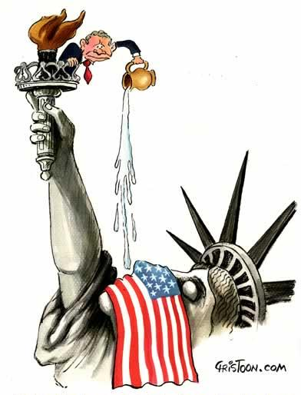
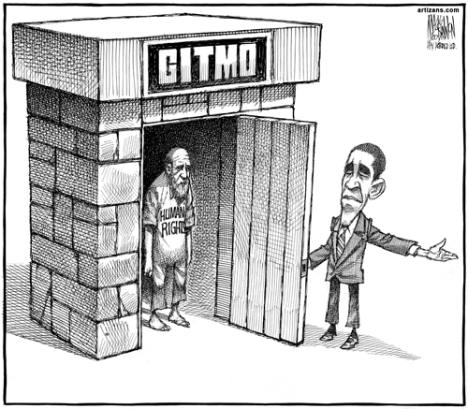

Beginning in 2004, accounts of physical, psychological, and sexual abuse, including torture, rape, sodomy, and homicide of prisoners held in the Abu Ghraib prison in Iraq (also known as Baghdad Correctional Facility) came to public attention. These acts were committed by personnel of the 372nd Military Police Company of the United States Army together with additional US governmental agencies.

Lynddie England holding a leash attached to a prisoner, known to the guards as “Gus”, who is collapsed on the floor.
As revealed by the 2004 Taguba Report, a criminal investigation by the United States Army Criminal Investigation Command had already been underway since 2003 where many soldiers of the 320th Military Police Battalion had been charged under the Uniform Code of Military Justice with prisoner abuse. In 2004 articles describing the abuse, including pictures showing military personnel abusing prisoners, came to public attention, when a 60 Minutes II news report (April 28) and an article by Seymour M. Hersh in The New Yorker magazine (posted online on April 30 and published days later in the May 10 issue) reported the story.

On June 12, 2008, the United States Supreme Court ruled in Boumediene v. Bush that the Guantanamo captives were entitled to the protection of the United States Constitution. Justice Anthony Kennedy, writing for the majority, described the SCR Tribunals as "an inadequate substitute for habeas corpus" although "both the DTA and the SCRT process remain intact."
Watch the following clips on waterboarding:

http://www.youtube.com/watch?v=8pAB0l9yYJ8 and http://www.youtube.com/watch?v=p-YSlARDNxs

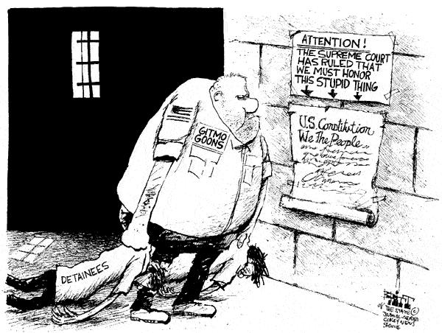
On October 21, 2008 US District Court Judge Richard J. Leon ordered the release of the five Algerians held at Guantanamo Bay, Cuba, and the continued detention of a sixth, Belkacem Bensayah. The Court ruled: "To allow enemy combatancy to rest on so thin a reed would be inconsistent with this court's obligation; the court must and will grant their petitions and order their release. This is a unique case. Few if any others will be factually like it. Nobody should be lulled into a false sense that all of the... cases will look like this one."

Omar Ahmed Khadr (born September 19, 1986) is the fifth child in the Canadian Khadr family. He was captured by American forces at the age of 15 following a four-hour firefight with militants in the village of Ayub Kheyl, Afghanistan. He has spent seven years in the Guantanamo Bay detention camps charged with war crimes and providing support to terrorism after allegedly throwing a grenade that killed a US soldier. In February 2008, the Pentagon accidentally released documents that revealed that although Khadr was present in the house, there was no other evidence that he had thrown the grenade. In fact, military officials had originally reported that another of the surviving militants had thrown the grenade just before being killed, and later rewrote their report to implicate Khadr instead. Defence lawyers have also suggested that the soldier may have been killed by friendly fire by his own comrades. It was later determined that Khadr had been crippled, blinded and trapped beneath rubble at the time, and American soldiers weren't even aware of his presence until one stepped on his prone body. A Canadian citizen born in Toronto, he is the youngest prisoner held in the Guantanamo Bay detention camp by the United States and has been frequently referred to as a child soldier. The only Western citizen remaining in Guantanamo, Khadr is unique in that Canada has refused to seek extradition or repatriation despite the urgings of Amnesty International, UNICEF, the Canadian Bar Association and other prominent organisations. In 2009, it was revealed that the government had spent over $1.3 million to ensure Khadr remained in Guantanamo.

In April 2009, the Federal Court of Canada ruled that the Charter of Rights and Freedoms made it obligatory for the government to immediately demand Khadr's return. After a hearing before the Court of Appeals produced the same result, the government announced they would argue their case before the Supreme Court of Canada.The Supreme Court heard the case on November 13, 2009 and their decision is pending.
Khadr was the only person charged under the 2006 Military Commissions Act who did not boycott the Guantanamo proceedings. Canadian authorities also determined that Khadr had little knowledge of his father's alleged activities, since "he was out playing or simply not interested"

The stories of Guantanamo Bay, waterboarding and the abuses at Abu Ghraib, raise issues about the extent to which ideologies should be defended. Discuss the following questions and write a brief personal response for each:

Do you think waterboarding is torture?
How would you respond to the following ethical dilemma?
You have captured a known terrorist in who has information that will save the lives of 100 innocent people. You can torture them to access the information, do you do it?
Source: Wikipedia.org

