MATH 10-3 Semester II 2012 Ms. Borle
Phone: 342 4800 Ext 263381
Email: mborle@rdcrd.ab.ca

Want to learn a trade? Or maybe you just want to finish high school and start working. This skill-building course is designed to prepare you for the everyday challenges that you face in math. Get the best deals when you go shopping, redecorate a room in your house, budget for your dream vacation; adapt recipes for different group sizes and so much more. This course is also ideal for students wishing to enter the trades. We’ll help prepare you for those apprenticeship exams.
Math 10-3 and Math 20-3 meet the minimum math required for an Alberta high school diploma.

Text: MATHWORKS

Unit Chapter # Classes

1) Unit Pricing and Income 1 13 5%
2) Length, Area and Volume 2 13 5%
3)Mass, Volume and Temperature 3 13 5%
4) Angles and Polygons 4 13 5%
5) Trigonometry 5 13 5%
6) Drill and Practice workbooks 5%
7) Projects (5) 25%
8) Vocabulary 5%
9) Quizzes 10%
10) Final 30%

Note: For students wanting to take 10C as their next course, Bonus Sheets will be available.

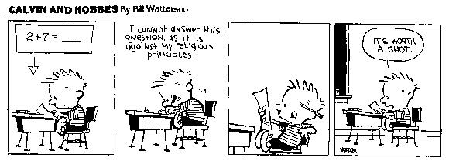

Classroom Expectations for Math 10-3

- Any assignment missed to unexcused absences will be given a mark of zero. Any assignment missed due to an excused absence must be made up immediately upon your return.

- Remember YOU are responsible for missed work. I can help you stay on track if you let me know in advance when you will be absent.

- When you’re on time for class and attend regularly, your chances for success in Math improve significantly.

- Unit projects tie together everything done within a unit. They are done during the unit and will be due at the end of the unit. They count for a significant portion of your overall mark.

- Show a positive attitude in class as well as a strong work ethic. Seek out extra help when you need it. Teachers will help students who help themselves.

- Ultimately, YOU are responsible for YOUR learning and YOUR achievement in this course!

