1. **Solving Proportions** 🡪 Solve for the unknown value in each. Show your work.
2. 
3. 
4. 
5. 
6. 
7. 
8. 
9. 
10. 
11. 
12. 
13. 
14. 
15. 
16. 
17. 
18. 
19. 
20. 
21. 
22. **Unit Price** 🡪 *Determine* the unit price in each situation below.
23. 9 Apples cost $4.95
24. $5.78 for 6 litres of gasoline
25. $6.98 for 16 toilet paper rolls
26. 40 songs for $32.95
27. A 16 oz can of tomatoes for $1.19
28. **Writing Percentage as a Decimal** 🡪 Write each percentage in decimal form.
29. 
30. 
31. 
32. 
33. 
34. 
35. **Writing a Decimal as a Percentage** 🡪 Write each decimal value as a percentage.
36. 0.15
37. 0.5
38. 0.06
39. 0.075
40. 0.00015
41. 1.5
42. **Finding a Percentage of a Number** 🡪 Determine what value each percentage is of the given number.
43. 
44. 
45. 
46. 
47. 
48. 
49. 
50. 
51. 
52. 

Name: _______________**1.1 Proportional Reasoning** Date: _______

1. There are 54 wheels on 3 long haul trucks. Write the ratio of wheels to truck in simplest form two ways.
2. 2. An administrative assistant types at a rate of 60 words per minute. Determine how long would it take them to type a 960 word letter

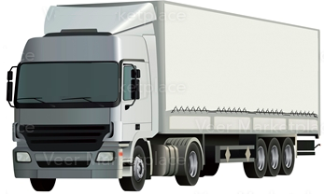

1. A car uses 81 Litres of gasoline for every 760 *km* it travels. Determine how much gasoline would be needed to travel just 250 *km*.

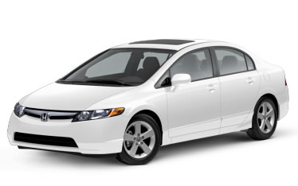

1. A recipe for rice crispie squares uses 500 grams of marshmallows for every 6 cups of cereal. A box of cereal has 21 cups of cereal inside. Determine how many grams of marshmallows are needed to use the whole box up.

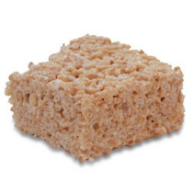

1. Coke is sold at a price of $3.99 for every 12 cans. How much should a vendor sell a single can of coke for?

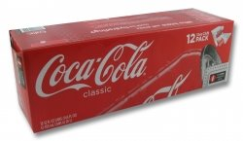

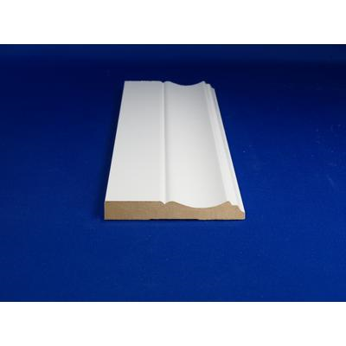6. Marcus needs 45 linear feet of baseboards to complete his room. Baseboards are sold in 12 foot lengths for $4.95 each. Determine how much it will cost Marcus for 45 feet of baseboards.

Name: _________ **1.2 Unit Price**Date: ________________

1. Bootlegger gets 24 pairs of jeans for $1248. Determine the unit cost for jeans.

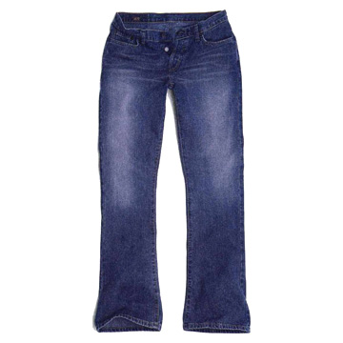

1. You can buy light bulbs at Wal-Mart or London Drugs. Wal-Mart sells 6 bulbs in a pack for $2.76 while London Drugs sells packs of 4 for $1.92 each. Determine which store has a better deal.
2. Purina Dog Chow comes in 3 sizes. A 5 *kg* bag for $12.95, a 10 *kg* bag for $19.95, or a 20 *kg* bag for $42.95. Determine the unit cost for each to decide which is the best value.
3. When you take out a cell phone plan with Pay & Talk they give you 3 choices. You can take a bundle of 100 minutes for $10, 500 minutes for $40 or 1000 minutes for $75. Determine which plan has the worst unit price.

Name: ____________________**1.3 Setting a Price**Date: ________________

1. Mary owns a snowboard store. She carries two very popular models. The Burton comes into the store with a wholesale price of $172.00 while the West Beach board has a wholesale price of $209.00. Determine the price she will set for each board if she marks up prices by 45%.

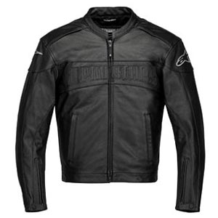

1. The sale price on a new leather jacket reads $76.95. Determine if $80 will be enough to cover the bill once a 5% GST surcharge is added.

Wal-Mart has a strict markup policy. Every wholesale price is marked up just 10% to determine the Wal-Mart retail price.

1. Complete the table below with the retail prices needed.

|  |  |  |
| --- | --- | --- |
| **Item** | **Whole Sale** | **Retail** |
| Cascade Dish Detergent | $6.50 |  |
| *Harry Potter & The Delinquent Student* on DVD | $19.90 |  |
| Nike *N2* Shoes | $85.00 |  |
| 4 Man Pop Up Tent | $259.00 |  |

1. Show your work..
2. Using a discount is the opposite of marking up a price. Instead of increasing the price it is decreased. Vendors do this when they want to clear out a product without making as much money.
3. Name 2 situations where a discount could be used.
4. Determine the new price of a $80.00 item that is discounted 15%.

Name: ____________________**1.4 On Sale!**Date: ________________

1. 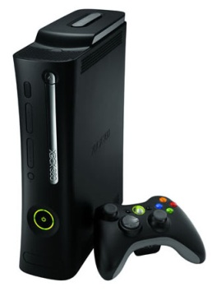A flyer shows that the Xbox 360 is finally going on sale. With a regular price of $199.99 the flyer says the first ten people to show up get 20% off.
2. Determine the amount discounted.
3. Determine the new price.
4. Another flyer shows that the Ipod Nano is discounted $20 off. Determine what the discount rate was to the nearest percent, if the original price was $239.98.

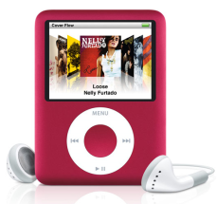

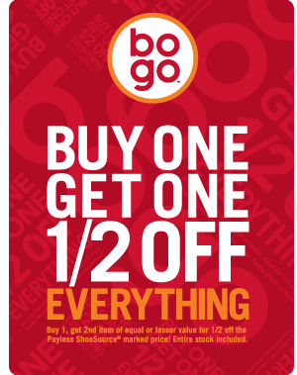

1. At Payless Shoes you get the second pair of shoes at half price. Each pair of shoes is $32.95.
2. Determine the total price that would be paid for both pairs of shoes.
3. Determine the discount rate as a percentage.
4. Two stores are competing on the sale of CD’s.

The first store offers a 25% discount on all CD’s normally priced at $21.99.

The second store will charge $21.99 on the first two CD’s but only $11.99 on the rest.

Determine which store is a better deal if you were to buy 7 CD’s.

Name: ____________________**1.5 Currency Exchange Rates**Date: ________________

1. What would it cost in Canadian dollars to **buy** 1 unit of each currency from the bank?
2. Swiss franc
3. Kenyan shilling
4. Australian dollar
5. Determine how much it would cost you to buy each of the following from the bank.
6. 45.00 Scottish pounds
7. 325.75 euros
8. 1298.98 krones
9. Determine how much you would get paid in each currency if you gave the bank $750 in Canadian funds.
10. Singapore dollars
11. euros
12. English pounds

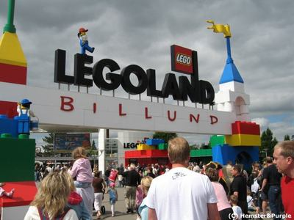

1. Blair has a dream of going to every Lego Land in the world. The admission prices are listed here but Bonnie needs to know how much to budge in Canadian dollars. Help her out by finding out how much it will cost to buy each currency.

|  |  |  |  |
| --- | --- | --- | --- |
| **Legoland** | **Country** | **Admission Price** | **Canadian Dollars** |
| Legoland Billund | Denmark | 180.00 Dkr |  |
| Legoland Windsor | England | 45.00 £ |  |
| Legoland California | United States | $49.95 US |  |
| Legoland Deutschland | Germany | 37.50 € |  |

How much will Blair need to spend on admissions to all 4 Legolands?

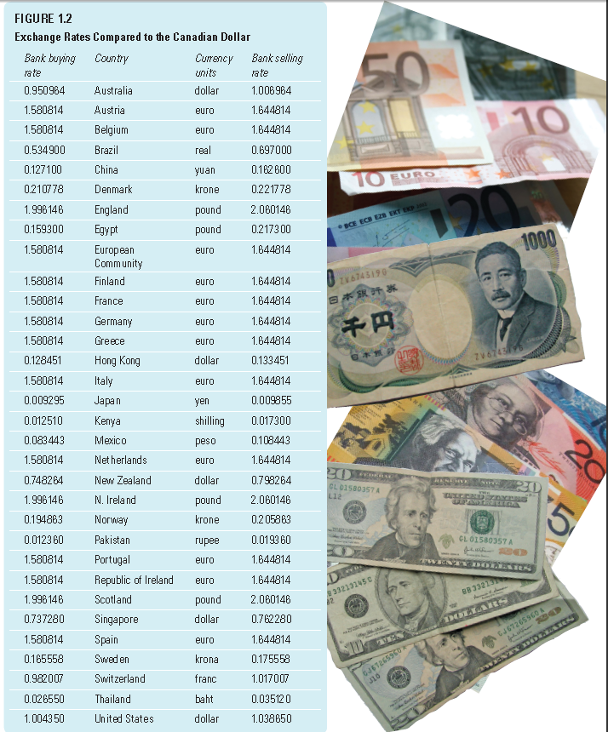

MathWorks 10 Page 45