Math 10-3 Unit 1 Lesson 11 Name: _____________________
Example Pay Stub
Calculateing CPP
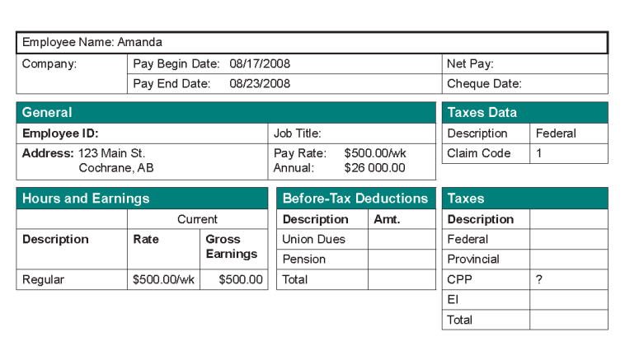

Calculating EI

Calculating Net Pay

