Deductions Sheet
Names: __________________________
__________________________
Date: __________________________
#1:
Susanne is a second year apprentice carpenter. She earns $28.00 per hour, works 40 hours per week and is paid bi-weekly. Each pay period her employer deducts $197.36 federal tax, $82.73 provincial tax, $78.45 for CPP and 1.73% for EI premiums.
Fill in her pay stub below and determine her gross and net pay for one pay period.

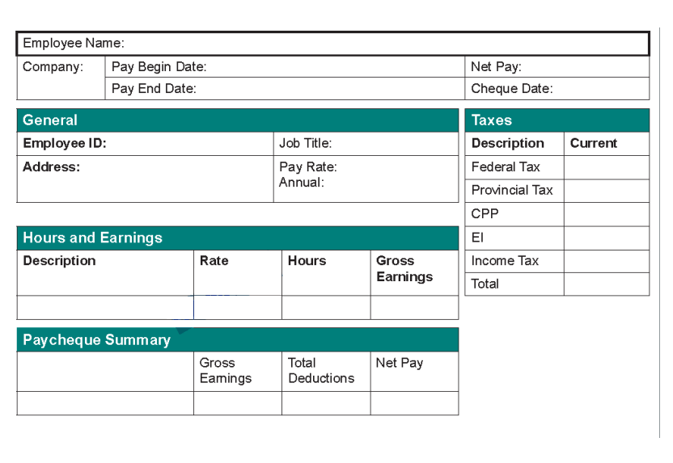

#2
Braeden is a Journeyman Automotive service technician earning $40.00 per hour. He is paid monthly. For the last pay period, he worked 40 hours each week and came in one Saturday for 5 hours at time and a half. . Each pay period his employer deducts $439.21 federal tax, $158.11 provincial tax, $78.45 for CPP and 1.73% for EI premiums.
Fill in his pay stub below and determine his gross and net pay for this pay period.

