Last Name: ________________ First Name: ______________________
Job: __________________________________________________________Wage: ________
Weekly Time Sheet and Pay Stub Time sheet for the week of _____________ to _______________
Tuesday , _________ ____
Time In | Time Out | Total Time
Monday , _________ ____
Time In | Time Out | Total Time

Wednesday , _________ ____
Time In | Time Out | Total Time
Thursday , _________ ____
Time In | Time Out | Total Time

Friday , _________ ____
Weekly Calculations:
Total minutes in the class: ___________ minutes
Calculation to convert time into work hours:

Total work hours: _________hours

Time In | Time Out | Total Time

Total earnings for Week: _________________ hrs at $___________per hour equals $__________________.
Fill in one cheque on the back of the form to match this information.
Sample:
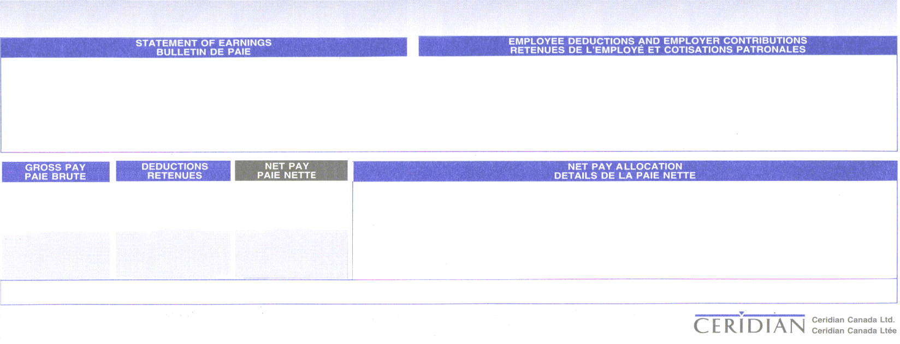
$399.00
$336.00
$63.00
12.60
5
Over time
40
8.40
Hourly
TYPE
HOURS
AMOUNT

TYPE
AMOUNT
TYPE
AMOUNT
RATE
DEPOSIT 012 34567 8910123

Employee Name: Print Both First and last name here.
For the week of: Print the week dates here
Job: Print your weekly job here
TYPE
HOURS
AMOUNT

TYPE
AMOUNT
TYPE
AMOUNT
RATE
DEPOSIT 012 34567 8910123

Employee #
For the week of:

