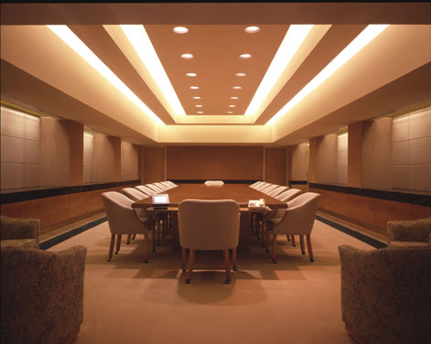Math 10-3 Design Your

Board Room Project

Objective: To design a high class board room employing skills in:

🡪 Unit Conversions

🡪 Surface Area Calculations

🡪 Capacity Calculations

🡪 Cost Analysis

Part 1: Establish the Scale

In consultation with your teacher, determine the scale reduction you will use for your room. Everyone will construct a board room with the same dimensions but to a different scale.

Length: 20 ft Width: 12 ft Height: 10 ft

*Note to teacher: The scale factor should be no larger than 0.055 in order for the net to be constructed on 73cm long bristol board. If the scale factor is larger than that the net will extend off the bristol board.*

Part 2: Unit Conversions

Using your scale from Part 1, show all calculations from the real size to reduce to your model size using your scale. You must convert all measurements to the common unit of centimetres for your model. Include the following measurements:

* 20 feet for length
* 12 feet for width
* 10 feet for height
* Large table *(Appendix I)*
* 8 office chairs *(Appendix I)*
* Fish tank *(Appendix II)*

Part 3: Constructing the Net

Using all the dimensions calculated in part 2 and *bristle board*, create a net (collapsed walls and floor) of your room. All the elements listed in part 2 must be constructed to the scale you received in part 1.

Part 4: The Model

Cut out and fold up the net of your board room. Tape it together. Include the scale-sized furniture and fish tank to your board room. Use the opportunity to make the room look realistic. You can use whatever materials or art supplies you want, just ensure that it is to scale.

Part 5: The Fish Tank Shopping List

Using the capacity of the tank you chose in *Appendix II*, choose the tank filter, tank light, tank heater and fish for your tank. Pay attention to the advertised specifications for each item. You must have at least five kinds of fish or aquatic animals. Be careful – some fish cannot be put in the same tank. Complete your fish tank shopping list (*Appendix IV*) using the flyer in *Appendix III*.

Part 6: The Cost Analysis

You now need to price out the supplies and furnishings for your board room. Show your calculations when you determine area, perimeter, etc. where necessary using *Appendix V*.

● Flooring – Calculate the area of your floor. The supplier sells everything by the square metre. Determine the cost for the whole thing. *Hint: Pay close attention to the units!*

● Trims – Calculate the perimeter of your room and the door. You must buy enough baseboard to go all the way around the room. *Hint: Pay close attention to the units!*

● Paint – Calculate the area of the walls. You must paint all 4 walls (do not subtract the door). Deter how many cans it will take so you can find the right price. *Hint: Pay close attention to the units!*

● Fish Tank – Using your shopping list from *Appendix IV* tabulate the pricing.

● Furniture – Include the pricing for the furniture you selected from *Appendix I*.

● TOTAL COST – Determine the final cost for your board room.

***Appendix I*** *🡪* ***Furniture World*** *(page 1 of 2)*

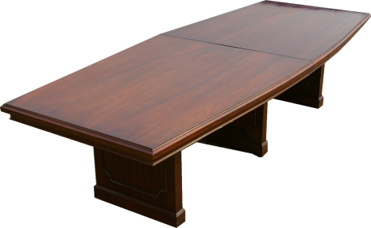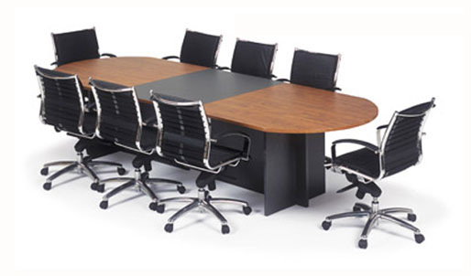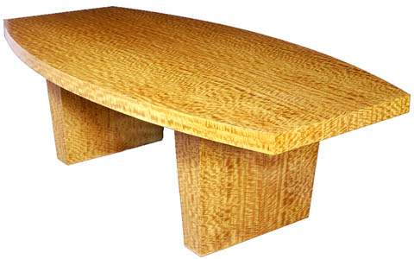

***Accented Oak Table***

Made of resilient solid oak and accented by a central black section, this rounded-ends model includes 8 stainless steel office chairs.

$3255.00

Table:Chairs: 

***Beachwood Table***

For a relaxed meeting. This table accommodates a very large group of people.

$2659.99



***Solid Mahogany Table***

For a refined looking office. Hand made quality with an elegant bevelling show the craftsmanship only an expert can deliver.

$2495.95



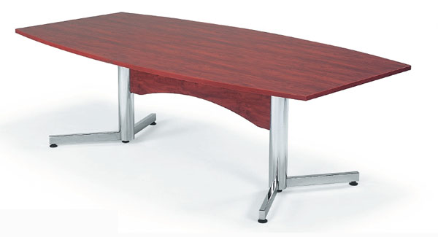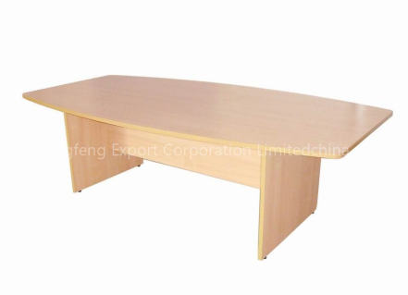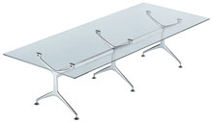

***Glass Table***

This table ways modern day design and the eco-responsibility in one product. Made from 100% recycled materials

$1799.99



***Pine Table***

This light colored pine table is clean, crisp and says frugal yet effective.

$1259.00



***Laminate Table***

This light table is supported by stainless steel legs. The laminate finish looks like wood but repels wear & tear and coffee spills alike.

$999.99



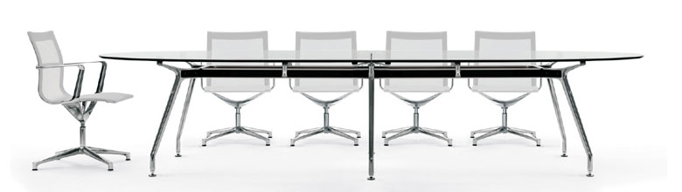

***Solid Acrylic Table***

The clear sightlines of this table have ‘Office of the Future’ written all over it.

Elegant yet ergonomic. This table will not be undersold!

Includes 8 matching swivel mesh chairs.

$3699.99

Table: Chairs: 

***The Chiropractor***

Ails bad backs with quality lumbar and neck support. Great for the hard worker.

$159.00



***The Cradle***

Inspired by the comfort of the hammock. Uses independent vinyl strips to support the weight evenly. Contours to your shape.

$295.00



***Acrylic Bubble Chair***

The future is now with these authentic hanging bubble chairs.

$329.00



***The Flexor***

The 86 independent rollers will cradle the spine of whoever uses it, extending their energy and improving overall worker efficiency.

$295.00



***Authentic Australian Leather Chair***

Made with 100% real ostrich hide and framed with wood of real Australian Flame Sheoak, this authentic style will surely speak volumes to the people you do business with.

$419.00



***Dark Tanned Leather Chair***

Bridging the timelessness of leather with modern ergonomics, this fully functional office chair shows clients that you mean business.

$299.99



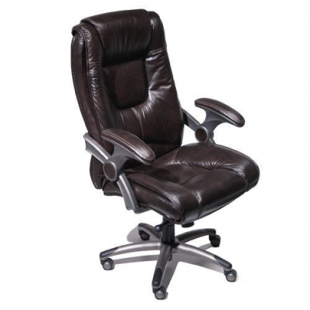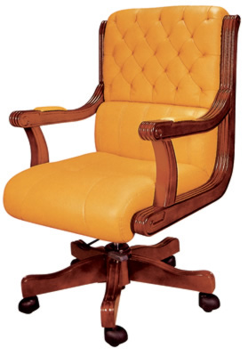

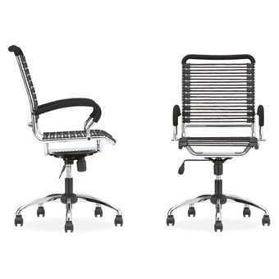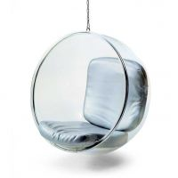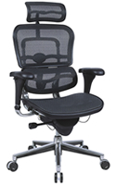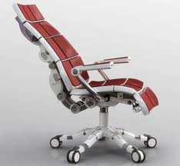

***Appendix II*** *🡪* ***Aquarium Emporium Supply SALE*** *(page 1 of 2)*

*NOTE: Fish can only be placed in one water type. Fresh Water Fish* ***cannot be combined*** *with Salt Water Fish!*

|  |  |  |
| --- | --- | --- |
| ***Aquariums*** *Note: All fish tanks are final sale. No returns.*  *Dimensions are length X width X height.* | | |
|  | | |
| ***189 L Bow Front Corner***  http://www.fishtanksdirect.com/productimages/tenecor/main/quartercylinder-large.jpg Dimensions: 24” x 24” x 66” **Cost:** $1453 | ***227L Cylinder Aquarium***  *http://www.fishtanksdirect.com/images/products/display/pearllightsmall.jpg* Dimensions: 28" x 74" **Cost:** $4108 | ***454 L Beachwood Flat***  *http://www.glasscages.com/gc2/prodpics/120-std-can-side.jpg* Dimensions: 49” x 25” x 70” **Cost:** $1221 |
|  | | |
| ***511 L Bow Front***  *http://www.fishtanksdirect.com/productImages/tenecor/thumb/bowfrontl.jpg* Dimensions: 60” x 24” x 62” **Cost:** $1526 | ***908 L Oak Flat***  *http://www.glasscages.com/gc2/prodpics/240long-std-can.jpg* Dimensions: 97” x 25” x 70” **Cost:** $1896 | ***360 L L-Shaped Redwood***  *http://www.fishtanksdirect.com/productImages/tenecor/thumb/l-shape1.jpg* Dimensions: 36 x 36 x 76 **Cost:** $1343 |
|  | | |
| ***189 L Single Dome***  *http://www.fishtanksdirect.com/ProductImages/midwest/C-40SB-large.jpg* Dimensions: 24” x 18” x 60” **Cost:** $1555 | ***1364 L Espresso Finish***  *Perfecto- 300gal Deep Dimension Corner-Flo Aquarium/Stand and Canopy* Dimensions: 72” x 36” x 81” **Cost:** $4296 | ***1893 L Bullet***  *bullet aquarium* Dimensions: 96” x 48” x 76” **Cost:** $9354 |
|  | | |

|  |  |  |  |
| --- | --- | --- | --- |
| ***Filters*** *Note: It is possible to combine up to two filters per tank.* | | | |
|  | | | |
| **Fluval G3 Premium**  **Tanks up to 80 Gal**  *Fluval G3 Premium Filtration System - For Aquariums up to 80 Gallons*  **Cost:** $105 | **Eheim 2217 Classic**  **Tanks up to 160 Gal**  *Eheim 2217 Classic Plus Kit With Free Double Tap Valves & Full Media Kit*  **Cost:** $185 | **Eheim 2080 Pro III Tanks up to 316 Gal**  **Eheim 2080 Pro III Canister Filter**  ***Cost:*** *$440* | **Eheim 2262 Canister**  **Tanks up to 500 Gal**  **http://www.clicshop.com/Scripts/Logs/VoirPhoto.asp?StoreID=2426&ItemID=17607331&Show=1&Format=normal&Language=2&U=jay**  **Cost:** $550 |

|  |  |  |  |
| --- | --- | --- | --- |
| ***Heaters*** *Note: All tanks require a minimum of 3 Watt per Gal.* | | | |
|  | | | |
| **Jager 150 Watt**  Jager 150 Watt Heater *Cost:$46* | **Fluval M 200 Watt**  Fluval M Submersible Heater 100 Watt *Cost:$60* | **Via Aqua 500 Watt**  Via Aqua 350 Watt Titanium Heater (Item Currently Unavailable) *Cost:$153* | **Hydor 900 Watt** Hydor 300 Watt External Thermal Heater for Inline Application - fits 5/8 *Cost:$342* |

|  |  |  |  |
| --- | --- | --- | --- |
| ***Aquarium Lights*** *Note: Lights are calibrated for type of water and require a minimum of 5 Watt per Gal.* | | | |
|  | | | |
| **Nova Extreme**  **400 Watt** (Fresh)  Current USA Nova Extreme 48 *Cost:$432* | **Aquatic Life T3**  **1500 Watt** (Fresh)  Aquatic Life 24 *Cost:$898* | **Coralife Aqualight T5**  **400 Watt** (Salt)  Coralife T5 HO Aqualight 48 *Cost:$46* | **Rena Metal Halide 1500 Watt** (Salt)  Aquarium Pendent Lighting *Cost:$46* |

***Appendix III*** *🡪* ***Aquarium Emporium******FISH SALE*** *(page 1 of 3)*

*NOTE: Fish can only be placed in one water type. Fresh Water Fish* ***cannot be combined*** *with Salt Water Fish!*

|  |  |  |  |
| --- | --- | --- | --- |
| **Spotter Puffer Fish** *(Fresh)*  *http://www.aquariumlife.net/images/gsp2.jpg*  Aggressive. Can only be with plecostomuses.  1 *gal*  per fish.  **$30.00** | **Blue Damsel** *(Salt)*  *http://www.ams1966.com/files/BLUE_DAMSEL.jpg*  Semi Aggressive. Cannot be with shrimp, starfish or corals.  10 *gal* per fish.  **$45.00** | **Blue-Tail Guppy** *(Fresh)*  *http://3.bp.blogspot.com/_DnZcct9AnCU/SFC9c5IxCHI/AAAAAAAAADU/FbefJRcf08o/s1600/guppy-blue-tail.jpg*  Non Aggressive. Needs to be in groups of 3 or more. $\frac{1}{2}$ *gal* per fish.  **$3.00** | **Giant Clam** *(Salt)*  *http://blogs.menupages.com/sanfrancisco/giant-clam.jpg*  Non Aggressive. Cannot be with angel fish, damsels, tangs, or foxfaces.  3 *gal* per clam.  **$52.00** |
| **Black Skirt Tetra** *(Fresh)*  *http://1.bp.blogspot.com/_jvsM6klryUg/SWBIRUyJ_uI/AAAAAAAACHs/B8pLNYRRWFk/s400/Black+Skirt+tetra.jpg*  Semi Aggressive. Cannot be with guppies. Needs to be in groups of 3 or more.  1 *gal* per fish.  **$6.00** | **Occilaris Clown Fish** *(Salt)*  *http://farm4.static.flickr.com/3204/3156016453_da4f802e3c.jpg*  Non Aggressive. Needs to be combined with an anemone.  1 *gal* per fish.  **$19.00** | **Cleaner Shrimp** *(Salt)*  *http://www.thereefshoppe.ca/images/cleaner_shrimp.jpg*  Non Aggressive. $\frac{1}{2}$ *gal* per shrimp.  **$21.00** | **Aquatic Frog** *(Fresh)*  *http://www.projectexploration.org/projectfrog/images/updates/06/dblackburn_082106_2025.jpg*  Non Aggressive. Can only be combined with tetras, shrimp, clams, snails, and bettas. $\frac{1}{2}$ *gal* per frog.  **$2.00** |
| **Marble Angel Fish** *(Fresh)*  http://0.tqn.com/d/freshaquarium/1/G/v/9/fw0080.jpg  Semi Aggressive. Cannot be combined with neon tetras, or guppies.  1 *gal* per fish.  **$25.00** | **Queen Angel Fish** *(Salt)*  *http://www.coralreefphotos.com/wp-content/uploads/2010/02/Queen-Angelfish-457x303.jpg*  Aggressive. Cannot be combined with corals, ocillaris clown fish, shrimp, or crabs.  20 *gal* per fish.  **$98.00** | **Red Bellied Piranha** *(Fresh)*    Aggressive. Cannot be combined with other fish.  5 *gal* per fish.  **$59.00** | **Neon Tetra** *(Fresh)*  *http://www.freshwaterhobbyist.com/images/blueneontetra.jpg*  Non Aggressive. Needs to be in groups of 3 or more. $\frac{1}{2}$ *gal* per fish.  **$4.00** |
| **Yellow Tang** *(Salt)*  *http://t1.gstatic.com/images?q=tbn:0yLdkOGhS-ql-M:http://www.bluereeffrags.com/images/yellow_tang_ta0o.jpg&t=1*  Semi Aggressive. Cannot be combined with corals or shrimp.  8 *gal* per fish.  **$28.00** | **Reticulated Starfish** *(Salt)*  *http://packerpedia.wiki.packer.edu/file/view/ReticulatedStarfish.jpg/39927058/ReticulatedStarfish.jpg*  Semi Aggressive. Cannot be combined with corals, and shrimp.    1 *gal* per starfish.  **$25.00** | **Betta Fish** *(Fresh)*  *http://bettasfish.net/wp-content/uploads/2010/05/141178873_2c99c722f9.jpg*  Aggressive. Cannot be with each other. Can only be with shrimp, snails, and frogs.  2 *gal* per fish.  **$6.00** | **Khuli Loach** *(Fresh)*  *http://animal-world.com/encyclo/fresh/loaches/images/KuhliLoachWFLo_Ap4A.jpg*  Non Aggressive. Cannot be combined with other loaches.  1 *gal* per fish.  **$8.00** |
| **Killifish** *(Fresh)*  *http://www.aboutfishonline.com/images/killifish.jpg*  Semi Aggressive. Cannot be with guppies or eachother.  2 *gal* per fish.  **$32.00** | **Cobamba** *(Fresh)*  *http://www.soaap.com/pets/images/products/Aquarium/PT-TD-7321.jpg*  This fluffy looking plant cannot be combined with barbs.  1 *gal* per plant.  **$8.00** | **Flame Scallop** *(Salt)*  *http://www.reefhotspot.com/store/images/CP_scallop_flame.jpg*  Non Aggressive.  3 *gal* per scallop.  **$10.00** | **Blue Tang** *(Salt)*  *http://0.tqn.com/d/saltaquarium/1/0/o/i/jdigenuahippo_600.JPG*  Semi Aggressive. Cannot be with corals or shrimp.  8 *gal* per fish.  **$27.00** |
| **Yellow Branch Coral** *(Salt)*  *http://t1.gstatic.com/images?q=tbn:ANd9GcQiUnPPOI2DYaWkmRApjgn_zc3gg46HMy7kF8y7FBa8aZMRj7A&t=1&usg=__SaVhvEvAxAlOXBgRr4O93qQCIHQ=*  5 *gal* per coral.  **$28.00** | **Peppermint Shrimp** *(Salt)*  *http://t2.gstatic.com/images?q=tbn:ANd9GcRhaL5qpgJWrBIgkXc9JTjgQWo4nxAZnk5zq9uN-yx6Xyfj-ag&t=1&usg=__3Lw70iLBePgr-BhgFPJRohbZX3M=*  Non Aggressive. $\frac{1}{2}$ *gal* per shrimp.  **$8.00** | **Algae Shrimp** *(Fresh)*  *http://ih3.redbubble.net/work.3635071.2.flat,550x550,075,f.darwin-algae-shrimp.jpg*  Non Aggressive. $\frac{1}{2}$ *gal* per fish.  **$4.00** | **Orange Balloon Molly** *(Fresh)*  *http://www.petsolutions.com/images/200/10190.jpg*  Non Aggressive. Cannot be combined with plants. Needs to be in groups of 2 or more.  1 *gal* per fish.  **$5.00** |
| **Emerald Crab** *(Salt)*  *http://www.meades.org/fish/fish_2005/green_crab_1.jpg*  Non Aggressive. $\frac{1}{2}$ *gal* per crab.  **$20.00** | **Tiger Barb** *(Fresh)*  *http://2.bp.blogspot.com/_ckBlasgNSzg/SYClOkR9k3I/AAAAAAAAK80/MUPuI7DTim4/s400/Puntius+tetrazona.jpg*  Semi Aggressive. Cannot be with guppies. Needs to be in groups of 3 or more.  1 *gal* per fish.  **$7.00** | **Colorful Anemone** *(Salt)*  *http://images.nationalgeographic.com/wpf/media-live/photos/000/174/cache/colorful01-sea-anemone_17425_600x450.jpg*  Non Aggressive.  5 *gal* per anemone.  **$33.00** | **Indian Flasher Barb** *(Fresh)*  *http://t0.gstatic.com/images?q=tbn:ANd9GcTeUIMdGIoFce7PzV42nWyfuTiiTa4Wp4g_MPU5tk644gnXHtE&t=1&usg=__2iMqQBbldUQJQ4CninDvls6akhQ=*  Semi Aggressive. Cannot be with guppies. Needs to be in groups of 3 or more.  3 *gal* per fish.  **18.00** |
| **Double Swordtail Molly** *(Fresh)*  *http://www.aquariumfish.net/images_01/molly_gold_metallic_lyre_w240.jpg*  Non Aggressive. Cannot be combined with plants. Needs to be in groups of 2 or more.  2 *gal* per fish.  **$7.00** | **Lion Fish** *(Salt)*  *http://dmarron.files.wordpress.com/2010/07/800px-pterois_volitans_manado-e_edit.jpg?w=500&h=362*  Aggressive and venomous. Can only be with urchins, puffers, scallops, eels, and nudibranchs.  10 *gal* per fish.  **$60.00** | **Fox Face** *(Salt)*  *http://t3.gstatic.com/images?q=tbn:7sQnT7f-Cet2nM:http://www.practicalfishkeeping.co.uk/pfk/images/foxface.jpg&t=1*  Semi Aggressive. Cannot be with shrimp, corals, or anemones.  8 *gal* per fish.  **$25.00** | **Rosy Barb** *(Fresh)*  *http://www.tropicalfishtanksonline.com/wp-content/uploads/2009/01/rosy_barb.jpg*  Semi Aggressive. Cannot be with guppies.  4 *gal* per fish.  **$6.00** |

|  |  |  |  |
| --- | --- | --- | --- |
| **Black Lettuce Nudibranch** *(Salt)*  *http://www.barrierreefaquariums.com/productcart/pc/catalog/Frilly%20Nudibranchmd.jpg*  Non Aggressive. Poisonous. $\frac{1}{2}$ *gal* per nudibranch.  **18.00** | **Black Spined Sea Urchin** *(Salt)*  *http://fw.dpnr.gov.vi/education/FactSheets/Images/Diadema1.jpg*  Non Aggressive. Venomous.  1 *gal* per urchin.  **$24.00** | **Bala Shark** *(Fresh)*    Semi Aggressive. Cannot be with guppies or mollies.  *10gal* per fish.  **$12.00** | **Fresh Water Clam** *(Fresh)*    Cannot be combined with loaches. $\frac{1}{2}$ *gal* per clam.  **$6.00** |
| **Wheat Plant** *(Fresh)*    2 *gal* per plant.  **$13.00** | **Black Spotted Puffer** *(Salt)*    Semi Aggressive. Poisonous. Cannot be with clownfish, shrimp, or corals.  15 *gal* per fish.  **$49.00** | **Green Moray Eel** *(Salt)*    Aggressive. Cannot be with tangs, crabs, clownfish, or shrimp.  30 *gal* per fish.  **$68.00** | **Glass Catfish** *(Fresh)*    Non Aggressive. Needs to be in groups of 3 or more.  2 *gal* per fish.  **$7.00** |
| **Brain Coral** *(Salt)*    7 *gal* per coral.  **$56.00** | **Blue Legged Hermit Crab** *(Salt)*    Non Aggressive. $\frac{1}{4}$ *gal* per crab.  **$2.00** | **Zebra Snail** *(Fresh)*    Non Aggressive. $\frac{1}{4}$ *gal* per snail.  **$6.00** | **Yo-yo Loach** *(Fresh)*    Cannot be with guppies. $\frac{1}{4}$ *gal* per fish.  **$9.00** |
| **Pink Egg Urchin** *(Salt)*    Non Aggressive.  1 *gal* per urchin.  **$21.00** | **Golden Apple Snail** *(Fresh)*    Non Aggressive. $\frac{1}{2}$ *gal* per snail.  **$6.00** | **Bi colored Dottiback** *(Salt)*    Non Aggressive. Cannot be with lionfish, eels, or puffers.  3 *gal* per fish.  **$33.00** | **Zebra Plecostomus** *(Fresh)*    Non Aggressive.  8 *gal* per fish.  **$55.00** |

***Appendix IV 🡪 Fish Tanks Shopping List***

|  |  |  |  |
| --- | --- | --- | --- |
| *Fish Tank – Show the* ***calculations*** *used to determine each of the right supplies.* | | | |
| *Aquarium* | *Filter(s)* | *Heater(s)* | *Light(s)* |
|  |  |  |  |

|  |  |  |  |  |  |
| --- | --- | --- | --- | --- | --- |
| ***Complete the following shopping list. Include your supplies and the fish you have chosen.*** | | | | | |
| ***Item*** | ***Capacity*** | **#** | ***Total Capacity*** | ***Unit Price*** | ***Total Cost*** |
| *Tank:* |  |  |  |  |  |
| *Filter(s):* |  |  |  |  |  |
| *Heater(s):* |  |  |  |  |  |
| *Light(s):* |  |  |  |  |  |
| ***Fish*** |  | | | | |
|  |  |  |  |  |  |
|  |  |  |  |  |  |
|  |  |  |  |  |  |
|  |  |  |  |  |  |
|  |  |  |  |  |  |
|  |  |  |  |  |  |
|  |  |  |  |  |  |
|  |  |  |  |  |  |
|  |  |  |  |  |  |
|  |  |  |  |  |  |
|  |  |  |  |  |  |
|  |  |  |  |  |  |
|  |  |  |  |  |  |
|  |  |  |  |  |  |
|  |  |  |  |  |  |
|  |  |  |  |  |  |
|  |  |  |  |  |  |
|  |  |  |  |  |  |
|  |  |  |  |  |  |
|  |  |  |  |  |  |
|  | | | | ***TOTAL*** |  |

***Appendix V 🡪 The Cost Analysis*** *– Complete the tables below.*

|  |  |  |
| --- | --- | --- |
| Calculate the Area of the Floor for the flooring | **Industrial Carpet**  $12.95 per square metre | Determine the cost of the flooring |
| Calculate the Perimeter of Room & Floor for Trims | **Baseboard Trim**    $0.73 per foot | Determine the cost of the trims |
| Calculate the Area of Walls (with door) for Painting | **Paint**    $49.95 per can.  Each = 500 square feet. | Determine the number of cans and cost of the paint |

**Overall Cost 🡪** Complete the table to determine your final price.

|  |  |
| --- | --- |
| **Supply** | **Cost** |
| Flooring |  |
| Trims |  |
| Paint |  |
| Cost of  Table |  |
| Cost of  Chairs |  |
| Fish Shopping List Total |  |
| **TOTAL** |  |

Name: ________________________ Block: _______ Teacher: ________________

|  |  |  |  |  |
| --- | --- | --- | --- | --- |
| **Design Your Board Room Project** | | | **Mark** | **Out of** |
| **Part 2 🡪Unit Conversions** *(Complete on a separate piece of paper)*  A proportion is used to determine the model size dimensions of: | | |  | 20 |
| □ Room Length  □ Table Length  □ Chair Length  □ Fish Tank Length | □ Room Width  □ Table Width  □ Chair Width  □ Fish Tank Width | □ Room Height  □ Table Height  □ Chair Height  □ Fish Tank Height |
| □ □ All measurements are scaled by multiplying by your scale factor  □ □ □ All measurements are converted into centimetres using a proportion  □ □ Neat & organized calculations  □ A table with the original and model size measurements is included | | |
| **Part 3 🡪 The Net**  □ □ □ □ □ □ □ □ □ □ □ □ The 12 dimensions are drawn & measured accurately | | |  | 12 |
| **Part 4 🡪 The Model**  □ □ □ □ □ □ □ □ □ □ Color and/or other materials to make the model realistic | | |  | 15 |
| **Part 5 🡪 The Fish Tank Shopping List**  The fish tank shopping list in *appendix IV* is correctly completed for the chosen tank  □ A fish tank is selected  □ □ Select enough tank filter(s) for the tank *(appropriate calculations)*  □ □ Select enough tank light(s) for the tank *(appropriate calculations)*  □ □ Select enough tank heater(s) for the tank *(appropriate calculations)*  □ □ □ □ □ At least 5 kinds of fish are selected  □ The total fish capacity of the tank is not exceeded  □ □ The pricing is correctly completed | | |  | 15 |
| **Part 6 🡪 The Cost Analysis**  Correct calculations in *appendix V* are used for determining the total cost of:  □ □ Area of the floor  □ □ The cost of the flooring  □ □ Perimeter of the room & door for trims  □ The cost of the trims  □ □ The area of the wall for painting  □ □ The amount and cost of paint to purchase  □ □ The total cost of all expenditures | | |  | 13 |
| **TOTAL** | | |  | **Out of 75** |