**UNIT 2 TARGETS**

* Demonstrate an understanding of the SI & Imperial system by describing relationships for length, area, volume, etc.
* Apply strategies to convert SI units to Imperial units and Imperial units to SI units.
* Solve problems (and verify solutions) that involve both SI and Imperial area measurements of regular, composite and irregular 2-D shapes and 3-D objects.
* Demonstrate an understanding of the Imperial System by describing relationships for volume and capacity between American and British imperial units for capacity.

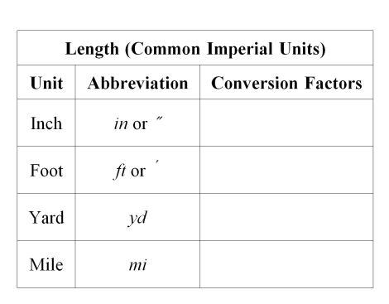

ex. Convert 3.5 miles to the nearest metre.

ex. Convert 2.5 feet to inches.

B. What has a greater base area, a circular hot tub with a diameter of 9 *ft* or a rectangular hot tub with dimensions ?

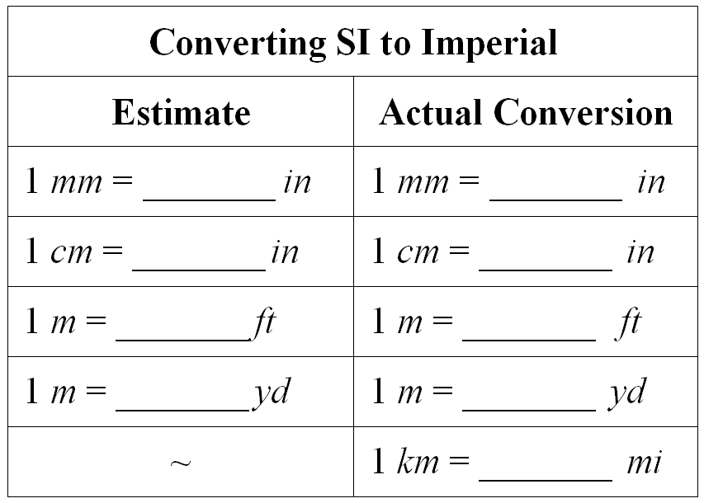

ex. Convert 372 feet to yards.

Rectangular Prism

*h*

*w*

*l*

ex. Convert 16 inches to centimetres.

Cylinder

*d*

*h*

Examples

1. Formula
2. Substitute
3. Solve

Ex:

Ex:

Ex:

Ex:

ex. Convert 26500*mL* to the nearest quart.

ex. Convert 3 *qt* to Litres.

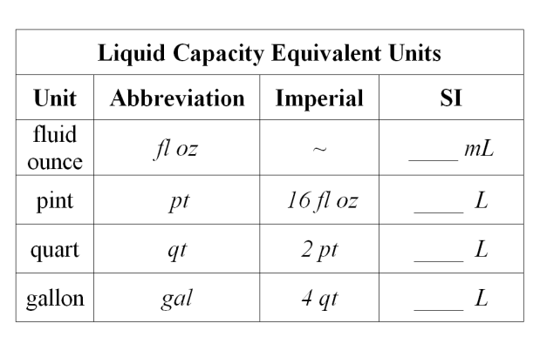

**Lesson 1: Systems of Measurement**

**Lesson 3: Surface Area**

**______________________**

**Name**

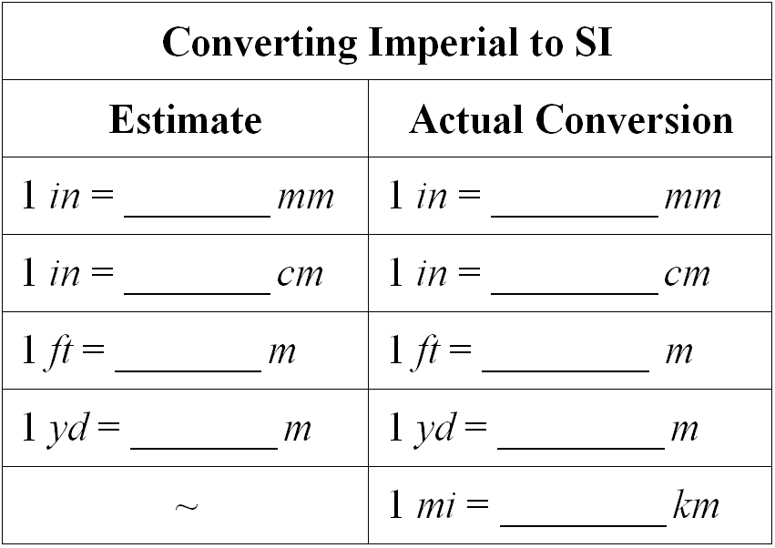

Selling Rate

ex. Convert 32 inches to feet.

ex. Convert 5 yards to feet.

ex. Convert 25*L* to the nearest tenth of a gallon.

ex. Convert 125 000 centimetres to the nearest yard.

ex. Convert 12 *fl* *oz* to the nearest *mL*.

**Surface Area**

Note: the height of a prism is

defined when the prism is

standing on its base:

**Things I have to Practice:**

ex. Convert 100 metres to the nearest foot.

Cone

Triangular Prism

**Lesson 4: Capacity Conversions**

**Lesson 2: Converting Measurements**

A. Mark is trying to set a world record for distance rolled by a tractor tire without falling. He has to beat the current record of 56 *km*. If his tire has a diameter of 4’5” then determine how many times he will have to roll the tire to beat the record.



*r*

*s*

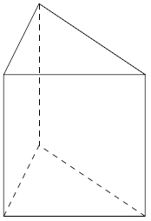

*H*

*h*

*b*