**Pre-Calculus 12: Operations of Functions Practice- Adding and Subtracting**

**Name: ______________**

1. For each pair of functions, determine  and 

a.  

b.  

c.  

2. Given ,   find each combined function and state its domain and range.

a. 

b.

3. Use the graphs of *f* (*x*) and *g*(*x*) to evaluate each of the following.

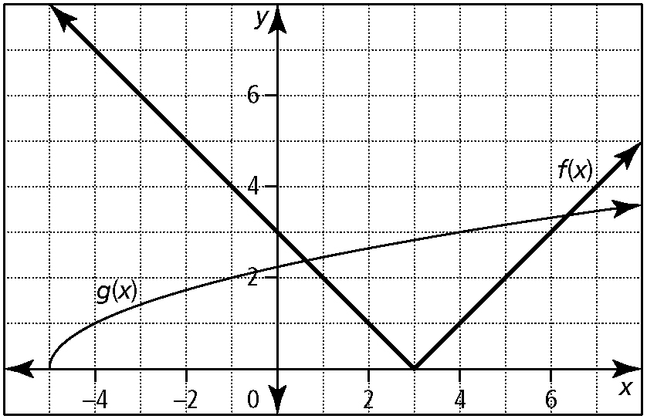

a.  b.  c.  d. 