**Pre-Calculus 12: Operations of Functions Practice- Multiplying and Dividing Functions**

**Name: ______________**

1. Consider the functions and .

a. Determine the equation of 

b. Sketch the graphs of , *,* and  on the same grid.

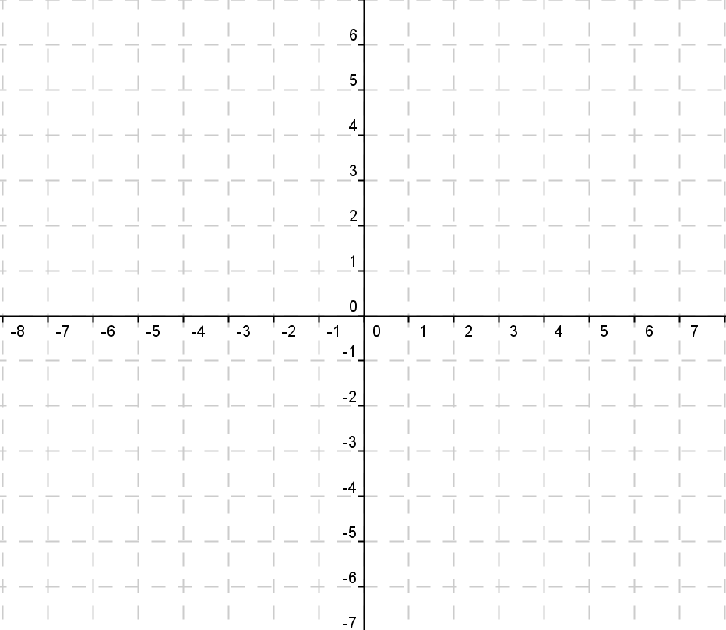

c. State the domain and range of .

2. Given , and , determine each combined function and state its domain and range.

a.  b. 

c. d. 

3. Use the graphs of  and  to determine each value.

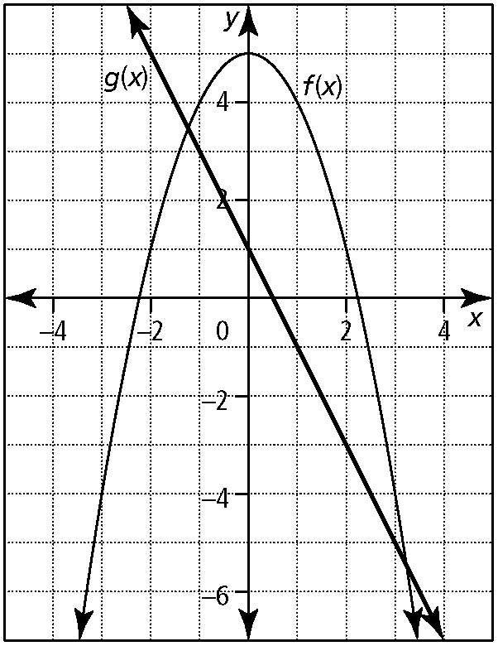

a.  b. 

c.  d. 

e.  e. 