**Math 30-1: Inverse of Relation**

Name:___________________________

1. For each graph below, sketch its image after a reflection in the line y = x.

Identify any invariant points.

2. Determine an equation of the inverse of each function.

a)  b) 

c) 

3. For each function below:

i) Determine an equation of its inverse.

ii) Sketch the graphs of the function and its inverse.

iii) Is the inverse a function? Explain.

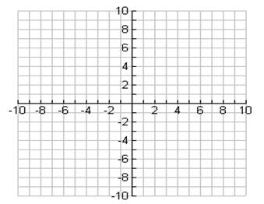a)  b) 

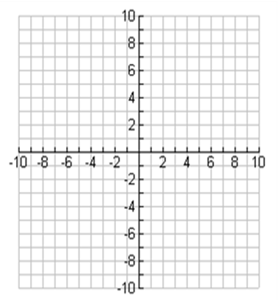4. Determine algebraically the inverse of . Graph the function and its inverse and restrict the domain of the function so that the inverse is a function.

