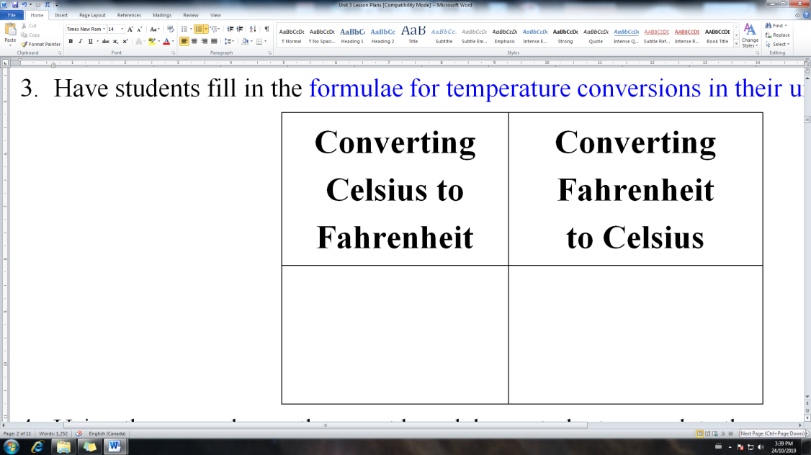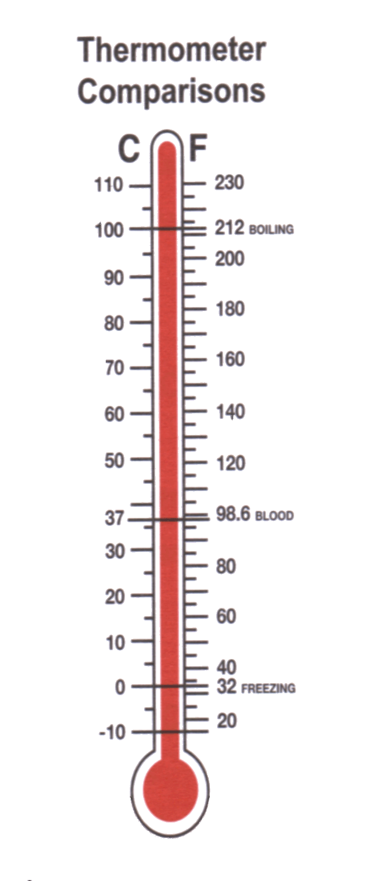

**Choose the best unit for mass unit for each.**

E.g. A bag of apples E.g. Medicine in a pill

E.g. Convert  to Fahrenheit

E.g. Convert 3450*g* to kilograms

E.g. Convert  to Celsius

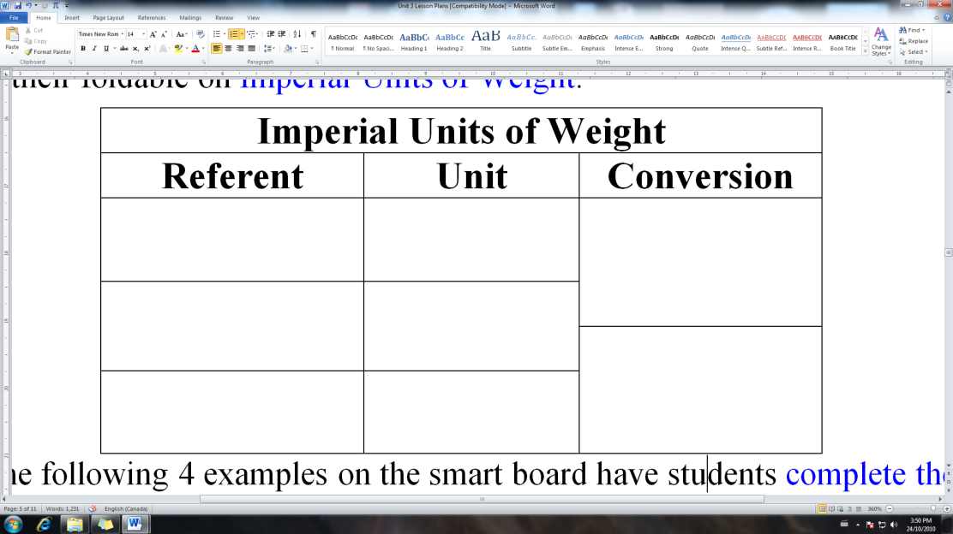

E.g. Convert 325 *g* to ounces

E.g. A load of gravel E.g. A ring

E.g. Convert 4250 *lb* to tonnes

E.g. Convert 7.2*lb* to the nearest ounce

**UNIT 3 TARGETS**

**Demonstrate an understanding of the Système International (SI) by:**

• describing the relationships of the units for length, area, volume, capacity, mass and temperature

• applying strategies to convert SI units to imperial units.

**Demonstrate an understanding of the imperial system by:**

• describing the relationships of the units for length, area, volume, capacity, mass and temperature

• comparing the American and British imperial units for capacity

• applying strategies to convert imperial units to SI units.

**c.)**

**a.)**

E.g. Rain is catering a dinner for 20 people. She consults a cookbook that tells her she will need approximately ¾ lb of beef for each person and that it will take approximately 20 minutes per pound to cook at 350°F.



Kilogram (*kg*)

Mass

Temperature

Ton (*tn*)

**______________________**

**Name**

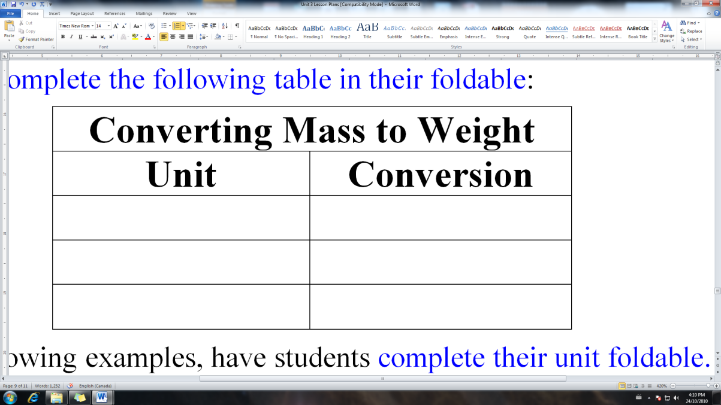

Selling Rate

E.g. Convert 23 750 *mg* to ounces

E.g. Convert  to Celsius

E.g. Convert  to Fahrenheit

E.g. Convert 5.4 *t* to the nearest tonne

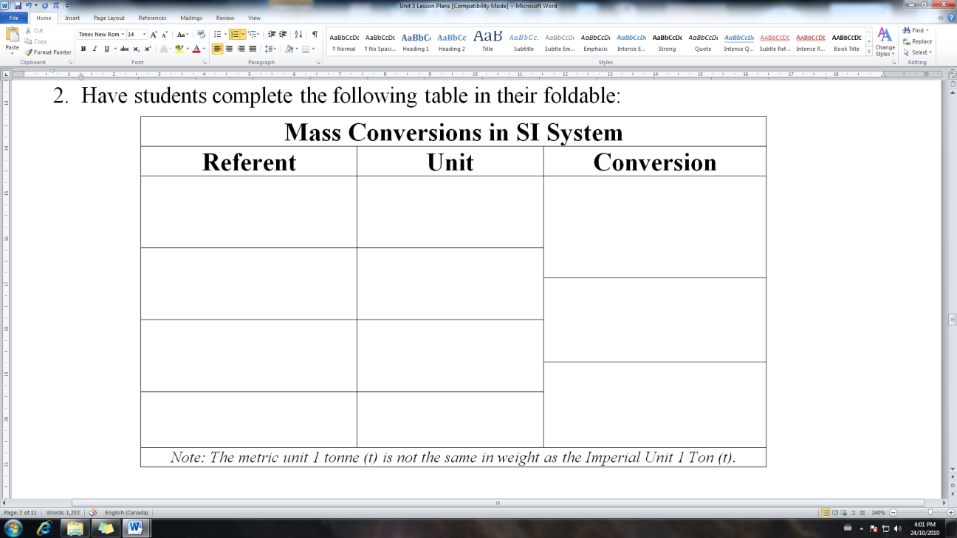

**Key Terms**

Celsius

Conversion Factor

Fahrenheit

Gram

**Choose the best unit of weight for each.**

E.g. A bag of potatoes E.g. A baby

a) Approximately how many kilograms of beef should Rain buy?

b) At what approximate temperature Celsius should she cook it?

c) Approximately how many minutes per kilogram will she have to cook the roast?

E.g. Convert 2.3*kg* to milligrams

**b.)**

E.g. A Honda Civic E.g. Sugar in a can

of pop

E.g. Convert 4250 *lb* to short tons

Tonne (*t*)

Weight

Ounce (*oz*)

Pound (*lb*)