**UNIT TARGET:**

*Algebra #1* – 1. Solve problems that require the manipulation and application of formulas related to:

• the Pythagorean theorem

• primary trigonometric ratios

**FORMULAE:**

**Pythagoras` Theorem**

🡪 The cosine ratio (determined from a reference angle) is equal to the . divided by the .

Ex: Solve for the length of the unknown side.

Ex: Solve for the length of the unknown side.











**Sine Ratio**



🡪 The tangent ratio (determined from a reference angle) is equal to the . divided by the .

Ex: Solve for the length of the unknown side.



Ex: Solve for the length of the unknown side.



**Definitions**

Hypotenuse 🡪

Opposite 🡪

Adjacent 🡪

Angle of Depression 🡪

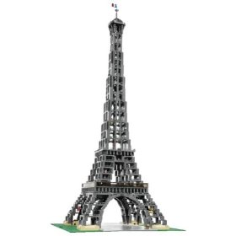

Angle of Elevation 🡪



Inclinometer 🡪

**Solving for Angles**

Ex: Solve for the unknown angle .



Ex: Solve for the unknown angle .



**______________________**

**Name**

**Tangent Ratio**



🡪 All right triangles have the property that the of

the hypotenuse is equal to the

of the of

the remaining sides.

Ex: Solve for the length of the unknown side.



Ex: Solve for the length of the unknown side.



**Cosine Ratio**



🡪 Setup the that has the two sides.

🡪 Solve for the angle by using the of the trig ratio.

Ex: Solve for the length of the unknown side.



Ex: Solve for the length of the unknown side.



Ex: Solve for the unknown angle .

🡪 The sine ratio (determined from a reference angle) is equal

to the divided

by the .



Ex: Solve for all the missing sides and angles

of the triangle below.

Ex: Determine the height of a telephone pole if

the angle of elevation to the top of the pole is

 when the pole is away.

