MATH 30-1

EXPONENTS & Logarithms

Exponent Laws
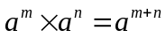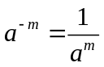
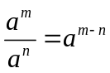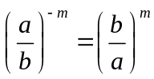
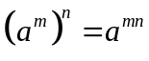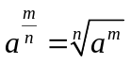
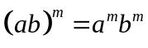

Log Laws
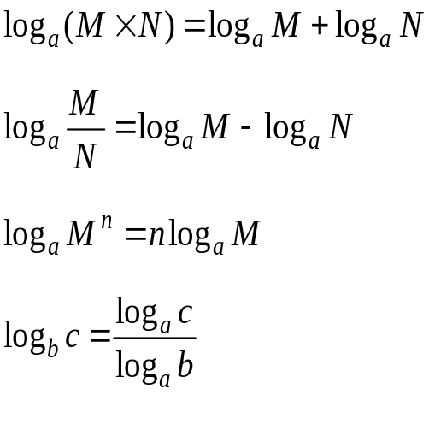

NAME:
TEACHER:
EXAM DATE:
Math 30-1
Unit: Exponents & Logarithms
Topic: Review of Exponents
Solving Equations Involving Exponents
Objective: The students will review their previous knowledge of exponents and solve related questions.

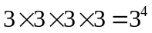 3 is the base, 4 is the exponent and 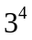 is a power.

Exponent Laws

Example:
Simplify. Write answers with positive exponents.

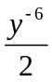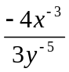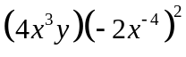

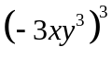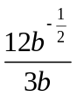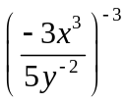

Example
Determine the exact value of the following.
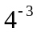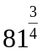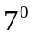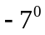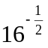

Example:
Change each of the following to the base indicated.

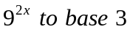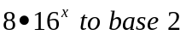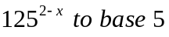

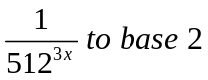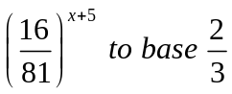

Exponential Equations:

An exponential equation is one in which the unknown is in the exponent. There are two types of exponential equations we will solve.

Type 1: Solving Equations With Rational Exponents
Procedure:
Raise the “other” side of the equation to the “reciprocal” power and solve using your exponent laws.
Example
Solve each
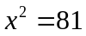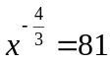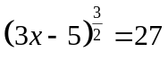

Type 2: Changing the Base
Change the bases to the same number, simplify using the laws of exponents until there is a single power on each side, and then ignore the bases and solve.

Example
Solve and express all solutions as an exact value.

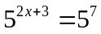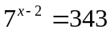

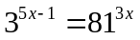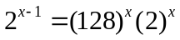

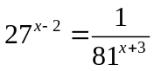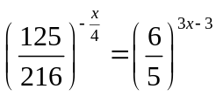

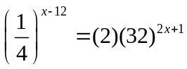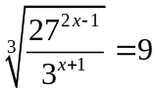

Math 30-1
Unit: Exponents & Logarithms
Topic: The Exponential Function
The Logarithmic Function
Objective: The students will discover how 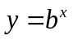 is related to 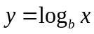.

Example
Use your calculater to evaluate each of the following

log 10 log 0.1

log 100 log 0.01

log 1000 log 0.001

log 10000 log 0.0001

Make a prediction about what the “log” button does.

Example
If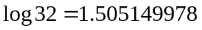, what is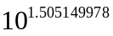?

Note
If , then 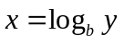.

Example
Write in the other form
Logarithmic Form | Exponential Form
 | 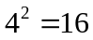
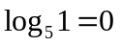
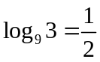
 | 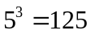
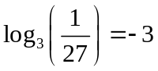

Example
Change to logarithmic form.

a. 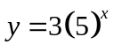 b. 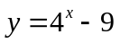

Example
Solve for x

a. 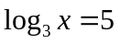 b. 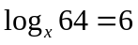 c. 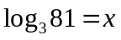

d. 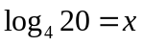 e. 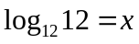 f. 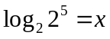

g. 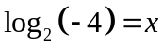 h. 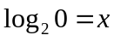 i. 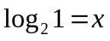

j. 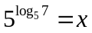 k. 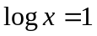

Example
Evaluate

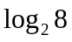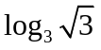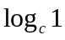

Find the Inverse of the following equations. Express your answer in the form “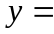”

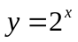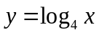
Collection of Useful Results
- 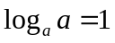
- 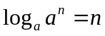
- 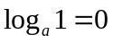
- 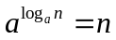
- We can’t take the log of 0 or of a negative number.

Math 30-1
Unit: Exponents & Logarithms
Topic: Changing the Base of Logarithms
Objective: The students will use the change of base identity to simplify logarithmic expressions.

Note
To this point, we have been unable to solve an equation like 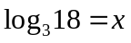, because 18 is not a power of 3. To solve equations of this form, we can use the change of base identity.

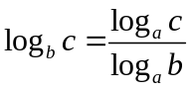

Example:
Evaluate 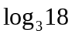

Example:
Evaluate by changing the base and write the meaning of each

a. 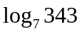 b. 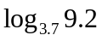 c. 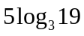
Math 30-1
Unit: Exponents & Logarithms
Topic: Laws of Logarithms
Objective: The students will apply the laws of logarithms to simplify and evaluate logarithmic expressions.

Example
Evaluate
a. 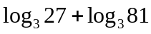 b. 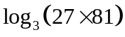

Laws of Logarithms
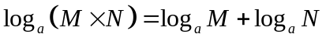
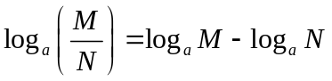
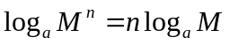

Example
Write as a single logarithm
a. 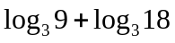 b. 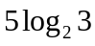

c. 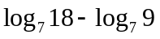 d. 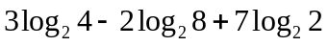

Example
Evaluate
a. 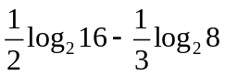 b. 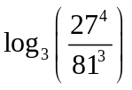

Example
If 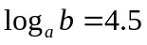 and 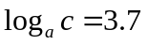, then 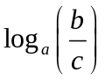=

Example
Write as a single logarithm
a. 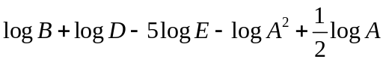 b. 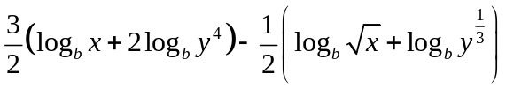

Example
If 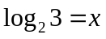, write an expression in terms of x for

a. 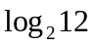 b. 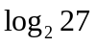 c. 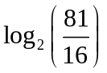

Math 30-1
Unit: Exponents & Logarithms
Topic: Solving Exponential and Logarithmic Equations
Objective: The students will use the laws of exponents and logarithms to solve equations.

Note
An exponential equation is one in which the unknown is in the exponent. There are two types of exponential equations we will solve.

Type 1 - The bases are powers of the same number.
Change the bases to the same number, simplify using the laws of exponents until there is a single power on each side, and then ignore the bases and solve.

Example
Solve for x.
a. 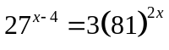 b. 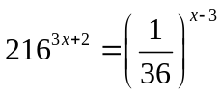

Type 2 – The bases are not powers of the same number
Simplify if possible, and then take the log of each side.

Example
Solve for x
a. 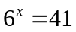 b. 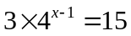

c. 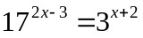 d. 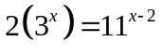

Note
To solve logarithmic equations simplify each side as much as possible using the laws of logarithms. Two situations can arise.

Case #1 - If there is a single logarithm on each side, ignore the logs, and solve the equation. You must always check for extraneous roots.

Example
Solve for x.

a. 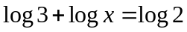 b. 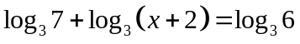

c. 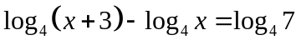

Case #2 - If there is a single logarithm on one side only, and a constant on the other side, change the equation to exponential form, and solve. Check for extraneous roots.

Example
Solve for x.
a. 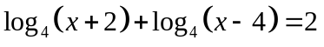 b. 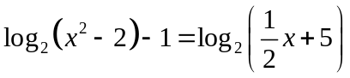

Math 30-1
Unit: Exponential Functions
Topic: Characteristics of Exponential Functions
Objectives:
- The students will graph 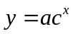 and determine all the characteristics of an exponential graph.

An exponential function is . .. .

Some examples of functions . . . circle those which are exponential.

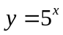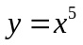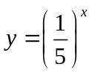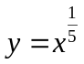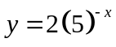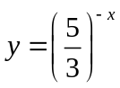

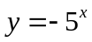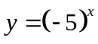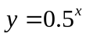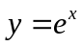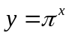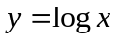

Sketch the graphs of and on the grid below using a table of values.
x | y
-2
-1
0
1
2
x | y
-2
-1
0
1
2

Domain: Domain:
Range: Range:
x-intercept: x-intercept:
y-intercept: y-intercept:
asymptotes: asymptotes:

Sketch the graphs of 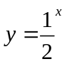 and 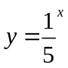on the grid below using a table of values.

x | y
-2
-1
0
1
2
x | y
-2
-1
0
1
2

Domain: Domain:
Range: Range:
x-intercept: x-intercept:
y-intercept: y-intercept:
asymptotes: asymptotes:

Example: Example:

Graph each function Graph each function
on the grid below on the grid below
a) 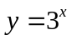 b) 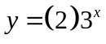 a) 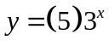 b) 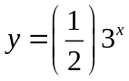

Value of a
Value of c
y-intercept of the graph
How could the letter “a” be described using “transformation” terminology?

Generalize the effect of “a” on the graph of the exponential function

Properties of Exponential Functions .

Domain
Range
y-intercept
x-intercept
Asymptote(s)

Homework: Pg. 342 (#1-12)
Math 30-1
Unit: Exponential Functions
Topic: Transformations of Exponential Functions
Objectives:
- The students will graph 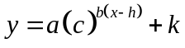 and determine all the transformations associated to an exponential graph.

Example:
Compare the graphs of the following functions to the graph of . . .

Function | Transformation(s) | Domain | Range | x-intercept | y-intercept | Asymptote
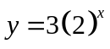
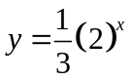
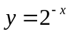
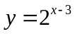

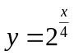
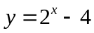
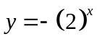
Summary of findings . . .

a

c

b

h

k

Example:
Show algebraically why and 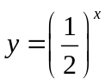 are reflections of each other in the y-axis.

Example:
Describe the transformations that must be applied to the graph of each exponential function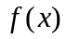 to obtain the transformed function. Write each tranformed function in the form

a) 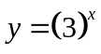, 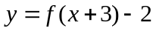 b) 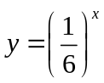, 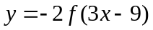

Homework:

Pg. 354 (#1-7, 9,11,12)
Math 30-1
Unit: Logarithmic Fucntions
Topic: Students will graph and determine the characterisitcis of a logarithmic function
Objective: The students will discover how is related to .

A logarithmic function

Example
Graph the function, its inverse and then determine the equation of the inverse.
a. 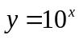 b. 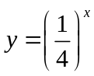

Properties of 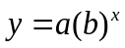
Domain
Range
y-intercept
x-intercept
Asymptote(s)

Example:
Find the inverse of the following equations. Express your answer in the form “”

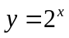

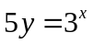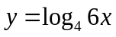

Math 30-1
Unit: Logarithmic Functions
Topic: Transformations of Logarithmic Functions
Objective: The students will graph 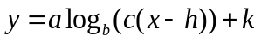 and describe all the transformations associated with a logarithmic function.

Example:
Compare the graphs of the following functions to the graph of 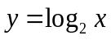 . . .

Function | Transformation(s) | Domain | Range | x-intercept | y-intercept | Asymptote
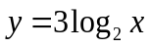
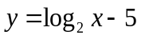
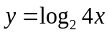
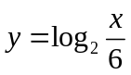
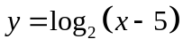
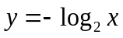

Summary of findings . . .

a –

b –

c –

h–

k –

Math 30-1
Unit: Logarithmic Functions
Topic: Solving Logarithmic Equations Graphically

Methods to Solving Logarithmic Equations Graphically

1.

2.

Examples
Solve graphically.

a.

b. c. 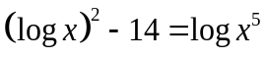

Math 30-1
Unit: Exponential Functions
Topic: Applications of Exponential and Logarithmic Functions

There are many applications of exponential functions in real life.

We use variations of the formula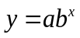 to solve problems involving population growth such as:
- Compound Interest
- Population Growth
- Bacteria Growth (Doubling/Half-Life/Tripling)

Compound Interest (Population Growth) Formula

The formula which can be used to calculate compound interest is:
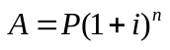
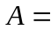
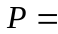
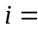

Example:
$7000 is invested in a 6 year GIC compounded quarterly at a rate of 5% per annum. Determine the value of the investment at the end of the term.

Example:
In 2002 the population of the city of Yoyoville is 160 000 and was increasing at an annual rate 4.5%.
- Write an equation to represent the population (P) of the city as a function of the number (n) of years since 2002.

- Determine the population in the year 2015.

- If the population continues to grow at this rate, determine the number of years, to the nearest year, for the population to double the number in 2002.

Example:
The number of fish in a lake is decreasing by 5% each year as a result of overfishing.
- Write an equation to represent the number of fish present after t years. Use N₀ to represent the initial population and N(t) to represent the final population.

- If 2005 fish were present in January of 2010, how many would you expect there to be in January of 2020?

Example:
The value of a bond, in dollars, is represented by 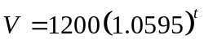where t is the time in years.
- State the initial value of the bond

- Determine the value of the bond, to the nearest dollar, after six years.

- Determine the time taken, to the nearest year, for the bond to double in value.

Bacteria Growth (Doubling/Half-Life/Tripling)
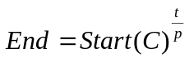

End =
Start =
C =
t =
p =

Example:
A patient feeling ill had a sample of bacteria taken from her throat. The sample contained 387 cells. Twenty four hours later the sample was recounted and found to contain 8012 cells.
- Determine the doubling period.

- Determine the number of bacteria after 8 hours.

- How long will it take for the sample to triple the original amount? (Round your solution to the nearest tenth of an hour)

Example
A radioactive isotope has a half-life of approximately 25 weeks. How much of a sample of 50 grams of the isotope would remain after 630 days? (Round the answer to the nearest hundredth of a gram)

- How long will it take until there is 10 grams of the sample left?

Example
In April 1986, the nuclear accident in Chernobyl contaminated the atmosphere with quantities of radioactive iodine-131. If the half-life of radioactive iodine-131 is 8.1 days, determine the number of days, to the nearest day, it took for the level of radiation to reduce to 2% of the original level.

Homework:
Pg. 364 (#10-14) and the assignment on the next

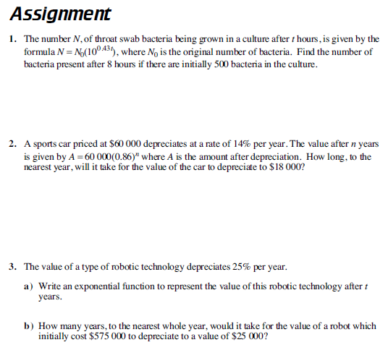

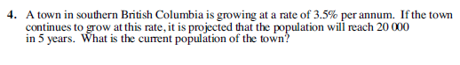

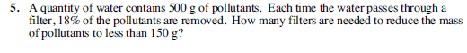

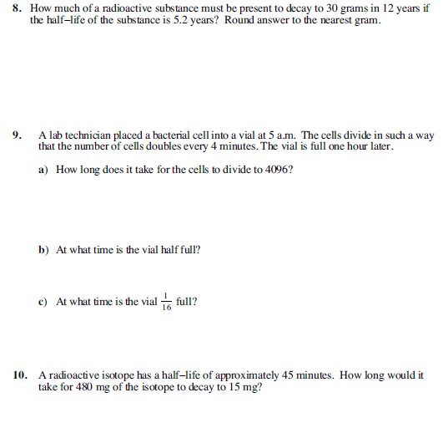

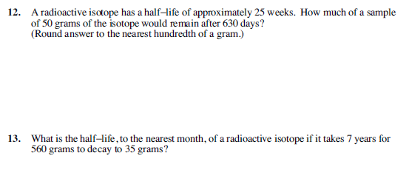

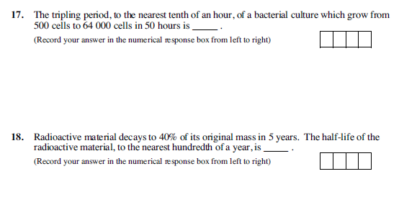

Solutions

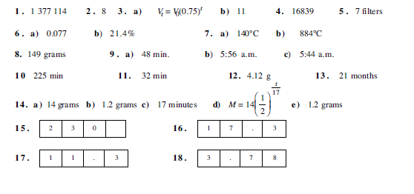

Math 30-1
Unit: Logarithmic Scales and Applications
Topic: Applications of Exponential and Logarithmic Functions

There are 3 common applications of logarithmic scales:
- The Richter Scale which measures the magnitudes of earthquakes
- The pH scale which measures pH
- The Bel Scale which measures the loudness of a sound

All of these scales are logarithmic and a difference of 1 on each of these scales corresponds to a factor of 10 difference in intensity

Examples

- An earthquake with a magnitude of 8 is times as intense as a magnitude of 7.

- An earthquake with a magnitude of 5 is times as intense as a magnitude of 2.

- A pH of 3 is times as acidic as a pH of 7.

- A pH of 12 is times as alkaline as a pH of 8.

- A power saw (120 dB or 12 B) is times as loud as a telephone (80 dB or 8 B)

- A whisper (30 dB or 3 B) is times as loud as a leaf rustling (10 dB or 1 B)

If you find the difference between two magnitudes, two pH’s or two loudnesses and raise 10 to the power of that difference, you can find the ratio of the two values.

Examples

- How many more intense is a magnitude of 6.5 than a magnitude of 4.4 on the Richter Scale?

- How many times as acidic is blood (pH of 8.1) than laundry detergent (pH of 11.8)?

- How many times louder is a train whistle (90 dB) than a piano (65 dB)?

Examples

- An earthquake with a magnitude of 7.5 is 500 times as intense as another earthquake. What is the magnitude of the other earthquake?

- Vinegar with a pH of 3 is 245 times more acidic than battery acid. What is the pH of battery acid?

- A power saw (12 Bels) is as intense as a rock concert. What is the loudness of a rock concert?

Example

The pH of a solution is defined 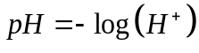

- If a substance has a pH of 5.7, what is the hydrogen ion concentration?

- If a substance has a hydrogen ion concentration of 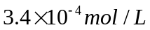 , what is its pH?

Homework:
Photocopied questions & Textbook
Pg. 381 (#17 - 19)
Pg. 391 (#12 - 14)
Pg. 401(#13 - 17)
Pg. 413 (#9 - 16)
Pg. 417 (#15 – 17, 21-23)
Pg. 419 (#6, 13 - 17)


