**Math 20-1 Year End Review Package Key**

**Chapter 1 Sequences & Series**

1. The value of ***n*** will be a natural number
2. Discrete. Values between the terms of the sequence

are not included in the sequence.

1. A
2. 5, 7, 9
3. d = 4, tn = 4n + 3
4. d = 7, t1 = -19
5. n = 32
6. S20 = 800
7. S19 = 893
8. n = 21
9. a) common difference, b) y-intercept + slope value equals t1.

c)continuous, domain is all real numbers discrete, domain is natural numbers

d) Continuous means that all values between known points are included. The points on the graph would be connected. Sequences are not continuous.

1. r = 3, tn = 8(3)n – 1
2. a) 9, 12, 15 b) 12, 24, 48
3. n = 10
4. 
5. r = 3, first 5 terms: 2, 6, 18, 54, 162
6. $38 906.14
7. 
8. Sn = 2 516 583
9. -1 < r < 1
10. a) a convergent infinite series has a sum
11. a) r = , convergent b) r = 2, divergent, no sum
12. 
13. A graph on left, Bgraph on right
14. a) Height after 4th bounce is t5 = 0.512 m

b) 46.4 m

**Chapter 2: Trigonometry**

1. 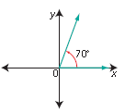
2.   

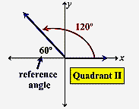

III

θR= 45˚

θ = 225˚

1. a) b)

VI

θR= 70˚

θ = 290˚

I

θR= 80˚

θ = 80˚

c) d)

1. a) Angle in standard position:

30˚ quadrant II 150˚,

45˚ quadrant III 225˚,

60˚ quadrant IV 300˚

b) θR = 54˚, 126˚, 234˚, 306˚

1. a) No. Reference angles in standard position are measured between the terminal arm and the nearest x-axis.

b) 250˚, 290˚

c) θR = 70˚

1. a) x-axis

b)The reference angles are the same for the related angles in standard position.

c) (3, -5) and (-3, -5)

|  |  |  |
| --- | --- | --- |
| sin ɵ | cos ɵ | tan ɵ |
|  |  | or |
| or | or | 1 |
|  |  |  |
| 1 | 0 | Undefined |
| 0 | -1 | 0 |
| -1 | 0 | Undefined |

1. sin 150˚ =  cos 120˚ = 

tan 300˚ = - sin 310˚ = -0.76604

cos 210˚ =  tan 200˚ = 0.36397

1. a) 41

b) sin θ = , cos θ = , tan θ =  θ = 347.3˚

1. sin θ =  , cos θ = , tan θ =  θ = 140.2˚
2. sin θ = 0.615, θ =37.95˚ or 142.05˚,

tan θ = -2.43, θ = 112.4˚ or 292.4˚

tan  θ = 150˚ or 330˚

cos θ =  θ = 45˚ or 315˚

sin θ =  θ = 210˚ or 330˚

cos θ =  θ = 30˚ or 330˚

1. 
2. a) a = 7.36

b) ambiguous case B = 72.9˚ or B = 107.1˚

c) c = 3.22

d) B = 73.4˚

1. A = 435 cm2
2. 9.5 yards
3. angle = 91.3˚
4. BC = 16.03 km

**Chapter 3: Quadratic Functions**

1. V(3, 1) Axis of Symmetry x = 3

Horizontally translated by 3 units right and vertically by 1 unit up. Domain  Range .



1. B
2. C

vertex (-2, -3)

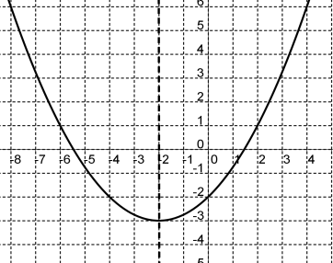

axis of symmetry x = -2

1. a) see diagram

b) x-intercepts , y-intercept -2

c) a = shape of parabola (wide than )

a is positive orientation (parabola opens up)

p is -2parabola shifts horizontally, 2 units left

q is -3 parabola shifts vertically, 3 units down

1. 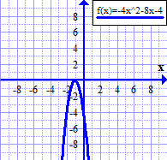V( -1, 0) A of S 

x-intercept -1

y-intercept -4

1. vertex (-4, -36), axis of symmetry x = -4,

opens up, minimum value y = -36,

x-intercepts -10 and 2, y-intercept -20

Domain=  Range 

1. 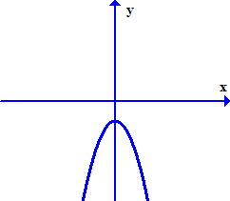
2. C
3. Vertex at (0, -b)

see diagram

1. y = 9(x + 5)2 + 6
2. y = 2x2 + 4x – 1
3. 



 V(3, -29)

1. a)  b) 
2. y = -2x2 + 2x + 4
3. x = 1
4. parabola shifts 6 units right and 3 units down
5. a)  vertex (-3, 6)

range , no zeros

b)  vertex (-6, 8)

range , 2 zeros

1. y coordinate of vertex is -8
2. A
3. C
4. B
5. B
6. C
7. a) y = -5x2 + 70x + 1200 or y = (120 – 5x)(10 + 1x)

b) best price $17, maximum revenue is $1 445

1. maximum area is 216 cm2
2. maximum area is 1800 m2
3. product is 
4. 72%
5. 5m x 25m

**Chapter 4: Quadratic Equations**

1. a) (x - 3)(x - 9) b) (2x – 1)(2x + 5)

c) -(x + 5)(x – 3) d) (x – 5y)(x + 5y)

e) (2x – 9y)(2x + 9y) f) (2x + 5)((x + 2)

g) -4(2x + 3)(x + 3) h)(5x – 11y – 26)(5x + 11y –4)

1. factors are k = -5
2. h = 2
3. x= -3.33 or x = -3, zeros
4. or 
5. x = 5 or x = -5
6. x = 9 or x = -5
7. x = -2 or x = -16
8.  or 
9. x =  and 
10. Discriminant is -76. There are no real roots.
11. a) no real roots

b) 2 distinct real roots

1. a) 2 distinct real roots

b) 2 distinct real roots

c)2 equal real roots

d) 2 distinct real roots

e) no real roots

1. k < - 7
2. 
3. x2 – 3x – 10 = 0 or where a is a number.
4. 3.12 seconds
5. The numbers are 3 and 12.
6. 21 m x 12 m
7. C
8. length of the photo is 28.97 cm.

**Chapter 5: Radical Expressions and Equations**

1. 1, 4, 9, 25, 36, 49, 64, 81, 100, 121, 144, 169
2. 1, 8, 27, 64, 125
3. 
4. True  ,  , 
5. C
6. a)  b)  c) 

d)  e) 

1. a)  b)  c) 

d)  e)  f) 

1. a)  b)  c) d) 
2. a)  b) 

c) 

1. a)  b)  c) 

d)  e) 

1. a)  b)  c) 

d)  e) 

1. a)  b)  c) 
2. conjugates, conjugate binomials, rational
3. a)  b) 14
4. a) x = 6 ,  b) x = 6,  c) no solution

d) x = 1,  e) x = 1, 

f) x = 23 , 

1. a) 1.90 minutes b) 223.4 m

**Chapter 6: Rational Expressions and Equations**

1. 
2. a) 15 b)  or 
3. a)  b) 

c) 

d)  e) 

f) 

g)  h) 

1. a)  b) 

c)  d) 

1. or 11.1 minutes
2. 12 Km/h
3. Superman 116.9 Km/h Flash 136.9 Km/h

**Chapter 7: Absolute Value and Reciprocal Functions**

1. 
2. a) -9 b) -25
3. possible ages are  or 
4. D
5. A

|  |  |
| --- | --- |
| x | f(x) |
| -3 | 10 |
| 0 | 5 |
| 3 | 0 |
| 6 | 5 |

|  |  |  |
| --- | --- | --- |
|  | f(x) | g(x) |
| x-int |  |  |
| y-int | -1 | 1 |
| domain |  |  |
| range |  |  |
| set of  invariant  points |  | |

1. 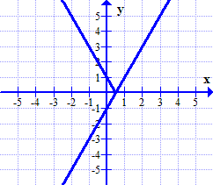graph
2. 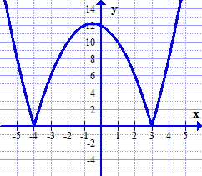graph

x-int -4 or 3

y-int 12

domain 

range 

set of invariant

points 

1. a) 

b) 

9c) 

d) 

1. a)  b) 

c)  d) no solution

1. a)  b) 
2. The x-intercept of the linear graph becomes the position of a vertical asymptote on the graph of the reciprocal.
3. The equations for the vertical asymptotes are equal to the value; the equations for the non-permissible values are not equal to the value.

Asymptote Equations: 

Non-permissible values 

1. invariant points (-2, 1) and (-4, -1)
2. 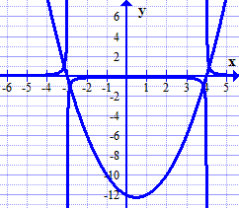graph
3. a) domain 

domain 

b) range

range 

1. 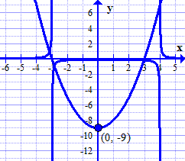

**Chapter 8: Systems of Equations**

1. (1, 3) is not a solution, (4, 0) is a solution
2. a) 

b) no solution

1. 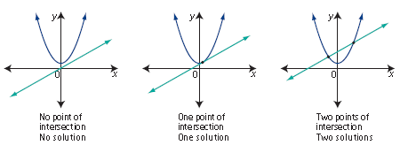.
2. 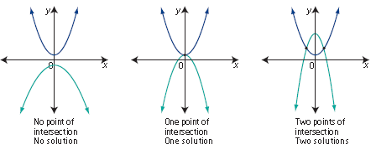.
3. a) x = -2 and y = 7

b) x = -4 and y = 9 or x = 4 and y = -7

1. a) perimeter , area 

b) x = -2 or x = 5

c) x must be a positive value, 

d)  dimensions are 15 x 10, perimeter is 50, area is 150

1. a)  b) 

**Chapter 9: Linear and Quadratic Inequalities**

1. 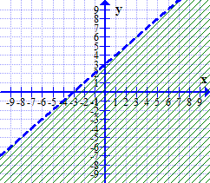a)

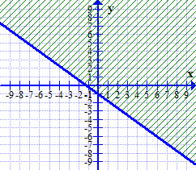b)

1. 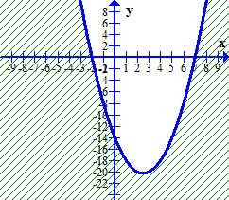a)

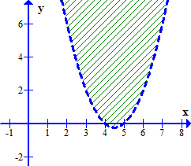b)

1. a) set notation or

interval notation 

b) set notation or

interval notation 

1. a) set notation or

interval notation 

b) set notation or

interval notation 

1. a) x is number of flats of marigolds, y is number of flats of petunias 

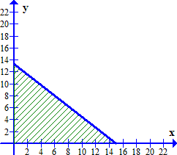b)

c) x and y must be whole numbers

 and 

d) any whole number ordered pair in shaded solution region.

1. a) 

b) x and y must be whole numbers

 and 

1. a) Price $7.50 b) between $6 and $9