Contents

Chapter 1 Arithmetic and Geometric Sequences and Series 2

Practice Questions: McGraw-Hill Ryerson Pre-Calculus 11 Pages 133 – 134, 136 – 137 2

Chapter 2 Trigonometry 4

Practice Questions: McGraw-Hill Ryerson Pre-Calculus 11 Pages 134 - 137 4

Chapter 3 Quadratic Functions 7

Practice Questions: McGraw-Hill Ryerson Pre-Calculus 11 Pages 264, 266 – 267 7

Chapter 4 Quadratic Equations 11

Practice Questions: McGraw-Hill Ryerson Pre-Calculus 11 Pages 264 – 267. 11

Chapter 5 Radical Expressions and Equations 13

Practice Questions: McGraw-Hill Ryerson Pre-Calculus 11 Pages 416, 418 – 419 13

Chapter 6 Rational Expressions and Equations 15

Practice Questions: McGraw-Hill Ryerson Pre-Calculus 11 Pages 416 – 419 15

Chapter 7 Absolute Value and Reciprocal Functions 16

Practice Questions: McGraw-Hill Ryerson Pre-Calculus 11 Page 417 16

Chapter 8 Systems of Equations 19

Practice Questions: McGraw-Hill Ryerson Pre-Calculus 11 Pages 508-512. 19

Chapter 9 Linear and Quadratic Inequalities 20

Practice Questions: McGraw-Hill Ryerson Pre-Calculus 11 Pages 509, 510 - 512. 20

# Chapter 1 Arithmetic and Geometric Sequences and Series

## Practice Questions: McGraw-Hill Ryerson Pre-Calculus 11 Pages 133 – 134, 136 – 137

1. What assumptions are made on the value of n in the formulas  and ?
2. Are arithmetic sequences and geometric sequences continuous or discrete? Explain.
3. Which statement best describes an arithmetic sequence?

A. An ordered list of terms in which the difference between consecutive terms is constant.

B. An ordered list of terms in which the difference between consecutive terms is growing.

C. An ordered list of terms in which the difference between constant terms is a variable.

D. An ordered list of variables in which the difference between consecutive terms is a constant.

1. Write the first three terms of the sequence .
2. Determine the value of the common difference for  and write the formula for the general term.
3. Determine the value of the first term and common difference of the arithmetic sequence given.
4. Determine the number of terms in the sequence -29, -24, -19, …., 126.
5. Calculate the sum of the first 20 terms of 
6. Use the appropriate formula to calculate the sum of the arithmetic series 2 + 7 + 12 + …..+ 92.
7. The sum of the first *n* terms for the series 19 + 15 + 11 + …. +  is -441. How many terms are in the series?
8. Describe the relationship between an arithmetic sequence, , and a linear function  .

a) The slope of the graph of a linear function relates to ____________ of an arithmetic sequence.

b) Given the equation of the linear function, how could you calculate the first term of the related sequence?

c) Insert the words continuous or discrete in the blanks below and describe the domain.

The graph of a linear function is _________ and the domain is

The graph of an arithmetic sequence is _________ and the domain is

d) The word continuous in the context of sequences does not mean that the sequence continues to infinity. We use infinite to describe that a sequence does not end. What does continuous mean?

1. Determine the value of the common ratio of the sequence  and write the equation of the general term.
2. Determine the next three terms in the sequence 3, 6, ……if the sequence was

a) arithmetic b) geometric

1. Determine the number of terms in the geometric sequence 3, 6, 12, …., 1536.
2. Given , determine the value of as an exact value.
3. In a geometric sequence, . Determine the value of the common ratio and then list the terms between.
4. A museum purchases a painting for $15 000. The painting increases in value each year by 10% of the original price. What is the value of the painting after ten years?
5. Determine the sum of the first 12 terms of the series 
6. Determine the sum of the series .
7. What interval of values for the common ratio must exist for a geometric series to be convergent?
8. Identify the type of infinite geometric series that has a sum, convergent or divergent.
9. Determine the value of the common ratio and label each series as convergent or divergent. Calculate the sum of the infinite series if it exists.

a)  b) 

1. The sum of an infinite geometric series is 120 and the common ratio is . State the first three terms of the series.
2. 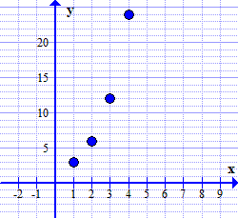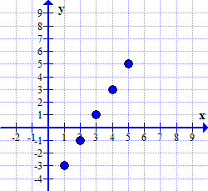Match the graph with the sequence it models.

A. 

B. 

1. A tennis ball dropped from a height of 20 m bounces to 40% of its previous height on each bounce. The total vertical distance travelled is made up of upward bounces and downward drops. Draw a diagram to represent this situation.

a) What is the height reached after the fourth bounce?

b) What is the total vertical distance the ball has travelled when it hits the floor for the sixth time? Express your answer to the nearest tenth of a metre.

# Chapter 2 Trigonometry

## Practice Questions: McGraw-Hill Ryerson Pre-Calculus 11 Pages 134 - 137

1. Circle the angle that is sketched in standard position.

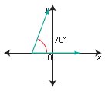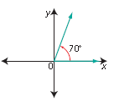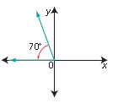

1. Write the ratios in terms of x, y and r.

  

1. Sketch each angle in standard position. Indicate the quadrant the angle terminates as well as the measure of the reference angle.

a) 120° b) 225° c) 290° d) 80°

1. a) Complete the following table

|  |  |  |
| --- | --- | --- |
| Reference Angle | Quadrant | Angle in Standard Position |
| 30° | II |  |
| 45° | III |  |
| 60° | IV |  |

b) List three other angles in standard position, 0º < θ < 360° that have a reference angle of 54°.

1. 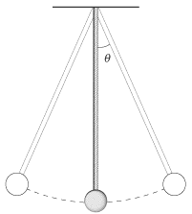Use the diagram of the pendulum to answer the questions.

a) Could angle θ be defined as the reference angle for an angle in standard position?

b) If θ = 20°, determine the measures of the angles formed by the arm of the pendulum as an angle in standard position.

c) What would the measure of the reference angle be for the angles in standard position given θ = 20°.

1. Consider the points (3, 5) and (-3, 5), both on terminal arms of different angles in standard position

a) If the point (3, 5) was reflected in the ______ axis, it would be at (-3, 5).

b) What relationship exists between the reference angles for the angles in standard position?

c) Name two other points on terminal arms of angles in standard position that would satisfy this relationship.

1. Fill in the table using exact values for the ratios.

|  |  |  |  |
| --- | --- | --- | --- |
| angle ɵ | sin ɵ | cos ɵ | tan ɵ |
| 30° |  |  |  |
| 45° |  |  |  |
| 60° |  |  |  |
| 90° |  |  |  |
| 180° |  |  |  |
| 270° |  |  |  |

1. Determine the value of each trig ratio. Use exact values when possible.

 

 

 

1. The point (40, –9) is on the terminal arm of angle A, in standard position.

a) What is the distance from the point to the origin?

b) Determine the exact primary trigonometric ratios for the angle, and determine the measure of the angle.

1. The point (-6, 5) lies on the terminal arm of an angle in standard position. Determine the exact value of the primary trig ratios and determine the measure of the angle.
2. Determine the measure(s) of angle θ when .

  

  

1. Marco is 45 m due east of the centre of the park. His friend Ray is 45 m due south of the centre of the park. Write a simplified radical expression for the exact distance between the two boys.
2. Solve for the unknown variable.

a)  b) 

c)  d) 

1. Determine the area of △TUV, to the nearest square centimetre.

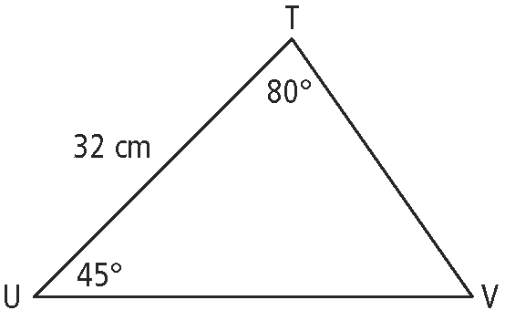

1. Amanda is playing a virtual golf game. The distance from the tee box to the hole is 190 yd. Her first shot was 160 yards long, but was 15° off a direct line to the hole. Amanda’s second shot (taken from where her first shot landed) was aimed at the hole, but it was only 45 yards long, and landed short of the hole. How far is it from where her second shot landed to the hole, to the nearest tenth of a yard?

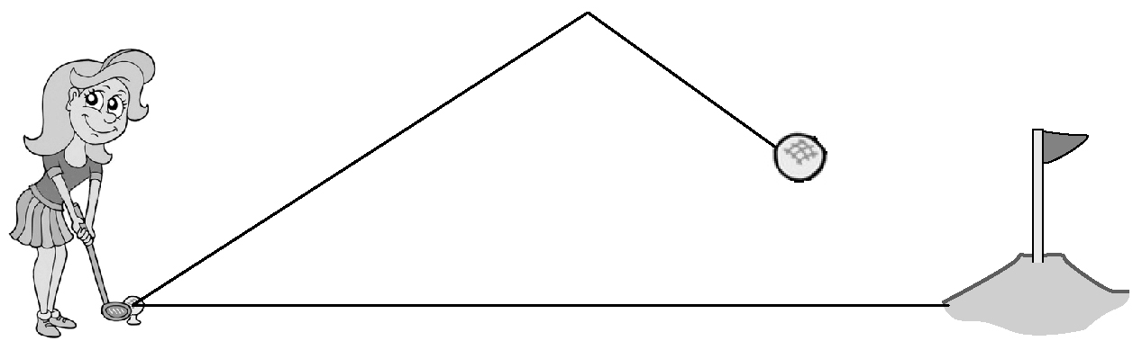

1. While flying, a helicopter pilot spots a water tower that is 7.4 km to the north. At the same time, he sees a monument that is 8.5 km to the south. The tower and the monument are separated by a distance of 11.4 km along the flat ground. What is the angle made by the water tower, helicopter, and monument?



1. Towns A, B, and C are located so that B is 25 km from A and C is 34 km from A. If angle ABC is 110 degrees, calculate the distance between B and C.

# 

# Chapter 3 Quadratic Functions

## Practice Questions: McGraw-Hill Ryerson Pre-Calculus 11 Pages 264, 266 – 267



1. Consider the graph of the quadratic function in the graph

* Coordinates of vertex __________
* Equation of axis of symmetry ________
* Congruent to f(x) = ax² translated horizontally by

____units and vertically by _______units

* Domain
* Range
* Write the equation in the form 

1. Multiple Choice: The coordinates of the vertex for

 are

A.  B.  C.  D. 

1. The parabola that is the narrowest is

A.  B.  C.  D. 

1. 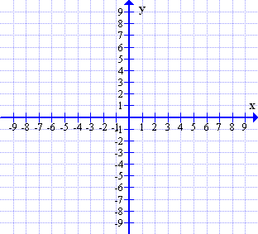a) Sketch the following function. Label the vertex and axis of symmetry



b) Algebraically Determine x and y int

c) Describe the effect of parameters a, p, and q when comparing the graph to the parent graph y = x2. Include a description of the translations and shape of the graph.



1. Sketch the following function. 

Label the vertex and axis of symmetry

Algebraically determine x and y intercepts

1. Determine the following characteristics for the graph of .

Vertex

Equation of Axis of Symmetry

Direction of opening

Max or min value

x int

y int

Domain

Range

1. Write the equation of the quadratic function with a vertex at (2, 6) and passes through the origin.
2. Multiple Choice: Which statement regarding the graph of is true?

A. crosses the *x*-axis

B. lies entirely above the *x*-axis

C. lies entirely below the *x*-axis

D. is tangent to the *x*-axis.

1. The function equation of a parabolic curve is defined by . Sketch a possible graph of the function if and .
2. The vertex of a parabola is located at ( -5, 6) . If the parabola has a y-intercept of 231. Determine the quadratic function equation that represents the parabola in the form .
3. Rewrite  in the form .
4. Fill in the blanks then complete the square to determine the coordinates of the vertex.

y = 2x2 − 12x + 7





1. Identify the coordinates of the vertex.

a)  b) 

1. Write the equation of a quadratic function that passes through the point (1, 4) and has zeros at -1 and 2 in the form .
2. Given the equation  determine the equation of the axis of symmetry.
3. Describe the transformations involved when the graph of becomes .
4. Complete the square to write each function in vertex form. State the vertex, range, and number of zeros.

a)  b) 

1. What is the y-coordinate of the vertex of the graph of the function ?
2. Multiple Choice: Which of the quadratic functions would have the narrowest graph?

A.  B.  C.  D. 

Use the following information to answer the next four questions.

The height in feet, *h*, of a ball thrown in the air after *t* seconds is modeled by the equation

.

1. Multiple Choice: Which characteristic of the graph of the function would be used to determine the maximum height of the ball?

A. y-intercept B. x- intercept C. vertex D. Axis of symmetry

1. Multiple Choice: What is the maximum height that the ball reaches?

A. 36 ft B. 39 ft C. 43 ft D. 51 ft

1. Multiple Choice: How long does it take for the ball to reach the maximum height?

A. 1.1 s B. 1.5 s C. 1.8 s D. 2.2 s

1. Multiple Choice: To the nearest hundredth of a second, how long is the ball in the air?

A. 2.83 s B. 3.00 s C. 3.06 s D. 3.17s

1. A club is planning a car wash fundraiser. Last year they charged $10 per car and washed 120 cars. They would like to earn more money this year, but according to market research for every $1 increase in price, they know they will wash 5 fewer cars.

a) Write a quadratic function equation to model this situation using x as the number of increments of $1 increases and y as the revenue.

b) Determine the best price to charge for the car wash and the expected total revenue at that price.

1. Determine the maximum area, in square centimetres, of the rectangle shown.



1. What is the maximum area of a rectangular field enclosed by 120 metres of fencing if fencing is only needed on three sides since an existing river is along one side?
2. Two numbers have a difference of 20. If the sum of their squares is a minimum, what is their product?
3. The percentage of information memorized by Brandy after t minutes of a lecture is given by the formula . What is the largest percentage of information that she can memorize?
4. The Edmonton SPCA wants to build a new rectangular enclose to have separate but equal in area pens for 9 animals. They only have 100 m of fencing for the entire enclosure. What dimensions will provide the maximum area for each pen?

# Chapter 4 Quadratic Equations

## Practice Questions: McGraw-Hill Ryerson Pre-Calculus 11 Pages 264 – 267.

1. Factor each expression completely.

a)  b)  c) 

d)  e)  f) 

g)  h)  i) 

j) 12(x + 2)2 + 24(x + 2) + 9 k) 

1. If one of the factors of  is , determine the value of *k*.
2. Two factors of the polynomial  are and . What is the value of *h*?
3. Solve  by graphing. Round answers to the nearest hundredth if necessary. The roots of the equation are related to the ____ of the graph of the related function.
4. Solve by factoring .
5. Solve by factoring .
6. Solve by determining square roots .
7. Complete the square to solve  .
8. Determine the exact value of the roots of the equation .
9. Determine the exact value for the solutions to 
10. What is the value of the discriminant for ? What does the discriminant tell us about the roots of the equation?
11. Use the discriminant to determine the nature of the roots for the following:

a)  b) 

1. List the number and nature of roots for each quadratic equation.

a)  b)  c) 

d)  e) 

1. Determine the value(s) for k for which has real and distinct roots.
2. What is the value of the smallest root of the equation .
3. A quadratic equation has the roots . Write a possible quadratic equation with these roots.
4. When a basketball is thrown, its height can be modeled by the function h(t) = – 4.9t2 +15t + 1, where h is the height of the ball, in meters, and t is the time, in seconds. Write and solve a quadratic equation that you can use to determine how long the basketball is in the air.
5. Two numbers have a sum of 15 and a product of 36. Determine the numbers.
6. One side of a rectangular field is 9 m longer than the other side. If the area is 252 m2, determine the lengths of the sides.
7. An object is thrown into the air in such a way that the distance above the ground at any time, t, in seconds, is given by the equation. Which characteristic of the graph of the function would determine how long the object is in the air?

A. vertex B. y-intercept

C. x-intercept D. axis of symmetry

1. A photographer wants to frame a square picture. The frame has a 6 cm border all around the picture. If the area of the photo is equal to the area of the border, determine the side length of the photo. Round to the nearest hundredth.

# Chapter 5 Radical Expressions and Equations

## Practice Questions: McGraw-Hill Ryerson Pre-Calculus 11 Pages 416, 418 – 419

1. List all the perfect square numbers up to 169.
2. List the first five perfect cubes.
3. Order the set of radicals from least to greatest. 
4. Circle the true statements for each group. Justify your choice.

a)  b) 

c) 

1. Multiple Choice: The value of the radicand in is

A. 7 B. 2 C. 5 D. 15.7

1. Express each as a mixed radical in simplest form

a) b) c) 

d) e)  List restrictions on the variables.

1. Write each mixed radical as an entire radical.

a)  b)  c)

d)  e) f)

1. List the restrictions on the variable for each.

a)  b)  c)  d) 

1. Determine each sum or difference in simplest form. State any restrictions on the variables.

a)  b) 

c) 

1. Express each product in simplest form.

a)  b) c) 

d)  e) 

1. Write each quotient with a rational denominator in simplest form.

a)  b) c)

d) e) 

1. Write each expression in reduced form.

a)  b)  c) 

1. Binomials such as  and are called _____________. The product of any two ________ will always be a ___________ number.
2. Would you believe that there are square watermelons? Watermelons are big and round and waste a lot of space in grocery stores. A Japanese farmer grew a watermelon in a square box to give them a cubic shape. Suppose one side of a cubic melon has an area of 98 cm2.

a) What is the length of one side of the cube in simplest radical form?

[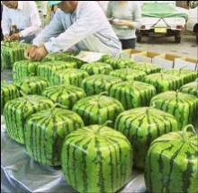](http://1.bp.blogspot.com/-_8v4cHb7gro/Tb98usJFWoI/AAAAAAAAGeg/gOZzI_uAGkc/s1600/square-watermelon.jpg)

b) What is the length of a diagonal of a side of the cubic watermelon?

1. Solve each radical equation and state the domain of the radicand (restrictions on the variable).

a)  b) 

c)  d) 

e)  f) 

1. The period of a pendulum is the time it takes for the pendulum to swing back and forth once. If the period of a pendulum is modeled by , where L is the length of the pendulum in metres and T is in minutes.

a) If one pendulum is 22 m and another pendulum is 14 m, what is the difference in the time each takes to swing back and forth once?

b) If T is 30 minutes, what is the length, L, of the pendulum?

# Chapter 6 Rational Expressions and Equations

## Practice Questions: McGraw-Hill Ryerson Pre-Calculus 11 Pages 416 – 419

1. What is the domain of ?.
2. Fill in the blank to determine equivalent rational expressions.

a)  b) 

1. Simplify each of the following.

a)  b) 

c)  d) 

e)  f) 

g)  h) 

1. Solve each and state all non-permissible values of the variable.

a)  b) 

c)  d) 

1. Penny and Paul are sharing a bag of popcorn at the movies. By himself, Paul can eat the whole bag of popcorn in 20 min. Penny takes 25 min to eat the whole bag. If they both eat popcorn at their usual rates, how quickly will they eat the popcorn?
2. A group of friends go on a 3hour bike ride together. They ride 15 km with the wind at their backs, and then 15 km straight into the wind. The wind adds or subtracts 3 km/h from their speed. What is the average speed of the group of friends with no wind?
3. Superman and The Flash decide to race to see who could is faster in a 400 km running race. If The Flash ran 20 km per hour faster than Superman, and won the race by half an hour, what were their respective speeds?

# Chapter 7 Absolute Value and Reciprocal Functions

## Practice Questions: McGraw-Hill Ryerson Pre-Calculus 11 Page 417

1. Compare and order the real numbers from least to greatest



1. Evaluate the following

a)  b) 

1. The average age in a grade 11 class is 16 years. The difference between Alan’s age and the average age is  of a year. Write an equation involving absolute value could be used to determine Alan’s age. Solve the equation to determine the two possible ages for Alan.
2. Multiple Choice: One winter day in Salmon Arm, BC the temperature rose from  to . Which expression represents the number of degrees of change in temperature?

A.  B.  C.  D.

1. Multiple Choice: The diameter of a child’s bouncy ball toy is 1.75 inches. The ball has a tolerance of  inches. Which of the following equations could be used to determine the upper and lower limits of the diameter of the ball?

A.  B.  C.  D. 

1. Complete the table of values for the absolute value of the function.

|  |  |
| --- | --- |
| x | f(x) |
| -3 | -10 |
| 0 | -5 |
| 3 | 0 |
| 6 | 5 |

|  |  |
| --- | --- |
| x | |f(x)| |
| -3 |  |
| 0 |  |
| 3 |  |
| 6 |  |

1. Consider the functions  sketch the graphs of f(x) and g(x) and identify the characteristics of each function



* x-intercept
* y-intercept
* domain
* range
* set of invariant points

1. Sketch the graph of and identify



* x-intercept
* y-intercept
* domain
* range
* set of invariant points

1. Express each as a piecewise function.

a)  b) 

c)  d) 

1. Determine the roots of each absolute value equation algebraically. Identify any extraneous roots.

a)  b) 

c)  d) 

1. State the equation(s) of the vertical asymptote(s) for each function.

a)  b) 

1. How is the x-intercept of related to the graph of the function ?
2. Explain the relationship between the equations of the vertical asymptotes for the graph of  and the non-permissible values for .
3. List the coordinates of all invariant points for the graphs of .
4. Sketch the graphs of on the same axes for the function .



1. 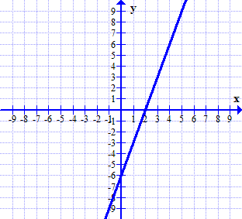Use the graph of the function 

to graph .

a) Compare and contrast the domain of  to the domain of .

b) Compare and contrast the range of  to the range of .

1. 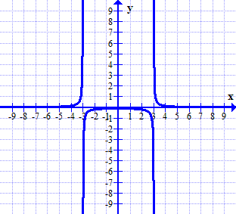Use the graph of the function  to graph .

Explain the strategies used.

The *y*-intercept of  is .

# Chapter 8 Systems of Equations

## Practice Questions: McGraw-Hill Ryerson Pre-Calculus 11 Pages 508-512.

1. Verify that (1,3) and (4, 0) are solutions to the following system of equations.



1. Solve the system of equations by graphing. Verify your solutions.

a)  b) 

1. Sketch the possible graphs for the types of solutions to a system of linear-quadratic equations.
2. Sketch the possible graphs for the types of solutions to a system of quadratic-quadratic equations.
3. Algebraically solve each the following system of equations. Verify the solutions.

a)  b) 

1. 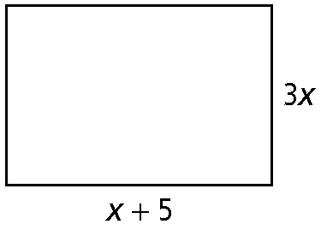In the given rectangle the perimeter is equal to y, and the area is equal to 3y.

a) Write equations in two variables to represent the perimeter and area.

b) Solve the system of equations algebraically to determine the value of x.

c) Are both solutions possible? Explain.

d) Determine the dimensions of the rectangle, the perimeter, and the area.

1. The sum of the squares of two numbers is 74 and the difference of their squares is 24.

a) Write a system of equations to model this situation.

b) What are the two numbers?

# Chapter 9 Linear and Quadratic Inequalities

## Practice Questions: McGraw-Hill Ryerson Pre-Calculus 11 Pages 509, 510 - 512.

1. Graph the solution region for each linear inequality.

a)  b) 

Test point: Test point:

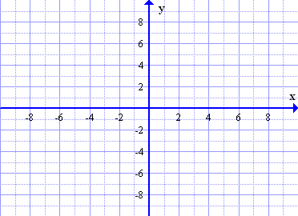

1. Graph the solution region for each quadratic inequality.

a)  b) 

Test point: Test point:

**

1. Use the process of sign analysis or case analysis to determine the solution intervals and provide a graph of the solution set on the number line:

 a) 

 b) 

1. Determine the solution interval for each.

a)  b) 

1. A worker is asked to plant flowers in a bed in front of an office building. During a sale at the garden store, a flat of marigolds costs $8 and a flat of petunias costs $9. The worker can spend at most $120. a) Write an inequality using two variables to represent this situation

b) Graph the inequality

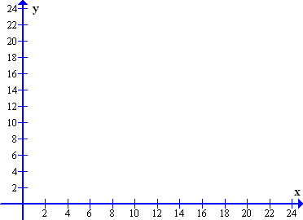

c) What are the restrictions on the variables?

d) Name two possible solutions.

1. A banquet room can seat up to 600 guests. Each rectangular table seats 11 guests and each circular table seats 6 guests.

a) Write an inequality using two variables to represent this situation.

b) What are the restrictions on the variables?

1. A bookstore can sell 1200 books at $3 each. The latest marketing results indicate that for every dollar increase in the price, 100 fewer books will be sold.

a) What price should the bookstore charge to maximize its revenue?

b) What interval of price could the bookstore charge to have revenue of at least $5400?