**Jig-Saw Problem - Circles**

**Jig Saw Instructions:**

1. In a group of 4, each member will solve the problem on their page individually.
2. Join 3 or 4 other people with the same shape and work together to become “experts” on the provided problem.
3. Rejoin your original group and each person will have a turn explaining the solution to the problem that they are now an “expert” on.

**Problem**

A regular pentagon is inscribed in a circle with center O, as shown in the diagram.

Determine the perimeter of the pentagon.



**Jig-Saw Problem - Triangles**

**Jig Saw Instructions:**

1. In a group of 4, each member will solve the problem on their page individually.
2. Join 3 or 4 other people with the same shape and work together to become “experts” on the provided problem.
3. Rejoin your original group and each person will have a turn explaining the solution to the problem that they are now an “expert” on.

**Problem**

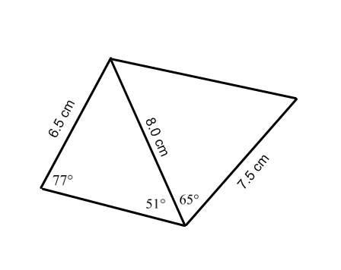

Determine the perimeter of the quadrilateral below.

**Jig-Saw Problem - Squares**

**Jig Saw Instructions:**

1. In a group of 4, each member will solve the problem on their page individually.
2. Join 3 or 4 other people with the same shape and work together to become “experts” on the provided problem.
3. Rejoin your original group and each person will have a turn explaining the solution to the problem that they are now an “expert” on.

**Problem**

Points *P* and *Q* lie 240 m apart in line with and on opposite sides of a communications tower. The angles of elevation to the top of the tower from *P* and Qare 50° and 45°, respectively. Determine the height of the tower to the nearest tenth of a metre.

**Jig-Saw Problem - Stars**

**Jig Saw Instructions:**

1. In a group of 4, each member will solve the problem on their page individually.
2. Join 3 or 4 other people with the same shape and work together to become “experts” on the provided problem.
3. Rejoin your original group and each person will have a turn explaining the solution to the problem that they are now an “expert” on.

**Problem**

A Good Year Blimp is flying at an altitude of 500 feet. Mark is standing directly below the Good Year Blimp. When Mark looks east the angle of elevation to the front of the Good Year Blimp is 82°. When Mark looks west the angle of elevation to the back of the Good Year Blimp is 72°. What is the length of the Good Year Blimp?