**Sinusoidal Transformations Investigation Name: ____________________**

**Step 1: Visualization**

Without using technology, complete the following table. For each parameter, place a checkmark in a cell if you think that adjusting the parameter will change the characteristic and otherwise leave the cell blank.

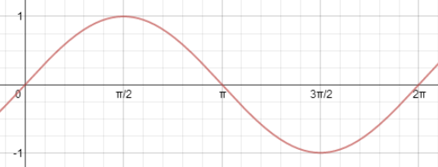



|  |  |  |  |  |  |  |  |  |
| --- | --- | --- | --- | --- | --- | --- | --- | --- |
|  |  | **Characteristics** | | | | | | |
|  |  | amplitude | period | midline | x-intercepts | y-intercept | domain | range |
| **Parameters** | *a* |  |  |  |  |  |  |  |
| *b* |  |  |  |  |  |  |  |
| *c* |  |  |  |  |  |  |  |
| *d* |  |  |  |  |  |  |  |

**Step 2: Verification**

Use the Desmos Online Graphing Calculator to verify your completion of the chart in step 1. I will assist you in getting things set up and then you may play with the sliders to see if your chart is correct. Always start with  (a = 1, b = 1, c = 0 and d = 0) before testing each parameter.

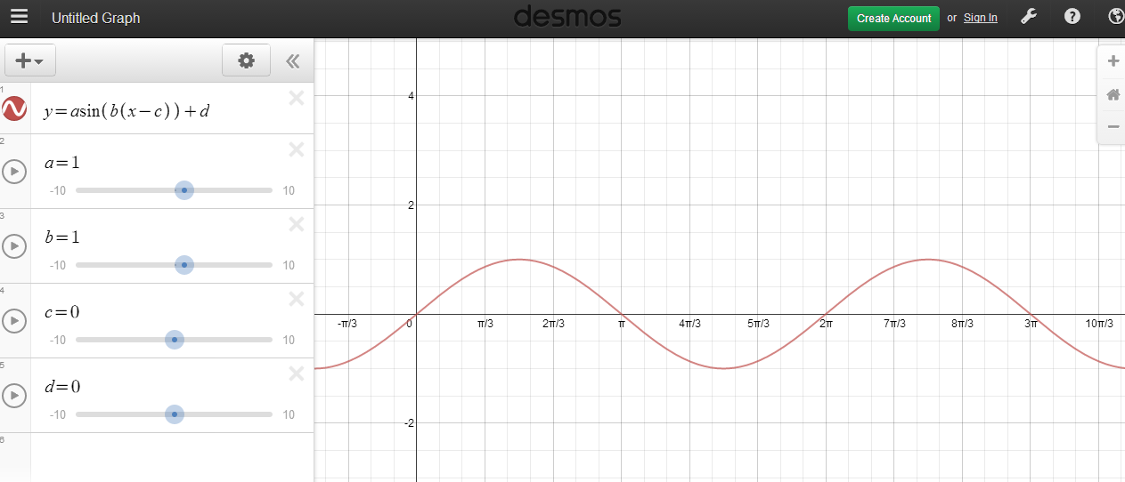

**Step 3: Explore Parameters**

Use Desmos to explore in more detail the relationship between the parameters and the characteristics of the graph.

**Explore *a*** : Begin with  (a = 1, b = 1, c = 0 and d = 0)

* When a = 1, the amplitude of the graph is _______ . Note: amplitude = (max – min) / 2
* When a = 2, the amplitude of the graph is ________.
* When a = 4, the amplitude of the graph is ________.
* When a = 0.5, the amplitude of the graph is _______.
* When a = -3, the amplitude of the graph is _______.

**Conclusion**:

**Explore *d*** : Begin with  (a = 1, b = 1, c = 0 and d = 0)

* When d = 0, the midline of the graph is _______. Note: midline = (max + min) / 2
* When d = 2, the midline of the graph is _______.
* When d = - 4, the midline of the graph is _______.
* When d = 3, the midline of the graph is ______.

**Conclusion**:

**Explore *b*** : Begin with  (a = 1, b = 1, c = 0 and d = 0)

* When b = 1, the horizontal stretch factor is 1 and the period of the graph is 2pi.
* When b = 2, the horizontal stretch factor is _____ and the period of the graph is _______.
* When b = 4, the horizontal stretch factor is _____ and the period of the graph is _______.
* When b = 0.5, the horizontal stretch factor is _____ and the period of the graph is ______.
* When b = -2, the horizontal stretch factor is _____ and the period of the graph is ______.

**Conclusion**:

**Explore *c*** : Begin with  (a = 1, b = 1, c = 0 and d = 0)

* The “starting point” of could be considered (0,0).
* Consider what happens to the “starting point” as the parameter *c* changes.
* The “starting point” of could be considered (0,1).
* Change the Desmos function to and consider what happens to the “starting point” as the parameter *c* changes.

**Conclusion**: