**GRAPH AND ANALYZE FUNCTIONS WITH A GRAPHING CALCULATOR**

**A. Enter Equation and Graph**

* Press Y= and enter equation.
* Press GRAPH

Ymax

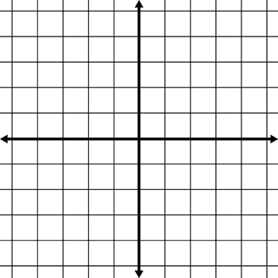**B. Adjust Window Settings**

* Press WINDOW to adjust the window settings as needed.

Xmax

Xmin

* x:[Xmin, Xmax, Xscl] y:[Ymin, Ymax, Yscl]

Ymin

Note: Use the table of values, TABLE, and context of the problem to help

choose window settings. TBLSET will help you navigate the table of values.

**C. Determine y when x is known**

* Press CALC then 1:value and enter the known x-value into X=__ and press ENTER.

or

* Press TABLE and scroll through the table to find the y-value for the known x-value.

**D. Determine x when y is known**

* Press Y= and set Y2 = known value of y, then GRAPH.
* Press CALC then 5:intersect and follow the calculator directions to determine the intersection point.

**E. Determine y-intercept**

* Determine y when x = 0 using the instructions in section C.

**F. Determine x-intercept**

* Determine x when y = 0 using the instructions in section D.

**G. Determine maximums / minimums**

* Press CALC then either 3:minimum or 4:maximum and follow the calculator directions to determine the maximum or minimum value.

**REGRESSION EQUATIONS WITH A GRAPHING CALCULATOR**

The graphing calculators have a feature that performs statistical analysis of data to determine an equation for a line or curve of best fit. This line or curve of best fit is called a regression function.

**regression function**: A line or curve of best fit, developed through a statistical analysis of data.

**A. Enter Data into Lists**

* Press Stat then 1:Edit and enter values for the independent variable (x) in L1 and values for the dependent variable (y) in L2.

Ymax

**B. Turn Plot1 On and Graph**

* Press Y= and use the arrow keys to move to highlight Plot1.

Xmin

Xmax

Press ENTER to turn Plot 1 on. It should now be dark.

* Press WINDOW to adjust the window settings as needed.

and then GRAPH.

Ymin

* x:[Xmin, Xmax, Xscl] y:[Ymin, Ymax, Yscl]

**C. Identify Type of Polynomial**

* Use the data points on your scatter plot and the context to decide which type of polynomial would best fit the data.

**D. Determine Regression Equation**

* Press STAT and use the right arrow key to go to the CALC menu.
* From the CALC menu select the regression type … 4:LinReg(ax+b) or 5: QuadReg or 6:Cubic Reg etc.
* The main screen should appear with your chosen regression type. Press ENTER to calculate the regression equation.

**E. Graph Regression Equation**

* Send regression equation to Y1 by pressing Y=.
* With the cursor in Y1 do the following:
  + VARS, 5:Statistics…, right arrow key to EQ menu, 1:RegEQ
* Equation should now be in Y1 so press GRAPH.