Quadratic

Functions



Math 20 – Pre-Calculus

Chapter 3

Name:__________________

Class:___________________

|  |  |
| --- | --- |
| **Relations and Functions** | **General Outcome:**  Develop algebraic and graphical reasoning through the study of relations |
| **Specific Outcomes** | **Achievement Indicators**:  *The following set of indicators may be used to determine whether students have met the corresponding specific outcome* |
| Analyze quadratic functions of the form and determine the:   * Vertex * Domain and range * Direction of opening * Axis of symmetry * *X*- and *y*-intercepts | * 1. Explain why a function given in the form  is a quadratic function   2. Compare the graphs of a set of functions of the form  to the graph , and generalize, using inductive reasoning, a rule about the effect of *a*.   3. Compare the graphs of a set of functions of the form to the graph , and generalize, using inductive reasoning, a rule about the effect of *q*.   4. Compare the graphs of a set of functions of the form to the graph , and generalize, using inductive reasoning, a rule about the effect of *p*.   5. Determine the coordinates of the vertex for a quadratic function of the form , and verify with or without technology.   6. Generalize, using inductive reasoning, a rule for determining the coordinates of the vertex for quadratic functions of the form .   7. Sketch the graph of , using transformations, and identify the vertex, domain and range, direction of opening, axis of symmetry and *x*- and *y*-intercepts.   8. Explain, using examples, how the values of *a* and *q* may be used to determine whether a quadratic function has zero, one or two *x*-intercepts.   9. Write a quadratic function in the form  for a given graph or set of characteristics of a graph. |
| Analyze quadratic functions of the form  to identify characteristics of the corresponding graph, including:   * Vertex * Domain and range * Direction of opening * Axis of symmetry * *X*- and *y*-intercepts   and to solve problems. | 4.1 Explain the reasoning for the process of completing the square as shown in a given example.  4.2      Write a quadratic function given in the form  as a quadratic function in the form by completing the square.  4.3 Identify, explain and correct errors in an example of completing the square.  4.4 Determine the characteristics of a quadratic function given the form  and explain the strategy used.  4.5 Sketch the graph of a quadratic function given in the form .  4.6 Verify, with or without technology, that a quadratic function in the form  represents the same function as a given quadratic function in the form .  4.7 Write a quadratic function that models a given situation, and explain any assumptions made.  4.8 Solve a problem, with or without technology, by analyzing a quadratic function. |

**Big Ideas:**

*Students will understand …*

* Information from quadratic equations and the graphs of quadratic functions can be used to solve problems in areas like physics, calculus, engineering, architecture, sports and business.

By the end of the unit students should:

* The basic shape and characteristics of the graph of a quadratic function.
* Quadratic functions and equations relate to real life situations.

3.1 Investigating Quadratic Functions in Vertex From

Part I – Parameters of Quadratic Functions

1. **Sketching **

**Investigation**: Graph each of the following quadratic functions.



***In General:*** The graph of  is the graph of  transformed as follows….

1. If a > 1 ________________________.
2. If 0 < a < 1 _____________________.

**Investigation**: Graph each of the following quadratic functions.



***In General:*** The graph of  is the graph of  transformed as follows….

1. If a < 0 ________________________.
2. **Sketching** 

**Investigation**: Graph each of the following quadratic functions.



***In General:*** The graph of  is the graph of  translated….

1. If *q* > 0 _____________.
2. If *q* < 0 ___________.
3. **Sketching **

**Investigation**: Graph each of the following quadratic functions.



***In General:*** The graph of  is the graph of  translated….

1. If *p* > 0 _____________.
2. If *p* < 0 ___________.

What is similar in all the graphs above?

What is different in all the graphs above?

Quadratic Function:

Parabola:

Vertex:

What is the vertex of each parabola? What is the maximum/minimum of each graph?

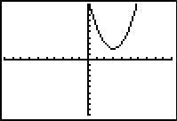 

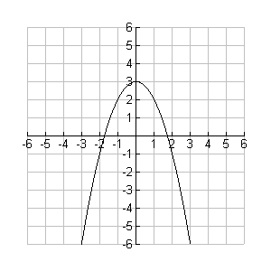



Axis of symmetry:

What is the axis of symmetry of the following parabolic graph?

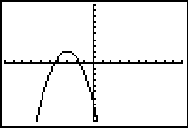

**Summary of Vertex from**



*a* tells us ________________________________ and ___________________________

(*p, q*) is the ______________________________

Maximum or minimum ____________________

Domain: _____________ Range: max ______________ or min _____________

Equation of the Axis of symmetry ________________________

Sketch the following quadratic equation by hand and identify the direction of opening, vertex, axis of symmetry, y-intercept and range.









Homework

Textbook Page 157 # 1 – 4, 6, 7

3.1 Investigating Quadratic Functions in Vertex From

Part II – Equations of Quadratic Functions and Word Problems

**Example #1**

Determine the number of x-intercepts for each quadratic function by using the vertex and the direction of opening.



The values of _________ and ___________ help determine if the parabola has ________,

___________ or _____________ *x*-intercepts.

**Example #2**

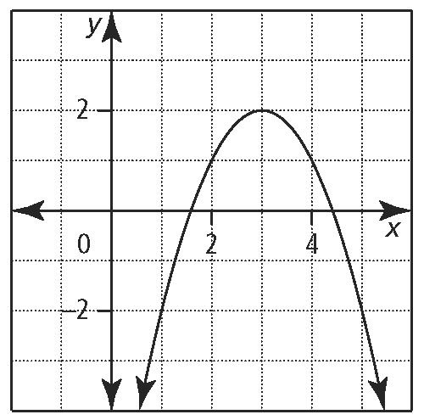Determine the equation of the Quadratic function in vertex form  given the following graphs.

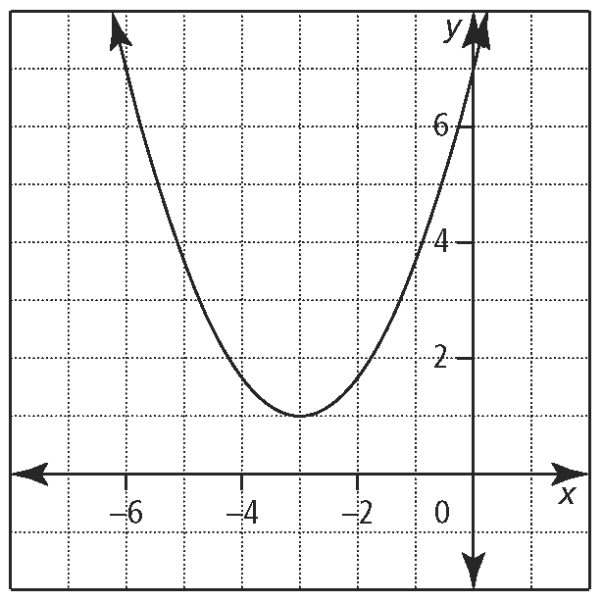

**Word Problems**

**Example #3**

A baseball is thrown from the centre outfield wall from an original height of 2m, to second base and follows the shape of a parabola. It is again 2m off the ground 90m away when the second baseman catches it. When in flight, the ball reaches a maximum height of 6m.

Determine the quadratic function, in vertex form, that models the shape of the baseball if the origin is on the ground directly below the spot from which the ball was thrown.

Determine the height of the ball when it is 10m away from second base.

**Example #4**

The largest practical functioning refracting telescope is at the [Yerkes Observatory](http://en.wikipedia.org/wiki/Yerkes_Observatory) in the USA. Its lens, in the shape of a parabola, has a diameter of 102 cm and a width of 8 cm, and has been used for astronomical and scientific observation for over a century.

Determine the quadratic function, in vertex form, of the cross-sectional shape if the lowest point in the centre of the lens is at the origin.

What is the equation if the outer most edge of the lens is at the origin?

Homework

Textbook Page 159 # 8-10, 13-15, 17, 18, 21

3.2 Investigating Quadratic Functions in Standard From

**Example #1**

For each of the following quadratic function, in vertex form, identify:

* The direction of opening
* Coordinates of the vertex
* Maximum or minimum value
* Equation of the axis of symmetry
* x-intercepts (if possible) and y-intercepts
* the domain and range

Change each to standard form 

 

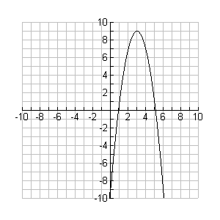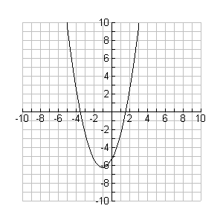



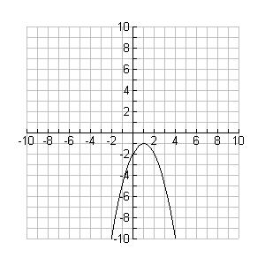

**Example #2**

A rock is thrown from a bridge into a river. Its height, *h* meters, above the river *t* seconds after it is released is modeled by the quadratic function.

Sketch a graph of the quadratic function. Indicate window settings used.



Using a graphing calculator, find, to the nearest tenth,

a) the maximum height of the rock.

b) the time it takes the rock to reach its maximum height.

c) the height at 2 seconds.

d) when it reaches a height of 25 metres.

1. the height of the bridge.
2. the time it takes the rock to hit the river.

**Example #3**

A farmer has 120 m of chicken wire. He wishes to construct a rectangular chicken pen, making use of a barn as one side of the pen.

1. Find an expression for the area of the pen in standard form.
2. Solve graphically the vertex and what do these numbers represent.
3. Determine the Domain and Range in the context of the question.

Homework

**Textbook Page 174 # 1-5, 7, 8, 12, 15a-f**

3.3 Completing the Square

Part I Convert from Standard Form to Vertex Form

You can express a quadratic function in standard form _________________ or in vertex from _____________________.

To change from one form to another you need to complete the square

 are examples of **perfect squares.**

**a)** Expand the following perfect squares.

= = ______________ = = ______________

= = _______________ = = _______________

Factor the following expressions into perfect squares.

= ______________ = ______________

= ______________ = ______________

Add an appropriate constant so that the following expressions can be written

as perfect squares.

** = ___________ **= ___________

**= ____________ **= ___________

**Example #1**

Rewrite each function in vertex form by completing the square

1.  b.  (and verify)

c.  d.  (and verify)

**Example #2**

The height, *h*, in metres above the ground, of a projectile at any time, *t*, in seconds, after the launch is defined by the function . Change to vertex form and determine the vertex, the maximum or minimum point and the time it takes for the projectile to reach that height.

Homework

**Textbook Page 192 # 1-4, 6, 8, 9, 12-15**

3.3 Completing the Square

Part II Maximum and Minimum Problems

**Example #1**

Find two numbers that differ by 18 and have a minimum product.

**Example #2**

The Summer Theater charges $4 per ticket, and it sells and average of 400 tickets nightly. The manager estimates that the ticket sales would decrease by 50 for each $1 increase in the ticket cost. What is the most profitable price to charge?

**Example #3**

A rectangular field is to be enclosed by a fence and divided into two smaller plots by a fence parallel to one of the sides. Find the dimensions of the largest such field if 1200 m of fencing material is available. What is the area of this field and what are the dimensions that will give the largest area?

**Example #4**

If a farmer harvests his crop today, he will have 1200 bushels worth $2/bushel. Every week that he waits, the crop increases by 100 bushels, but the price drops $0.10 per bushel. Determine:

1. The maximum revenue he can make.

1. How many weeks he should wait to harvest the crop in order to maximize his revenue.
2. The selling price per bushel when making maximum revenue.

Homework

Textbook Page 192 #18-24

Maximum and Minimum Problems

Algebraically solve the following problems.

1. A projectile is fired straight up from a height of 6 feet. Its height (*h*) in feet after *t* seconds is given by . Algebraically determine the maximum height of the projectile.
2. The path of a basketball shot on the moon can by modeled by the equation  where *h(d)* is the height of the basketball, in metres and *d* is the horizontal distance of the ball from the player, in metres. Determine:
3. The height of the basketball before it is shot.
4. What is the maximum height reached by the ball?
5. How long does it take the ball to reach maximum height?
6. Find two numbers whose difference is 13 and whose “squares”, when added together, are a minimum.
7. A farmer has 100 m of chicken wire. He wishes to construct a rectangular chicken pen, making use of the barn as one side of the pen. Find the dimensions of the pen so that it will have maximum area for his chickens.
8. A rectangular field is to be enclosed by a fence and divided into two smaller plots by a fence parallel to one of the sides. Find the dimensions of the largest such field if 1200 m of fencing material is available. Also, state the area of this field.
9. The Environment Club sells sweatshirts as a fundraiser. They sell 1200 shirts a year at $20 each. They are planning to increase the price. A survey indicates that for every $2 increase in price, there will be a drop of 60 sales a year. What should the selling price be in order to maximize the revenue?
10. An amusement park charges $8 admission and averages 2000 visitors per day. A survey shows that, for each $1 increase in admission cost, 100 fewer people would visit the park. Find the admission cost and number of visitors that gives the maximum revenue.