Systems

of

Equations & Inequalities



Math 20 – Pre-Calculus

Chapter 8 & 9

Name:__________________

Class:___________________

|  |  |
| --- | --- |
| **Relations and Functions** | **General Outcome:**  Develop algebraic and graphical reasoning through the study of relations |
| **Specific Outcomes** | **Achievement Indicators**:  *The following set of indicators may be used to determine whether students have met the corresponding specific outcome* |
| Solve, algebraically and graphically, problems that involve systems of linear-quadratic equations and quadratic-quadratic equations in two variables. | * 1. Model a situation, using a system of linear-quadratic equations or quadratic-quadratic equations   2. Relate a system of linear-quadratic equations or quadratic-quadratic equations to the context of a given problem   3. Determine and verify the solution of a system of linear-quadratic equations or quadratic-quadratic equations, with technology   4. Determine and verify the solution of a system of linear-quadratic equations or quadratic-quadratic equations algebraically   5. Explain the meaning of the points of intersection of a system of linear-quadratic equations or quadratic-quadratic equations   6. Explain, using examples why a system of linear-quadratic equations or quadratic-quadratic equations may have zero, one, two or an infinite number of solutions   7. Solve a problem that involves a system of linear-quadratic equations or quadratic-quadratic equations |
| Solve problems that involve linear and quadratic in two variables | * 1. Explain, using examples, how test points can be used to determine the solution region that satisfies an inequality   2. Explain, using examples, when a solid or broken line should be used in the solution for an inequality   3. Sketch, with or without technology, the graph of a linear or quadratic inequality   4. Solve a problem that involves a linear or quadratic inequality |
| Solve problems that involve quadratic inequalities in one variable | 8.1 Determine the solution of a quadratic inequality in one variable using  strategies such as: case analysis, graphing, roots and test points, or  sign analysis  8.2 Represent and solve a problem that involves a quadratic inequality in  one variable  8.3 Interpret the solution to a problem that involves a quadratic  inequality in one variable |

**Big Ideas**

*By the end of this unit you should be able to . . .*

* model a situation using a system of equations
* Solve a system of equations algebraically and graphically
* Interpret points of intersection
* Interpret the number of solutions a system has
* Solve a problem that involves a system of equations
* Graph linear and quadratic inequalities
* Solve problems that involve linear and quadratic inequalities

8.1 Solving Systems of Equations Graphically

**Recap from 10C**: System of linear equations –

**New to Math 20-1**:

* System of linear-quadratic equations –
  + Graph will involve . . .
* System of quadratic-quadratic equations –
  + Graph will involve . . .

**Solution of a system of equations** –

* Graphically . . .
* Algebraically . . .

**Number of solutions**

* Sketch a graph to represent each scenario involving a system of . . .

**Linear-quadratic equations**

|  |  |  |  |
| --- | --- | --- | --- |
| **No Solution** | **One solution** | **Two Solutions** | **Infinite #** |
|  |  |  |  |

**Quadratic-quadratic equations**

|  |  |  |  |
| --- | --- | --- | --- |
| **No Solution** | **One solution** | **Two Solutions** | **Infinite #** |
|  |  |  |  |

**Problem:**

A girl is standing on a diving board that is 3 m above the water. Sketch a graph of the system of equations representing the girls height above the water relative to the height of the diving board.

Which system could be modeling this scenario? Explain what the intersection point between the two graphs represents in this situation.

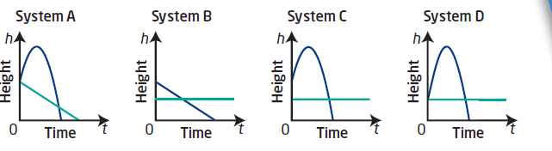

**Problem:**

Two divers start their dives at the same time. One diver jumps from a 1 m springboard, the other jumps from a 3 m springboard. Which of the following graphs could model this scenario?

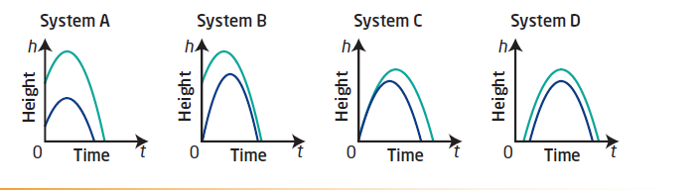

Explain why there is no point of intersection in the graph you chose.

**Solving linear-quadratic systems graphically**

Example:

A system is defined by the equations:





‘Solve” this system graphically BY HAND and VERIFY your solution:

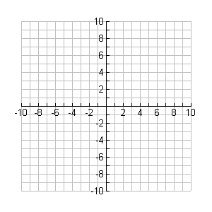

Show that your answer satisfies both equations:

L.S. R.S. L.S. R.S.

Example:

A system is defined by the equations:





**Solve this system using technology. Verify you solution(s).**

Show that your answer satisfies both equations:

L.S. R.S. L.S. R.S.

**Solving quadratic-quadratic systems graphically**

Example:

A system is defined by the equations:





**Solve this system using technology. Verify you solution(s).**

L.S. R.S. L.S. R.S.

**Textbook**

**Page 435 #1-8**

8.1 Applying and Modeling Systems of Equations

Example 1: Applying a System of Equations

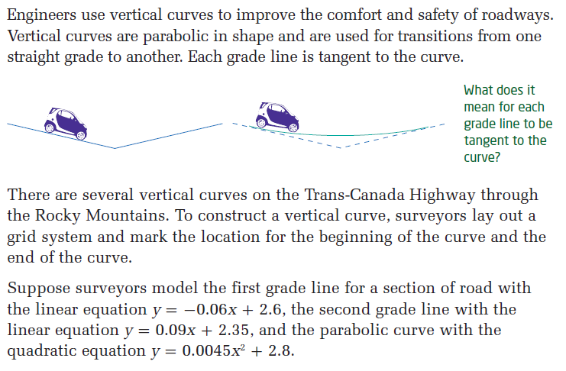

* Write the two systems of equations that would be used to determine the coordinates of the points of tangency.
* Using graphing technology, show the surveyor’s layout of the vertical curve. Sketch below.
* Determine the coordinates of the points of tangency to the nearest hundredth.
* Interpret each point of tangency.

Example 2: Applying a System of Equations

A flare is shot up into the air. The path of the flare is modeled by the equation . In this equation, *y* is the height of the flare and *x* is the horizontal distance from where it was shot.

A telescope is placed in the same spot from where the flare was shot. The line of sight from the telescope is modeled by the equation .

Solve the system formed by the two equations using technology. Give the answers to the nearest tenth.

Explain the meaning of the solution.

Example 3: Modeling a System of Equations

After a football is kicked, it reaches a maximum height of 14 m and it hits the ground 32 m from where it was kicked. After a soccer ball is kicked, it reaches a maximum height of 8 m and it hits the ground 38 m from where it was kicked. The paths of both balls are parabolas.

* Create an equation that represents the path of the football.
* Create an equation that represents the path of the soccer ball.
* To the nearest tenth of a meter, determine the horizontal distance that both balls have travelled when they are at the same height.

Example 4: Modeling a System of Equations

Two numbers are related:

The first number minus 12 is equal to the second number.

The square of the first number minus 30 times the second number is equal to 360.

* Create a system of equations to represent this relationship.
* Solve the system to determine the numbers.

**Textbook**

**Page 435 #9-15**

8.2 Solving Systems of Equations Algebraically

**Recap from 10C**: Solving a system of equations algebraically – 2 methods . . ..

1. . . .
   * This method involves . . .

* + here’s a system that might be appropriate to solve using this method





* + here’s a system that would probably not be appropriate to solve using this method





1. . . .
   * This method involves . . .

* + here’s a system that might be appropriate to solve using this method





* + here’s a system that would probably not be appropriate to solve using this method





**Examples**

Solve each of the following systems ALGEBRAICALLY and verify your solution.

1. 
2. 
3. 

Applications

Number Problem

* Determine 2 integers such that the sum of the smaller number and twice the larger number is 46. Also, when the square of the smaller number is decreased by three times the larger, the result is 93.
* Create a system of equations and solve the system in order to determine the two numbers.

Linear-Quadratic Problem

* A cargo plane drops a crate of emergency supplies to workers on the ground. The crate drops freely at first but when the parachute opens the crate gently hits the ground. The crates height above the ground can be represented by the following equations .

. . . represents the height of the crate during free-fall

 . . . represents the height of the crate with parachute

open

* Determine how long after the crate leaves the aircraft does the parachute open.

* What height above the ground is the crate when the parachute opens?

**Textbook**

**Page 451 #1, 3, 4, 9, 13**

9.1 Linear Inequalities in Two Variables

The speed limit on a highway is 100 km/h. A car is breaking the speed limit. This means that the speed, *s*, at which the car is traveling is given by the inequality *s* > 100.

An inequality must contain ONE of the following symbols . . .

The following are examples of linear inequalities in two variables . ..

  

The solution region to a linear inequality in two variables can be represented on a coordinate plane using a **boundary line**.

The **boundary line** will be solid or broken according to the following rule

* A **solid line** is used to represent or
* A **broken line** is used to represent or

**How to Graph a Linear Inequality in Two Variables**

**Examples**

Graph the following linear inequalities in two variables.













**Examples**

The diagrams show the solution region to an inequality. Determine the equation of the boundary line and, hence, determine the inequality.

*y*

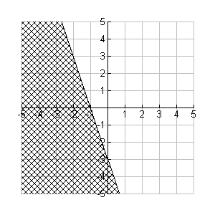

*x*

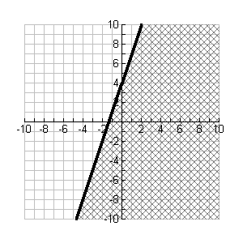

**Writing and Solving an Inequality**

You would like to make a mosaic using tile and stone. Tile costs $2.50/ft2 and stone costs $7.50/kg. Your budget for the mosaic is $60.

Write an inequality to represent this situation. Graph the inequality and state some possible combinations of tile and stone that could be used to make the mosaic.

**Textbook**

**Page 472 #1-4, 9,11**

9.2 Quadratic Inequalities in One Variable

Recap: Solve the following quadratic equations by factoring.

  

Example

Consider the quadratic function 

* Determine the zeros of the function by factoring
* Sketch the function on the grid provided



* Identify the x-values that work for the inequality 
* Identify the x-values that work for the inequality 

**How to Solve a Quadratic Inequality**

There are several methods to solving a quadratic inequality.

1. Graph the function

Example: Determine the solution to 

* + Start by finding the zeros of the function 
  + Sketch the graph of the function
  + To determine the solution to  , look for all the values of  for which the graph of  lies on or below the axis.

1. Roots and Test Points

Example: Determine the solution to 

* + Start by solving the related equation  for its roots.
  + Draw a number line and indicate the location of the roots (using closed circles because of the  sign). Now, use “test points” in each of the regions of the number line to see which intervals satisfy the inequality.

1. Sign Analysis

Example: Determine the solution to 

* + Start by factoring the quadratic inequality.
  + Using a chart, put your factors along the top and intervals up to and between the roots along the side.

In each box, fill in the “sign” that the factor would be over that interval.

Multiply all the signs in each row to find the sign of the final product.

|  |  |  |  |  |
| --- | --- | --- | --- | --- |
| Interval |  |  |  | Sign of |
|  |  |  |  |  |
|  |  |  |  |  |
|  |  |  |  |  |

* + State the intervals of *x* that satisfy the inequality.

Solve the following quadratic inequalities using a method of your choice.

1.  c) 
2.  d) 

**Textbook**

**Page 485 #1-9**

9.3 Quadratic Inequalities in Two Variables

Recap: a quadratic inequality in ONE variable looks like  and it’s solution is expressed as an interval of *x*-values , such as .

A quadratic inequality in TWO variables looks like  and it’s solution is a region of the graph that is shaded and bound by a broken or solid line.

Example

Graph 

* Step 1: find the x-intercepts of the graph (factor ☺)
* Step 2: Draw the “boundary” line of the function (remember, < or > gets a broken line, whereas  or  gets a solid line.

* To determine which region is the “solution region” (that region that will get shaded), choose a test point from either above or below the parabola.

If the coordinates of the test point satisfy the inequality, then shade the region containing the test point.

If the coordinates of the test point does not satisfy the inequality, then shade the region that does NOT contain the test point.

**Example**

Graph the inequality  . Verify using a test point.



**Example**

Determine whether each ordered pair is a solution of the quadratic inequality .

  

Example

Are the points on the graph of  part of the solution of the inequality ? Explain.

**Example**

Graph the inequality  . Write the coordinates of two points that satisfy the inequality.



**Example**

Graph the inequality  . Write the coordinates of two points that satisfy the inequality.



**Example**

Determine the equations of the following inequalities.

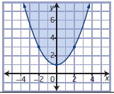

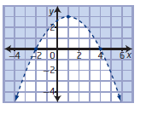

**Textbook**

**Page 496 #1-7,9**



